// Employee Class

import java.util.\*;

class Employee

{

String fn;

String ln;

double sal;

public Employee()

{

fn="";

ln="";

sal=0.0;

}

public void getData()

{

Scanner sc=new Scanner(System.in);

System.out.println("Enter the First name");

fn = sc.nextLine();

System.out.println("Enter last name");

ln = sc.nextLine();

System.out.println("Enter the salary");

sal = sc.nextDouble();

if(sal<0.0)

sal=0.0;

}

public void raise()

{

double anus = sal\*12;

System.out.println("Annual Salary = "+anus);

double incr = anus\*1.10;

System.out.println("Incremented Annual salary = "+incr);

}

public void setData()

{

System.out.println("Name : "+fn+ " "+ln);

System.out.println("Monthly Salary = "+sal);

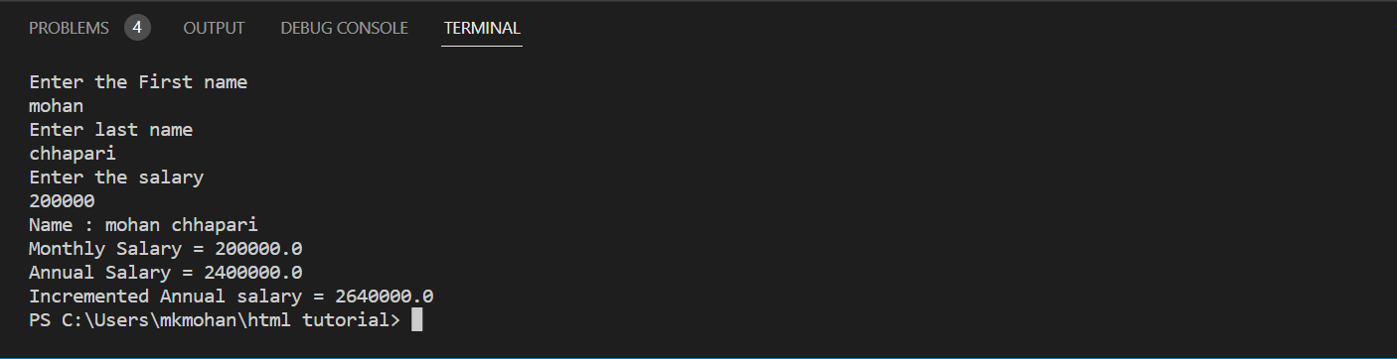 }

public static void main (String a[])

{

Employee e = new Employee();

e.getData();

e.setData();

e.raise();

}

}

// Rectangle

import java.util.\*;

class Rectangle

{

double length,breadth;

public void setDim(double l,double b)

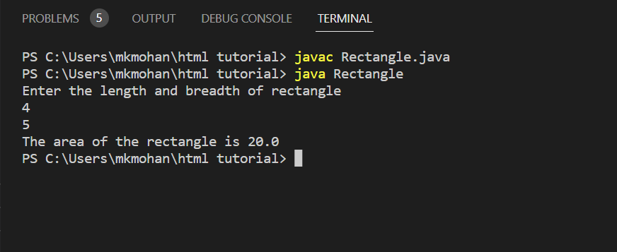 {

length=l;

breadth=b;

}

public double getDim()

{

return length\*breadth;

}

public static void main (String a[])

{

Rectangle r=new Rectangle();

Scanner sc=new Scanner(System.in);

System.out.println("Enter the length and breadth of rectangle");

double l=sc.nextDouble();

double b=sc.nextDouble();

r.setDim(l,b);

double area = r.getDim();

System.out.println("The area of the rectangle is "+area);

}

}

// Static

import java.util.\*;

class Staticdemo

{

static int a=20;

static int b;

static

{

System.out.println("Static Block Executed");

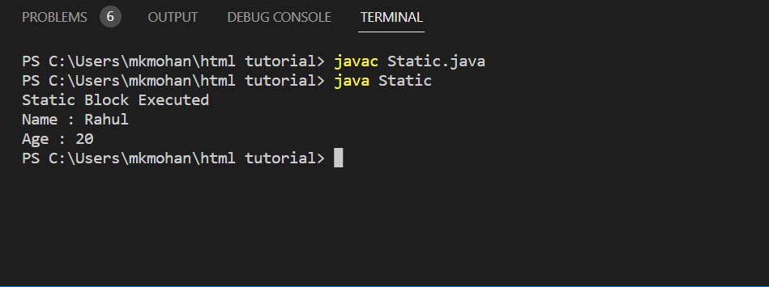 b=a\*5;

}

static int age;

static String name;

static void display()

{

System.out.println("Name : "+name+"\nAge : "+age);

}

public static void main (String[] a)

{

age = 20;

name = "Rahul";

display();

}

}