**TrendzOle**

**( Online Shopping Zone )**



By

Name of the student: Roll no:

A. Chandu Mani Kumar 16CS036

N. Sunil 16CS042

MINOR PROJECT

(CS-281)

AT

School Of Computer Science

**LINGAYA’S VIDYAPEETH, FARIDABAD**

**SESSION 2017-2018**

**A PROJECT REPORT**

**ON**

**TrendzOle ( Online Shopping Zone )**

By

NAME OF THE STUDENT ROLL NO DISCIPLINE

A. Chandu Mani Kumar 16CS036 CSE

N. Sunil 16CS042 CSE

**PROJECT REPORT SUBMITTED IN PARTIAL FULFILLMENT OF THE REQUIREMENTS OF THE COURSE**

**Minor Project**

**(CS-281)**

At

**School of Computer Science**

**Lingaya’s Vidyapeeth**

Guide

Faculty/Associate Professor Ms. Sonia

**SCHOOL OF COMPUTER SCIENCE**

**LINGAYA’S VIDYAPEETH, FARIDABAD**

**SESSION 2017-2018**

**LINGAYA’S VIDYAPEETH**

**BONAFIDE CERTIFICATE**

Certified that this project report **“TRENDZOLE** **( Online Shopping Zone )** is the bonafide work of  **A. Chandu Mani Kumar ( 16CS036 ) and N. Sunil ( 16CS042 )** who carried out the project in collaboration with **School of Computer Science, Lingaya’s Vidyapeeth**, embodies the work done by her under the guidance of **Ms.Sonia**, towards partial fulfilment of the requirements of the Degree of Bachelor of Technology in Computer Science and Engineering from Lingaya’s Vidyapeeth, Haryana. They have fulfilled all the requirements needed as per the rules of the Lingaya’s Vidyapeeth, for the completion of Project. This work is original and has not been submitted in part or in full to any University or Institution.

Signature of the supervisor

Ms. Sonia

School of Computer Science

Lingaya’s Vidyapeeth , Faridabad.

Haryana.

**LINGAYA’S VIDYAPEETH**

**CERTIFICATE OF AUTHENTICATION**

I solemnly declare that this project “**TRENDZOLE** **( Online Shopping Zone ) ”** is the bonafide work done purely by me, carried out under the supervision of **Ms. Sonia,** towards partial fulfilment of the requirements of the Degree of Bachelor of Technology in Computer Science and Engineering from Lingaya’s Vidyapeeth, Faridabad, during the year 2017-2018.

It is further certified that this wok has not been submitted, either in part or in full, to any other department of the Lingaya’s Vidyapeeth, or any other University, institute or elsewhere, or publication in any form.

Date: **A.CHANDU MANIKUMAR ( 16CS036 )**

Date: **N. SUNIL ( 16CS042 )**

**ACKNOWLEDGEMENT**

In completing of our project, we are very thankful to many individuals and we must place on record our sincere thanks to all of them.

First of all, we would like to express our deep sense of gratitude to our supervisor Ms. Sonia, who gave us his invaluable guidance glowing with his words of encouragement and inspiration, criticisms and discussions throughout the problem designing.

We are very much grateful to Ms. Latha Banda (Professor & H.O.D. (SCS)) for his valuable support and cooperation in conceptualizing the project/research work and to all those outstanding individuals with whom we have worked, who helped us in understanding the concept.

We are highly thankful to our family members for their all-time support in initiating us and bringing a spark in us to pursue the work.

**TABLE CONTEXT**

|  |  |
| --- | --- |
| **S.NO** | **NAME OF THE TOPIC** |
| 1. | Introduction about the project |
| 2. | Project Category |
| 3. | Introduction about Hyper Text Markup Language |
| 4. | Advantages of HTML |
| 5. | Introduction about Cascading Style Sheet (CSS) |
| 6. | Advantages of CSS |
| 7. | Main Tags used in designing the Webpages |
| 8. | Purpose of the project |
| 9. | Features of the project |
| 10. | Coding of the project |
| 11. | Outputs of the project |
| 12. | Conclusion |
| 13. | Future scope |
| 14. | References |

**INTRODUCTION ABOUT PROJECT:**

* This project is basically a website which contains all the information about TRENZOLE ( Online Shopping Zone )
* The website contains all the information about the type of shirts, designs, texts and colors
* From this website the user can get any type of shirts and designs. The main contents of the webpage are:
* About TrendzOle ( Online Shopping Zone ) : This webpage basically contains the three type shirts which user can buy through online.
* Ordering in TrendzOle : This webpage basically contains the orders from the users which can send the design to print on shirt or send the design or photo to design for the user satisfaction.

* Contact : This webpage basically consist the information about to contact or send the message to the TrendzOle.
* About Us : This webpage basically consist the information about the TrendsOle creators.

**PROJECT CATEGORY:**

* The language that is used in this project is Hyper Text Markup Language (HTML), Cascading Style Sheet (CSS) and Java.

**INTRODUCTION TO HYPER TEXT MARKUP LANGUAGE.**

* HTML is the standard markup language for creating Web pages.
* HTML stands for Hyper Text Markup Language.
* HTML is proposed by Tim Berners Lee in 1987.
* HTML describes the structure of Web pages using markup.
* HTML elements are the building blocks of HTML pages.
* HTML elements are represented by tags.
* HTML tags label pieces of content such as "heading", "paragraph", "table", and so on.
* Browsers do not display the HTML tags, but use them to render the content of the page.
* HTML web pages are saved in ‘.htm’ or ‘.html’ format.
* Hyper Text Markup Language is extended from SGML and it is extended up-to Extensive Hyper Text Markup Language (XHTML).
* Hyper Text Markup Language is developed by World Wide Web Consortium (W3C) & WHATWG.
* HTML is an application of Standard Generalized Markup Language (SGML).
* HTML posses many versions like HTML 2, HTML3, HTML4.0, HTML 5.

**ADVANTAGES OF HYPER TEXT MARKUP LANGUAGE**

* Hyper Text Markup Language (HTML) is highly flexible.
* HTML is almost supported by every type of browser.
* HTM is user friendly.
* HTML is an open technology.
* HTML is consistent and efficient.
* HTML is very easy to understand and does not require any training.
* HTML is easier to maintain and update any website.
* For HTML it takes less time to load the webpages.
* HTML validation is another key factor which increases the web accessibility
* HTML does not involve strain on the web servers.

**INTRODUCTION TO CASCADING STYLE SHEET (CSS) :**

* CSS means Cascading Style Sheet.
* CSS describes how HTML elements are to be displayed on the screen, on the paper or any other media.
* CSS saves a lot of work and time.
* CSS can control the layout of multiple webpages all at once.
* External style sheets are stored in CSS files.
* External CSS files are saved in .css extension.
* CSS is a style sheet language.
* CSS is developed by World Wide Web Consortium.
* CSS is a cornerstone technology used by most websites to create visually engaging web-pages, user interfaces for web applications, and user interfaces for many mobile applications.
* CSS is designed primarily to enable the separation of presentation and content, including the aspects such as layouts, colours and fonts.
* A style sheet consists of list of rules and each rule or rule set consist of one or more selectors and a declaration block.
* CSS possess various versions like CSS 1, CSS 2, CSS 2.1, CSS 3, CSS 4.

**ADVANTAGES OF CASCADING STYLE SHEET:**

* Web pages are easier to load and uses less band width.
* A CSS style sheet compliments well with HTML.
* CSS allows you to position your elements any where in your webpage.
* CSS is compatible with all browsers.
* CSS can be used to create print friendly webpages.
* CSS style sheet allows the user to customize the webpage.
* CSS style sheet makes it easy for the website to feature in search engines.

**DIFFERENT TYPES HTML AND CSS TAGS THAT ARE USED IN CREATING THE WEBSITE :**

Basically in HTML, we use basic tags to create the webpages and there are different type of tags like text tags, font tags etc.

**TAGS THAT ARE USED IN HTML :**

* **<html>** **:** This is the basic tag which shows that the document type is html and it has both beginning and ending tags I;e <html>…</html>
* **<head>:** The head element is a container for metadata I;e data inside data and it has both beginning and ending tags. <head> ..</head>
* **<title>:** The title element is used to just give the title to the webpage the user is creating .The title element has both beginning and ending tags I;e <title>…</title>.
* **Heading tags :** The heading tag in HTML is used to set the headings in the HTML webpage and the headings have 6 versions and heading also have both opening and closing tags I;e <h1>..</h1> , <h2> ..</h2>, <h3>..</h3> ,<h4> ..</h4> ,<h5>…</h5> ,<h6>..</h6>.

* **Paragraph Tag :** The <p> tag offers a way to structure your text into different paragraphs. Each paragraph of text should go in between an opening <p> and a closing </p> tag

* **Line brake tag :** Whenever you use the <br /> element, anything following it starts from the next line. This tag is an example of an empty element, where you do not need opening and closing tags, as there is nothing to go in between them.

The <br /> tag has a space between the characters br and the forward slash. If you omit this space, older browsers will have trouble rendering the line break, while if you miss the forward slash character and just use <br> it is not valid in XHTML.

* **Body tag :** This tag represents the document's body which keeps other HTML tags like <h1>, <div>, <p> etc.

* **Center tag :** The HTML center tag is used to center the content in the webpage. The center tag also has both closing and opening tags.
* **List tags :** The list tags are the tags that are used to write the content in the form of list .There are two types of list *ordered list (ol) , *unordered list(ul). <li> is the list tag with both opening and closing tags.
* **Anchor tag :** The anchor tag is a tag that is used for the hyper linking of two or more web pages. The anchor tag also has both closing and opening tags. The syntax of the anchor tag be like

Syntax:<a href= “source” >content</a>

* **Marquee tag :** Marquee tag is a special tag that is used in HTML for the movement of the content in the webpage. Marquee tag has its many attributes like behavior, direction , scrollamount , scrollspeed. The syntax of Marquee tag be like ..

Syntax: <marquee behavior= “slide” scrollamount= “4” >content (or) image</marquee>

* **Image tag :** Image tag in HTML is used to insert the images in the webpage according to our view by using different image attributes like width , height , border .There is no closing for the image tag. The syntax of the image tag is as follows:

Syntax:<img src= “url of image” width= “no.px” height= “no.px” border= “no.” >

* **Video tag :** Video tag in HTML is used to insert the videos in the webpage according to our view by using its different video attributes like width and height .There is closing of the video tag .The syntax of the video tag is as follows:

Syntax: <video width= “no.” height= “ no.” controls> url of the video </video>

* **Division tag :** The division tag in HTML is used to separate the content of the webpage. Division tag has its attributes as class and id , by using this class name and id user can style the webpage by using CSS and the division tag has both opening and closing tags. The syntax of the division tag is:

Syntax:<div class= “xyz” >content</div>

* **Search box :** The search box is inserted in HTML webpage by using the search box. The syntax of the search box is as follows.

Syntax: <input class= “scr” type = “text” place holder= “search”>

**TAGS THAT ARE USED IN CSS**

* Style tag : Style tag is the main tag of the CSS for styling the webpage and its contains all other CSS tags like font, background etc..Style tag has both opening and closing tags. The value of the style attribute is the rules that is separated by a semicolon .The syntax of the Style tag is as follows.

Syntax:<style>…</style>

* CSS always used with the markup language, it is a simple design language intended to simplify the process of making webpages presentable.
* SYNTAX : table { border:1 px solid #coo;}
* 1px=12 points.
* MIME : Multipurpose Internet Mail Extension.
* SELECTOR :
* A selector is an HTML tag at which a style will be applied this could be any tag like <h1> or <table> etc.
* Property :

A property is a type of attribute of HTML tag they could be color (or) border (or) image (or) bg color.

* Value : Values are assigned to properties for eg: Color property can have either red (or) “#f1f1f1” etc.

**FONTS:**

(1) Font family: This property is used to change the face of a font.

(2) Font style: This property is used to give a italic, bold or underlined style.

(3) Font variant: This property is used to create small caps effect.

(4) Font weight: This property is used to increase or decrease how bold or light font appears.

(5) Font Size: Used to increase or decrease the size of the font.

(6) Font: Used to specify, no.of other font properties.

(7) Color: Used for setting up of a color.

(8) Direction: It defines in which directions the text should be inclined.

(9) Letterspacing: It is used to add (or) subtract space between the letters that make up a word.

(10) Word spacing: It is used to add (or) subtract space between the two words.

(11) Text Indent: It is used to indent the text of a paragraph.

(12) Text Align: It is used to align the text in the document.

(13) Text Decoration: It is used to underline, strike, box, etc.

(14) Text transform: It is used to capitalise text or convert text to uppercase or lowercase letters.

(15) White space: It basically controls the flow and formatting of text.

(16)Text Shadow: It is basically defines the type of text shadow you want to give to your text.

**CSS COLORS:**

CSS uses color values to specify a color. Typically, these are used to set a color either for the foreground of an element (i.e., its text) or for the background of the element. They can also be used to affect the color of borders and other decorative effects.

You can specify your color values in various formats. Following table lists all the possible formats.

Format Syntax Example

Hex Code #RRGGBB p{color:#FF0000;}

Short Hex Code #RGB p{color:#6A7;}

RGB % rgb(rrr%,ggg%,bbb%) p{color:rgb(50%,50%,50%);}

RGB Absolute rgb(rrr,ggg,bbb) p{color:rgb(0,0,255);}

keyword aqua, black, etc. p{color:teal;}

**PURPOSE OF THE PROJECT:**

* The main purpose of the project is to give a bulk of information regarding Bangalore.
* The other purpose of the project is to just provide updates about Bangalore.

**FEATURES OF THE PROJECT:**

* It is a user friendly website
* It provides all the information about Bangalore
* One can keep updates about Bangalore
* A person do not need any extraneous knowledge to operate this website
* One can gain as much as knowledge about Bangalore by referring this website.
* One can put up a query or comment regarding any information in the website.

**CODING OF THE PROJECT:**

**CODE OF HOME PAGE :**

<!Doc Type HTML>

<html>

<head>

<title>TrendzOle</title>

<link rel="stylesheet" href="TrendzOle1.css">

<style></style>

<link rel="icon" href="TrendzOlePhotos/TO%20logo.ico">

</head>

<body>

<nav class="nav">

<ul>

<li><a href="About.html">About</a></li>

<li><a href="contact.html">Contact</a></li>

<li><a href="Ord.html">Order</a></li>

<li><a href="TrendzOle.html">Home</a></li>

</ul>

<form class="search-bar">

<input type="text" placeholder="search" class="search-bar" >

<button class="search-button" type="submit">Search</button>

</form>

</nav>

<img id="trendzole-logo" src="TrendzOlePhotos/TrendzOle%20logo02.png" width="15%">

<img id="to-logo" src="TrendzOlePhotos/TO%20logo%2002.png" width="15%">

<div class="adv-part">

<img class="adv-img" src="TrendzOlePhotos/Adv.jpg">

</div>

<div class="shirt-part"><div class="absolute"><a style="text-decoration: none;color: #00ff00" href="Shirt%2003.html"><img class="Shirt-img" src="Shirts/03/3-1.png"><h2 class="shirt-part-text"> C Style T-Shirt</h2></a></div></div>

<div class="shirt-part"><div class="absolute"><a style="text-decoration: none;color: #00ff00" href="Shirt%2002.html"><img class="Shirt-img" src="Shirts/02/2-4.png"><h2 class="shirt-part-text">C Style Hoodies</h2></a></div>

</div>

<div class="shirt-part"><div class="absolute"><a class="Text-shirt" href="Shirt%2001.html" style="color: #00ff00"><img class="Shirt-img" src="Shirts/MCA_T-Shirt_Front.png"><h2 class="shirt-part-text">MCA T-Shirt</h2></a></div></div>

<div class="shirt-part"><div class="absolute"><a style="color: #00ff00;text-decoration: none" href="Shirt%2004.html"><img class="Shirt-img" src="Shirts/04/4-3.png"><h2 class="shirt-part-text">TrendzOle Logo</h2></a></div></div> <div class="shirt-part"><div class="absolute"><img class="Shirt-img" src="Shirts/3-3.png"></div><h2 class="shirt-part-text"> Polo Shirt </h2></div>

<div class="shirt-part"><div class="absolute"><img class="Shirt-img" src="Shirts/3-1.png"></div><h2 class="shirt-part-text">C S K T-Shirt</h2></div>

<div class="shirt-part"><div class="absolute"><img class="Shirt-img" src="Shirts/3-9.png"></div><h2 class="shirt-part-text">C Style Hoodies</h2></div>

<div class="shirt-part"><div class="absolute"><img class="Shirt-img" src="Shirts/3-8.png"></div><h2 class="shirt-part-text">K K R T-Shirt</h2></div>

<div class="shirt-part"><div class="absolute"><img class="Shirt-img" src="Shirts/3-7.png"></div><h2 class="shirt-part-text">Thalaivar T-Shirt</h2></div>

<div class="shirt-part"><div class="absolute"><img class="Shirt-img" src="Shirts/3-6.png"></div><h2 class="shirt-part-text">Pirates Logo</h2></div>

<div class="shirt-part"><div class="absolute"><img class="Shirt-img" src="Shirts/3-5.png"></div><h2 class="shirt-part-text">Car Design</h2></div>

<div class="shirt-part"><div class="absolute"><img class="Shirt-img" src="Shirts/3-4.png"></div><h2 class="shirt-part-text">Love Quotes T-Shirt</h2></div>

</body>

</html>

**CODING OF STYLE SHEET OF HOME PAGE:**

body{

background-color: black;

color: white;

border: 3px solid #00ff00 ;

margin: 0.3%

}

.nav{

background-color: #008000;

width: 99%;

overflow: auto;

height: 9%;

position: fixed;

}

.nav ul{

position: fixed;

padding-left: 50%;

margin-top: 3px;

list-style: none;

line-height: 48px;

margin-left: 00px;

}

.nav li{

float:right;

margin:3px;

padding-top: 3px;

margin-top: auto;

padding-left: 5px;

padding-right: 5px;

}

.nav ul li a{

background-color: black;

text-decoration: none;

width:auto;

border: 2px solid #adadad;

border-radius: 15px 0 15px 0;

display: block;

text-align: center;

color: #00ff00;

padding-left: 5px;

padding-right: 5px;

font-size: 37px;

font-family: bold;

letter-spacing: 0.5px;

}

.nav ul li a:hover{

cursor: pointer;

border : 2px solid black;

background-color: #00ff00;

color: black;

transform: scale(1.1);

}

.nav ul li a:active{

background-color: rgba(0, 255, 0, 0.53);

}

.search-bar{

padding-top: 12px;

margin-top: 3px;

float: left;

margin-left: 10%;

}

.search-bar[type=text]{

position: fixed;

padding: 7px;

border: 2px solid black;

border-radius: 20px 0 20px 0;

background-color: #88c086;

font-size: 14px;

width: 21%;

margin-left: 10%;

font-family: bold;

}

input[type=text]:hover{

background-color: white;

}

input[type=text]:focus{

background-color: white;

}

.search-button{

position: fixed;

float: right;

width: 7.5%;

background-color: black;

color: #00ff00;

border-radius: 15px 0 15px 0;

cursor: pointer;

font-size: 15px;

margin-top: 1px;

margin-left: 32.5%;

letter-spacing: 2px;

padding: 6px;

font-family:bold;

}

.search-button:hover{

transform: scale(1.1);

}

.search-button:active{

background-color: white;

border-radius: 15px 0 15px 0;

color: black;

border: solid black;

}

#trendzole-logo {

width: 20%;

height: 9%;

position: fixed;

top: 5px;

left: 4px;

}

#to-logo {

width: 6%;

height: 8%;

position: fixed;

top: 7px;

right: 0.4%;

}

.adv-part{

margin-top: 100px;

display: inline-block;

width: 99%;

height: 500px;

border: 2px solid #00ff00;

margin: 5px;

margin-left: 7px;

margin-top: 75px

}

.adv-img{

width: 100%;

height: 500px;

}

.shirt-part{

display: inline-block;

border: 2px solid #00ff00;

width: 340px;

height: 480px;

margin: 10px 17px 10px 12px;

}

.shirt-part-text{

color: #00ff00;

display: inline-block;

margin-top: 10px;

font-size: 30px;

text-align: center;

margin-left:70px;

}

.shirt-img{

width: 320px;

margin-left: 10px;

margin-top: 15px;

}

.order-details{

width: 99%;

height: 100%;

font-size: 50px;

text-decoration:underline;

text-align: center;

display: inline-block;

}

.order{

color:#00ff00;

margin-left: 380px;

font-size: 30px;

}

.order input{

width: 400px;

height: 30px;

font-size: 20px;

}

.mail-phone{

color:#00ff00;

margin-left: 450px;

font-size: 30px;

}

.mail-phone input{

width: 400px;

height: 30px;

font-size: 20px;

}

.shirt-type-date{

color:#00ff00;

margin-left: 480px;

font-size: 30px;

}

.shirt-type-date select{

font-size: 25px;

background-color: rgba(0, 0, 0, 0.58);

color: white;

width: 300px;

}

.shirt-type-date input{

width: 250px;

font-size: 20px;

background-color: rgba(0, 0, 0, 0.58);

color: white;

}

.add{

margin-left: 550px;

font-size: 30px;

color: white;

}

.Address{

color:#00ff00;

margin: 10px;

margin-left: 320px;

font-size: 30px;

}

.Address input{

width: 250px;

height: 30px;

font-size: 20px;

}

.city{

color:#00ff00;

margin: 10px;

margin-left: 210px;

font-size: 30px;

}

.city input{

width: 250px;

font-size: 20px;

height: 30px;

}

.submit{

background-color: #0ad00a;

width: 1200px;

margin-left: 340px;

margin-top: 50px;

border-radius: 15px 0 15px 0;

text-align: center;

color: black;

font-size: 37px;

font-family: bold;

letter-spacing: 0.5px;

}

.submit:hover{

border: 2px solid #00ff00;

background-color: black;

color: white;

}

.submit:active{

background-color: rgba(0, 255, 0, 0.33);

}

.Text-shirt {

text-decoration: none;

}

**CODING OF ORDER PAGE:**

<!Doc Type HTML>

<html>

<head>

<title>TrendzOle</title>

<link rel="stylesheet" href="Order.css">

<link rel="icon" href="TrendzOlePhotos/TO%20logo%2002.png">

</head>

<body>

<nav class="nav">

<ul>

<li><a href="About.html">About</a></li>

<li><a href="contact.html">Contact</a></li>

<li><a href="Ord.html">Order</a></li>

<li><a href="TrendzOle.html">Home</a></li>

</ul>

<form class="search-bar">

<input type="text" placeholder="search" class="search-bar" >

<button class="search-button" type="submit">Search</button>

</form>

</nav>

<img id="trendzole-logo" src="TrendzOlePhotos/TrendzOle%20logo02.png">

<img id="to-logo" src="TrendzOlePhotos/TO%20logo%2002.png" width="15%">

<div >

<form action="Payment.html">

<h2 class="order-details">Order Details</h2>

<h2 class="order">First Name : <input type="text" required autofocus placeholder=" Last Name"> Second Name : <input type="text" required autofocus placeholder=" Last Name"></h2>

<h2 class="mail-phone">Email : <input type="email" required placeholder=" Example@gmail.com" width="800px"> Phone No : <input type="number" required autofocus placeholder=" 987654321 " pattern="[0-9]{4} [0-9]{3} [0-9]{3}" title="please enter the phone number in this format:#### ### ###"></h2>

<h2 class="shirt-type-date">Shirt Tpye :

<select name="Shirt-Type" required autofocus >

<option>Select-Shirt-Type</option>

<option>Shirt</option>

<option>T-shirt</option>

<option>Hoodies</option>

</select> </h2>

<h2><input type="radio" required autofocus name="File" value="file">Photo <input type="file" name="file" value="file"> </h2>

<h2 class="add">--------------------------------- Address ---------------------------------</h2>

<h2 class="Address">House No : <input type="text" required autofocus placeholder=" abc-123-123" > Street Name : <input type="text" required autofocus placeholder=" Street Name" max="30"> Land Mark : <input type="text" required autofocus placeholder=" Land Mark" max="30">

<br><br>

</h2><h2 class="city"> City : <input type="text" required autofocus placeholder=" City" max="30"> State : <input type="text" required autofocus placeholder=" Sate" max="40"></h2>

<button style="cursor: pointer;margin: 40px;width: 900px" class="button-ord-msg" name="Submit">Proceed To Pay </button>

<p>You have pay 500/- for ordering your design on shirt/T-shirt/Hoodeis</p>

</form>

</div>

</body>

</html>

**CODING OF STYLE SHEET OF ORDER PAGE :**

body{

background-color: black;

color: white;

border: 3px solid #00ff00 ;

margin: 0.3%

}

.nav{

background-color: #008000;

width: 99%;

overflow: auto;

height: 9%;

position: fixed;

}

.nav ul{

position: fixed;

padding-left: 50%;

margin-top: 3px;

list-style: none;

line-height: 48px;

margin-left: 00px;

}

.nav li{

float:right;

margin:1;

margin-top: auto;

padding-left: 5px;

padding-right: 5px;

}

.nav ul li a{

background-color: black;

text-decoration: none;

width:auto;

border: 2px solid #adadad;

border-radius: 15px 0 15px 0;

display: block;

text-align: center;

color: #00ff00;

padding-left: 5px;

padding-right: 5px;

font-size: 37px;

font-family: bold;

letter-spacing: 0.5px;

}

.nav ul li a:hover{

transform: scale(1.1);

border:2px solid Black;

background-color: #00ff00;

color: black;

}

.search-bar{

padding-top: 12px;

margin-top: 3px;

float: left;

margin-left: 10%;

}

.search-bar[type=text]{

position: fixed;

padding: 7px;

border: 2px solid black;

border-radius: 20px 0 20px 0;

background-color: #88c086;

font-size: 14px;

width: 21%;

margin-left: 10%;

font-family: bold;

}

input[type=text]:hover{

background-color: white;

}

input[type=text]:focus{

background-color: white;

}

.search-button{

position: fixed;

float: right;

width: 7.5%;

background-color: black;

color: #00ff00;

border-radius: 15px 0 15px 0;

cursor: pointer;

font-size: 15px;

margin-top: 1px;

margin-left: 31.5%;

letter-spacing: 2px;

padding: 6px;

font-family:bold;

}

.search-button:active{

background-color: white;

border-radius: 15px 0 15px 0;

color: black;

border: solid black;

}

#trendzole-logo {

width: 20%;

height: 9%;

position: fixed;

top: 5px;

left: 4px;

}

#to-logo {

width: 6%;

height: 8%;

position: fixed;

top: 7px;

right: 0.4%;

}

form{

text-align: center;

}

.order-details{

width: 99%;

margin-top: 80px;

font-size: 50px;

text-decoration:underline;

text-align: center;

display: inline-block;

}

.order{

text-align: center;

color:#00ff00;

text-align: center;

font-size: 30px;

}

.order input{

width: 400px;

height: 30px;

font-size: 20px;

}

.mail-phone{

color:#00ff00;

font-size: 30px;

}

.mail-phone input{

width: 400px;

height: 30px;

font-size: 20px;

}

.city{

color:#00ff00;

margin: 10px;

font-size: 30px;

}

.city input{

width: 250px;

font-size: 20px;

height: 30px;

}

.button-ord-msg {

border-radius:16px 16px 16px 16px;

font-size: 30px;

font-family:serif;

color: black;

background-color: rgba(0, 255, 0, 0.74);

width: 400px;

height: 50px;

}

.button-ord-msg:hover{

color: white;

cursor: pointer;

transform: scale(1.2);

border: 3px solid #00ff00;

background-color: rgba(0, 255, 0, 0.5);

}

.month {

width: 70px;

font-size: 20px;

}

**CODING OF SHIRT PAGE :**

<!DOCTYPE html>

<html>

<head>

<title>C logo Hoodies</title>

<link href="TrendzOle1.css">

<link type="text/css" rel="stylesheet" href="css/lightbox.min.css">

<script type="text/javascript" src="js1.js"></script>

<style>

body {

margin: 0;

background-color: black;

}

.slider-container {

margin-left: 200px;

position: fixed;

margin-top: 150px;

}

.slide,.slide1 {

display: none;

}

.prev,

.next {

position: absolute;

top: 50%;

color: black;

background-color: white;

font-weight: bold;

border-radius: 0 4px 4px 0;

cursor: pointer;

padding: 8px 8px;

}

.next {

right: 0;

border-radius: 4px 0 0 4px;

}

.prev:hover,

.next:hover {

background-color: rgba(0, 0, 0, 0.46);

}

.dots,.dots1 {

width: 8px;

margin-top:0;

margin-left: 10px;

height: 8px;

display: inline-block;

padding: 5px;

border-radius: 50%;

}

.dots,.dots1:active{

transform: scale(1.2);

}

.fade {

animation-name: fade;

animation-duration: 0.5s;

}

@keyframes fade {

from {

opacity: 0.3

}

to {

opacity: 1

}

}

.active,

.dots:hover {

background-color: black;

}

h1{

text-align: center;

margin-left: 450px;

}

p,h2{

text-align: center;

margin-left: 450px

}

</style>

<link rel="stylesheet" href="TrendzOle1.css">

<link rel="stylesheet" href="ShirtMainPage.css">

<style></style>

<link rel="icon" href="TrendzOlePhotos/TO%20logo.ico">

</head>

<body>

<nav class="nav">

<ul>

<li><a href="About.html">About</a></li>

<li><a href="contact.html">Contact</a></li>

<li><a href="Ord.html">Order</a></li>

<li><a href="TrendzOle.html">Home</a></li>

</ul>

<form class="search-bar">

<input type="text" placeholder="search" class="search-bar" >

<button class="search-button" type="submit">Search</button>

</form>

</nav>

<img id="trendzole-logo" src="TrendzOlePhotos/TrendzOle%20logo02.png" width="15%">

<img id="to-logo" src="TrendzOlePhotos/TO%20logo%2002.png" width="15%">

<div>

<div class="slider-container">

<div style="display: block;" class="slide fade">

<div><img src="Shirts/01/1-4.png" width="400px"></div>

</div>

<div class="slide">

<div><img src="Shirts/01/1-1.png" width="400px"></div>

</div>

<div class="slide">

<div><img src="Shirts/01/1-2.png" width="400px"></div>

</div>

<div class="slide">

<div><img src="Shirts/01/1-3.png" width="400px"></div>

</div>

<a class="prev" onclick="plusIndex(-1)">&#10094;</a>

<a class="next" onclick="plusIndex(+1)">&#10095;</a>

</div>

<form action="Payment.html">

<br><h1 style="margin-top: 100px;">C Logo Hoodies</h1><p>Hoodies</p>

<p>You can get in different types colours shirts in this MCA Model</p>

<h2>Prize : 725/-</h2>

<h2> Color </h2>

<div style="text-align: center; margin-left: 450px;">

<span style="background-color: grey;" class="dots" onclick="currentSlide(1)"></span>

<span style="background-color:green;" class="dots" onclick="currentSlide(2)"></span>

<span style="background-color:blue ;" class="dots" onclick="currentSlide(3)"></span>

<span style="background-color:red;" class="dots" onclick="currentSlide(4)"></span>

</div>

<h2>Size </h2>

<h2><input type="radio" required autofocus name="File" value="file">S

<input type="radio" required autofocus name="File" value="file" style="margin-left: 30px">M

<input type="radio" required autofocus name="File" value="file" style="margin-left: 30px">L

<input type="radio" required autofocus name="File" value="file" style="margin-left: 30px">XL

</h2>

<h2 style="text-align: left;margin-left: 450px"><button style="cursor: pointer;width: 400px;text-align:center" class="submit" type="submit" name="Submit"> Buy </button></h2>

<h2 style="text-align:center;margin-left:;">Guide <p style="font-size: 15px;margin-left: 0px">100% Original Products, Free Delivery on online payment, Easy returns.</p></h2>

<h2 style="text-align:center;margin-left:;"> Material & Care <p style="font-size: 15px;margin-left: 0px">100% Cotton, Machine-wash. </p></h2><br><br>

</form>

</div>

<script type="text/javascript">

var slideIndex = 1;

showIndex();

function currentSlide(n) {

showImage(slideIndex = n);

}

function plusIndex(n) {

showImage(slideIndex += n);

};

function showImage(n) {

var slide = document.getElementsByClassName("slide");

var dots = document.getElementsByClassName("dots");

if (n > slide.length) {

slideIndex = 1

};

if (n < 1) {

slideIndex = slide.length

};

for (i = 0; i < slide.length; i++) {

slide[i].style.display = "none";

};

slide[slideIndex - 1].style.display = "block";

for (i = 0; i < dots.length; i++) {

dots[i].className = dots[i].className.replace("active", "")

}

dots[slideIndex - 1].className += " active ";

}

</script>

</body>

</html>

**CODING OF CONTACT PAGE :**

<!Doc Type HTML>

<html>

<head>

<title>TrendzOle</title>

<link rel="stylesheet" href="Order.css">

<link rel="icon" href="TrendzOlePhotos/TO%20logo%2002.png">

<style>

.map{

text-align: center;

margin-top: 100px;

width: 100%;

}

iframe{

width: 80%;

height: 440px;

}

section{

text-align: center;

color: #00ff00;

font-size: 25px;

}

label{

margin-left: 10px;

}

input{

width: 300px;

height: 30px;

font-size: 20px;

}

button{

margin-top: 35px;

width: 300px;

height: 40px;

background-color: #00ff00;

color: black;

font-size: 25px;

font-family:serif;

border-radius: 20px;

}

button:hover{

background-color: black;

border: 2px solid #00ff00;

color: #00ff00;

cursor: pointer;

transform: scale(1.2);

}

button:active{

background-color: rgba(0, 255, 0, 0.26);

}

</style>

</head>

<body>

<nav class="nav">

<ul>

<li><a href="About.html">About</a></li>

<li><a href="contact.html">Contact</a></li>

<li><a href="Ord.html">Order</a></li>

<li><a href="TrendzOle.html">Home</a></li>

</ul>

<form class="search-bar">

<input type="text" placeholder="search" class="search-bar" >

<button class="search-button" type="submit">Search</button>

</form>

</nav>

<img id="trendzole-logo" src="TrendzOlePhotos/TrendzOle%20logo02.png">

<img id="to-logo" src="TrendzOlePhotos/TO%20logo%2002.png" width="15%">

<div class="map">

<iframe src="Wallpapers/Map.png">

</iframe>

</div>

<section >

<div>

<div>

<h2 style="text-decoration: underline">Drop Your Message</h2>

<p>Sed do eiusmod tempor incididunt ut labore et dolore magna aliqua.</p>

</div>

<div>

<div style="display: none"></div>

<form action="Trendzole.html">

<div >

<label>Name *</label>

<input type="text" name="name" class="form-control" required="required">

<label>Email *</label>

<input type="email" name="email" class="form-control" required="required">

</div>

<div class="col-sm-5">

<div style="margin-top: 20px">

<label>Message *</label>

<br><textarea name="message" id="message" required="required" class="form-control" rows="5" cols="70" ></textarea>

</div>

<div>

<button type="submit" name="submit" required="required">Submit Message</button>

</div>

</div>

</form>

</div><!--/.row-->

</div><!--/.container-->

</section><!--/#contact-page-->

</body>

</html>

**CODING OF ABOUT US PAGE :**

<!Doc Type HTML>

<html>

<head>

<title>About Us</title>

<link rel="stylesheet" href="TrendzOle1.css">

<style></style>

<link rel="icon" href="TrendzOlePhotos/TO%20logo.ico">

<style>

body{

text-align: center;

}

.block{

display: block;

width: 100%;

/*border: 3px solid red; */

height: 500px;

margin-top: 120px ;

}

.in-block{

border: 3px solid white;

width: 25%;

margin-left: 40px;

margin-right: 40px;

height: 530px;

display: inline-block;

animation: transformation 2s;

}

@keyframes transformation {

0%{ transform: scale(0);

border-radius: 15%;}

50%{transform: scale(1);

border-radius: 13%;}

100%{border-radius: 0;}

}

.image{

margin-top:15px ;

width: 350px;

}

h1{

text-decoration: underline;

color: #00ff00;

}

p{

color:#13b206;

}

</style>

</head>

<body>

<nav class="nav">

<ul>

<li><a href="About.html">About</a></li>

<li><a href="contact.html">Contact</a></li>

<li><a href="Ord.html">Order</a></li>

<li><a href="TrendzOle.html">Home</a></li>

</ul>

<form class="search-bar">

<input type="text" placeholder="search" class="search-bar" >

<button class="search-button" type="submit">Search</button>

</form>

</nav>

<img id="trendzole-logo" src="TrendzOlePhotos/TrendzOle%20logo02.png" width="15%">

<img id="to-logo" src="TrendzOlePhotos/TO%20logo%2002.png" width="15%">

<div class="block">

<div class="in-block"><img class="image" src="TrendzOlePhotos/Chandu.png"><br><h1>Director</h1><h2>A. Chandu Mani Kumar</h2><p>arepallichandumanikumar@gmail.com</p></div>

<div class="in-block"><img class="image" src="TrendzOlePhotos/Sunil.png"><br><h1>Co - Director</h1><h2>N. Sunil</h2><p>nallurisunil@gmail.com</p></div>

</div>

</body>

</html>

**OUTPUTS OF THE PROJECT:**

**HOME PAGE :**

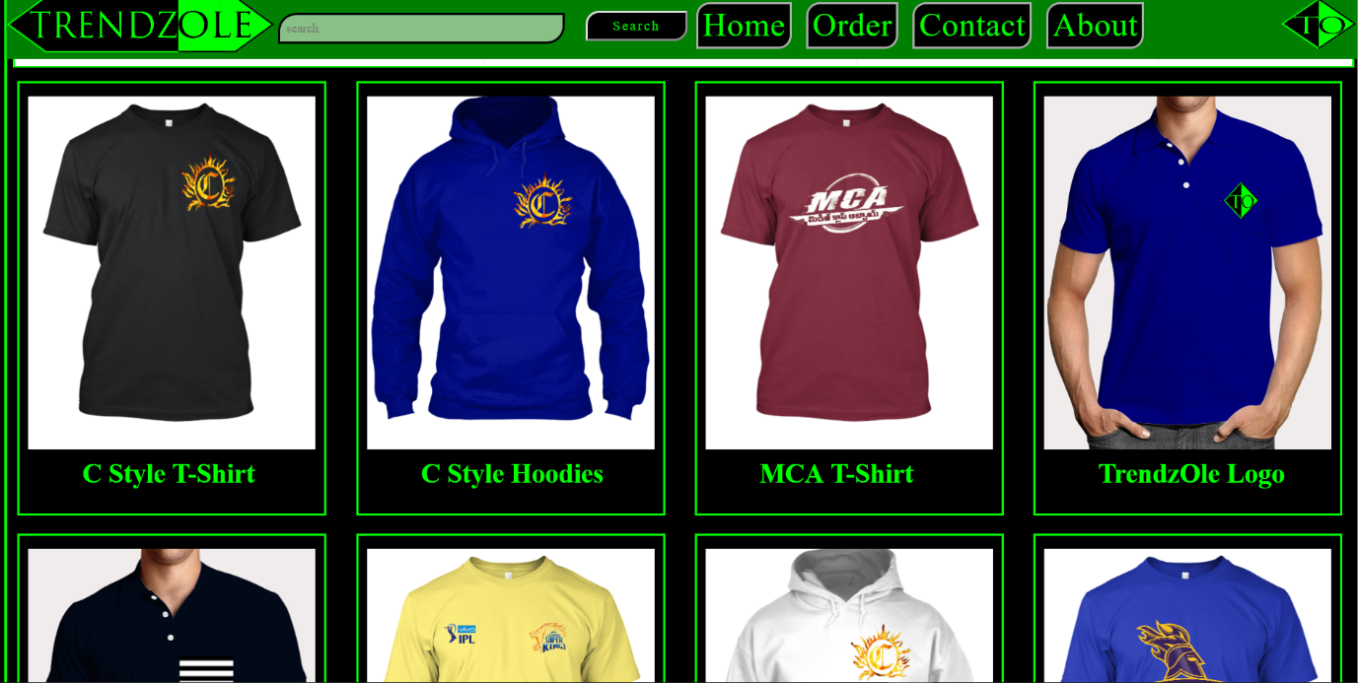

**SHIRT PAGE :**

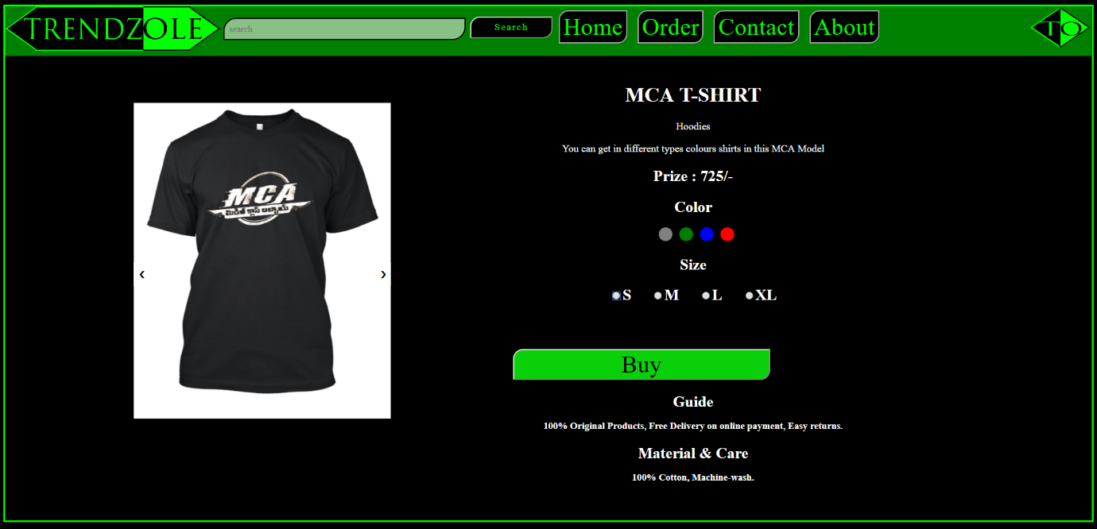

**ORDER PAGE :**

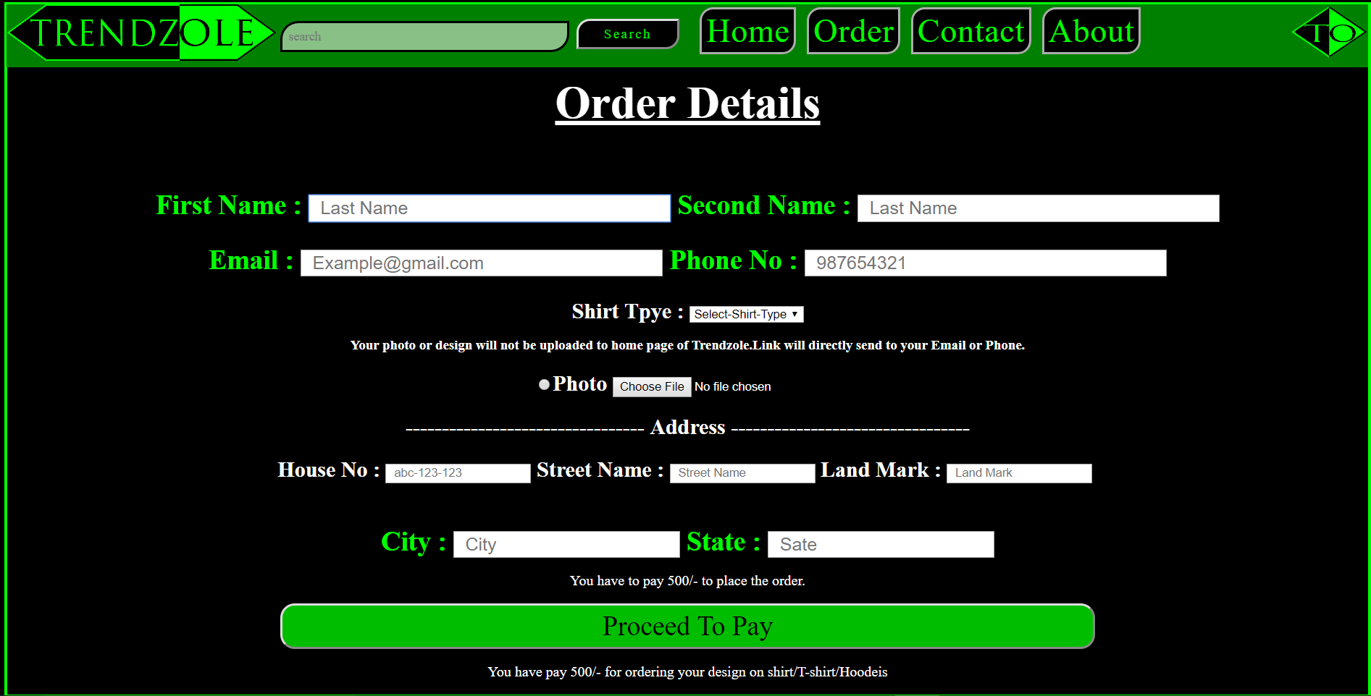

**CONTACT PAGE :**

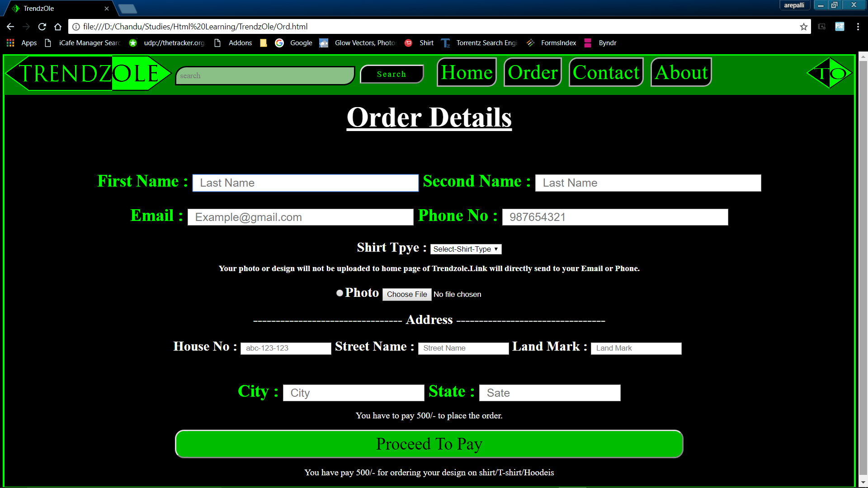

**ABOUT US PAGE :**

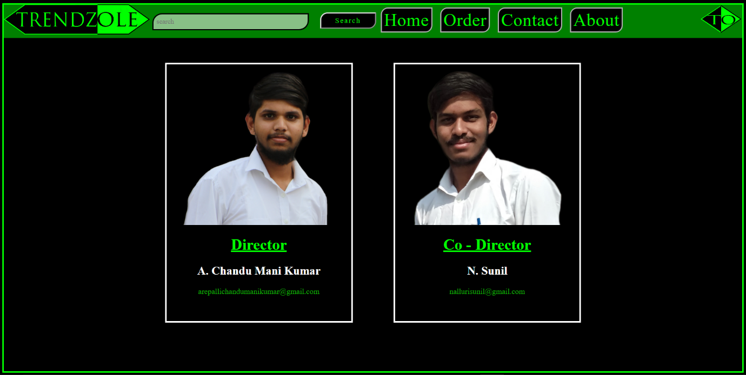

**CONCLUSION :**

My project “ TrendzOle ( Online Shopping Zone ) ” is a online shopping website which contains the basic details of the shirts types of designs and texts. This project provide the designs and texts what the customer need. This project provides different types of shirts with different designs, different color, different texts. This project provides three types of shirts T-shirts, hoodies, Polo T-shirts.

**FUTURE SCOPE :**

* This website is basically created by using HTML, CSS. It can be further developed by using Javascript and Python.
* Provide the online design flat form.
* Provide the user-friendly home page by directly to see the different colors of shirt without opening the shirt page.

**REFERENCES :**

* <https://www.youtube.com/watch?v=aYSgpR5VGPM&spfreload=10>
* <https://www.tutorialspoint.com/html/index.htm>
* <https://www.tutorialspoint.com/html_online_training/index.asp>
* <https://www.tutorialspoint.com/css_online_training/index.asp>