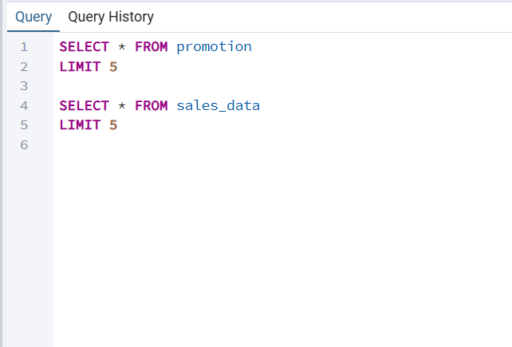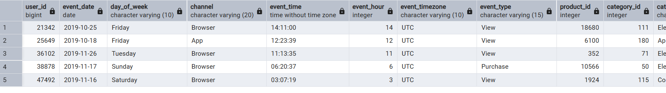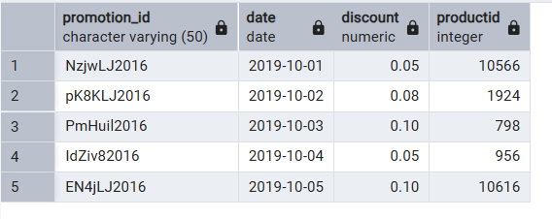

GENERAL VIEW OF TABLES

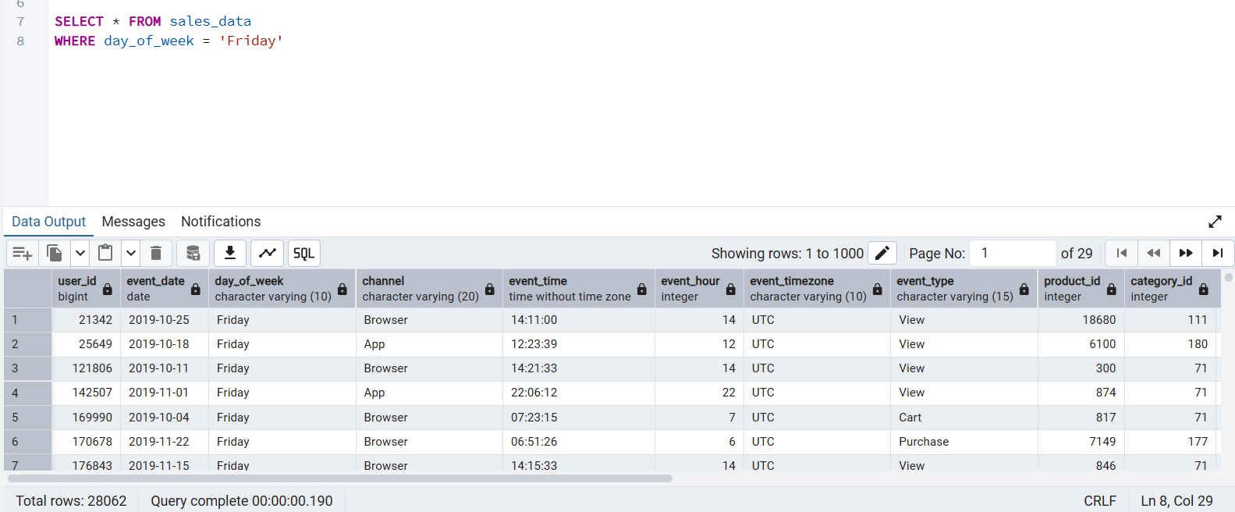

WHERE clause to filter the rows which has day_of_week as Friday

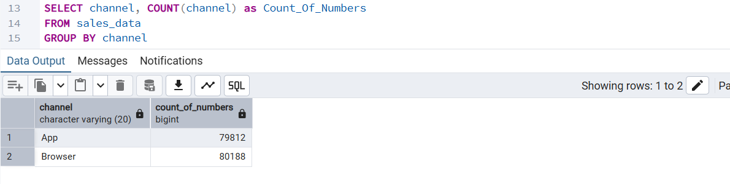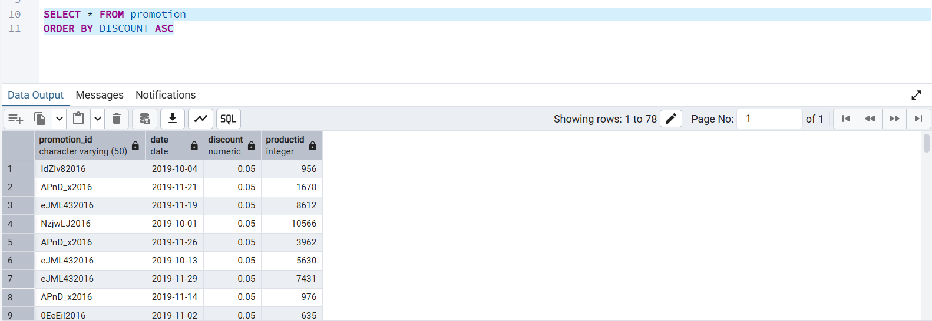

USING GROUP BY TO GROUP THE CHANNEL OF SALES AND COUNT OF IT

ORDER THE PROMOTION DATASET BY DISCOUNT IN ASCENDING ORDER

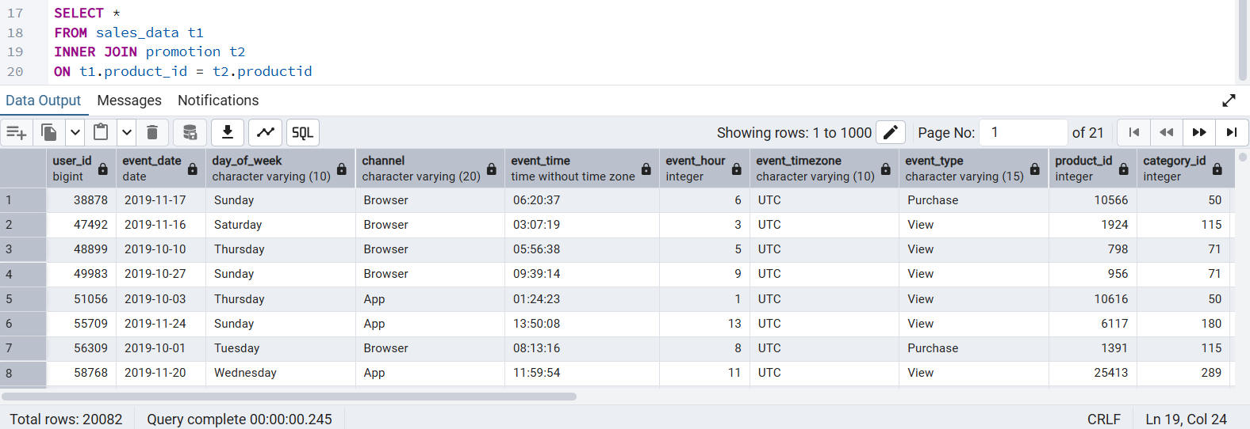

INNER JOIN TO JOIN BOTH TABLES WITH RESPECT TO PRODUCTID COLN

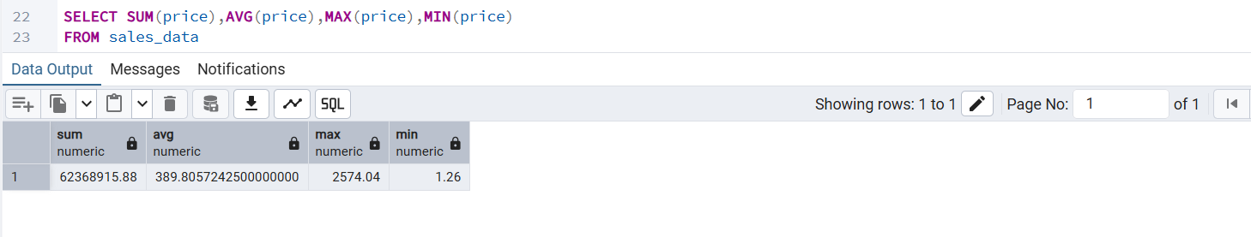

AGGREGATE FUNCTIONS

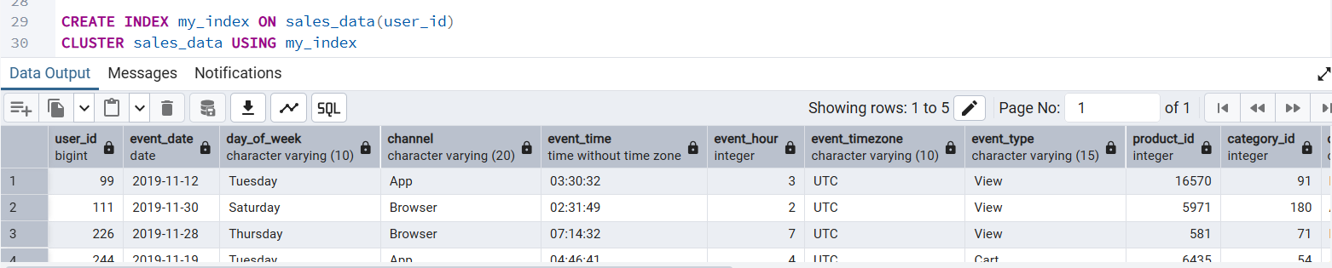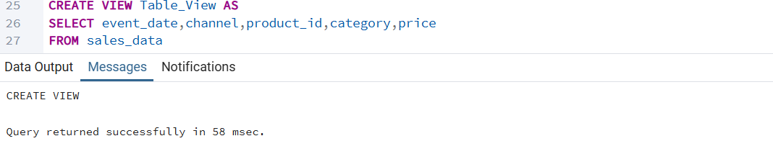

INDEX CREATION AND CLUSTERING

CREATING A VIEW