**UNIT-I**

**SOFT SKILLS DEVELOPMENT**

***An introductory overview***

Soft skills are a cluster of productive personality traits that characterize one's relationships in a milieu [a person's social environment]. These skills can include social graces, communication abilities, language skills, personal habits, cognitive or emotional empathy, time management, and teamwork and leadership traits. A definition based on review literature explains soft skills as an umbrella term for skills under three key functional elements:

**People Skills**

**Social Skills**

**Personal Career Attributes**

A study conducted by Harvard University noted that 80% of achievements in career are determined by soft skills and only 20% by hard skills. A person's soft skill is an important part of their individual contribution to the success of self as well as an organization. Soft skills are increasingly sought out by employers in addition to standard qualifications.

**Soft Skills for Successful People**

The following 10 skills are to be mastered for the growth of a self as well as an organization:

**Communication** – oral speaking capability, written, presenting, listening, clear speech & writing.

**Courtesy** – manners, etiquette, business etiquette, gracious, says please and thank you, respectful.

**Flexibility** – adaptability, willing to change, lifelong learner, accepts new things, adjusts, teachable.

**Integrity** – honest, ethical, high morals, has personal values, does what’s right.

**Interpersonal skills** – nice, personable, sense of humor, friendly, nurturing, empathetic, has self-control, patient, sociability, warmth, and social skills.

**Positive attitude** – optimistic, enthusiastic, encouraging, happy, confident.

**Professionalism** – businesslike, well-dressed, appearance, poised.

**Responsibility** – accountable, reliable, gets the job done, resourceful, self-disciplined wants to do well, conscientious, common sense.

**Teamwork** – cooperative gets along with others, agreeable, supportive, helpful, and collaborative.

**Work ethic** – hard working, willing to work, loyal, initiative, self-motivated, on time, good attendance.

**SELF-DISCOVERY**

**Self-Esteem -**

**Self-esteem** is the opinion one will have of oneself and his perception on his value as a person. Low (negative) self-esteem can cause people to be negative, lack motivation, and be moody. Those with higher (positive) self-esteem like themselves, so they expect others to like them, too. They don’t harshly judge themselves and are comfortable with which they are.

**Self-confidence**, on the other hand, is your belief in yourself and your abilities. Often, people with high self-esteem also have self-confidence, although this may not always be the case. Both self-esteem and self-confidence can translate to positive human relations because if a person feels good about himself or herself, it is more likely he or she will be more comfortable communicating and working in teams—key components for success.

One will attain self confidence, when one will have:

**1. Actual experience**: When you have accomplished something and succeeded, it is likely you will have the self-confidence to be successful at the task again.

**2. Experiences of others**: If you watch another person perform a task, you may know you can do the same thing.

**3. Social comparison:** When we see others with similar abilities able to perform a task, we may feel more confident in our own abilities to perform the same task.

**4. Social persuasion:.** A boost in self-confidence can come from the encouragement of someone we trust.

**5. Emotional arousal:** This refers to our inner feelings of being adequate or inadequate when it comes to accomplishing a certain task. This can come from negative or positive self-talk.

**6. Self-efficacy**: is the confidence one has to carry out a specific task. Someone may have generally lower self-confidence but have self-efficacy in certain areas of his or her life.

**7. Self-image:** is a bit different than self-esteem in that it means how an individual thinks others view him or her. One’s self-image may not always be in line with what people actually think, but you can imagine the impact this can have on human relations at work.

**Improving Self-Confidence**

Even if our self-confidence needs improvement, the good news is that there are many ways we can improve it. The following are examples:

**Use positive self-talk and visual imagery**. Self-talk refers to the things we tell ourselves in quiet moments. We constantly have an internal dialogue and our subconscious does not know the difference between truth and reality. By focusing on a positive outcome, we begin to believe it, thereby making it more likely to happen. This helps get us mentally ready to perform.

**Take risks**. Risk-taking is an important source of gaining self-confidence. Of course, not all risks work out the way we want them to, but until we take risks, we are unable to accomplish tasks.

**Accomplish**. Accomplishing something is important such as earning a degree or a promotion can help us gain self-confidence. Of course, as mentioned earlier, often it involves risk taking in order to accomplish.

**Know your strengths and weaknesses**. Everyone has a set of things they are good at. Knowing what you are good at and focusing on those things can improve self-esteem. Also, knowing what you are not good at and working to improve those skills can build self-confidence, too.

Everyone can continue working on their self-esteem and self-confidence throughout life. The Johari window is one tool that can help us determine how we see ourselves and how others see us. The Johari window was created in 1955 by JosephyLuft and Harry Ingham. When it was created, the researchers gave people fifty-six adjectives they could use to describe themselves.

Having higher self-esteem and higher self-confidence can improve our projection, meaning we can better accept criticism, learn from our mistakes, and communicate more effectively. This can result in better human relations at work and, ultimately, higher productivity and higher profitability.

**Key Takeaways**

**Self**-**esteem** is defined as the opinion one has about their value as a person. This is different than self-confidence, which refers to the belief someone has in themselves. Both are important determinants to career and human relations success.

**Self-efficacy** is the confidence someone has to carry out a specific task. Self-confidence and self-fficacy can come from a variety of sources.

**Self-image** is how you think others view you, while projection refers to how your self-esteem is reflected in others.

**GOAL SETTING THEORY OF MOTIVATION**

In 1960’s, Edwin Locke put forward the Goal-setting theory of motivation. This theory states that goal setting is essentially linked to task performance. It states that specific and challenging goals along with appropriate feedback contribute to higher and better task performance.

In simple words, goals indicate and give direction to us about what needs to be done and how much efforts are required to be put in.

**The important features of goal-setting theory are as follows:**

1. The willingness to work towards attainment of goal is main source of job motivation. Clear, particular and difficult goals are greater motivating factors than easy, general and vague goals.
2. Specific and clear goals lead to greater output and better performance. Unambiguous, measurable and clear goals accompanied by a deadline for completion avoids misunderstanding.
3. Goals should be realistic and challenging. This gives an individual a feeling of pride and triumph when he attains them, and sets him up for attainment of next goal. The more challenging the goal, the greater is the reward generally and the more is the passion for achieving it.
4. Better and appropriate feedback of results directs the employee behavior and contributes to higher performance than absence of feedback. Feedback is a means of gaining reputation, making clarifications and regulating goal difficulties.
5. Participation of setting goal, however, makes goal more acceptable and leads to more involvement.

Goal setting theory has certain eventualities such as:

**Self-efficiency**: Self-efficiency is the individual’s self-confidence and faith that he has potential of performing the task. Higher the level of self-efficiency, greater will be the efforts put in by the individual when they face challenging tasks. While, lower the level of self-efficiency, less will be the efforts put in by the individual or he might even quit while meeting challenges.

**Goal commitment:** Goal setting theory assumes that the individual is committed to the goal and will not leave the goal. The goal commitment is dependent on the following factors:

Goals are made open, known and broadcasted.

Goals should be set-self by individual rather than designated.

**How Setting Goals Affects Your Career Success**

Setting goals is a significant component of the career planning process. To have a successful and satisfying career, define your goals and devise a strategy to achieve them. A roadmap that will take you from choosing an occupation to working and succeeding at it is called a career action plan.

Your career action plan must have both long and short-term goals. It is imperative to include the steps to take to reach each one, along with ways to get around barriers that might get in your way.

Since plans, even very well-thought-out ones, don't always work out, it is also essential to include alternatives to implement when the need arises.

**The Difference between Short and Long Term Goals**

Goals are broadly classified into two categories: short-term goals and long-term goals. You will be able to accomplish a short-term goal in approximately six months to three years, while it will usually take three to five years to reach a long-term one. Sometimes you can achieve a short-term goal in fewer than three months and a long-term one may take more than five years to complete.

Our hard work will play the most prominent role in our success. Goals must be SMART

**S**: **S**pecific

**M**: **M**easurable

**A**: **A**ttainable

**R:** **R**ealistic

**T**: Time-bound

**JOHARI WINDOW**

1. The **Johari window** is a technique that helps people better understand their relationship with themselves and others. It was created by psychologists Joseph Luft (1916–2014) and Harrington Ingham (1916–1995) in 1955, and is used primarily in [self-help](https://en.wikipedia.org/wiki/Self-help) groups and corporate settings as a [heuristic](https://en.wikipedia.org/wiki/Heuristic) exercise. Luft and Ingham named their model "Johari" using a combination of their first names.
2. The Johari window is a tool to look at our own self-esteem and learn how others view us. The Johari window involves the open area, hidden area, blind area, and unknown area.

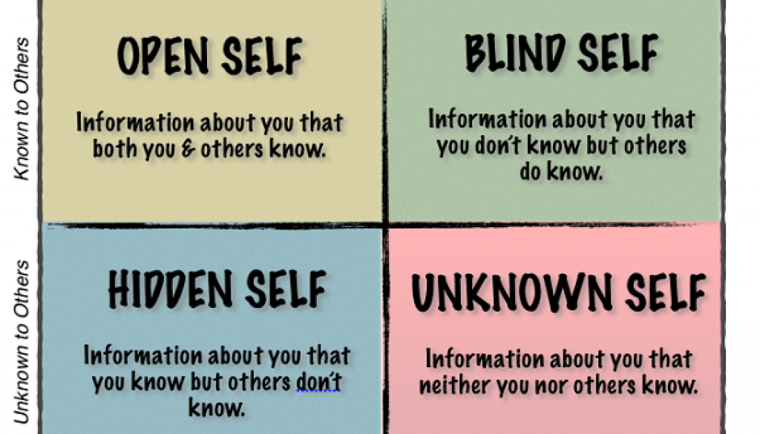

**Description**

In the exercise, subjects pick a number of [adjectives](https://en.wikipedia.org/wiki/Adjective) from a list, choosing ones they feel describe their own personality. The subject's peers then get the same list, and each picks an equal number of adjectives that describe the subject. These adjectives are then inserted into a two-by-two grid of four cells.

The philosopher [Charles Handy](https://en.wikipedia.org/wiki/Charles_Handy) calls this concept the *Johari House with four rooms.*

Room one is the part of ourselves that we and others see.

Room two contains aspects that others see but we are unaware of.

Room three is the private space we know but hide from others.

Room four is the [unconscious](https://en.wikipedia.org/wiki/Unconscious_mind) part of us that neither ourselves nor others see.

**The 4 Quadrants**

**Open, or Arena**

Adjectives that both the subject and peers select go in this cell (or *quadrant*) of the grid. These are traits that subject and peers perceive.

**Blind Spot**

Adjectives not selected by subjects, but only by their peers go here. These represent what others perceive but the subject does not.

**Hidden, or Façade**

Adjectives selected by the subject, but not by any of their peers, go in this quadrant. These are things the peers are either unaware of, or that are untrue but for the subject's claim.

**Unknown**

Adjectives that neither subject nor peers selected go here. They represent subject's behaviors or motives that no one participating recognizes—either because they do not apply or because of collective ignorance of these traits.

**Johari Adjectives-**

The participant can use adjectives like these as possible descriptions in the Johari window.

|  |  |  |
| --- | --- | --- |
| able  accepting  adaptable  bold  brave  calm  caring  cheerful  clever  loving  mature  modest  nervous  observant  organized  patient  powerful  proud  quiet | confident  dependable  dignified  empathetic  energetic  extroverted  helpful  idealistic  independent  ingenious  intelligent  introverted  kind  knowledgeable  logical  friendly  giving  happy | silly  spontaneous  sympathetic  tense  trustworthy  warm  wise  witty  relaxed  religious  responsive  searching  self-assertive  self-conscious  sensible  sentimental  shy  reflective |

**Exercises:**

1. Write down the five words that describe you the best. When you look at these words, are they positive? If they are not positive, what steps can you take to improve your self-esteem? How will the steps you take improve your human relations skills?
2. Take the self-esteem quiz at http://testyourself.psychtests.com/testid/3102. What were the results? Do you agree with the results?
3. 3**.**Write down your short term and long term goals
4. Describe yourself with the help of Johari window
5. What are the hidden qualities of your blind-*self*; identified by others