**UNIT-II**

**PERSONALITY DEVELOPMENT**

**Personality Development**: Personalityis concerned with the psychological pattern of an individual— the thoughts, emotions and feelings—that are unique to a person. In fact, the totality of character, ,attributes and **traits** of a person are responsible for molding his **personality**.

**Personality** traits reflect people's **characteristic** patterns of thoughts, feelings, and behaviors. **Personality** traits imply consistency and stability—someone who scores high on a specific trait like Extraversion is expected to be sociable in different situations and over time.

Big Five personality traits, ("the five-factor model"): Many psychologists currently believe that the following five factors are sufficient to understand a person:**.**

* Openness
* Conscientiousness
* Extraversion
* Agreeableness
* Neuroticism

## Openness

Openness is shorthand for "openness to experience." People who are high in openness enjoy adventure. They're curious and appreciate art, imagination and new things. The motto of the open individual might be "Variety is the spice of life."

## Conscientiousness

People who are conscientious are organized and have a strong sense of duty. They're dependable, disciplined and achievement-focused.

## Extraversion

Extraversion is possibly the most recognizable personality trait of the Big Five. The more of an extravert someone is, the more of a social butterfly they are. Extraverts are chatty, sociable and draw energy from crowds. They tend to be assertive and cheerful in their social interactions.

Introverts, on the other hand, need plenty of alone time, perhaps because their brains process social interaction differently.. Introversion is often confused with shyness, but the two aren't the same. Shyness implies a fear of social interactions or an inability to function socially. Introverts can be perfectly charming at parties — they just prefer solo or small-group activities.

## Agreeableness

Agreeableness measures the extent of a person's warmth and kindness. The more agreeable someone is, the more likely they are to be trusting, helpful and compassionate. Disagreeable people are cold and suspicious of others, and they're less likely to cooperate.

## Neuroticism

People high in neuroticism worry frequently and easily slip into anxiety and depression. If all is going well, neurotic people tend to find things to worry about.

The Big Five are the ingredients that make up each individual's personality.

# 5 Characteristics of Personality Development

We have heard this phrase quite often, “Don’t go by looks, Go with the personality”, why? It’s because personality is an inner characteristic of an individual that lasts in the long run. Simply, it is an identity of an individual, which is created by numerous unique features such as honesty, loyalty, spontaneous, good humor and much more

The 5 Characteristics of Personality Development are:

1. Free Mind & Spirit  
2. Positive Thinking  
3. Importance of Ethics  
4. Flexibility  
5. Honesty

**Free Mind & Spirit:** The person with a free mind has strong inner positivity and wisdom to deal with changes. Thus, the world renowned personality development book, “The Alchemist” by Paulo Coelho points out that if we dearly want something, the universe conspires to help you achieve it, for which sometimes we need to let our mind and spirit run free and embark on a journey to widen our horizon and change our perspective.

**Positive Thinking:**The famous personality development book of all time, “The Monk who sold his Ferrari” explains that quality of life depends on a person’s thought. He also points out that there is no room for mistakes in life; there are rooms only for lessons. Which implies that we as a person should constantly try to improve ourselves and our personality because whatever mistakes we make are just lessons for a brighter and better future.

**Importance of Ethics:** As we know that discipline brings order in life, therefore ethics and discipline are one of the much-needed characteristics to improve personality development. Hence, the sprightliest book called “Personality Development” by Swami Vivekananda also talks about the importance of ethics, discipline, kindness, goodwill, happiness, wisdom and understanding to lift up our professional and personal lives.

**Flexibility:** Change is the only constant thing in this world. Therefore, it is imperative to learn how to cope up positively with change, be it in terms of career, relationships, and family life. The renowned author Spencer Johnson’s identity improvement book “Who Moved My Cheese”? also explains the importance to accept changes in life and know how to figure out ways to be able to adjust as per the changes. Otherwise, you will leave behind or extinct.

**Honesty:** Honesty is one of the greatest personality of an individual. The person who is honest and a good listener has the power to win hearts and to influence people with their positivity.

**Body language**

**Body language (disambiguation)**

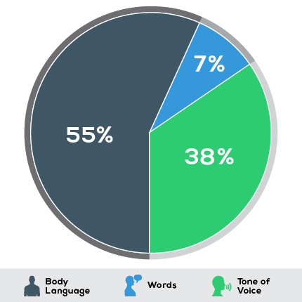

Body language is a type of nonverbal communication in which physical behaviors, as opposed to words, are used to express or convey information. Such behavior includes facial expressions, body posture, gestures, eye movement, touch and the use of space. Body language exists in both animals and humans, but this article focuses on interpretations of human body language. It is also known as kinesics.

**Contents**

* Physical appearance [dress, hair, watches, shoe, belt, jewelry,
* Facial expression [pleasant, confident, willing to take up,]
* Body postures [standing, sitting, and walking]
* Gestures [hands, fingers, head]
* Handshakes [firm, welcoming, warmth, friendly]
* Eye contact [look into who you communicate, confident, challenging]
* Smile [pleasant ,]

**Other subcategories**

* Oculesics
* Haptics
* Proxemics

**Body postures**

Emotions can also be detected through body postures. Research has shown that body postures are more accurately recognized when an emotion is compared with a different or neutral emotion. For example, a person feeling angry would portray dominance over the other, and their posture would display approach tendencies

Sitting or standing postures also indicate one’s emotions. A person, who is sitting till the back of his chair, leans forward with his head nodding along with the discussion implies that he is open, relaxed and generally ready to listen. On the other hand, a person who has theirhis legs and arms crossed with the foot kicking slightly implies that he is impatient and emotionally detached from the discussion.

In a standing discussion, a person stands with arms akimbo with feet pointed towards the speaker could suggest that they are attentive and is interested in the conversation. However, a small difference in this posture could mean a lot.

The superman pose, both hands and fists near the hips or lower back and the package pose is moving the elbows inwards and hands with/without fingers dug into or resting on the belt or pants suggest male attraction to women.

**Gestures**

Gestures are movements made with body parts (example hands, arms, fingers, head, legs) and they may be voluntary or involuntary. Arm gestures can be interpreted in several ways. In a discussion, when one stands, sits or even walks with folded arms, it is normally not a welcoming gesture. It could mean that they have a closed mind and are most likely unwilling to listen to the speaker’s viewpoint. Another type of arm gesture also includes an arm crossed over the other, demonstrating insecurity and a lack of confidence.

The shrug is a good example of a universal gesture that is used to show that a person doesn't understand what you are saying. "It's a multiple gesture that has three main parts," they continue.

"Exposed palms to show nothing is being concealed in the hands, hunched shoulders to protect the throat from attack, and raised brow, which is a universal, submissive greeting."

Hand gestures often signify the state of well-being of the person making them. Relaxed hands indicate confidence and self-assurance, while clenched hands may be interpreted as signs of stress or anger. If a person is wringing their hands, this demonstrates nervousness and anxiety.

**Finger gestures** are also commonly used to exemplify one's speech as well as denote the state of well-being of the person making them. In certain cultures, pointing using one's index finger is deemed acceptable. However, pointing at a person may be viewed as aggressive in other cultures – for example, people who share Hindu beliefs consider finger pointing offensive. Instead, they point with their thumbs. Likewise, the thumbs up gesture could show "OK" or "good" in countries like the United States, France and Germany. But this same gesture is insulting in other countries like Iran, Bangladesh and Thailand, where it is the equivalent of showing the middle finger in the US.

In most cultures the **Head Nod** is used to signify 'Yes' or agreement. It's a stunted form of bowing – the person symbolically goes to bow but stops short, resulting in a nod. Bowing is a submissive gesture so the Head Nod shows we are going along with the other person's point of view. Research conducted with people who were born deaf and blind shows that they also use this gesture to signify 'Yes', so it appears to be an inborn gesture of submission.

**Handshakes**

Handshakes are regular greeting rituals and commonly done on meeting, greeting, offering congratulations or after the completion of an agreement. A firm, friendly handshake has long been recommended in the business world as a way to make a good first impression, and the greeting is thought to date to ancient times as a way of showing a stranger you had no weapons.

**Other subcategories**

**Oculesics**

Oculesics, a subcategory of body language, is the study of eye movement, eye behavior, gaze, and eye-related nonverbal communication. As a social or behavioral science, oculesics is a form of nonverbal communication focusing on deriving meaning from eye behavior. It is also crucial to note that Oculesics is culturally dependent. For example, in traditional Anglo-Saxon culture, avoiding eye contact usually portrays a lack of confidence, certainty, or truthfulness

**Haptics**

Haptics, a subcategory of Body Language, is the study of touching and how it is used in communication. As such, handshakes, holding hands, back slapping, high fives, brushing up against someone or patting someone all have meaning.

Public touch can serve as a ‘tie sign’ that shows others that your partner is “taken”. When a couple is holding hands, putting their arms around each other, this is a ‘tie sign’

The amount of touching that occurs within a culture is also culturally dependent.

**Proxemics** : Proxemics is the study of measurable distances between people as they interact with one another. In the book, Body Language, Julius Fast mentioned that the signals that we send or receive to others through body language are reactions to others’ invasions of our personal territories, which links Proxemics an important part of Body Language.

Hall also came up with four distinct zones in which most men operate

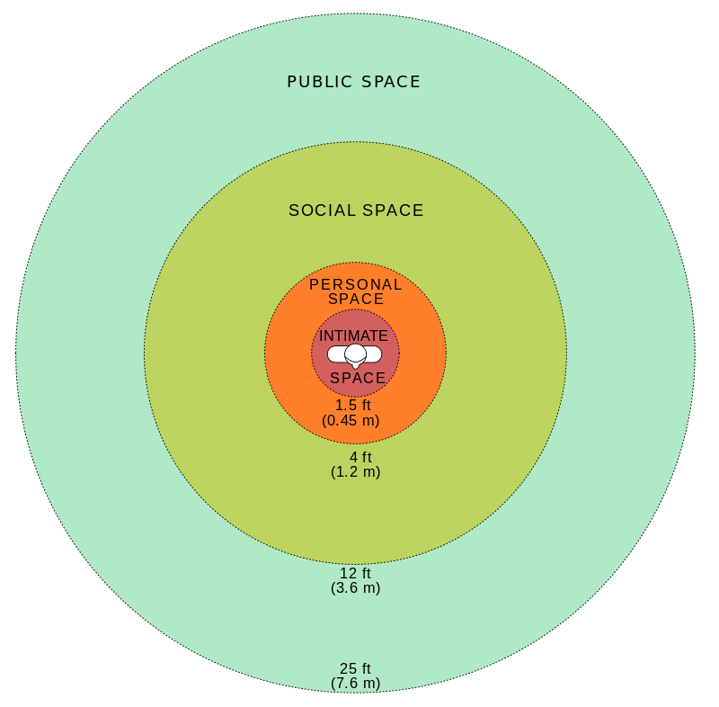

**Tone of voice**

Tone of voice is a combination of spoken language and body language. The manner in which something is said can affect how it should be interpreted. Shouting, smiling, irony and so on may add a layer of meaning which is neither pure body language nor speech..

Body language is a major contributor to the attitude a person conveys to others.

**Etiquette**

It is all about how to conduct oneself beautifully.

In fact, the basic rules of etiquette are pretty simple. It’s a culture of speech, common courtesy, neat appearance, and control over your emotions.

Bright Side presents you with the etiquette rules, which every self-respecting person should know.

If one says, ’I invite you,’ that means he has to pay. He/she may say, ’Let’s go to a restaurant,’ and in this case, everyone pays for themselves. If a man offers to pay for a woman, she can agree.

Never pay a visit without a calling first. If someone came to see you without warning, you might be wearing a bathrobe and hair curlers

one’s phone shall not be placed on the table in public. By doing so, he/she shows how important a role this device plays in his/her life, how bored he/she are of what’s happening, and that at any moment he/she ready to stops a useless conversation.

One’s shoes should always be clean.

Avoid meaningless talk on the phone. If he/she needs someone to talk to, it’s better to meet with them in person.

If someone offends you, you shouldn’t return the favor or raise your voice to the person who insulted you. Don’t sink to their level. Just smile and leave the ill-mannered company.

Drivers should remember that puddle-splashing of passers-by is an immoral behavior.

Nine things should be kept secret: age, wealth, family quarrels, religion, medical problems, love affairs, gifts, honor, and disgrace.

In the cinema, theatre, or concert hall, you should move to your seat facing those sitting. A man goes first.

If someone calls to you rudely (’You there!’), you shouldn’t answer. Be a model of good etiquette and polite social manners.

The golden rule when using perfume is moderation. If you can still smell your perfume in the evening, everyone else is already tired of it.

A well-bred man will always show proper respect to a woman.

.

Whoever you are — a company director, an academician, an elderly woman, or a student — when you enter a room you should be the first person to greet everyone there.

Respect the privacy of correspondence. Parents shouldn’t read their children’s letters. Couples should show the same respect for each other. Сhecking someone’s pockets in search of love notes, letters, and other things is extremely rude.

Don’t try to chase fashion. It’s better to wear nice, even if not fashionable, things than look awful in a brand-new suit.

If you’re forgiven after you’ve apologized, don’t touch the offensive subject again just to say you’re sorry. You should try to avoid such mistakes in the future.

Avoid laughing and talking too loudly, as well as staring at people — it’s insulting.

Don’t forget to thank your loved ones, relatives, and friends. They help you not because they have to. It’s their desire. Appreciate them.

Good manners cost us nothing, but may win almost everything. They are the skills of making people feel easy and comfortable. We can have better relationships with people we know and meet in day to day life just by behaving well. Courtesy, politeness or having good manners are an about respecting others and ourselves. If we show good manners everywhere we go, then we are more likely to encourage others to behave in the same way towards us.

**Exercise**

1. Analyze your team member’s personality based on his goal setting.
2. How do you rate your personality
3. Describe your personality
4. Describe the most embarrassing moment you experienced due to the bad etiquette of your friend or relative
5. What are manners that you have cultivated in your life?