Login from mwadmin user to 10.96.9.191

cd /home/mwadmin/.ssh

cat id_rsa.pub

[mwadmin@MDCMWADMIN01 .ssh]$ cat id_rsa.pub

ssh-rsa  mwadmin@MDCMWADMIN01

ssh mwadmin@10.82.34.52

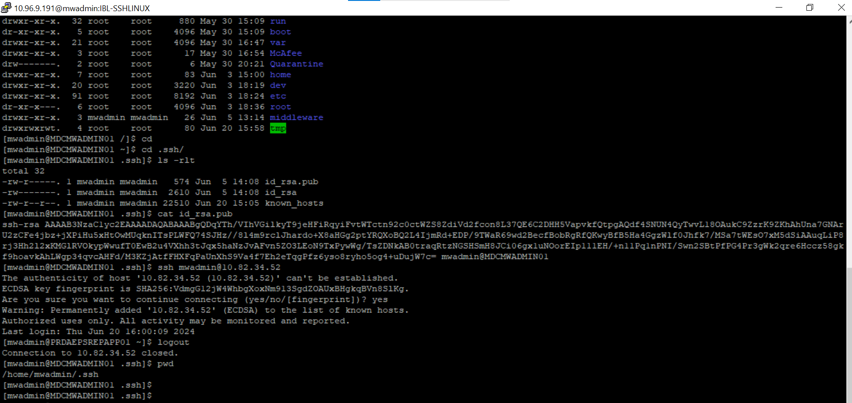

Destination server - 10.82.34.52

sudo su – mwadmin

mkdir .ssh

cd .ssh/

vi authorized_keys

cat authorized_keys

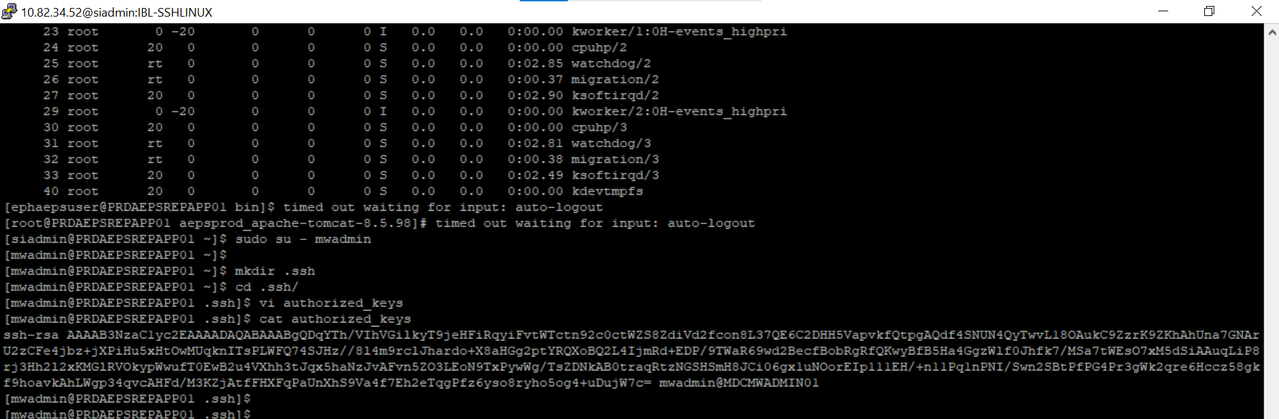

[mwadmin@PRDAEPSREPAPP01 .ssh]$ cat authorized_keys

ssh-rsa  mwadmin@MDCMWADMIN01