Project Report

Customer Retention Strategy

Racherla Chandu

Contents

Page no. | Topic Name
5 | EC-2 Instance Setup
8 | EMR Cluster Setup
10 | Live Data Streaming From EC2-EMR Cluster
12 | Receiving Live Streaming Data in EMR
15 | Loading Data to Redshift From S3
17 | Query Execution on Redshift

Customer Retention Strategy Project – Overview
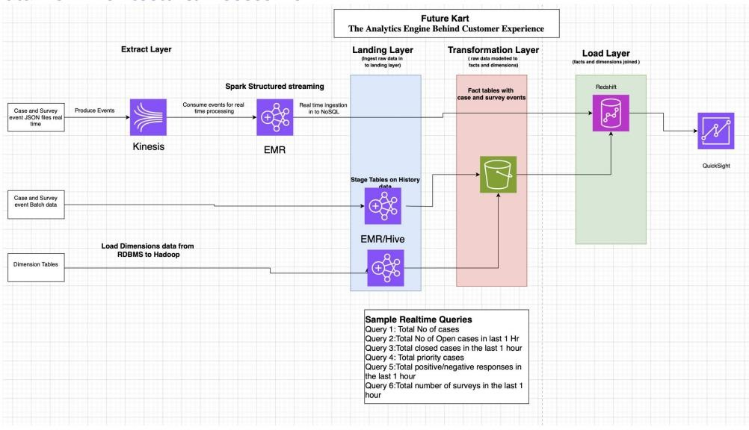

Business Challenge
FutureCart Inc., a leading retail chain with 5000+ stores and a strong e- commerce presence in India, aims to strengthen customer retention and
satisfaction through improved after-sales service. To achieve this, the company has implemented a CRM strategy that leverages data warehousing and real- time analytics.
A dedicated support team handles customer complaints across multiple
contact centers, allowing customers to raise issues via calls, chats, or emails. Each complaint is registered as a case, assigned a priority, and tracked with a defined SLA. After resolution, customers may complete a feedback survey, rating their experience on a scale of 1–10.
The collected data powers both real-time and batch analytics to optimize the CRM process and improve service quality.

KPIs Tracked
- Total cases (open/closed) by hour/day/week/month
- Priority case volumes
- SLA compliance
- Positive/negative survey responses
- Real-time case and sentiment trends

Project Goal

Business Goals
  - Improve SLA compliance and customer satisfaction
  - Use CRM insights to boost customer loyalty and retention

Technical Goals
  - Implement data pipelines for real-time and batch ingestion using Kinesis, Spark, and Glue
  - Clean and transform data using Spark and Hive
  - Store processed data in Hive/DynamoDB/HDFS
  - Build dashboards to monitor key metrics in real time
  - Adopt a Lambda architecture for hybrid processing

EC2-Instance Setup

    - Login to the EC2 Instance from command line using credentials
    - Once logged in to the instance download SQL into the instance
    - Once installation is done and mysql service is enabled using the command
Sudo systemctl start mysql
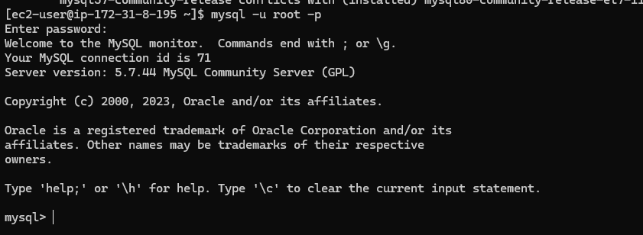
    - Login to mysql server using the initial temporary password set during installation

    - Once logged in change the password for root and set a permanent password
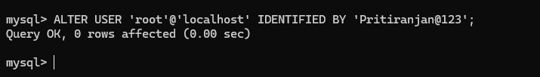
    - Now create a new user with all the privileges to access the database from any desired IP address

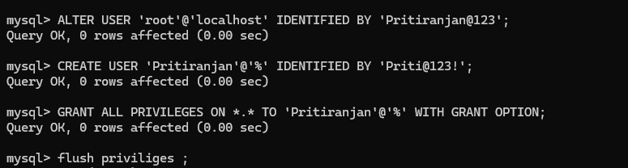

    - Importing the data from local machine to EC2 Instance
    - Now move all the datasets provided , into the EC2 instance with the help of which we will be creating the tables
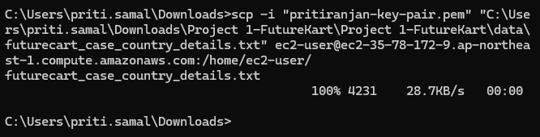
    - Now once the datasets are moved inside the EC2 Instance we have to move it to ‘/var/lib/mysql-files/’ because mysql can access files from that directory
    - Once moved start creating table and load the data into the table from the dataset in ‘/var/lib/mysql-files/’
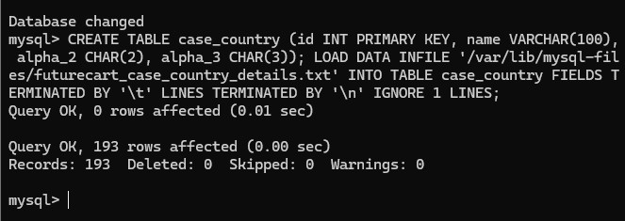
    - Check if table has been created and data has been inserted

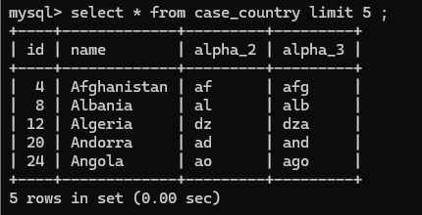
    - Check if the database and the tables can be accessed from anywhere from any IP address
    - As it can be assessed from any point so now we can set up the EMR Cluster

EMR Cluster Setup
    - As all the privileges to the user has been granted from the EC2 instance to access the data from the database so we will be using Sqoop in order to fetch data from the database and put in HDFS
    - First to setup HDFS run the commands :

Sudo -u hdfs hdfs dfs -mkdir -p /user/ec2-user
Sudo -u hdfs hdfs dfs -chown ec2-user /user/ec2-user
Sudo -u hdfs hdfs dfs -chown ec2-user /

    - Once the ‘/user/ec2-user ’ directory is created and the ec2-user has accessibility
    - Now start moving the data from SQL in EC2-Instance to HDFS system in EMR Cluster
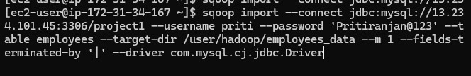
    - Once all the data is moved to HDFS start creating table in Hive and loading data from HDFS

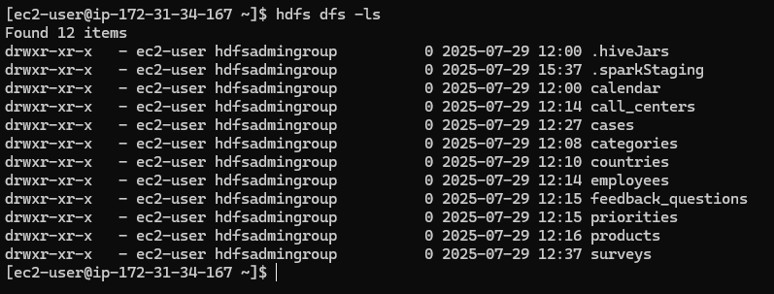
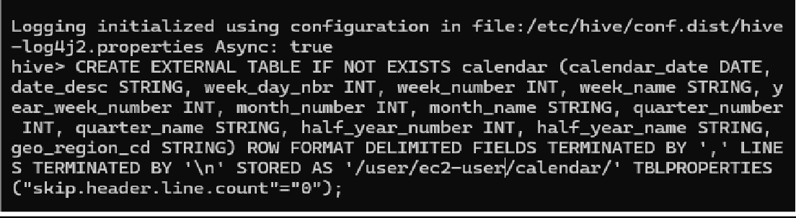
    - Once all the tables are created then upload it to S3-Bucket in JSON Format using spark job .
    - While uploading data to S3 in JSON format, I got an error saying the data wasn’t properly formatted. So, I downloaded a newer version of the
SerDe library, updated my Spark job to use it, and then uploaded the data again successfully.
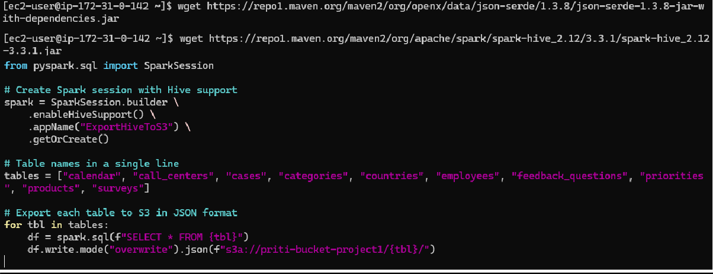
    - Now create a Python script to generate historical data of cases and surveys

Live Data Streaming From EC2-EMR Cluster
    - Now to work with live data or streaming data we need to create a python script in some other EC2-Instance which would generate some sample continuous streaming data
    - We would be sending that data with the help of Kinesis DataStream and be receiving it on the EMR cluster using a spark job
    - So in order to create the live streaming data we would create and run the script
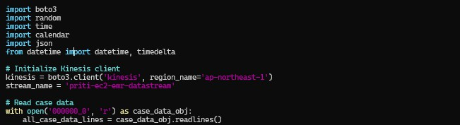
    - Opens the file named 000000_0 . Reads all lines into a list called all_case_data_lines
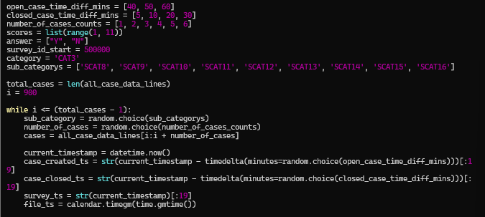
    - This code block simulates survey case records by adding random timestamps and details to existing case data

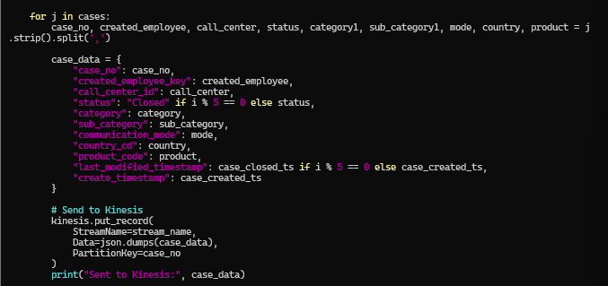
    - This block processes each individual case and sends it to an AWS Kinesis data stream in JSON format.
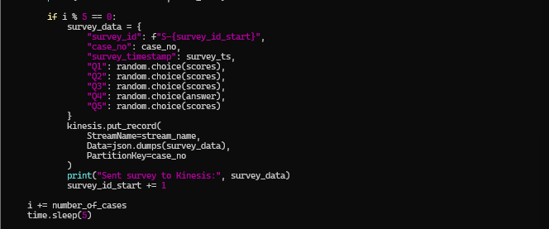
    - This final part of code handles sending survey responses to Kinesis, but only for every 5th batch of cases.
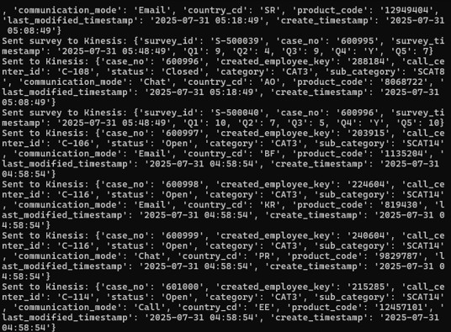

Receiving Live Streaming Data in EMR :
    - Once the data start live streaming we have to fetch it into the EMR using a spark job
    - We will extract the data from the kinesis data using boto3 client and send it over to Redshift using JDBC connector
    - So the data flow is something like :

EC2 Instance --> Live data sent over data stream --> EMR --> Redshift
    - We have already started generating the live data using the above generated script now we will be collecting it from the EMR Cluster
    - In order to collect data from Kinesis datastream in EMR Cluster and send it to redshift we will be using a python script
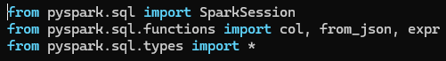
    - SparkSession lets you create and manage a Spark application. col,
from_json, and expr are functions used to reference columns, parse JSON strings, and run SQL-like expressions on data .
    - Create the structure of cases and surveys because we are using json.dumps to extract the data from incoming json records in order to correctly map it respective columns we would be using it .
    - It reads real-time data from an AWS Kinesis Data Stream (priti-ec2-emr- datastream) in the ap-northeast-1 region, starting from the latest
records.
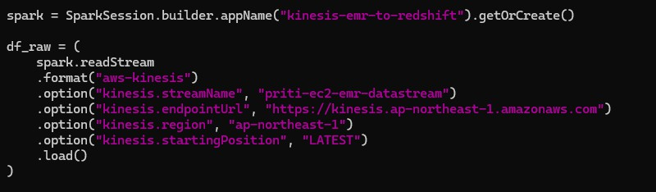

    - The code first converts the binary data field from Kinesis into a readable string using CAST(data AS STRING) and stores it in a new column called data_string.
    - It then filters out case-related events by checking for the presence of "case_no" and "status" in the string, parses them using a predefined case_schema, and extracts the structured fields.
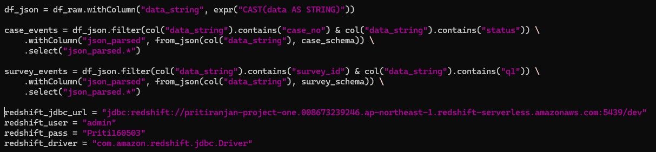
    - This function write_to_redshift writes a Spark DataFrame (df) to a
Redshift table using JDBC in append mode. It connects using the
provided Redshift URL, username, password, and driver, and saves the data to the given table_name.
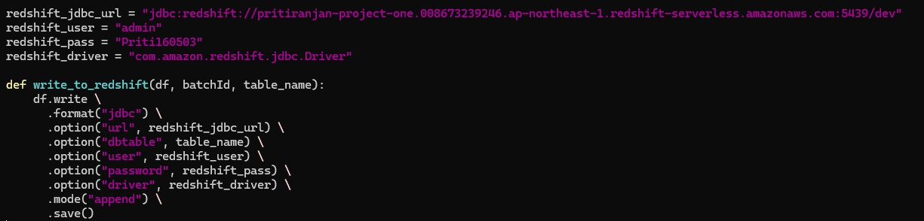
    - This starts a streaming query that sends micro batches and writes case_events to the Redshift table cases using the write_to_redshift function.
    - It uses append mode for fault tolerance and exactly-once processing.
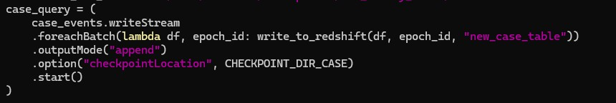
    - This starts a streaming query that writes survey_events to the Redshift table surveys using write_to_redshift.
    - It uses append mode to ensure no duplicate writes.

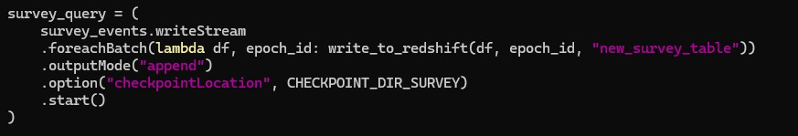
    - The lines case_query.awaitTermination() and survey_query.awaitTermination() ensure that both streaming queries keep running continuously.
    - They block the main program from exiting, allowing Spark to keep processing incoming data from Kinesis and writing it to Redshift in real time.

Loading Data to Redshift From S3
    - Now we will load data from S3 to Redshift . The data I stored in S3 from earlier historical data and the data sent to S3 from the EMR Cluster using spark job.
    - The data are stored in S3 in JSON Format . We have to create the Schema in the Redshift and then Load data from S3 into it .
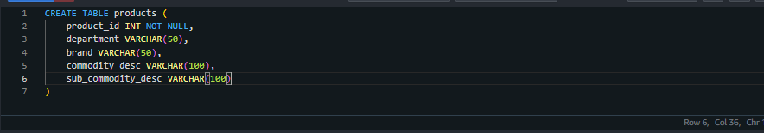
    - Now we have to load the data in table from S3. We will be using the below query:

COPY products
FROM 's3://priti-bucket-project1/priorities/'
IAM_ROLE ' arn:aws:iam::008673239246:role/redshift-s3fullacess-priti' FORMAT AS JSON ‘auto’
REGION 'ap-northeast-1'

    - Regarding the Data from the live streaming that is sent from the EMR Cluster is being loaded into the case and survey table automatically with the help of that script .
    - We just have to keep in note that the schema we are providing in the code should be same as that to the schema of the table present in the redshift database .
    - We can see the data has been added to the table , from the execution of the above code .

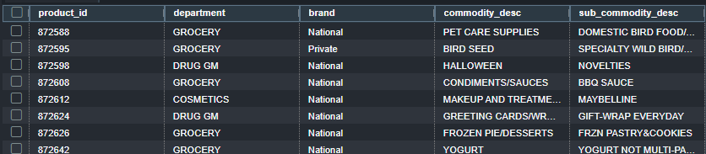
    - Same goes for all the tables . For each table we load the data from the S3 bucket to the respective table .
    - Further based on this data we will be running the queries . Some of the queries do need multiple tables to be accessed i.e both fact and dimensional tables . we can access both with the help of matching columns .

Query Execution on Redshift

    - Total numbers of cases
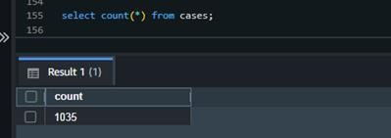
SELECT COUNT(*) FROM CASES

- Total open cases in the last 1 hour
SELECT COUNT(*) AS open_cases FROM cases WHERE status = ‘Open’ AND DATEDIFF (minute ,CAST(create_timestamp as timestamp), CAST(last_modified_timestamp AS timestamp)) <=60 ;

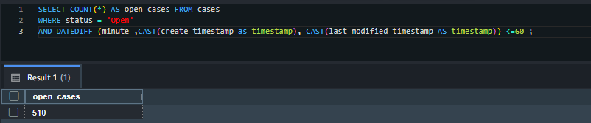
- Total closed cases in the last 1 hour
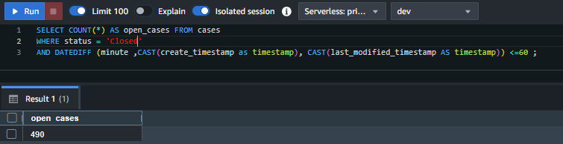
SELECT COUNT(*) AS open_cases FROM cases WHERE status = ‘Closed’ AND DATEDIFF (minute ,CAST(create_timestamp as timestamp), CAST(last_modified_timestamp AS timestamp)) <=60 ;

- Total priority cases
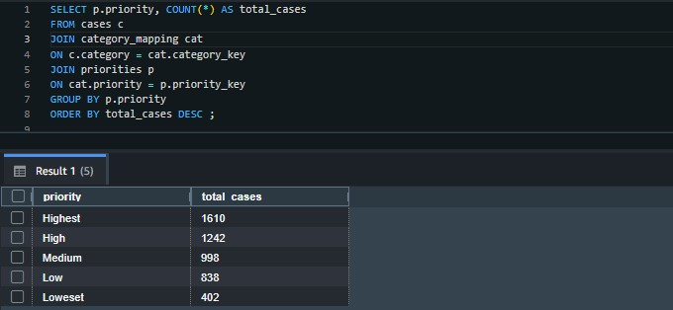
SELECT p.priority, COUNT(*) AS total_cases FROM cases c
JOIN categories cat
ON c.category = cat.category_key JOIN priorities p
ON cat.priority = p.priority_key GROUP BY p.priority
ORDER BY total_cases DESC ;

- Total number of surveys in the last 1 hour
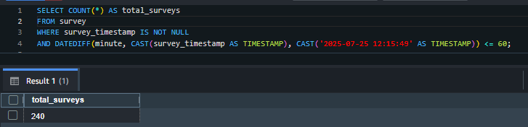
SELECT COUNT (*) AS total_surveys FROM survey
WHERE survey_timestamp IS NOT NULL
AND DATEDIFF(minute,CAST(survey_timestamp as
TIMESTAMP),CAST(‘2025-07-25 12:15:49’ AS TIMESTAMP)) <=60 ;

- Total open cases in a day/week/month
SELECT COUNT (*) AS open_Case_in_month FROM cases
WHERE status = ‘Open’
AND DATEDIFF(day,CAST(create_timestamp AS TIMESTAMP),CAST(‘2025- 07-25 12:15:49’ AS TIMESTAMP)) BETWEEN 0 AND 29 ;

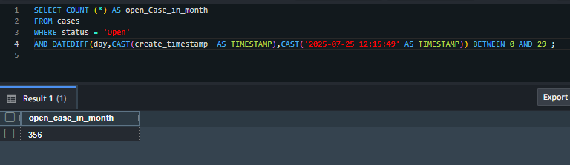
- Total closed cases in a day/week/month
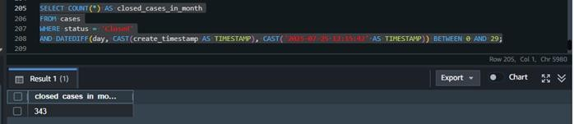
SELECT COUNT (*) AS closed_Case_in_month FROM cases
WHERE status = ‘Closed’
AND DATEDIFF(day,CAST(create_timestamp AS TIMESTAMP),CAST(‘2025- 07-25 12:15:49’ AS TIMESTAMP)) BETWEEN 0 AND 29 ;

- Total positive/negative responses in a day/week/month
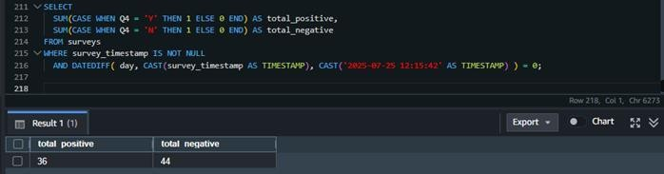

- Total number of surveys in a day/week/month Real-time KPIs
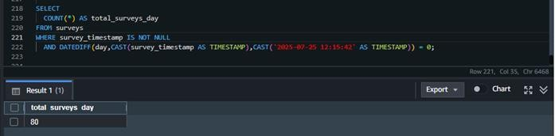
- Total numbers of cases that are open and closed out of the number of
cases received
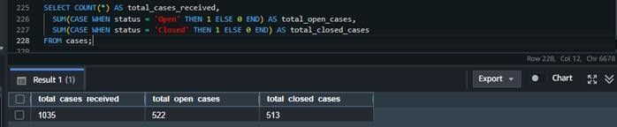
- Total number of cases received based on priority and severity
