Functional programming Mini Project - Server Log Analyzer

Group Members
- EG/2020/3990 - Jayasooriya LPM
- EG/2020/3994 - Jayathilake HACP
- EG/2020/3996 - Jayawardhana MVTI
- EG/2020/4040 - Lakpahana AGS

Technology Stack: Haskell (GHC 9.x), Stack Build Tool
Dataset: https://www.kaggle.com/datasets/eliasdabbas/web-server-access-logs

1. Problem Statement and Industrial Motivation

1.1 Real-World Context
Modern web infrastructure generates massive volumes of log data daily. Enterprise servers handling millions of requests produce log files that can exceed gigabytes in size within hours. These logs contain critical operational intelligence about:
- Traffic patterns - User behavior, peak usage times, and popular endpoints
- Security threats - DDoS attacks, bot traffic, and unauthorized access attempts
- System performance - Error rates, response times, and resource bottlenecks
- Compliance requirements - Audit trails for regulatory standards

1.2 Industrial Challenges
Traditional imperative log analysis systems face significant limitations:
- Data Integrity Issues: Mutable state in concurrent processing leads to race conditions and inconsistent results
- Scalability Constraints: Difficulty parallelizing operations safely without complex locking mechanisms
- Reliability Concerns: Side effects make testing difficult and results unpredictable
- Maintenance Complexity: Tightly coupled code with side effects throughout makes modifications risky

1.3 Functional Solution
- Immutable Data Structures: Guarantees thread-safety and reproducible results
- Parallel Processing: Leverages Haskell’s parallel evaluation strategies for safe concurrency
- Type Safety: Compile-time guarantees eliminate entire classes of runtime errors
- Compositional Architecture: Modular pipeline design enables easy testing and extension
The analyzer processes Apache/Nginx Combined Log Format, extracting metrics such as traffic patterns, error distributions, anomaly detection, and user session analysis.

2. Functional Design

2.1 System Architecture
The system follows a functional pipeline architecture with clear separation between pure logic and effects:
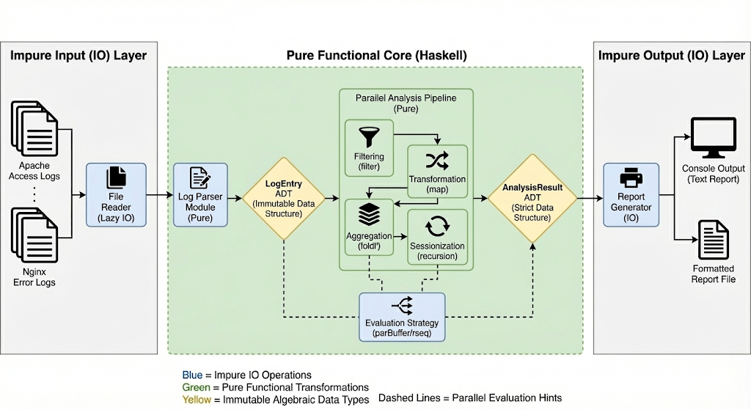
Figure 1: The figure of System Architecture
This architecture isolates side effects at the boundaries while keeping core transformations pure and testable.

2.2 Core Data Types (ADTs)
HTTP Method Representation (Sum Type)
Purpose: Type-safe representation of HTTP methods with extensibility for unknown methods.
Log Entry Structure (Product Type)
Purpose: Structured representation of parsed log entries with strong typing.
Status Categorization (Sum Type)
Purpose: Pattern-based classification of HTTP status codes.
Analysis Result (Product Type with Strict Fields)
Purpose: Aggregated analysis results with strict evaluation for parallel processing.

2.3 Main Functions with Type Signatures
Parsing Functions
-- Parse a single log line using regex pattern matching
parseLogLine :: String -> Maybe LogEntry
-- Parse entire file content into list of log entries
parseLogFile :: String -> [LogEntry]
-- Parse with statistics tracking
parseLogFileWithStats :: String -> ([LogEntry], Int, Int)
-- Parse timestamp in Apache format
parseTimestamp :: String -> Maybe UTCTime
-- Parse HTTP method from string
parseMethod :: String -> Maybe HttpMethod
Processing Functions
-- Count entries by status category using strict fold
countByLevel :: [LogEntry] -> Map StatusCategory Int
-- Extract top N IP addresses by request count
topIPs :: Int -> [LogEntry] -> [(String, Int)]
-- Bucket errors into time intervals
errorsOverTime :: NominalDiffTime -> [LogEntry] -> [(UTCTime, Int)]
-- Group requests into sessions with timeout-based splitting
sessionize :: NominalDiffTime -> [LogEntry] -> [[LogEntry]]
-- Detect traffic and error anomalies
computeAnomalies :: [LogEntry] -> [String]
-- Main processing pipeline combining all analyses
processLogs :: [LogEntry] -> AnalysisResult
I/O Functions
-- Read log file with error handling
readLogFile :: FilePath -> IO String
-- Output formatted analysis report
writeReport :: AnalysisResult -> Int -> Int -> IO ()
Utility Functions
-- Bucket timestamp to nearest interval boundary
bucketTime :: NominalDiffTime -> UTCTime -> UTCTime
-- Extract domain from referrer URL
extractDomain :: String -> String
-- Classify user agent into bot types
classifyBot :: String -> BotType

3. Functional Programming Concepts Demonstrated

3.1 Pure Functions
All data transformations are pure - they have no side effects, always produce the same output for the same input, and don’t modify external state.
Example: Status categorization: Predictable, cacheable, testable, and safe for parallel execution.

3.2 Algebraic Data Types (ADTs)
Sum types (OR relationships) and product types (AND relationships) model the domain precisely. Compiler enforces all cases are handled (exhaustiveness checking), prevents invalid states.

3.3 Recursion and Tail Recursion
Natural iteration through recursive patterns without mutable loop variables:
-- Session splitting using recursion with accumulator
splitSessions :: [LogEntry] -> [[LogEntry]]
splitSessions [] = []
splitSessions (x:xs) = go [x] xs
where
go currentSession [] = [reverse currentSession]
go currentSession@(latest:_) (next:rest)
| gap > timeout = reverse currentSession : go [next] rest
| otherwise = go (next:currentSession) rest
where
gap = diffUTCTime (leTimestamp next) (leTimestamp latest)
Benefits: Clear logic, no index management, compiler can optimize tail calls.

3.4 Higher-Order Functions
Functions as first-class values enable powerful abstractions:
-- Generic aggregator accepting an extractor function
requestsPerEndpoint :: (LogEntry -> Maybe String) -> [LogEntry] -> Map String Int
requestsPerEndpoint extractor = foldl' aggregate M.empty
where
aggregate acc entry = case extractor entry of
Just endpoint -> M.insertWith (+) endpoint 1 acc
Nothing -> acc
Common higher-order patterns used,
map Transform each element (e.g., map parseLogLine lines)
filter: Select elements (e.g., filter (isError . leStatusCode))
foldl': Accumulate results with strict evaluation (e.g., building Maps)
sortOn: Sort by extracted key (e.g., sortOn leTimestamp)
Benefits: Eliminates code duplication, creates reusable abstractions.

3.5 Lazy Evaluation
Computation is deferred until results are needed, enabling infinite data structures and memory efficiency:
parseLogFile :: String -> [LogEntry]
parseLogFile content =
[entry | Just entry <- map parseLogLine (lines content)]
Only the needed log entries are parsed and held in memory at any time, allowing processing of files larger than available RAM.
Benefits: Memory-efficient streaming, ability to work with infinite sequences.

3.6 Immutability
No mutable state eliminates entire classes of bugs:
countByLevel :: [LogEntry] -> Map StatusCategory Int
countByLevel = foldl' countEntry M.empty
where
countEntry acc entry =
let category = statusCategory (leStatusCode entry)
in M.insertWith (+) category 1 acc -- Creates new map
Each operation creates a new data structure rather than modifying existing ones.
Benefits: Thread-safe by default, easier reasoning about code, time-travel debugging.

3.7 Parallel and Concurrent Processing
Safe parallelism without locks using evaluation strategies:
sessionize :: NominalDiffTime -> [LogEntry] -> [[LogEntry]]
sessionize timeout entries =
concatMap sessionizeIP groupedByIP `using` parBuffer 100 rseq
The using function applies parallel evaluation strategy parBuffer 100 rseq, which evaluates up to 100 elements in parallel. Since all functions are pure, this is completely safe.
Benefits: Automatic parallelization, no race conditions, scales to multiple cores.

3.8 Monads for Effect Management
Maybe Monad for composable error handling:
parseLogLine :: String -> Maybe LogEntry
parseLogLine line = do
-- Pattern match and extract fields
timestamp <- parseTimestamp timeStr -- Fails gracefully if invalid
method <- parseMethod methodStr
status <- readMaybe statusStr
return LogEntry {...}
IO Monad for controlled side effects:
main :: IO ()
main = do
filePath <- getFilePath -- IO: User interaction
content <- readLogFile filePath -- IO: File reading
let entries = parseLogFile content -- Pure: Parsing
let result = processLogs entries -- Pure: Processing
writeReport result -- IO: Output
Benefits: Eliminates null pointer exceptions, clear separation of pure/impure code.

3.9 Type-Driven Development
Type signatures as documentation and contracts:
topIPs :: Int -> [LogEntry] -> [(String, Int)]
errorsOverTime :: NominalDiffTime -> [LogEntry] -> [(UTCTime, Int)]
sessionize :: NominalDiffTime -> [LogEntry] -> [[LogEntry]]
The type signature topIPs :: Int -> [LogEntry] -> [(String, Int)] clearly communicates: “Give me a number and a list of log entries, and I’ll return IP addresses paired with counts.”
Benefits: Self-documenting code, compiler enforces correctness, guides implementation.

3.10 Pattern Matching
Destructure data elegantly:
parseMethod :: String -> Maybe HttpMethod
parseMethod "GET" = Just GET
parseMethod "POST" = Just POST
parseMethod "DELETE" = Just DELETE
parseMethod other = Just (UNKNOWN other)
Benefits: Exhaustiveness checking ensures all cases handled, readable code.

4. Expected Outputs and Possible Extensions

4.1 Current Output
The analyzer produces a comprehensive report including:
============================================
LOG ANALYSIS REPORT
============================================
Total Lines Processed: 21
Successful Parses: 20
Failed Parses: 1
--------------------------------------------
Traffic by Status Category:
Success : 19
ClientError : 1
Top 10 IP Addresses:
40.77.167.129 : 11 requests
31.56.96.51 : 2 requests
...
Error Distribution (Hourly Buckets):
2019-01-22 00:00:00 UTC : 1 errors
============================================
!!! ANOMALIES DETECTED !!!
[ALERT] High traffic from IP 40.77.167.129: 11 requests

4.2 Possible Extensions
1. Real-time Stream Processing
- Monitor logs in real-time using conduit or pipes libraries
- Trigger alerts immediately when anomalies detected
- Integrate with monitoring systems (Prometheus, Grafana)
2. Advanced Anomaly Detection
Machine learning integration for anomaly scoring
- Statistical outlier detection (Z-score, IQR methods)
- Pattern recognition for attack signatures
- Behavioral analysis for bot detection
3. Geolocation Analysis
IP to location mapping
- Integrate with GeoIP databases
- Visualize global traffic distribution
- Detect geographic attack patterns
4. Performance Metrics
Response time analysis
- Calculate percentiles (p50, p95, p99)
- Identify performance bottlenecks
- SLA compliance monitoring

5. Why Functional Programming Improves Reliability and Concurrency

5.1 Reliability Advantages
1. Referential Transparency
Pure functions always produce the same output for the same input:
statusCategory 404 == statusCategory 404 -- Always true
This enables, Deterministic testing: Same inputs always yield same results, Memoization: Safely cache function results, Equational reasoning: Substitute function calls with their values
2. Type Safety
The compiler prevents entire classes of errors:
Real-world impact: Zero null pointer exceptions, zero type coercion bugs.
3. Immutability Guarantees
Once data is created, it cannot be modified:
Benefits: - No defensive copying needed - Easier debugging (data doesn’t change under you) Safe sharing between threads
4. Explicit Effect Management
The type system distinguishes pure from impure code:
This makes code behavior explicit and auditable.

5.2 Concurrency Advantages
1. Fearless Parallelism
Pure functions can be parallelized without coordination,
-- Process each IP's sessions in parallel
sessionize timeout entries =
concatMap sessionizeIP groupedByIP `using` parBuffer 100 rseq
No locks, mutexes, or semaphores needed. The compiler guarantees thread safety.
2. No Race Conditions
Race conditions are impossible with immutable data:
-- Both threads safely read the same entries
let thread1 = processLogs entries
let thread2 = computeAnomalies entries
In imperative languages, this would require careful locking to prevent data corruption.
3. Scalability
The log analyzer automatically scales to available CPU cores
No code changes needed, just compile with parallel runtime flags.
4. Automatic Work Distribution
Haskell’s parallel strategies handle work distribution:
parBuffer 100 rseq -- Evaluates up to 100 elements in parallel
parList rdeepseq -- Fully evaluates list in parallel
The runtime system manages thread pools, work stealing, and load balancing.

5.3 Industrial Use Cases
DevOps & Site Reliability Engineering
- Incident Response: Quickly identify error spikes and affected systems
- Capacity Planning: Analyze traffic trends for infrastructure scaling
- Post-mortem Analysis: Reproducible reports for compliance and auditing
Security Operations
- DDoS Detection: Identify abnormal traffic from specific IPs
- Threat Hunting: Pattern matching for attack signatures
- Access Control: Audit who accessed what and when
Business Intelligence
- User Analytics: Session analysis and engagement metrics
- A/B Testing: Compare traffic patterns across experiments
- Performance Optimization: Identify slow endpoints and bottlenecks

5.4 Comparison with Imperative Approaches
Aspect | Functional (Haskell) | Imperative (Python/Java)
Thread Safety | Guaranteed by immutability | Manual synchronization required
Parallel Scaling | Automatic with parallel strategies | Manual thread management
Testing | Pure functions easily testable | Side effects complicate testing
Debugging | No unexpected state changes | Mutable state hard to track
Correctness | Type system prevents many bugs | Runtime errors common
Refactoring | Safe due to type guarantees | Risky, requires extensive testing

