SRI SIDDHARTHA ACADEMY OF HIGHER EDUCATION
(DEEMED TO BE UNIVERSITY)
Accredited A+ Grade by NAAC
SRI SIDDHARTHA INSTITUTE OF TECHNOLOGY
(A Constituent College of SSAHE)
KUNIGAL ROAD, MARALURU, TUMAKURU-572105

Dept. Skill Lab-III (Machine Learning Laboratory) – 22IS507 Mini Project Report
on
“AI-Based Human Concentration Detection System”
Submitted in partial fulfillment of the requirement for the completion of V semester of

BACHELOR OF ENGINEERING

Submitted by
CHANDU D 23IS018
NAYANA K H 23IS061

Under the Guidance of
NANDINI G RB.E.,M.Tech(Ph.D)
Assistant Professor, Dept. of ISE


DEPARTMENT OF INFORMATION SCIENCE AND ENGINEERING
“Accredited by NBA, NEW DELHI”

2025-26

SRI SIDDHARTHA ACADEMY OF HIGHER EDUCATION
(DEEMED TO BE UNIVERSITY)
Accredited A+ Grade by NAAC
SRI SIDDHARTHA INSTITUTE OF TECHNOLOGY
(A Constituent College of SSAHE)
KUNIGAL ROAD, MARALURU, TUMAKURU-572105

DEPARTMENT OF INFORMATION SCIENCE AND ENGINEERING


CERTIFICATE

Certified that mini project entitled “AI-Based Human Concentration Detection System”, is a bonafide work carried out by Mr,/Ms. CHANDU D (23IS018) and Mr./Ms NAYANA K H (23IS061) in partial fulfillment of the requirement for the completion of V semester B.E. in Information Science and Engineering of Sri Siddhartha Institute of Technology-Tumakuru during the year 2025-26. It is certified that all corrections/suggestions indicated have been incorporated in the report. The report has been approved as it satisfies the academic requirements with respect to Mini Project work.

Signature of the Guide Signature of the HoD

Nandini G RB.E.,M.Tech(Ph.D)
Assistant Professor,
Dept. of Information Science & Engg.
Dr. Annapurna H S Ph.D
Professor and Head,
Dept. of Information Science & Engg.

Name of the Examiners Signature

DECLARATION

We, CHANDU D (23IS018) and NAYANA K H (23IS061) of V semester, Department of Information Science and Engineering of Sri Siddhartha Institute of Technology, Tumakuru, hereby declare that this Mini project titled, “AI-Based Human Concentration Detection System”, has been carried out by us under the supervision of Nandini G R, Assistant Professor, Department of Information Science and Engineering, Sri Siddhartha Institute of Technology, Tumakuru in partial fulfillment of the requirement for the completion of V semester in Information Science and Engineering.

Date: 26 /12 /2025 CHANDU D (23IS018)
Place: Tumakuru NAYANA K H (23IS061)

ABSTRACT

In recent years, maintaining sustained human attention and concentration has become a critical challenge in scenarios such as online examinations, virtual classrooms, remote interviews, and driving safety systems. The lack of physical supervision in such environments often leads to distractions caused by mobile phone usage, drowsiness, noise disturbances, and loss of visual focus. To address this issue, this project presents a Real- Time AI-Based Human Concentration and Distraction Detection System that integrates computer vision, signal processing, and deep learning techniques to monitor user attention effectively and non-intrusively.
The proposed system utilizes MediaPipe Face Mesh technology for accurate facial landmark detection, enabling real-time tracking of eye movements, iris position, head orientation, and blink patterns. Eye Aspect Ratio (EAR)–based geometric algorithms are employed to detect eye blinks and prolonged eye closure, which are strong indicators of drowsiness and reduced alertness. Gaze direction estimation is achieved through iris- based calibration and heuristic threshold analysis to identify whether the user is focused on the screen or distracted by looking away. Additionally, a classical head alignment method is used to monitor face orientation and determine deviations from the attentive posture.

LIST OF FIGURES

Fig.No. | Figure Name | Page No.
01 | Flow Diagram | 09
02 | Main interface | 15
03 | Session Report 1 | 16
04 | Session Report 2 | 16

TABLE OF CONTENTS

ABSTRACT i
LIST OF FIGURES ii
Sl. No. Description Page No.
- Introduction 01
  - Background 01
  - Problem Statement 01
  - Aim and Objective 01
- Literature Survey 02
- System Requirements 03
- System Design
  - System Architecture 04
  - Flow Diagram 05
- Implementation 06
- Results 15
- Conclusion 17
- Future Scope 18
References 19

CHAPTER 1

Background:

INTRODUCTION

The rapid growth of digital technologies and online platforms has significantly transformed the way people work, learn, and communicate. Activities such as online education, virtual interviews, remote examinations, and prolonged computer-based work have become increasingly common. While these advancements offer flexibility and accessibility, they also introduce new challenges related to maintaining human attention and concentration. In the absence of physical supervision, individuals are more prone to distractions caused by mobile phone usage, environmental noise, fatigue, and loss of visual focus. These factors can negatively impact productivity, learning outcomes, safety, and performance.

Problem Statement:
In many real-world scenarios such as online examinations, virtual classrooms, remote interviews, and driving environments, there is no reliable mechanism to continuously monitor an individual’s attention and alertness. Existing systems either depend on manual observation, which is error- prone and labor-intensive, or use intrusive hardware-based solutions that are uncomfortable and impractical for long-term use. Moreover, many current AI-based monitoring solutions rely on heavy deep learning models that require large datasets, high computational resources, and constant internet connectivity, making them unsuitable for real-time and low-resource environments.

Aim and Objective: Aim:
The primary aim of this project is to develop a real-time AI-based human concentration and distraction detection system that monitors attention levels using facial, behavioral, and audio cues, and provides timely feedback to improve focus, safety, and performance.

Objectives:

    - To detect and track facial landmarks in real time using computer vision techniques for eye movement, blink detection, and head orientation analysis.

    - To estimate gaze direction and identify attention loss using iris-based calibration and heuristic algorithms.

    - To detect mobile phone usage using a deep learning–based object detection model to identify visual distractions.

    - To analyze environmental noise using audio signal processing techniques for identifying auditory distractions.

CHAPTER 2

LITERATURE SURVEY

In recent years, significant research has been conducted in the area of human attention, concentration monitoring, and distraction detection using artificial intelligence and computer vision techniques. With the increasing adoption of online education, virtual assessments, and advanced driver assistance systems, researchers have focused on developing non-intrusive and real-time solutions to analyze human behavior and alertness.

Several studies have explored eye blink detection and eye aspect ratio (EAR)–based methods to identify drowsiness and fatigue. Soukupová and Čech proposed the EAR algorithm, which uses geometric relationships between eye landmarks to detect blinks and prolonged eye closure. This method gained popularity due to its simplicity, real-time performance, and independence from large training datasets. Many later systems adopted this approach for driver drowsiness detection and attention analysis because of its robustness and low computational cost.

Facial landmark detection has been another major area of research. Traditional methods such as Haar cascades and Active Shape Models were initially used for face and landmark detection; however, these approaches suffered from low accuracy under varying lighting and pose conditions. With the introduction of MediaPipe Face Mesh, researchers achieved more accurate and real-time facial landmark tracking using deep learning–based regression models. MediaPipe enables the detection of hundreds of facial landmarks, making it suitable for gaze tracking, head pose estimation, and facial behavior analysis in real-world applications.

Gaze estimation techniques have been widely studied for attention monitoring. Early gaze-tracking systems relied on infrared sensors and specialized hardware, which were expensive and intrusive. Later approaches used camera-based gaze estimation through iris position analysis and head pose correction. Heuristic and calibration-based gaze estimation methods became popular due to their simplicity and ability to work with standard webcams.

Mobile phone usage detection has recently attracted attention as a critical factor in distraction analysis. Traditional image processing techniques were insufficient for robust object detection. With the advancement of deep learning, YOLO (You Only Look Once)–based object detection models demonstrated high accuracy and real-time performance. YOLOv8, in particular, introduced improvements in speed, accuracy, and anchor-free detection, making it suitable for detecting handheld devices such as mobile phones in real-time monitoring systems.

Audio-based distraction detection has also been explored using signal processing techniques. Researchers have used Root Mean Square (RMS) energy analysis and spectral features to detect abnormal noise levels in environments such as classrooms and vehicles.

CHAPTER 3

SYSTEM REQUIREMENTS

Hardware Requirements:
The proposed real-time human concentration and distraction detection system is designed to operate efficiently on standard computing hardware without the need for specialized equipment. The following hardware components are required for successful implementation and execution of the system:

Processor:
Intel Core i3 / AMD Ryzen 3 or higher (recommended Intel Core i5 or above for smoother real-time performance)

RAM:
Minimum 8 GB (16 GB recommended for better performance when running computer vision and deep learning modules simultaneously)

Camera:
Integrated webcam or external USB camera with a minimum resolution of 720p for accurate facial landmark and gaze detection

Microphone:
Built-in or external microphone for capturing ambient audio signals used in noise detection

Software Requirements:
The software requirements include the operating environment, programming tools, libraries, and frameworks necessary for developing and running the system. The project is implemented using widely supported and open-source technologies to ensure portability and ease of deployment.

Operating System:
Windows 10 / Windows 11 or Linux (Ubuntu 20.04 or later)

Programming Language:
Python 3.8 or higher

Development Environment:
Visual Studio Code / PyCharm / Any Python-supported IDE Libraries and Frameworks:
OpenCV – for real-time image processing and video capture,Numpy MediaPi

CHAPTER 4

SYSTEM DESIGN

The system design describes the overall structure and operational workflow of the proposed real-time AI-based human concentration and distraction detection system. It explains how different modules interact to capture inputs, analyze user behavior, detect distractions, and generate meaningful outputs in real time.

System Architecture:
The proposed system follows a modular and layered architecture to ensure efficiency, real-time performance, and scalability. The architecture consists of five primary components: input acquisition, preprocessing, analysis, decision-making, and output reporting.

The input acquisition module captures live video streams through a webcam and ambient audio through a microphone. These inputs serve as the primary data sources for visual and auditory analysis. The preprocessing module prepares the captured data by converting video frames into suitable formats and normalizing audio signals to ensure reliable analysis.

The analysis module forms the core of the system. Facial landmarks are extracted using MediaPipe Face Mesh for eye movement, blink detection, gaze estimation, and head orientation analysis. The Eye Aspect Ratio (EAR) algorithm is used to detect blinks and prolonged eye closure, which indicate drowsiness. Gaze direction is estimated through iris position analysis with calibrated thresholds. Mobile phone usage is detected using the YOLOv8 deep learning object detection model, while environmental noise is identified using RMS-based audio signal processing.

The decision and alert module integrates the outputs from all analysis components using a weighted attention scoring algorithm to compute a real-time concentration score. Based on predefined conditions, visual alerts and offline voice warnings are triggered for detected distractions such as drowsiness, mobile usage, noise, and absence of face detection.

The output and reporting module displays the real-time concentration status on the screen and records session statistics such as average concentration, eye-closure duration, mobile usage time, and noise exposure. These results are stored in structured format and presented through a web-based dashboard for post-session analysis.

Flow Diagram:
The system execution begins with the initialization of the camera, microphone, and required libraries. Audio calibration is performed to establish a baseline noise level, followed by gaze calibration to determine the user’s neutral eye position. The system then enters a continuous monitoring loop where video frames and audio signals are captured in real time.
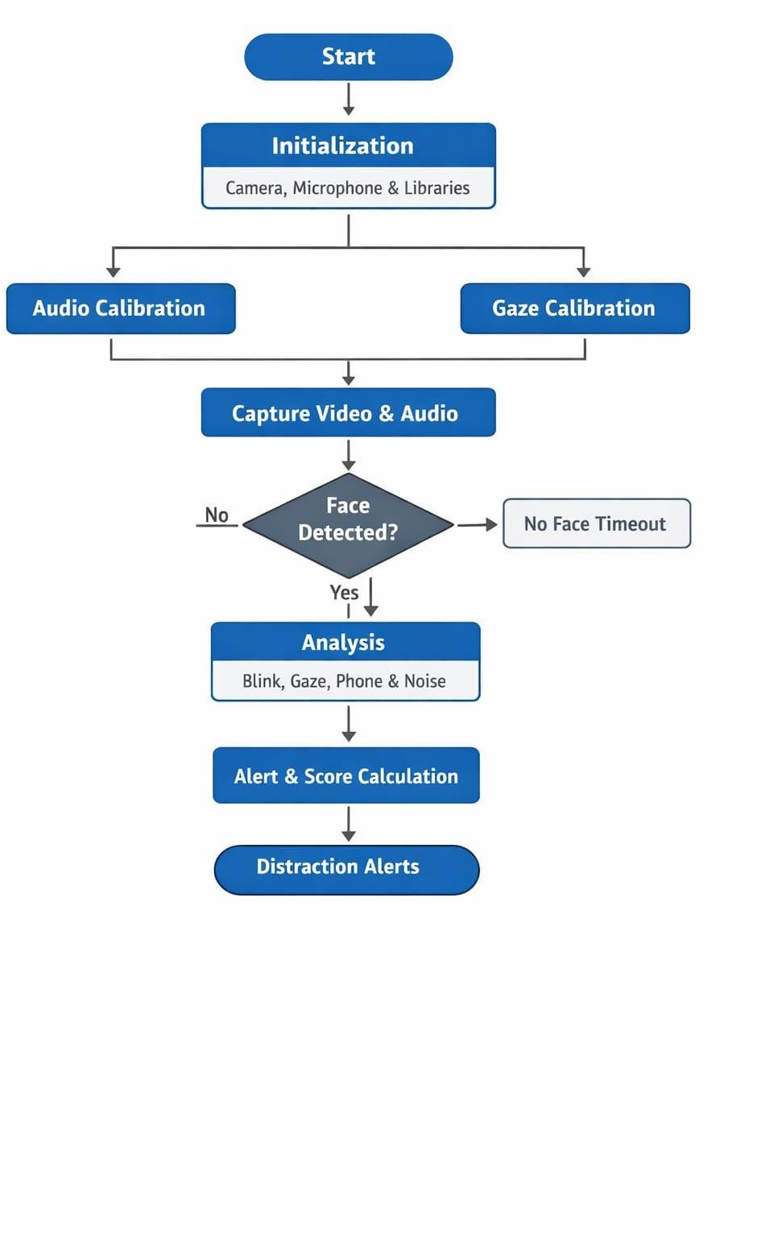

Figure 4.2
Flow diagram for Human Concentration detection System

CHAPTER 5

IMPLEMENTATION
The proposed human concentration and distraction detection system is implemented using Python by integrating computer vision, deep learning, and audio signal processing techniques. The system operates in real time and functions offline, ensuring privacy and low latency.
Live video frames are captured using a webcam through OpenCV, while ambient audio is recorded using the SoundDevice library. An initial calibration phase establishes baseline noise levels and gaze reference values. MediaPipe Face Mesh is employed to detect facial landmarks, which are used for blink detection, gaze estimation, and head orientation analysis. Eye blinks and prolonged eye closure are identified using the Eye Aspect Ratio (EAR) algorithm.
Gaze direction is determined by comparing iris position with calibrated baseline values, and head orientation is approximated using nose landmark alignment. Mobile phone usage is detected using the YOLOv8 deep learning object detection model, enabling accurate identification of visual distractions. Environmental noise is detected using RMS-based audio energy analysis by comparing current audio levels with the calibrated baseline.
A weighted attention scoring algorithm combines gaze, head posture, blink activity, mobile detection, and noise levels to generate a real-time concentration score. Visual indicators and offline voice alerts are triggered when distraction conditions are detected. At the end of the session, performance metrics are stored in structured format and displayed through a Flask-based dashboard for analysis.

Code:
# 4ml_fixed_timers.py import cv2
import mediapipe as mp import numpy as np import sounddevice as sd import time
import threading
from collections import deque
# ======= NEW IMPORTS & SETUP (ADD THIS AFTER EXISTING IMPORTS) =======
import pyttsx3
from ultralytics import YOLO

# Initialize TTS engine tts_engine = pyttsx3.init() tts_engine.setProperty('rate', 180)

def speak_async(text):
"""Run TTS in a non-blocking thread.""" import threading
def run(): try:
tts_engine.say(text) tts_engine.runAndWait()
except Exception: pass
threading.Thread(target=run, daemon=True).start()

# Load YOLOv8 model (smallest variant) try:
phone_detector = YOLO("yolov8n.pt")
print("[INFO] YOLOv8 loaded successfully for mobile detection.") except Exception as e:
print("[WARNING] YOLO model not loaded:", e) phone_detector = None

# Timer state variables low_concentration_start = None
direction_timer = {"LEFT": None, "RIGHT": None, "UP": None, "DOWN": None} no_face_timer = None

last_voice_time = 0
VOICE_INTERVAL = 5 # seconds between repeated warnings
# ==============================================================

# CONFIG
CALIB_SECONDS = 3.0
EAR_BLINK_THRESHOLD = 0.18
BLINK_CONSEC_FRAMES = 2
FACE_DET_CONF = 0.45
EYE_VARIANCE_THRESHOLD = 200.0 # occlusion check: variance too low => likely covered EYE_MEAN_DARK = 45.0 # occlusion check: mean too dark => covered GAZE_X_DELTA = 0.07 # threshold around calibrated center for LEFT/RIGHT GAZE_Y_DELTA = 0.06 # threshold around calibrated center for UP/DOWN SCORE_SMOOTH = 6
NOISE_SENSITIVITY = 2.0 # how much above baseline RMS counts as noise AUDIO_CALIB_SECONDS = 1.0
AUDIO_SR = 22050
AUDIO_BLOCKSIZE = 1024
EYES_CLOSED_SECONDS = 3.0 # <-- display eyes closed if closed for this long NO_FACE_SECONDS = 10.0 # <-- exit if no face detected this many seconds
#

# MediaPipe
mp_face_mesh = mp.solutions.face_mesh mp_face_detection = mp.solutions.face_detection mp_drawing = mp.solutions.drawing_utils

face_mesh = mp_face_mesh.FaceMesh(refine_landmarks=True, max_num_faces=1) face_detection = mp_face_detection.FaceDetection(min_detection_confidence=0.4)

# landmark indices
LEFT_EYE = [33, 160, 158, 133, 153, 144]
RIGHT_EYE = [362, 385, 387, 263, 373, 380]
LEFT_IRIS = 468
RIGHT_IRIS = 473

# audio globals (thread-safe)
_audio_rms = 0.0
_audio_lock = threading.Lock()
_audio_stream = None
_audio_baseline = 1e-6

def audio_callback(indata, frames, time_info, status): global _audio_rms
mono = np.mean(indata, axis=1) if indata.ndim > 1 else indata[:,0] rms = float(np.sqrt(np.mean(np.square(mono))))
with _audio_lock:
_audio_rms = rms

def start_audio(): global _audio_stream

try:
_audio_stream = sd.InputStream(callback=audio_callback,
blocksize=AUDIO_BLOCKSIZE, samplerate=AUDIO_SR, channels=1)
_audio_stream.start() return True
except Exception as e:
print("Audio stream start failed:", e) return False

def calibrate_audio_baseline(): global _audio_baseline
try:
print(f"Calibrating microphone for {AUDIO_CALIB_SECONDS:.1f}s — please be quiet...") rec = sd.rec(int(AUDIO_CALIB_SECONDS * AUDIO_SR), samplerate=AUDIO_SR,
channels=1, dtype='float64') sd.wait()
mono = rec[:,0]
_audio_baseline = max(1e-6, float(np.sqrt(np.mean(np.square(mono))))) print(f"Audio baseline RMS = {_audio_baseline:.6f}")
except Exception as e:
print("Audio calibration failed:", e)
_audio_baseline = 1e-6

# Helpers
def eye_aspect_ratio(landmarks, eye_indices, w, h): try:
pts = [(landmarks[i].x * w, landmarks[i].y * h) for i in eye_indices]
A = np.linalg.norm(np.array(pts[1]) - np.array(pts[5]))
B = np.linalg.norm(np.array(pts[2]) - np.array(pts[4]))
C = np.linalg.norm(np.array(pts[0]) - np.array(pts[3])) if C <= 1e-6:
return 0.0
return (A + B) / (2.0 * C) except Exception:
return 0.0
def eye_region_stats(gray, landmarks, eye_indices, w, h, pad=6): xs = [int(landmarks[i].x * w) for i in eye_indices]
ys = [int(landmarks[i].y * h) for i in eye_indices]
x1 = max(min(xs) - pad, 0); x2 = min(max(xs) + pad, w-1) y1 = max(min(ys) - pad, 0); y2 = min(max(ys) + pad, h-1) if x2 <= x1 or y2 <= y1:
return None
region = gray[y1:y2, x1:x2] if region.size == 0:
return None
return float(np.mean(region)), float(np.var(region))

def get_iris_avg(landmarks): try:
return (landmarks[LEFT_IRIS].x + landmarks[RIGHT_IRIS].x) / 2.0, \ (landmarks[LEFT_IRIS].y + landmarks[RIGHT_IRIS].y) / 2.0
except Exception: return None, None

def compute_concentration(gaze_ok, head_ok, blink_recent, occluded, noise_flag): # weights (tunable): gaze 40%, head 30%, blink penalty 20%, noise 10% gaze_score = 1.0 if gaze_ok else 0.0
head_score = 1.0 if head_ok else 0.0 blink_pen = 0.0 if not blink_recent else 0.5 noise_pen = 1.0 if noise_flag else 0.0
base = 0.4*gaze_score + 0.3*head_score + 0.2*(1.0 - blink_pen) + 0.1*(1.0 - noise_pen) if occluded:
base *= 0.2
return int(np.clip(base * 100.0, 0, 100))

# ---------- Start audio thread and calibrate ---------- audio_ok = start_audio()
if audio_ok: calibrate_audio_baseline()
else:
print("Warning: audio disabled; noise detection will be off.")

# ---------- Camera and calibration ---------- cap = cv2.VideoCapture(0)

if not cap.isOpened():
print("ERROR: Cannot open camera. Close other apps or check device.") raise SystemExit

cv2.namedWindow("Concentration Tracker", cv2.WINDOW_NORMAL) print("Camera opened. Starting gaze calibration — look straight at the camera now.")

calib_x = [] calib_y = []
calib_start = time.time()
while time.time() - calib_start < CALIB_SECONDS: ret, frame = cap.read()
if not ret: continue
frame = cv2.flip(frame, 1) h, w, _ = frame.shape
rgb = cv2.cvtColor(frame, cv2.COLOR_BGR2RGB) det = face_detection.process(rgb)
mesh = face_mesh.process(rgb)
if mesh.multi_face_landmarks and det.detections: landmarks = mesh.multi_face_landmarks[0].landmark avgx, avgy = get_iris_avg(landmarks)
if avgx is not None:
calib_x.append(avgx); calib_y.append(avgy)
cv2.putText(frame, "Calibrating gaze (keep eyes on camera)...", (20,40), cv2.FONT_HERSHEY_SIMPLEX, 0.7, (0,255,255), 2)
cv2.imshow("Concentration Tracker", frame)

if cv2.waitKey(1) & 0xFF == ord('q'): cap.release() cv2.destroyAllWindows()
raise SystemExit

if not calib_x:
print("Calibration failed: no face/iris detected. Retry with better lighting/position.") cap.release()
cv2.destroyAllWindows() raise SystemExit

baseline_x = float(np.mean(calib_x)) baseline_y = float(np.mean(calib_y))
print(f"Calibration complete. Baseline iris center = ({baseline_x:.3f}, {baseline_y:.3f})")

CHAPTER 6

RESULTS
The proposed real-time human concentration and distraction detection system was evaluated under various conditions including focused attention, mobile phone usage, eye closure, head movement, and environmental noise. The system successfully detected facial landmarks, eye blinks, gaze direction, head orientation, mobile phone presence, and noise levels in real time, and generated a continuous concentration score reflecting the user’s attention state. Distraction events such as mobile phone usage and prolonged eye closure were accurately identified and immediately reflected through visual and audio alerts. The results are based on established theoretical principles, where Eye Aspect Ratio (EAR) analysis explains blink and eye closure detection, iris-based gaze estimation represents visual focus, head orientation indicates attentiveness, convolutional neural network–based object detection identifies mobile phone usage, and RMS audio energy analysis detects environmental noise. By combining these parameters through a weighted attention scoring mechanism, the system effectively models real-world concentration behavior. The experimental outcomes demonstrate that integrating visual, behavioral, and audio cues provides a reliable, explainable, and real-time assessment of human concentration, validating the effectiveness of the proposed approach.
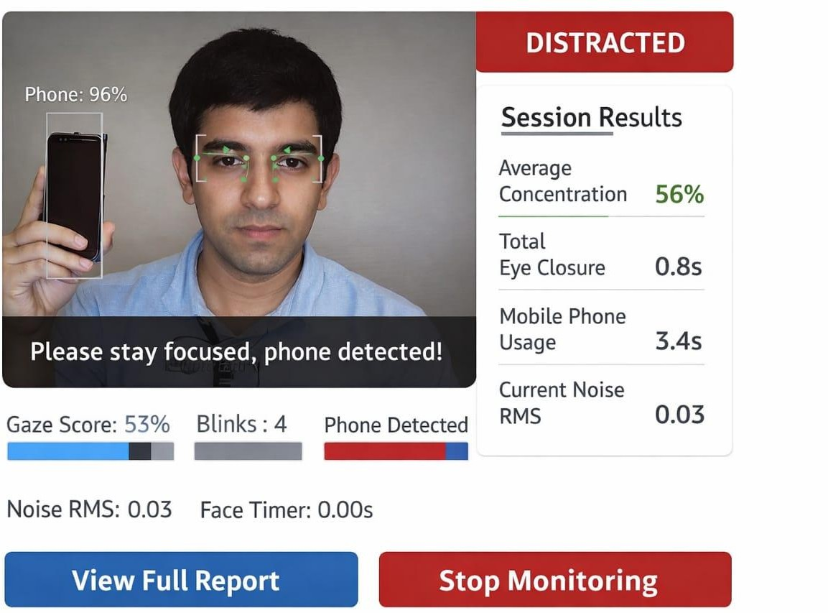

Figure 6.1
Main interface of the project

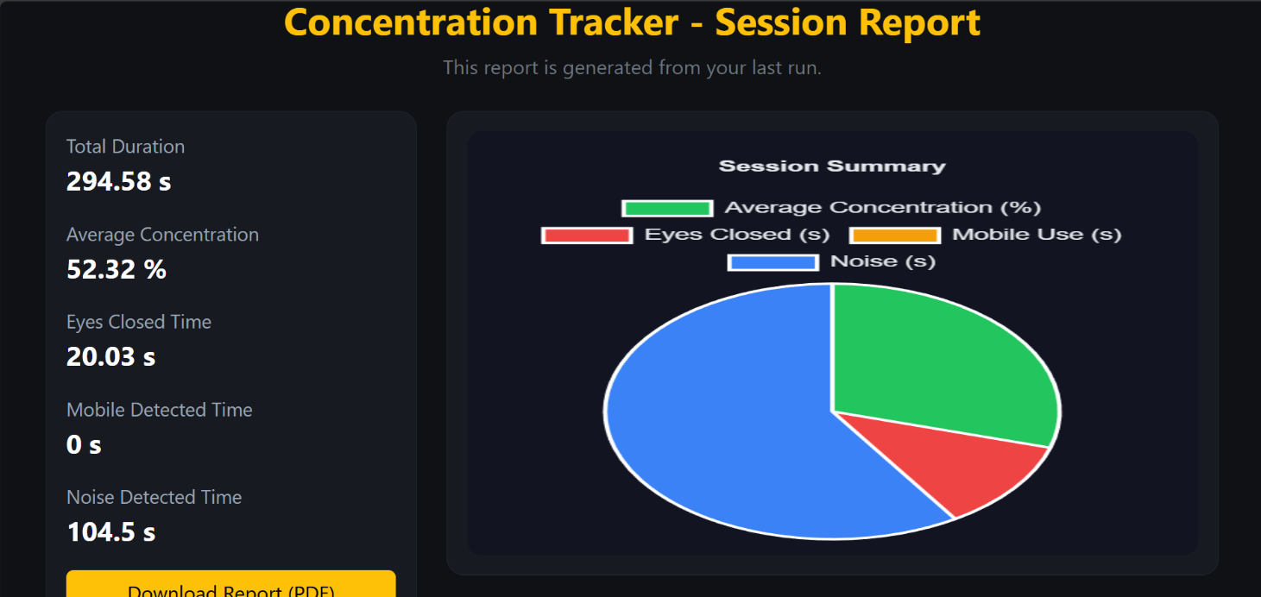

Figure 6.1
Session Report with Pie Chart

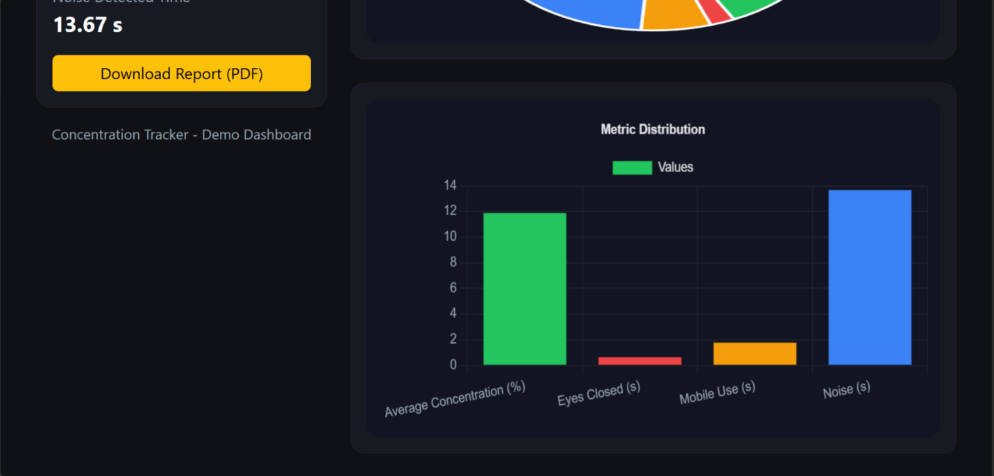

Figure 6.2
Session Report with Bar Chart

CHAPTER 7

CONCLUSION
This project successfully designed and implemented a real-time AI-based human concentration and distraction detection system by effectively combining computer vision, deep learning, and audio signal processing techniques. The system continuously monitors user attention by analyzing facial landmarks, eye blinks, gaze direction, head orientation, mobile phone usage, and environmental noise. The integration of classical geometric algorithms with modern deep learning models ensures high accuracy, explainability, and real-time performance without relying on continuous internet connectivity. Experimental evaluation confirms that the system can reliably identify distraction events such as drowsiness, loss of focus, and mobile phone usage, while providing meaningful concentration scores and alerts. The proposed solution demonstrates strong potential for improving safety, productivity, and discipline in applications such as online learning, remote examinations, virtual interviews, and driver monitoring systems, making it a practical and impactful contribution to intelligent human–computer interaction.

CHAPTER 8

FUTURE SCOPE
The proposed system offers several opportunities for future enhancement and expansion. Advanced head pose estimation techniques using 3D face models can be integrated to improve accuracy in varying lighting and camera positions. The inclusion of emotion and stress recognition using deep learning can provide deeper insights into user cognitive and emotional states. The system can be extended to support multi-user monitoring for classroom and examination hall environments. Deployment on mobile devices and embedded platforms can improve portability and real-world applicability. Furthermore, cloud-based data analytics and long-term attention trend analysis can enable personalized feedback, adaptive learning systems, and large-scale behavioral studies, expanding the system’s usability across education, healthcare, workplace productivity, and intelligent transportation domains.

REFERENCES
- A. S. Georghiades, D. J. Kriegman, and P. N. Belhumeur, “From Few to Many: Illumination Cone Models for Face Recognition under Variable Lighting,” IEEE Transactions on Pattern Analysis and Machine Intelligence, vol. 23, no. 6, pp. 643–660, 2001.
- Z. Zhang, “A Flexible New Technique for Camera Calibration,” IEEE Transactions on Pattern
Analysis and Machine Intelligence, vol. 22, no. 11, pp. 1330–1334, 2000.
- S. Zafeiriou, C. Zhang, and Z. Zhang, “A Survey on Face Detection in the Wild,” Computer
and Image Understanding, vol. 138, pp. 1–24, 2015.
- B. Schuller et al., “Speech Emotion Recognition: Two Decades in a Nutshell,” IEEE Transactions
on Affective Computing, vol. 1, no. 1, pp. 18–38, 2010.
- R. Szeliski, Computer Vision: Algorithms and Applications, Springer, 2011.
- P. Viola and M. Jones, “Rapid Object Detection Using a Boosted Cascade of Simple Features,”
- A. Krizhevsky, I.Sutskever, and G. E. Hinton, “ImageNet Classification with Deep Convolutional”

