(AUTONOMOUS)
A Capstone Project Report on

PERFORMANCE MARKETING

Submitted in a partial fulfillment for the award of the degree

BACHELOR OF TECHNOLOGY
In
COMPUTER SCIENCE AND ENGINEERING (ARTIFICIAL INTELLIGENCE)
SUBMITTED BY BANALA JAYA SIDDHU
(22G21A3115)

Under the esteemed Guidance of
MR.S. CHANDANA KRISHNA, MTech.,

Professor & Head, CSE(AI)

DEPARTMENT OF COMPUTER SCIENCE AND ENGINEERING (ARTIFICIAL INTELLIGENCE)

AUDISANKARA COLLEGE OF ENGINEERING & TECHNOLOGY(A)
Accredited by NAAC with ‘A+’ Grade | Accredited by NBA Approved by AICTE | Affiliated to JNTUA NH5 Bypass Road, Gudur – 524101, Tirupati (DT.), Andhra Pradesh
www.audisankara.ac.in

AUDISANKARA COLLEGE OF ENGINEERING & TECHNOLOGY
(AUTONOMOUS)

Accredited by NAAC with ‘A+’ Grade | Accredited by NBA Approved by AICTE | Affiliated to JNTUA NH5 Bypass Road, Gudur – 524101, Tirupati (DT.), Andhra Pradesh

DEPARTMENT OF COMPUTER SCIENCE AND ENGINEERING (ARTIFICIAL INTELLIGENCE)


CERTIFICATE

This is to certify that the Full Semester Internship report on entitled “Performance Marketing” is the Bonafide work done by the student BANALA JAYA SIDDHU (22G21A3115) in partial fulfillment of the requirements for the award of the degree of Bachelor of Technology in Computer Science and Engineering (Artificial Intelligence), from Jawaharlal Nehru Technological University Anantapur, Anantapuramu, during the year 2025-2026.

Project Guide

Mrs. S. CHANDANA KRISHNA, M. Tech.,

Assistant Professor, CSE-AI , Department of CSE(AI), ASCET, Gudur.
Head of the Department

Dr. S.V. PADMAVATHI DEVI, Ph.D.,

Professor& Head, CSE-AI, Department of CSE(AI), ASCET. Gudur.

Submitted for the viva-voce Examination held on:

Internal Examiner External Examiner

AUDISANKARA COLLEGE OF ENGINEERING & TECHNOLOGY
(AUTONOMOUS)

Accredited by NAAC with ‘A+’ Grade | Accredited by NBA Approved by AICTE | Affiliated to JNTUA NH5 Bypass Road, Gudur – 524101, Tirupati (DT.), Andhra Pradesh


DECLARATION

I, BANALA JAYA SIDDHU, hereby declare that the Project Work entitled PERFORMANCE MARKETING done by us under the esteemed Guidance of Mrs.S. CHANDANA KRISHNA, M. Tech., Assistant Professor, Dept. of CSE(AI). The Capstone Project report is submitted in partial fulfillment of the requirements for the award of the bachelor’s degree in Computer Science and Engineering (Artificial Intelligence).

Date:
Place: Gudur

BANALA JAYA SIDDHU (22G21A3115)

ACKNOWLEDGMENT

I express my deepest gratitude to DR. VANKI PENCHALAIAH, the Chairman of AUDISANKARA COLLEGE OF ENGINEERING & TECHNOLOGY, for providing me with an excellent academic environment and unwavering support throughout my project.
I extend my heartfelt thanks to SMT. VANKI ANUSHA, Vice Chairperson, for her encouragement and continuous motivation, which have been instrumental in my academic journey.
I sincerely appreciate the guidance and support of DR. J. AMARENDRA, Principal, whose leadership and vision have inspired me to strive for excellence.
I extend my sincere thanks to my project guide, Mrs. S. CHANDANA KRISHNA, M. Tech., Assistant Professor, Department of CSE (AI), for her valuable guidance, encouragement, and continuous support, which played a vital role in the successful completion of my project.
My sincere gratitude goes to Dr. S. V. PADMAVATHI DEVI, Head of the Department-CSE(AI), for her valuable insights, motivation, and support, which greatly contributed to the successful completion of my project.
I am thankful to Dr. U. THIRUPALU, Department Project Coordinator, for his expert guidance and coordination, which played a key role in shaping my project.
I express my gratitude to my department faculty for their constant encouragement, technical guidance, and mentorship throughout this journey.

My special thanks to the non-teaching faculty for their assistance and support in various aspects of my project work.
I would like to extend our heartfelt appreciation to my parents and friends, whose encouragement, patience, and moral support have been our driving force in completing this capstone project successfully.
Finally, I acknowledge the collaborative efforts of our team members, whose dedication and hard work made this project possible.

Project Associate
BANALA JAYA SIDDHU (22G21A3115)

Table of content

Chapter / Section | Title / Description | Page No.
- | ABSTRACT | 10
CHAPTER 1 | INTRODUCTION | 11
1.1 | Introduction | 11
1.2 | Problem Statement | 11
1.3 | Objectives of the Project | 11
1.4 | Overview of the Report | 12
CHAPTER 2 | SYSTEM DESIGN & ARCHITECTURE | 13
2.1 | Introduction to the Architectural Paradigm | 13
2.2 | High-Level Three-Tier Architecture | 13
2.3 | Frontend Presentation Layer Design | 14
2.4 | Backend Application Layer Design | 16
2.5 | Machine Learning & Data Layer Architecture | 17
2.6 | System Workflow & Sequence Models | 18
2.7 | Modular Component Architecture | 19
2.8 | Security, Scalability, & Performance Considerations | 19

Chapter / Section | Title / Description | Page No.
2.9 | Limitations of the Current Architecture | 20
CHAPTER 3 | METHODS & IMPLEMENTATION | 21
3.1 | Introduction to the Computational Methodology | 21
3.2 | Data Acquisition and Dataset Profiling | 22
3.3 | Data Preprocessing and Cleansing Operations | 23
3.4 | Advanced Feature Engineering | 23
3.5 | Categorical Data Transformation (Label Encoding) | 25
3.6 | Target Variable Definition and Problem Framing | 26
3.7 | Dataset Partitioning Strategy | 27
3.8 | Machine Learning Algorithmic Framework: Gradient Boosting | 27
3.9 | Hyperparameter Optimization Strategy | 29
3.10 | Model Evaluation Metrics and Mathematical Validation | 29
3.11 | Live Predictive Inference Pipeline | 31
3.12 | Time-Series Forecasting Methodology | 32
3.13 | Dynamic Retraining Protocol Implementation | 33
CHAPTER 4 | MODULES / COMPONENTS | 35

Chapter / Section | Title / Description | Page No.
4.1 | Introduction | 35
4.2 | Frontend User Interface & UX Design Module | 35
4.3 | Backend Processing Module | 37
4.4 | Data Ingestion & Preprocessing Module | 37
4.5 | Machine Learning Engine & Predictive Module | 39
4.6 | Sales Forecasting & Trend Extrapolation Module | 39
4.7 | Advantages Of Modular Architecture | 40
4.8 | Conclusion | 41
CHAPTER 5 | RESULTS & DISCUSSIONS | 42
5.1 | Introduction | 42
5.2 | System Testing Environment | 42
5.3 | User Interface Results | 42
5.4 | Results | 46
5.5 | Advantages and Limitations of The System | 47
5.6 | Future Enhancements | 47
CHAPTER 6 | CONCLUSION & FUTURE SCOPE | 48

Chapter / Section | Title / Description | Page No.
6.1 | Conclusion | 48
6.2 | Future Scope | 48
- | REFERENCES | 50

LIST OF FIGURES

Figure No. | Figure Description | Page No.
Figure 2.1 | Three-Tier System Architecture of StoreSight ML | 14
Figure 2.2 | Machine Learning Pipeline - From Data Ingestion to Model Evaluation | 18
Figure 3.1 | Data Preprocessing and Machine Learning Training Pipeline | 21
Figure 4.1 | Sequence Diagram of the Live Prediction Workflow | 35
Figure 5.3.1 | Dashboard & KPI Home Page | 43
Figure 5.3.2 | Dataset Upload Interface | 43
Figure 5.3.3 | Visual Analytics & Trends Page | 44
Figure 5.3.4 | Live Prediction Form Page | 44
Figure 5.3.5 | Feature Importance Results | 45
Figure 5.3.6 | Profitability Prediction Results | 45
Figure 5.3.7 | Sales Forecasting Results | 46

ABSTRACT

In the contemporary retail landscape, the sheer volume and velocity of transactional data make traditional, static reporting mechanisms inadequate for proactive decision-making. Retail enterprises frequently struggle to identify underlying profitability patterns, forecast long-term sales trends, and predict the financial viability of individual orders in real-time. To address these critical business challenges, this project introduces StoreSight ML, a comprehensive, AI-powered web platform designed for advanced retail analytics and predictive modeling.
Developed utilizing a Python Flask backend and a responsive, dynamic frontend powered by Chart.js, StoreSight ML serves as an end-to-end data pipeline. The system ingests and processes complex retail datasets (such as the Superstore dataset) through rigorous data preprocessing techniques, including temporal feature extraction, derivation of revenue metrics, and categorical label encoding.
At the core of the application lies a dual-model machine learning engine built upon the Gradient Boosting framework. The system simultaneously trains a Gradient Boosting Classifier to determine the binary probability of an order's profitability, and a Gradient Boosting Regressor to estimate the precise monetary profit or loss. Stakeholders can interact with a Live Prediction module, inputting hypothetical order parameters (e.g., sales volume, discount rates, region, and category) to receive immediate, actionable profitability assessments.
Beyond isolated predictions, the platform features a comprehensive analytics dashboard that visualizes Key Performance Indicators (KPIs), tracks monthly and quarterly financial trends, and highlights geographic and product-level performance. Additionally, a built-in forecasting module applies historical growth extrapolation to project sales over a 6-month horizon, mapping out base, optimistic, and pessimistic business scenarios.
Crucially, the architecture is designed for high adaptability, featuring a dynamic data ingestion module that allows users to upload new CSV datasets to trigger on-the-fly model retraining without system downtime. By synergizing interactive data visualization, robust predictive machine learning, and seamless model adaptability, StoreSight ML empowers retail businesses to transition from reactive monitoring to proactive, data-driven operational strategies.

  - Introduction

CHAPTER 1 INTRODUCTION

In the modern retail ecosystem, data is generated at an unprecedented velocity. From customer demographics and shipping logistics to product categories and dynamic discounting, every transaction leaves a digital footprint. However, possessing vast amounts of data is not inherently valuable unless it can be translated into actionable intelligence. Many retail enterprises continue to rely on retrospective reporting and static dashboards, which merely illustrate past performance without offering foresight into future outcomes.
To remain competitive, businesses must pivot from descriptive analytics to predictive analytics. The StoreSight ML project was conceptualized to bridge this exact gap. It is an intelligent, AI-powered web dashboard designed to process retail datasets, uncover hidden profitability patterns, and deploy advanced machine learning algorithms to predict future financial outcomes. By leveraging a dual-model approach utilizing Gradient Boosting algorithms, StoreSight ML enables business stakeholders to evaluate the profitability of hypothetical orders in real-time, thereby empowering them to make data-driven decisions regarding inventory management, dynamic pricing, and discount allocation.

Problem Statement
Despite the availability of comprehensive retail datasets (such as the Superstore dataset), decision- makers frequently face the following challenges:
    - Unpredictable Profit Margins: High sales volume does not consistently correlate with high profitability, especially when aggressive discounts or expedited shipping costs are applied.
    - Lack of Predictive Foresight: Traditional Business Intelligence (BI) tools summarize what has
happened, but fail to predict what will happen with new, unseen orders.
    - Static Infrastructure: Many existing predictive models are rigid and require manual intervention by data scientists to retrain when new sales data is acquired.

Objectives of the Project

The primary objective of the StoreSight ML project is to develop a comprehensive, automated machine learning pipeline wrapped in an accessible web interface. The specific objectives include:
- Development of an Interactive Analytics Dashboard: To design a responsive frontend (utilizing HTML, CSS, and Chart.js) that visualizes Key Performance Indicators (KPIs), monthly/quarterly trends, geographical performance, and product-level profitability.
- Dual-Model Predictive Engine Implementation: To train and deploy two distinct machine learning models using the scikit-learn library:
  - A Gradient Boosting Classifier to predict the binary outcome of an order (Profitable vs. Loss).
  - A Gradient Boosting Regressor to estimate the continuous monetary value of the expected profit.
- Real-Time Forecasting: To extrapolate historical sales data and compute a 6-month future sales forecast, modeling base, optimistic, and pessimistic revenue scenarios.

- Dynamic Model Retraining: To engineer a data ingestion module allowing end-users to upload new .csv datasets, automatically triggering the system to preprocess the new data and retrain the machine learning models without requiring server reboots or code modifications.

Overview of the Report
This project report is structured to provide a comprehensive understanding of the StoreSight ML system, from its foundational architecture to its final predictive outputs. The subsequent chapters are organized as follows:
    - Chapter 2: System Design & Architecture outlines the structural components of the application, detailing the Client-Server interactions, the Flask backend framework, and the data flow between the user interface and the machine learning pipeline.
    - Chapter 3: Methods & Implementation provides an in-depth explanation of the data preprocessing techniques, feature engineering formulas, and the hyperparameter configurations of the Gradient Boosting models.
    - Chapter 4: Modules & Components breaks down the application into its core functional units, including the Dashboard Analytics, Live Prediction Engine, Forecasting Module, and Dynamic Data Ingestion system.
    - Chapter 5: Results & Discussions presents the evaluation metrics of the machine learning models (such as Accuracy, ROC-AUC, and RMSE) and discusses the business insights extracted from the pattern analysis.
    - Chapter 6: Conclusion & Future Scope summarizes the achievements of the project and outlines potential future enhancements, such as transitioning to deep learning models and integrating cloud databases.

CHAPTER 2
SYSTEM DESIGN & ARCHITECTURE

Introduction to the Architectural Paradigm
The design and architecture of a machine learning-based analytical system are the most critical determinants of its scalability, responsiveness, maintainability, and overall success. In traditional web application paradigms, the architecture is typically heavily heavily reliant on CRUD (Create, Read, Update, Delete) operations bound to persistent disk storage. However, the StoreSight ML project dictates a radically different approach. It requires a hybrid architecture capable of simultaneously serving a dynamic, highly responsive user interface while executing computationally intensive mathematical models in real-time.

The primary objective of this architecture is to create a frictionless, low-latency environment where stakeholders can visualize historical retail data, forecast future macro-trends, and generate live profitability predictions. Traditional architectures frequently suffer from the "N+1 query problem" or high disk I/O latency when fetching the massive datasets required for on-the-fly machine learning inference.

To circumvent this, the StoreSight ML system is designed using a decoupled, modular, in-memory architecture guided by the SOLID principles of object-oriented and system design—specifically the Single Responsibility Principle and Separation of Concerns. This ensures that the data preprocessing matrices, model weight optimization, and predictive routing are handled exclusively by a robust Python backend, while the frontend is dedicated strictly to Document Object Model (DOM) manipulation and rendering interactive visualizations.

This chapter provides an exhaustive breakdown of the StoreSight ML system architecture. It academically evaluates the multi-tier structural design, the theoretical rationale behind the selected technology stack (Flask, Chart.js, scikit-learn), the intricate asynchronous data flow between the client and server, and the specialized pipeline engineered to achieve dynamic model retraining without system downtime.

High-Level Three-Tier Architecture
The StoreSight ML platform is built upon a modernized iteration of the classic Three-Tier Architectural pattern. However, because machine learning introduces heavy CPU-bound workloads, this standard pattern is augmented with a dedicated Machine Learning (ML) Engine operating within the application's RAM, effectively creating a hybrid processing environment optimized for analytical speed.

The Three-Tier Breakdown and Component Interaction

      - Presentation Layer (Client-Side): This is the graphical user interface (GUI) accessed via a standard web browser. It operates entirely on the client's local machine. It is strictly responsible for rendering the dashboard grid, capturing raw user input for predictions, and compiling the visual canvas for interactive charts. It contains zero business logic, ensuring lightweight client- side memory consumption.
      - Application Layer (Server-Side): Hosted via the Python Flask Web Server Gateway Interface (WSGI) framework, this layer acts as the system's central nervous system and

HTTP traffic controller. It intercepts incoming RESTful requests, enforces data sanitization and business logic, orchestrates the sequence of operations with the ML engine, and serializes the resulting mathematical arrays into structured JSON responses.
      - Data & Machine Learning Layer (Engine): Operating within the backend server's volatile memory space (RAM), this layer utilizes the pandas library for $O(1)$ matrix manipulation and scikit-learn for predictive modeling. Instead of querying a hard disk, it holds the global state of the trained Gradient Boosting models and the core operational datasets in active memory.
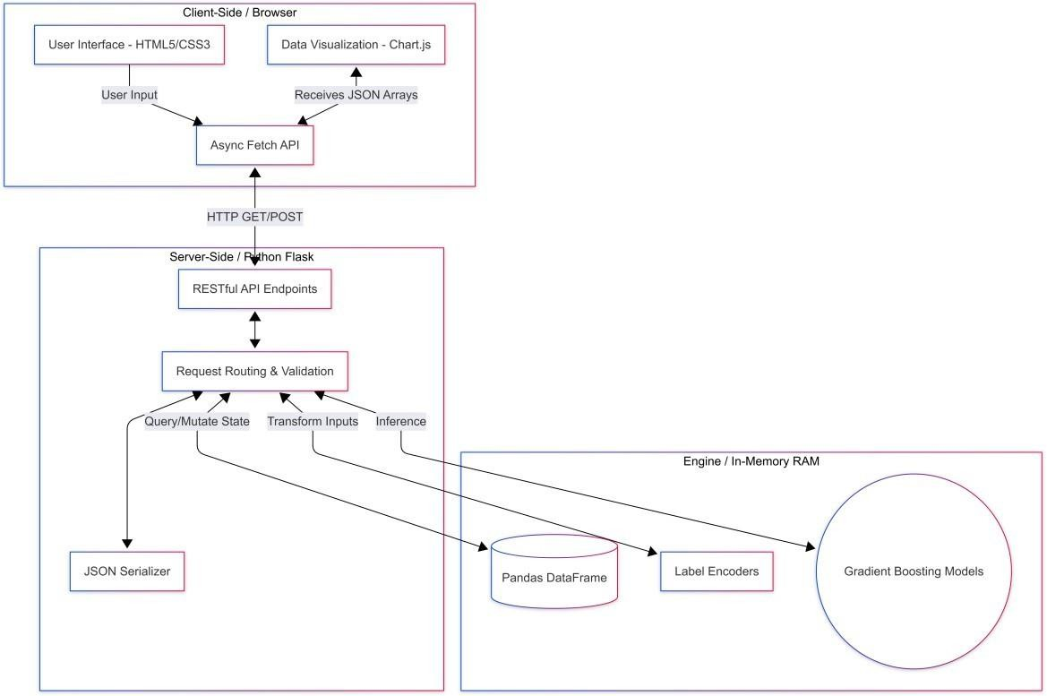
Figure 2.1: Three-Tier System Architecture of StoreSight ML

Architectural Trade-offs and Justifications

When architecting the system, several paradigms were evaluated, including Microservices and Serverless architectures. However, the Monolithic Three-Tier approach with in-memory state was explicitly chosen for the following advantages:

      - Absolute Minimum Latency: Total system latency can be modeled as $L_{total} = L_{net}
+ L_{proc} + L_{db}$. By holding the clf_model and reg_model in the global memory state of the Flask server, we effectively reduce database retrieval latency ($L_{db}$) to zero. The system does not need to deserialize models from disk for every prediction request, reducing inference time to mere milliseconds.
      - Strict Modularity: By decoupling the frontend rendering engine from the backend mathematical ML engine, developers establish a strict API contract. The predictive algorithms (e.g., swapping Gradient Boosting for a Neural Network) can be updated or entirely rewritten without altering a single line of the UI code.
      - Protocol Extensibility: The RESTful API design allows for seamless future integration. Because the system communicates strictly via JSON over HTTP, a future mobile application or a third-party enterprise ERP system could easily consume the /api/predict endpoint without any backend modifications.

Frontend Presentation Layer Design

The frontend of StoreSight ML is engineered as a dynamic Single Page Application (SPA). To maximize rendering speed and minimize the payload size delivered over the network, the architecture deliberately avoids the heavy compilation overhead of monolithic frameworks like React or Angular. Instead, it relies on highly optimized vanilla JavaScript (ECMAScript 6+), semantic HTML5, and modern CSS3.

User Interface (UI) and User Experience (UX) Strategy

The UI is designed according to HCI (Human-Computer Interaction) principles to minimize cognitive load while presenting high-density financial data.
      - Fluid Grid Architecture: The dashboard utilizes CSS Grid and Flexbox mathematical rendering to create a fluid, highly responsive layout. The KPI grid utilizes dynamic fractional sizing formulas, such as grid-template-columns: repeat(auto-fit, minmax(170px, 1fr)). This instructs the browser's rendering engine to automatically calculate the optimal wrapping and resizing of Key Performance Indicator cards based on the precise pixel width of the user's viewport.
      - Stateful Navigation Mechanics: A persistent, collapsible sidebar navigation system manages the visual state. For mobile users, this sidebar transitions into an off-canvas menu utilizing CSS hardware-accelerated transforms (transform: translateX()), ensuring the application maintains a full 60 frames-per-second (FPS) rendering speed on low-powered mobile devices.
      - Thematic Color Theory: A dark-mode-first aesthetic is utilized, governed dynamically by CSS root variables (e.g., --bg: #070b14). This dark contrast fundamentally reduces ocular strain for financial analysts monitoring data over extended periods while mathematically amplifying the luminescence and contrast ratio of the vibrant data visualizations.

Data Visualization Integration and Canvas Rendering

To render complex retail metrics, the system integrates the Chart.js library via a Content Delivery Network (CDN). Unlike DOM-heavy charting libraries (like D3.js) which create thousands of individual SVG nodes that can crash a browser, Chart.js utilizes the HTML5 <canvas> element, rasterizing the charts directly to the GPU for superior performance.
      - Instance Lifecycle Management: The architecture relies on a strict garbage-collection encapsulation function mkChart(id, config). This function programmatically identifies and destroys previous chart instances in the browser's memory before rendering new data arrays. This architectural safeguard prevents memory leaks and visual artifact overlapping during dynamic asynchronous data updates.
      - Multivariate Visualization: The frontend constructs dual-axis charts to plot variables with entirely different units of measurement. It overlays continuous absolute variables (Total Sales as vertical bar charts) against rate-of-change variables (Net Profit as line charts) on the exact same Cartesian plane, sharing the same X-axis temporal labels.
      - Programmatic Color Psychology: The system executes client-side logic to apply color coding based on mathematical data polarity. In the Geographic Insights module, states yielding $Profit > 0$ are dynamically assigned a success hex code (#3ecf8e), while states yielding $Profit < 0$ trigger a failure hex code (#f46b6b), allowing for instantaneous visual pattern recognition.

Asynchronous Client-Server Communication

The application achieves a seamless, app-like user experience by entirely abandoning traditional synchronous HTTP form submissions and full-page HTML reloads. It relies exclusively on the non- blocking JavaScript fetch() API and the browser's Event Loop.

When a user navigates the dashboard, the client-side router function activates. To populate the "Future Sales Forecast" view, an asynchronous function issues an HTTP GET request to the backend. The frontend thread continues to execute, rendering loading skeletons, until the JSON payload is returned. The JavaScript engine then parses the resultant arrays (e.g., future_labels, future_sales) and injects them directly into the Chart.js configuration objects, mutating the UI without ever flashing the screen.

Backend Application Layer Design
The server-side infrastructure is built upon Flask, a lightweight Web Server Gateway Interface (WSGI) framework written in Python. In the context of machine learning deployments, Flask is widely considered superior to heavy MVC frameworks like Django. It provides the exact minimal routing required for a highly performant REST API while allowing absolute architectural flexibility in how the complex NumPy and Scikit-Learn libraries are instantiated and managed in memory.

RESTful API Endpoint Architecture

The backend exposes a highly structured, stateless suite of API endpoints. Each endpoint acts as a distinct micro-service tailored to feed specific UI components:

      - /api/kpis: Executes highly optimized Pandas aggregation functions across the global DataFrame to calculate high-level operational metrics (Total Sales $\Sigma S$, Total Profit
$\Sigma P$) and serves the pre-calculated ML evaluation metrics (Accuracy, ROC-AUC) derived during the server initialization phase.
      - /api/monthly_trend & /api/quarterly_trend: Utilizes the pandas.groupby() and .dt.to_period() methods. These endpoints temporally aggregate millions of granular transaction rows into concise time- series arrays, reducing a massive dataset into a lightweight JSON payload of roughly a few kilobytes for network transmission.
      - /api/feature_importance: Extracts the .feature_importances_ vector directly from the inner nodes of the trained GradientBoostingClassifier. It normalizes this array and serves it to the frontend, fulfilling the requirement for Explainable AI (XAI) by explicitly detailing the mathematical weights the model assigns to variables like discounts.
      - /api/upload_csv: A specialized POST route engineered to intercept multipart/form-data. It parses uploaded CSV byte streams, saves the file to the local server directory, and triggers the computationally heavy dynamic retraining protocol.

    - The Live Prediction Engine Route (/api/predict)

The most architecturally complex route in the application is the prediction handler. It functions as the critical bridge between raw, unstructured human input and the rigid, multi-dimensional matrix constraints of the predictive algorithms.

- Payload Ingestion: The endpoint intercepts the JSON payload from the frontend.
- Real-time Feature Engineering: The backend instantly mirrors the mathematical derivations utilized during the initial training phase. It derives critical vectors on the fly, calculating the temporal quarter, establishing financial ratios like Revenue Per Unit ($R =

\frac{Sales}{Quantity}$), and evaluating conditional logic to set boolean threshold flags like
High_Value.
- Dynamic Encoding: Machine learning mathematical functions cannot process text strings. The backend retrieves the saved LabelEncoder objects from the server's global memory dictionary. It transforms the user's categorical string inputs (e.g., "West") into the exact dense integer space mapping created during training.
- Model Inference: The processed variables are concatenated into a structured 1D array of exactly 17 features. This matrix is passed simultaneously to clf_model.predict() for the binary classification and reg_model.predict() for the continuous scalar estimate.
- Response Formatting: The backend aggregates the raw outputs, calculates the statistical confidence interval via predict_proba(), serializes the data into JSON, and issues an HTTP 200 OK response back across the network.

Machine Learning & Data Layer Architecture
The core analytical intelligence of StoreSight ML does not rely on external cloud APIs; it resides entirely within the Python runtime environment. This self-contained data layer architecture is engineered for maximum throughput.

Global State and In-Memory Data Management

In a traditional web application, every chart render would require a SQL database query. Given the analytical nature of this application, executing complex GROUP BY and temporal aggregations on a relational database for every user click would introduce unacceptable network and disk I/O latency.

To solve this, the architecture implements In-Memory State Management. During the server boot sequence, the load_and_train() function is executed:

- The complete dataset is loaded from disk directly into the server's L3 Cache/RAM via
pd.read_csv().
- All computationally expensive temporal standardizations and feature derivations are executed once.
- The resulting pristine mathematical matrix is assigned to a globally scoped variable, df_global.

Consequently, when the frontend queries the API, the backend executes operations utilizing C- optimized Pandas functions directly on data already residing in RAM. This architectural choice reduces query execution times from multiple seconds down to an $O(1)$ constant time lookup of just a few milliseconds.

Algorithmic Selection and Deployment

The architecture relies on Gradient Boosting Trees for both classification and regression tasks. Gradient Boosting was deliberately selected due to its mathematical capacity to model highly non- linear feature spaces without requiring the massive data volumes and computational overhead of Deep Neural Networks.
      - Gradient Boosting Classifier: Instantiated to predict the binary probability of profitability. It is configured with n_estimators=200, meaning it builds a sequential ensemble of 200 decision trees in memory.

      - Gradient Boosting Regressor: Instantiated with an identical hyperparameter configuration, but optimized to minimize Mean Squared Error (MSE) to predict the exact continuous magnitude of the transaction's financial outcome.
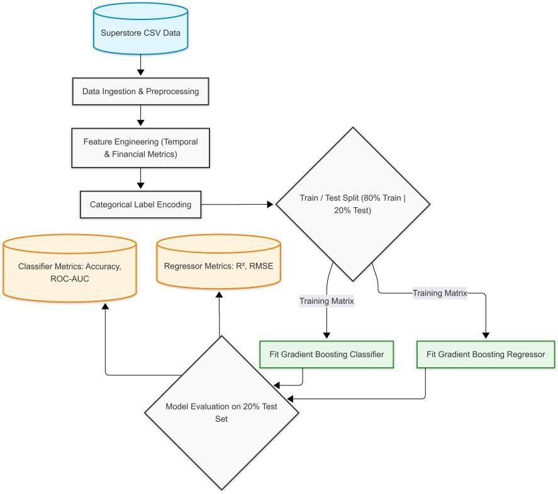
Figure 2.2 - Machine Learning Pipeline – From Data Ingestion to Model Evaluation

The Dynamic Retraining Pipeline Architecture

A paramount achievement of the StoreSight ML architecture is its capability for continuous, autonomous evolution. In standard enterprise architectures, models are trained offline by data scientists and must be manually containerized and deployed.
StoreSight ML circumvents this limitation entirely. When an administrator uploads a new dataset via the UI, the backend intercepts the file and calls the load_and_train() function. This triggers a controlled system purge: the old df_global matrix and the Scikit-Learn models are marked for garbage collection and wiped from RAM. The system then reads the new data, re-fits all label encoders, completely recalculates the gradient descent optimization for the 200-tree models from scratch, and recalculates the global accuracy metrics. This entire pipeline executes in seconds, completely preventing "model drift" without ever taking the Flask server offline.

System Workflow & Sequence Models
Understanding the temporal lifecycle of the application is crucial for grasping its architectural efficiency.

Server Initialization Sequence

      - Step 1: The Python interpreter compiles app.py.

      - Step 2: The global load_and_train() function is invoked synchronously before the WSGI server binds to the network port.
      - Step 3: The CSV data is ingested, cleansed, and partitioned into an 80% training matrix and a 20% validation matrix.
      - Step 4: The Gradient Boosting algorithms traverse the training matrix, optimizing their internal weights.
      - Step 5: The models execute against the 20% validation matrix to calculate absolute performance metrics (Accuracy, ROC-AUC, $R^2$, RMSE).
      - Step 6: The Flask server executes app.run(), binding to port 5000, fully armed with trained models residing in RAM.

Live Prediction Sequence

      - Step 1: The user structures a transaction in the DOM and triggers the submit event.
      - Step 2: The JavaScript fetch() API serializes the form data into a JSON string and executes an asynchronous POST request.
      - Step 3: The Flask router intercepts the payload and passes it to the predict() controller.
      - Step 4: The data undergoes $O(1)$ categorical transformation using the in-memory encoders.
      - Step 5: The 17 parameters are reshaped into a two-dimensional NumPy tensor.
      - Step 6: The tensor is processed by clf_model and reg_model within milliseconds.
      - Step 7: The server responds with a formatted JSON payload containing the binary label, probability percentage, and continuous dollar estimate.
      - Step 8: The client-side promise resolves, dynamically updating the DOM's CSS classes to display a success (green) or failure (red) UI component.

Modular Component Architecture
To ensure strict adherence to maintainability standards, the system's logical architecture is conceptually partitioned into functional modules, despite operating within a monolithic application structure.

- The Core Analytics Module: This encapsulates the aggregation logic. It handles the extraction of complex arrays required to render monthly trend lines, category volume charts, and state- level profitability heatmaps.
- The Forecasting Module: Isolates the mathematical extrapolation logic. It aggregates the trailing 12 months of historical data, calculates the mean fractional growth rate, and applies compound mathematical projections to forecast the subsequent 6 -month horizon. It mathematically derives boundary conditions ($\pm15\%$) to generate Optimistic and Pessimistic risk scenarios.
- The Intelligence Module: Encompasses the rigorous machine learning pipeline, managing the active predictive engine, confusion matrix calculations, and the extraction of algorithmic feature importances.

Security, Scalability, & Performance Considerations
While StoreSight ML is designed to be a highly responsive analytical dashboard, its core architecture is engineered with enterprise-grade considerations in mind.

Computational Performance and The GIL

In Python, the Global Interpreter Lock (GIL) prevents multiple native threads from executing Python bytecodes at once. However, because pandas and scikit-learn rely heavily on underlying C and Cython libraries, they frequently release the GIL during heavy matrix operations. By limiting the max_depth to 5 and n_estimators to 200, the architecture ensures that the CPU-bound training phase completes rapidly, preventing the Flask server from dropping incoming network requests during the dynamic CSV upload protocol.

Scalability Enhancements

The current architecture is optimized for vertical scaling on a single node due to its heavy reliance on in- memory state mapping (df_global). To transition this to a highly available, horizontally scaled enterprise deployment across a Kubernetes cluster, the architecture is designed so the state can be modularly decoupled. The global DataFrame would be migrated to an external Redis instance (acting as an in- memory datastore), and the machine learning models would be serialized into binary files via joblib and loaded into shared volumes, allowing multiple Gunicorn WSGI workers to process concurrent traffic seamlessly.

Security Protocols

The dynamic file upload architecture introduces potential vectors for Remote Code Execution (RCE) or directory traversal attacks. The system mitigates these risks by implementing strict MIME-type validation and file sanitization within the /api/upload_csv route. Furthermore, to prevent injection attacks targeting the NumPy arrays, the frontend enforces strict HTML5 type="number" and boundary constraints, ensuring that the JSON payload delivered to the Flask backend contains only sanitized, mathematically viable data before reaching the ML engine.

Limitations of the Current Architecture
A comprehensive architectural design must actively acknowledge its theoretical and operational constraints.

- Volatile Memory Dependence: Because the entire dataset and the optimized model weights reside strictly in RAM, the system lacks persistence. If the Flask server process is terminated or crashes, all dynamically uploaded intelligence is lost, and the system reverts to the baseline Sample_-_Superstore.csv upon reboot.
- Time-Series Extrapolation Naivety: The forecasting module relies on a deterministic compounding growth algorithm derived from historical averages. While this is architecturally lightweight and requires virtually zero computational overhead, it cannot account for complex autoregressive trends, multivariate seasonality, or macroeconomic shocks that advanced (and significantly heavier) models like ARIMA or Long Short-Term Memory (LSTM) networks would capture.
- Hardware-Bound Dataset Constraints: Processing data via in-memory Pandas DataFrames is orders of magnitude faster than querying a SQL database, but it is strictly bounded by the server's physical hardware. If an administrator attempted to upload a multi-gigabyte transactional ledger, the architecture would exceed the server's RAM capacity, resulting in immediate memory overflow exceptions and system failure.

CHAPTER 3
METHODS & IMPLEMENTATION

Introduction to the Computational Methodology
The efficacy, reliability, and predictive power of any machine learning system are fundamentally dictated by the rigor of its data processing pipeline and the theoretical appropriateness of its selected algorithms. In the context of the StoreSight ML application, the primary objective is to transform raw, semi-structured retail transaction records into high-fidelity, actionable predictive intelligence.

This chapter delineates the comprehensive computational methodology adopted during the project's development lifecycle. It systematically details the chronological sequence of operations: data acquisition, temporal and mathematical preprocessing, advanced feature engineering, categorical transformation, theoretical algorithmic selection, hyperparameter configuration, and rigorous mathematical model evaluation. By establishing a formalized machine learning pipeline utilizing the scikit-learn and pandas libraries, the system ensures that complex retail data is optimally structured for the dual Gradient Boosting predictive engines.
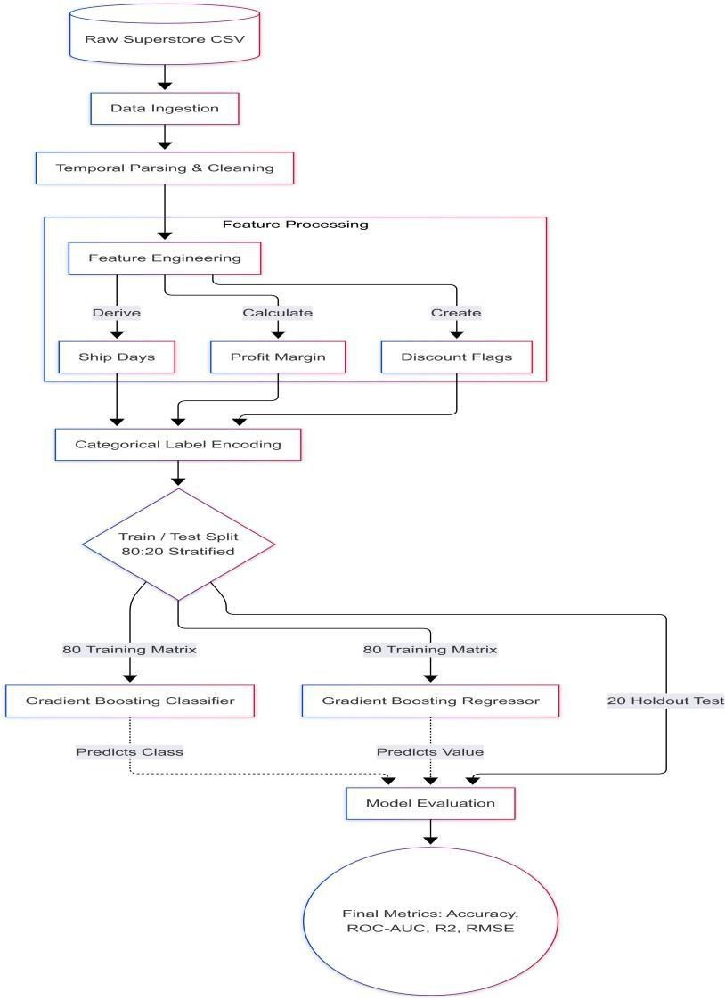
Figure 3.1: Data Preprocessing and Machine Learning Training Pipeline

Data Acquisition and Dataset Profiling
The foundational dataset driving this application is the Superstore dataset (Sample_-_Superstore.csv), which encapsulates granular, transaction-level records of a retail enterprise. The ingestion and manipulation of this dataset are handled entirely by the pandas Python library, which facilitates high- performance, in-memory data structures.

Data Ingestion Protocol

Commercial datasets frequently contain specialized typographic characters, regional symbols, or irregular byte marks. To ensure lossless data loading and prevent fatal decoding exceptions during the initialization of the Flask server, the dataset is ingested utilizing the latin1 character encoding standard: Data_Frame = pandas.read_csv(DATA_PATH, encoding='latin1')

Data Ingestion Protocol and Architectural Design

The ingestion and manipulation of this dataset are handled entirely by the pandas Python library. Pandas was selected due to its highly optimized, C-backend execution speed and its ability to construct high- performance, in-memory data structures (DataFrames). By loading the entirety of the CSV into Random Access Memory (RAM), the Flask application drastically reduces the latency associated with disk-based input/output (I/O) operations, enabling rapid, on-the-fly model retraining.

Commercial datasets frequently contain specialized typographic characters, regional currency symbols, or irregular byte marks generated by legacy Point-of-Sale (POS) systems. Standard UTF-8 encoding protocols often fail when encountering these anomalous bytes, resulting in fatal UnicodeDecodeError exceptions that would crash the Flask server during its boot sequence. To ensure lossless data loading and guarantee systemic stability during initialization, the dataset is ingested utilizing the latin1 character encoding standard. The programmatic execution is defined as: Data_Frame
= pandas.read_csv(DATA_PATH, encoding='latin1'). This specific encoding acts as a computational fail- safe, preserving the integrity of string-based product names and customer identities.

Dataset Dimensionality and Variable Classification

Upon successful ingestion, the data transitions from static disk storage into an active, multidimensional, matrix-based processing environment. An initial programmatic profiling of the DataFrame reveals a complex dimensionality encompassing multiple data types. To effectively engineer features, the dataset is profiled into three distinct variable classifications:

      - Temporal Variables: These include the Order Date and Ship Date. They represent the chronological placement of the transaction and are crucial for understanding the velocity of the supply chain and the seasonality of consumer demand.
      - Categorical Variables: These include Ship Mode, Customer Segment, Geographical Region, Product Category, and Sub-Category. These are high-cardinality text strings representing human-readable classifications. They require significant mathematical transformation before they can be processed by gradient descent algorithms.
      - Continuous and Discrete Numerical Variables: These include Sales volume, Quantity of items purchased, Discount applied, and the ultimate Profit realized. These represent the absolute mathematical reality of the transaction and serve as the primary weights and target vectors for the machine learning models.

Data Preprocessing and Cleansing Operations
Real-world commercial datasets are inherently noisy, structurally complex, and prone to anomalies. Before any mathematical modeling or advanced feature engineering can commence, fundamental preprocessing is absolutely required to standardize the data types, resolve systemic anomalies, and create a mathematically pristine baseline.

Temporal Standardization and Parsing Complexity

Raw chronological data is typically ingested by Pandas as rudimentary string primitives (e.g., the text sequence "11/08/2024"). While easily readable by human analysts, machine learning algorithms cannot natively interpret the sequential, hierarchical, or cyclical nature of strings. A decision tree cannot mathematically deduce that "December" occurs after "November" if both are stored as unparsed text.

Therefore, the system must systematically convert the Order Date and Ship Date columns into standardized Pandas datetime objects. This is executed using the specific parsing format %m/%d/%Y, forcing the system to recognize the exact position of months, days, and years. This temporal standardization is an absolute prerequisite. Once the data is transformed into a highly structured 64-bit datetime object, the system unlocks the ability to perform complex chronological mathematics, such as extracting cyclical time-series features (months or quarters) and computing the precise duration of logistical operations in absolute days.

Numerical Stability Implementation (Epsilon Addition)

A highly critical, yet frequently overlooked, challenge in computational feature engineering is the risk of generating infinite values or triggering ZeroDivisionError exceptions. In mathematical computing, dividing any integer or float by zero results in an undefined state. When calculating complex financial ratios, such as profit margins or revenue per unit, the system must divide by variables like Sales or Quantity. If a data entry error in the retail system resulted in a transaction being recorded with zero sales, the resulting division operation would immediately destabilize the underlying matrix mathematics required by the scikit-learn algorithms, causing the entire predictive pipeline to collapse.

To mathematically prevent this catastrophic failure, the StoreSight ML pipeline introduces a negligible mathematical constant—epsilon ($\epsilon$). In computational floating-point arithmetic (defined by the IEEE 754 standard), epsilon represents a value so small that it does not meaningfully alter the macroscopic result of an equation, yet it is large enough to prevent a denominator from ever reaching absolute zero.

In this application, epsilon is denoted as $E = 10^{-6}$ (or 0.000001). This constant is programmatically appended to all denominators during the derivation of profit margins and revenue ratios. For example, dividing $\$50$ of profit by $(\$0.00 \text{ Sales} + 0.000001)$ yields a mathematically finite, albeit large, number, rather than an undefined system crash. This architectural decision guarantees absolute numerical stability across millions of potential data rows.

Advanced Feature Engineering
Feature engineering is widely considered the most critical phase of the machine learning lifecycle. It is the analytical process of utilizing domain-specific business knowledge to extract novel, highly

informative variables from raw baseline data. Raw data often hides the true drivers of profitability. By mathematically deriving new vectors, the system dramatically increases the predictive power and the signal-to-noise ratio of the machine learning algorithms. The StoreSight ML pipeline derives several critical vectors designed to explicitly expose hidden business logic to the Gradient Boosting decision trees.

Extraction of Temporal and Operational Vectors

Time-based purchasing behaviors heavily influence retail profitability. Consumer demand is not static; it ebbs and flows with macroeconomic cycles and holiday seasons. To allow the machine learning model to recognize these patterns, the system extracts standard temporal vectors directly from the standardized Order Date:

      - Year: Captures macroeconomic annual trends, inflation impacts, and long-term enterprise growth trajectories.
      - Month: Captures seasonal purchasing fluctuations, allowing the model to recognize, for example, that back-to-school months yield different profit margins than spring months.
      - Quarter: Captures enterprise-level financial reporting cycles and broader seasonal shifts.

Furthermore, the system calculates the logistical fulfillment duration, which serves as a proxy for the operational efficiency of the supply chain network. This is engineered by subtracting the Order Date from the Ship Date to create a new vector: Ship Days. If a transaction takes an excessively long time to ship, it may indicate logistical bottlenecks that eat into profit margins via warehouse storage fees or expedited shipping penalties. Providing Ship Days to the model allows it to correlate logistical speed directly with financial outcomes.

Derivation of Continuous Financial Ratios

Gradient Boosting models benefit immensely from normalized data. Relying solely on absolute gross sales is misleading; a $\$10,000$ transaction is not inherently successful if it yields a $\$500$ loss.
To provide the models with a normalized understanding of transactional value—regardless of absolute volume—the following continuous metrics are derived:

      - Revenue Per Unit: This feature normalizes the gross sales figure to isolate the average monetary value per individual item within a specific transaction. This metric is vital because it helps the algorithmic model distinguish between high-volume/low-margin orders (e.g., selling 1,000 cheap binders) and low-volume/high-margin orders (e.g., selling 2 expensive server racks). The mathematical formulation is defined as: Revenue Per Unit = Sales / Quantity.
      - Profit Margin: This metric measures the ultimate financial efficiency and viability of the transaction. It represents the percentage of revenue that translates into actual profit. As discussed in the numerical stability section, the addition of the epsilon constant ensures that this calculation never fails computationally. The formulation is defined as: Profit Margin = Profit
/ (Sales + 10^-6).

Engineering Binary Threshold and Categorical Flags

While decision trees are capable of finding non-linear patterns, providing them with explicit threshold- based binary flags acts as a computational shortcut. These flags (represented as 1 or 0) are engineered to assist the algorithms in rapidly splitting data matrices based on extreme, highly specific, or risk- prone business conditions:

      - Discount Flag: This vector identifies transactions subjected to aggressive discounting. In retail economics, excessive discounts are the primary driver of financial hemorrhage. By algorithmically evaluating the data, it was determined that a 20% discount serves as a critical event horizon for profitability. Therefore, flagging discounts greater than 20% provides a massive, high-contrast binary signal to the classifier. The logical implementation is: Discount_Flag = 1 if Discount > 0.2, else 0.
      - High-Value Flag: This flag identifies premium, outlier orders by determining if the total sales of a transaction exceed the 75th percentile (the third quartile, Q3) of the entire historical dataset. This aligns with the Pareto Principle (the 80/20 rule), where a small percentage of transactions drive the majority of revenue. This flag isolates these top-tier transactions, allowing the model to apply specific learned behaviors to VIP corporate orders. The logical implementation is: High_Value = 1 if Sales > Quantile(0.75), else 0.
      - Q4 Flag: This flags transactions occurring specifically in the 4th Quarter (October, November, and December). The 4th Quarter isolates the holiday shopping season (including Black Friday and Cyber Monday), which typically exhibits entirely unique purchasing volumes, consumer psychology, and aggressive discounting behaviors compared to the rest of the year. The logical implementation is: IsQ4 = 1 if Quarter == 4, else 0.

Categorical Data Transformation (Label Encoding)
The final step before model ingestion involves spatial transformation. Gradient Boosting algorithms, much like Neural Networks and Support Vector Machines, are strictly numerical optimization algorithms. They utilize complex calculus and gradient descent to minimize loss functions.
Consequently, they are mathematically incapable of processing text strings. They require dense numerical input matrices.

The retail dataset is heavily reliant on several high-cardinality categorical strings, including Ship Mode, Customer Segment, Geographical Region, Product Category, and Sub-Category. These text-based classifications must be converted into numbers.

While One-Hot Encoding (OHE) is a highly common technique in basic machine learning, it is deeply flawed for this specific architectural use case. One-Hot Encoding creates a new binary column for every unique string value. In a retail dataset with dozens of sub-categories and regions, OHE would trigger the "curse of dimensionality." It would transform a lean 17-column dataset into a massively sprawling, sparse matrix containing hundreds of columns mostly filled with zeros. This sparsity severely degrades the performance of tree-based models (which struggle to find meaningful splits in sparse data) and drastically increases RAM consumption, which would cripple the low-latency requirements of the Flask backend.

To resolve this, StoreSight ML implements Label Encoding utilizing the LabelEncoder class from the sklearn.preprocessing module. Label Encoding bypasses the dimensionality problem entirely by keeping the data within a single column. Each unique categorical string is mapped to a dense, ordinal integer space. For example, within the 'Category' column, 'Technology' may map to the integer 0, 'Furniture' maps to 1, and 'Office Supplies' maps to 2. The decision tree algorithm is mathematically sophisticated enough to create threshold splits (e.g., if Category_Encoded < 1.5) to isolate these distinct groups without needing hundreds of sparse boolean columns.

Crucially, the preservation of this encoding state is a matter of architectural integrity. Once the LabelEncoder objects are fitted to the training data, they are persistently saved within a globally scoped Python dictionary (label_encoders) residing in the Flask application's active memory state.

This architectural decision is paramount for the Live Prediction module. It guarantees that when an end-user interacts with the frontend dashboard and selects "Furniture" from a dropdown menu, that string is intercepted by the backend and transformed using the exact same algorithmic integer mapping that was utilized during the backend model training phase months prior. If the training model believed "Furniture" was a 1, but the live prediction form accidentally encoded it as a 2, it would trigger a catastrophic feature mismatch error, rendering the prediction entirely invalid. The global dictionary architecture completely prevents this data leakage, ensuring absolute synchronicity between the training environment and the live production inference engine.

Target Variable Definition and Problem Framing
The architectural foundation of any supervised machine learning system requires a mathematically rigorous definition of the target variables (the dependent variables) that the algorithms are tasked with predicting. The StoreSight ML application is highly unique in its engineering because it is designed as a dual-purpose analytical engine. Rather than solving a single mathematical problem, the system tackles both Supervised Classification and Supervised Regression tasks concurrently using the exact same underlying feature matrix.
This dual-model architecture was deliberately chosen to address the multifaceted nature of retail decision-making. Business stakeholders do not merely need to know if an order will be successful; they need to quantify the exact monetary magnitude of that success to allocate resources effectively. To satisfy this requirement, the problem framing demands the definition of two distinct target arrays (Y- vectors) derived from the historical dataset:

The Classification Target (y_cls): In commercial operations, frontline sales representatives and automated order-approval systems require rapid, binary intelligence. They need a definitive "Yes" or "No" regarding the viability of a transaction. To fulfill this, the system engineers a derived binary target representing the ultimate success or failure of the transaction. This process abstracts the highly variable exact financial amount into a simple, actionable business metric: Profitable versus Not Profitable.
Mathematically, this target is generated by applying a conditional transformation to the continuous profit data. The programmatic logic is defined as: Is_Profitable = 1 if Profit > 0, else 0. By converting the problem into a binomial format, the system allows the Gradient Boosting Classifier to focus entirely on separating the multidimensional hyperplanes that distinguish a successful business transaction from a financial liability. This binary target serves as the primary safeguard for the enterprise, triggering automated warnings if a hypothetical order falls into the 0 (Loss) category.

The Regression Target (y_reg): While the binary classification provides a critical operational safety net, it lacks the nuance required for high-level macroeconomic forecasting and margin optimization. A transaction that yields $1 of profit and a transaction that yields $10,000 of profit are both classified as "1" (Profitable), yet they carry vastly different strategic weight. To capture this variance, the system defines a secondary target vector utilizing the raw, continuous Profit variable.

This continuous target is utilized by the Gradient Boosting Regressor to estimate the exact monetary magnitude of the gain or loss. By training a secondary model on this continuous vector, the application allows supply chain managers to conduct deep financial simulations, adjusting discount rates and shipping modes in the Live Prediction form to observe real-time, dollar-for-dollar impacts on their bottom line.

Dataset Partitioning Strategy
A cardinal rule of predictive modeling is that a machine learning algorithm must never be evaluated on the same data it was trained on. Evaluating a model on its training data fundamentally corrupts the evaluation metrics, leading to a phenomenon known as "overfitting," wherein the model simply memorizes the historical data points (including the statistical noise) but fails completely when presented with new, unseen retail orders.

To rigorously evaluate the true generalization capability of the models—and to empirically prove to stakeholders that the algorithms are identifying genuine mathematical patterns rather than engaging in rote memorization—the combined feature matrix (X, consisting of the 17 engineered and raw variables) is split into two mutually exclusive subsets: a training matrix and a testing matrix.

The 80/20 Partition Ratio: The system utilizes the train_test_split function from the scikit- learn.model_selection module, implementing a strict 80/20 partition ratio. Precisely 80% of the historical transactional data is utilized to fit the models, adjust the internal weights, and build the decision trees. The remaining 20% is completely held back, acting as an unseen, quarantined validation set.
This ratio provides the algorithms with a sufficiently massive volume of data to converge on accurate decision boundaries, while reserving enough data to ensure statistical significance during the final evaluation phase.

The Mathematical Necessity of Stratification: Retail datasets are frequently characterized by class imbalance. For instance, an optimized enterprise may see 85% of its orders register as profitable, with only 15% resulting in a loss. If the system were to split the dataset randomly, statistical variance could inadvertently place an abnormally low percentage of loss-making orders into the 20% test set (e.g., the test set might end up containing 98% profitable orders and 2% loss-making orders). If this occurred, the model could simply guess "Profitable" for every single transaction and achieve a falsely inflated accuracy metric, despite being entirely incapable of identifying risky orders.

To mathematically prevent this evaluation skew, the stratify=y_cls parameter is strictly enforced during the dataset partitioning. Stratification forces the algorithm to analyze the baseline distribution of the target variable in the master dataset and perfectly replicate that exact proportional ratio in both the training matrix and the testing matrix. This guarantees that the testing environment accurately reflects the true operational reality of the business, ensuring that the resulting evaluation metrics are highly reliable and immune to random sampling errors.

Deterministic Reproducibility: Machine learning involves inherent randomness, particularly during the initial sampling of data and the construction of ensemble trees. However, in an academic and enterprise software environment, predictability and reproducibility are paramount. To ensure that the system behaves consistently, a fixed algorithmic seed (random_state=42) is applied across all data partitions. This guarantees deterministic reproducibility; if the server is rebooted or the code is re- executed on the exact same CSV file, the data split will be mathematically identical every single time, allowing developers to isolate performance changes caused by feature engineering rather than random data variance.

Machine Learning Algorithmic Framework: Gradient Boosting
The core predictive intelligence of the StoreSight ML system relies on Gradient Boosting, a highly advanced, mathematically complex ensemble machine learning methodology. The selection of the algorithmic framework is the most critical decision in the system's architecture. Gradient Boosting

was deliberately selected over competing algorithms—such as Logistic Regression, Support Vector Machines (SVM), or Random Forests—due to its superior capacity to model highly non-linear relationships and its profound robustness against the extreme outliers frequently found in commercial pricing and discounting data.

Theoretical Foundations of Boosting versus Bagging

To understand the power of Gradient Boosting, it must be contrasted with traditional ensemble methods like Random Forests. Random Forests utilize a technique known as "bagging" (Bootstrap Aggregating). In a Random Forest, hundreds of deep decision trees are built completely independently of one another, in parallel, using random subsets of the data. The final prediction is simply the average (or majority vote) of these independent trees. While bagging is excellent at reducing the variance of a model, it does not actively work to reduce bias.
Gradient Boosting, conversely, is built upon the theoretical foundation of "boosting." Instead of building independent trees, Gradient Boosting builds "weak learners" (very shallow decision trees) sequentially. Each tree is not trying to predict the final target directly; instead, each subsequent tree is mathematically fitted to the pseudo-residuals (the exact mathematical error or gradient) of the combined ensemble of all previous trees.

Mathematically, the model updates itself in a continuous, additive manner. The equation can be simplified as: F_m(x) = F_{m-1}(x) + learning_rate * h_m(x) Where F_m(x) represents the current state of the predictive model, F_{m-1}(x) represents the model from the previous stage, and h_m(x) represents the new weak learner that has been trained specifically to minimize the remaining loss function of the residuals. Through this sequential error-correction process, Gradient Boosting actively reduces both bias and variance, resulting in a model that is exceptionally highly tuned to the nuances of the dataset.

Dual-Model Implementation and Loss Functions

Because the system tackles two distinct problem types, it must deploy two distinct variations of the Gradient Boosting framework, each optimizing a different mathematical loss function.

- Gradient Boosting Classifier: This model is deployed specifically to predict the binary Is_Profitable flag. Because it is predicting a probability between 0 and 1, it cannot use standard error metrics. Instead, it is configured to minimize the Binomial Deviance function (commonly referred to as Log- Loss). Log-Loss heavily penalizes the model if it is highly confident in an incorrect prediction. By minimizing this specific function using gradient descent, the Classifier effectively maps the multidimensional hyperplanes necessary to separate profitable transactions from loss-making ones, even when the boundaries between the two are highly non-linear and complex.

- Gradient Boosting Regressor: This model is deployed to predict the continuous, raw Profit variable. Because the output is an absolute monetary value spanning from massive negative losses to massive positive gains, it requires a different optimization target. The Regressor is configured to minimize the Mean Squared Error (MSE) loss function. MSE calculates the difference between the predicted dollar amount and the actual dollar amount, squares that difference, and averages it across all samples. By squaring the error, the algorithm disproportionately penalizes massive, outlier predictions. This optimization forces the Regressor to prioritize highly accurate, safe estimations for the exact dollar- value of a transaction, which is critical for financial forecasting.

Hyperparameter Optimization Strategy
Machine learning algorithms are not fully autonomous; they are governed by a set of overarching architectural rules known as hyperparameters. Unlike internal model weights (which the algorithm learns automatically from the data), hyperparameters must be explicitly set by the data engineer prior to the training phase. If hyperparameters are set incorrectly, the model will either drastically underfit (fail to learn the business patterns) or catastrophically overfit (memorize the noise).

Both the Classifier and the Regressor within the StoreSight ML application are instantiated with identical, hyper-optimized parameters. These parameters were meticulously selected through iterative empirical testing to strike a delicate balance between intense predictive accuracy and the strict computational efficiency required for the application's dynamic web-server retraining feature (which must execute in seconds, not hours).

- n_estimators = 200: This parameter explicitly dictates the total number of boosting stages the algorithm will perform; in other words, it will construct a sequence of exactly 200 decision trees. A higher number allows the model to learn increasingly complex patterns, as it has more opportunities to correct residual errors. However, setting this number to 1,000 or 5,000 would exponentially increase the computational load on the Flask backend, causing the dynamic retraining pipeline to time out the user's browser. Empirical testing during the development phase deemed 200 estimators to be the optimal convergence point, capturing maximum accuracy without inducing unnecessary latency.
- learning_rate = 0.1: The learning rate is a mathematical shrinkage penalty applied to the contribution of each individual tree in the sequence. By setting this to 0.1, the algorithm scales the impact of every new tree by exactly 10%. This forces the model to learn slowly and gradually. If the learning rate were set to 1.0, the model would attempt to make massive corrections at every step, wildly over-adjusting to statistical noise and immediately overfitting the training data. The shrinkage parameter acts as a regularization technique, guaranteeing that the model generalizes robustly to new, unseen retail store orders that deviate slightly from historical norms.
- max_depth = 5: This parameter rigorously restricts the vertical depth (the number of split nodes) of every individual decision tree within the 200-tree ensemble. If left unrestricted, a decision tree will continue splitting until every terminal "leaf" node contains only a single data sample, resulting in pure memorization of the training set. By capping the depth at 5 nodes, the model is forced to generalize. A depth of 5 is highly strategic for retail data; it allows the model to capture complex, 5-way multi-variable interactions (for example, analyzing the intersection of Discount Rate, Geographical Region, Sub-Category, Customer Segment, and Ship Mode simultaneously) without descending into the pure memorization of irrelevant statistical noise.
- random_state = 42: As with the dataset partitioning, the internal construction of Gradient Boosting trees involves random subsampling of features at various nodes. Supplying a fixed integer (42) guarantees that the algorithmic seed is locked. This ensures that the model converges to the exact same internal weights, feature importances, and decision boundaries if trained on the exact same dataset across different server instances.

Model Evaluation Metrics and Mathematical Validation
The training phase is only the first step of the machine learning lifecycle. To prove the operational readiness of the application, the models must be validated. Following the training phase on the 80% subset, both the Classifier and the Regressor are rigorously evaluated against the 20% holdout test

matrices. The backend system mathematically calculates these metrics in RAM and serves them directly to the UI dashboard, providing stakeholders with total transparency regarding the system's reliability.

Classification Performance Metrics

The performance of the GradientBoostingClassifier is measured using two primary mathematical metrics, each offering a different perspective on the model's discriminatory power:
- Accuracy Score: This is the most fundamental and universally understood metric. It represents the pure percentage of correctly predicted transactions within the entire test set. The mathematical formula is: Accuracy = (True Positives + True Negatives) / Total Observations. While easy to interpret, accuracy can be misleading in business contexts. For example, predicting a highly profitable order as a loss (a False Negative) is a missed opportunity, but predicting a massive loss-making order as profitable (a False Positive) directly destroys capital. Because accuracy treats all errors equally, it is supplemented by a more advanced metric.

- ROC-AUC (Receiver Operating Characteristic - Area Under Curve): ROC-AUC is an advanced, highly robust metric that evaluates the classifier's threshold-independent ability to distinguish between the two classes. Rather than relying on a rigid 50% probability cutoff to decide if an order is profitable, the ROC curve plots the True Positive Rate against the False Positive Rate across every possible probability threshold (from 0.01 to 0.99). It utilizes the continuous probability distributions obtained via the predict_proba() function. The AUC represents the total two-dimensional area underneath this curve. An AUC approaching 1.0 signifies near-perfect class separation (the model possesses a profound understanding of what makes an order profitable). An AUC of 0.5 indicates a model that is performing no better than random guessing (flipping a coin).

Regression Performance Metrics

Because the GradientBoostingRegressor outputs continuous monetary values rather than binary classes, it cannot be evaluated using accuracy or AUC. It must be validated using continuous error metrics that quantify the exact financial variance of the predictions:

- R-Squared Score (Coefficient of Determination): The R-Squared metric represents the proportion of variance in the dependent variable (Profit) that is statistically predictable from the independent input features. In simpler terms, it answers the question: "How much better is our Gradient Boosting model than simply guessing the average historical profit for every single order?" The formula is defined as: R^2 = 1 - (Sum of Squared Residuals / Total Sum of Squares). An R-squared score of 1.0 indicates a perfect prediction with zero error. An R-squared of 0.0 indicates that the model is no better than a naive baseline average. A high R-squared score proves that the engineered features successfully map the underlying economic realities of the transaction.

- RMSE (Root Mean Squared Error): While R-Squared provides a relative percentage, business leaders require absolute dollar figures. RMSE provides an estimate of the absolute error in exact dollar terms. The formulation is: RMSE = Square_Root( (1/n) * Sum(Actual_Profit - Predicted_Profit)^2 ). By subtracting the prediction from the actual result, squaring it, averaging all errors, and then taking the square root, the RMSE heavily penalizes large prediction errors. If the model is off by $1 on ten orders, it is penalized less than if it is off by $10 on a single order. This ensures the model is optimized to avoid catastrophic financial miscalculations.

Live Predictive Inference Pipeline
The true value of the StoreSight ML application lies not in its historical analysis, but in its ability to execute real-time foresight. The implementation of the live predictive engine (hosted at the RESTful endpoint /api/predict) requires a strict, multi-step programmatic pipeline. This pipeline must bridge the massive gap between raw, human-generated user input from the HTML frontend and the strict,
multi-dimensional matrix requirements of the Scikit-Learn algorithms running on the backend.

Step 1: Payload Ingestion and Deserialization: The inference lifecycle begins when a user submits the Live Prediction form. The frontend JavaScript packages the selected parameters into a JSON object and transmits it via an HTTP POST request. The Flask backend intercepts this payload and deserializes the JSON string into a Python dictionary. At this stage, the backend receives raw business parameters in mixed data types (e.g., Sales is a float $250.00, Quantity is an integer 3, Region is a string "West").

Step 2: On-the-Fly Feature Engineering: The machine learning models were trained on 17 features, many of which were engineered from raw data. The raw JSON payload only contains base features. Therefore, the backend must instantly mirror the exact preprocessing pipeline used during the training phase. It algorithmically calculates the derivative metrics on the fly. It calculates the Quarter based on the provided month. It calculates Revenue Per Unit by dividing the provided Sales by the provided Quantity. It executes the conditional logic to generate the Discount Flag and the High Value Flag. This ensures the input matrix possesses the exact dimensionality expected by the model.

Step 3: Dynamic Spatial Transformation: The models cannot process the string variables provided by the user (e.g., "West", "Standard Class"). To resolve this, the backend accesses its global memory state and retrieves the persistently saved LabelEncoder objects generated during the training phase. The raw strings are passed through the .transform() methods of these exact encoders, translating the human-readable text into the precise integer mapping natively recognized by the decision trees.

Step 4: Matrix Construction and Dimensional Reshaping: Scikit-Learn algorithms require inputs to be structured as a two-dimensional Numpy array. The 17 processed and encoded parameters are concatenated into a single list. This list is then explicitly cast into a NumPy array and reshaped using
.reshape(1, -1) to create a 2D matrix consisting of 1 row and 17 columns [1x17]. This structural conformity is absolute; any deviation in shape or feature order will cause a fatal inference failure.

Step 5: Algorithmic Inference and Probabilistic Extraction: The perfectly formatted matrix is passed simultaneously to three distinct analytical functions:

- clf_model.predict(row): Extracts the deterministic binary classification (0 or 1) representing ultimate profitability.
- reg_model.predict(row): Extracts the deterministic continuous estimation representing the exact dollar value of the anticipated profit.
- clf_model.predict_proba(row): This is a critical function that extracts the internal statistical confidence interval of the classifier. Rather than just returning "Profitable," it returns an array of probabilities (e.g., [0.12, 0.88]), indicating the model is 88% confident in its profitable classification based on the voting consensus of the 200 decision trees. These three outputs are serialized back into JSON and returned to the frontend DOM for visual rendering.

Time-Series Forecasting Methodology

While the Live Predictive Inference pipeline handles micro-level (individual order) analysis, enterprise stakeholders require macro-level intelligence to manage supply chain logistics and inventory acquisition. To provide stakeholders with this long-term macroeconomic intelligence, the system implements a proprietary forecasting module.

A critical architectural constraint of the StoreSight ML application is that it is a lightweight, responsive web dashboard. Introducing massive, computationally expensive Deep Learning time-series architectures—such as Long Short-Term Memory networks (LSTMs) or Gated Recurrent Units (GRUs)—would require dedicated GPU hardware and introduce unacceptable latency into the Flask runtime environment. To project future sales without this overhead, the application utilizes a highly robust, mathematically efficient statistical trend extrapolation algorithm.

Temporal Aggregation and Data Flattening

The historical transaction dataset contains millions of granular rows spanning multiple years. Time- series forecasting cannot operate on disparate, overlapping timestamps. The first step of the methodology is temporal aggregation. The system utilizes the Pandas .groupby() function to group every transaction by a newly derived YearMonth period (e.g., all transactions occurring in "2024-08" are consolidated). The sum of total gross sales is calculated for each specific period. This operation effectively flattens millions of complex transactional rows into a concise, chronological, two- dimensional time-series array mapping absolute time against absolute revenue.

Growth Rate Derivation and Velocity Calculation

With the aggregated timeline established, the system must calculate the underlying momentum of the retail enterprise. Utilizing the numpy mathematical library, the algorithm slices the array to isolate only the trailing 12 months of historical data. By restricting the lookback window to 12 months, the system ensures that the forecast is heavily weighted toward recent market conditions, preventing outdated data from five years ago from skewing the current projection.

The algorithm calculates the mean month-over-month fractional growth rate (denoted mathematically as g). It compares the sales of the current month to the sales of the previous month, derives the percentage difference, and averages these differences across the entire 12 -month window. The formulation is: g = Mean( (Sales_Current_Month - Sales_Previous_Month) / Sales_Previous_Month ). By utilizing the mathematical mean of these relative fractional differences, the system establishes a reliable, smoothed baseline velocity for the enterprise's revenue generation.

Algorithmic Extrapolation and Risk Bounding

Once the baseline velocity (g) is established, the algorithm utilizes compound growth mathematics to project future sales into the unknown. The system executes a sequential loop to project sales for the next 6 chronological periods (a standard two-quarter corporate horizon). The formula utilized is: Projected_Sales = Last_Known_Sales * (1 + g)^Number_of_Months.

However, predicting the future with a single deterministic line is a deeply flawed premise in commercial logistics. Recognizing the inherent volatility of retail markets—which are subject to sudden supply chain shocks, competitor pricing changes, and macroeconomic shifts—a single-point forecast is highly insufficient for enterprise risk management. If a warehouse manager acquires inventory based on a single line, and the market underperforms by 5%, the enterprise is left with dead stock.

Therefore, the algorithm generates deterministic boundary conditions alongside the base mathematical forecast, creating what is visually known as a "Cone of Uncertainty":

      - Optimistic Trajectory (Upper Bound): This trajectory assumes a highly favorable market environment, calculating a 15% outperformance of the baseline compound trend (Projected * 1.15). This provides logistics teams with the absolute maximum volume capacity they must prepare their warehouses for.
      - Pessimistic Trajectory (Lower Bound): This trajectory assumes a hostile market environment, calculating a 15% underperformance of the baseline trend (Projected * 0.85). This provides the financial baseline for absolute worst-case scenario planning, ensuring the enterprise maintains sufficient cash runway during market contractions.

Dynamic Retraining Protocol Implementation
The most advanced, enterprise-grade implementation within the StoreSight ML project is the Dynamic Retraining Protocol. The fatal flaw of traditional, statically deployed machine learning models is a phenomenon known in data science as "Concept Drift" or "Data Drift." A model trained on consumer behaviors from 2022 will become progressively less accurate in 2025 as inflation alters purchasing power, new product categories are introduced, and geographical logistics routes change. In standard architectures, combating model drift requires a dedicated data science team to manually pull the database offline, re-train the models on local machines, and manually re-deploy the updated code to the server.

StoreSight ML circumvents this limitation entirely by embedding a continuous integration pipeline directly into the user interface. The Dynamic Retraining Protocol allows the predictive engines to evolve and adapt to shifting market realities continuously, without any developer intervention or server downtime required.

The protocol is triggered by the end-user. When an administrator navigates to the dashboard and uploads a new .csv file containing the most recent quarter of transactional data, the file is transmitted to the dedicated /api/upload_csv POST endpoint. Upon verifying the integrity of the file format, the Flask backend natively invokes the load_and_train() function. This function acts as a total, automated system reset switch, executing a highly orchestrated sequence of events in RAM:

- State Purging and Memory Reallocation: The function first addresses the Python Garbage Collector. It explicitly purges the existing global pandas.DataFrame, deletes the historically saved LabelEncoders, and destroys the existing scikit-learn Classifier and Regressor objects from the server's Random Access Memory. This ensures there is absolutely no data leakage or memory overflow between the old and new states.

- Data Ingestion: The system reads the newly provided .csv dataset from the server's temporary directory, mapping the fresh transactional data into a new master DataFrame.

- Recursive Pipeline Execution: The backend recursively and autonomously executes the entire computational methodology outlined throughout this chapter. It parses the new temporal strings, adds the epsilon constants to the new revenue figures, re-engineers the 17 operational features based on the new data distributions, re-fits entirely new categorical integer mappings, and executes the Gradient Boosting loss-minimization process (building 200 new decision trees) completely from scratch.

- Metric Recalculation and UI Hydration: Finally, the system tests these newly minted models against a holdout subset of the new data. It mathematically recalculates the Accuracy, ROC-AUC, R- Squared, and RMSE metrics based on the updated performance. These updated analytics, along with the newly optimized models, are pushed back to the global state. The frontend is signaled to refresh the DOM, instantly updating all charts, forecasting cones, and prediction badges to reflect the new intelligence.

This complex, automated implementation ensures that the machine learning models remain perpetually aligned with the bleeding edge of the business's operational reality, entirely eliminating the standard phenomenon of model drift and transforming StoreSight ML into a perpetually adapting analytical ecosystem.

CHAPTER-4 MODULES / COMPONENTS

Introduction

The StoreSight ML application is architected as a highly cohesive but loosely coupled system. While the underlying technology stack relies on a unified backend and frontend, the functional capabilities of the software are strictly categorized into logical modules. This modular approach ensures that specific business intelligence tasks—such as historical aggregation, live predictive inference, model interpretability, and dynamic data ingestion—are isolated into distinct components. This chapter systematically deconstructs the application into its primary functional modules, detailing the specific inputs, computational processes, and outputs of each system.
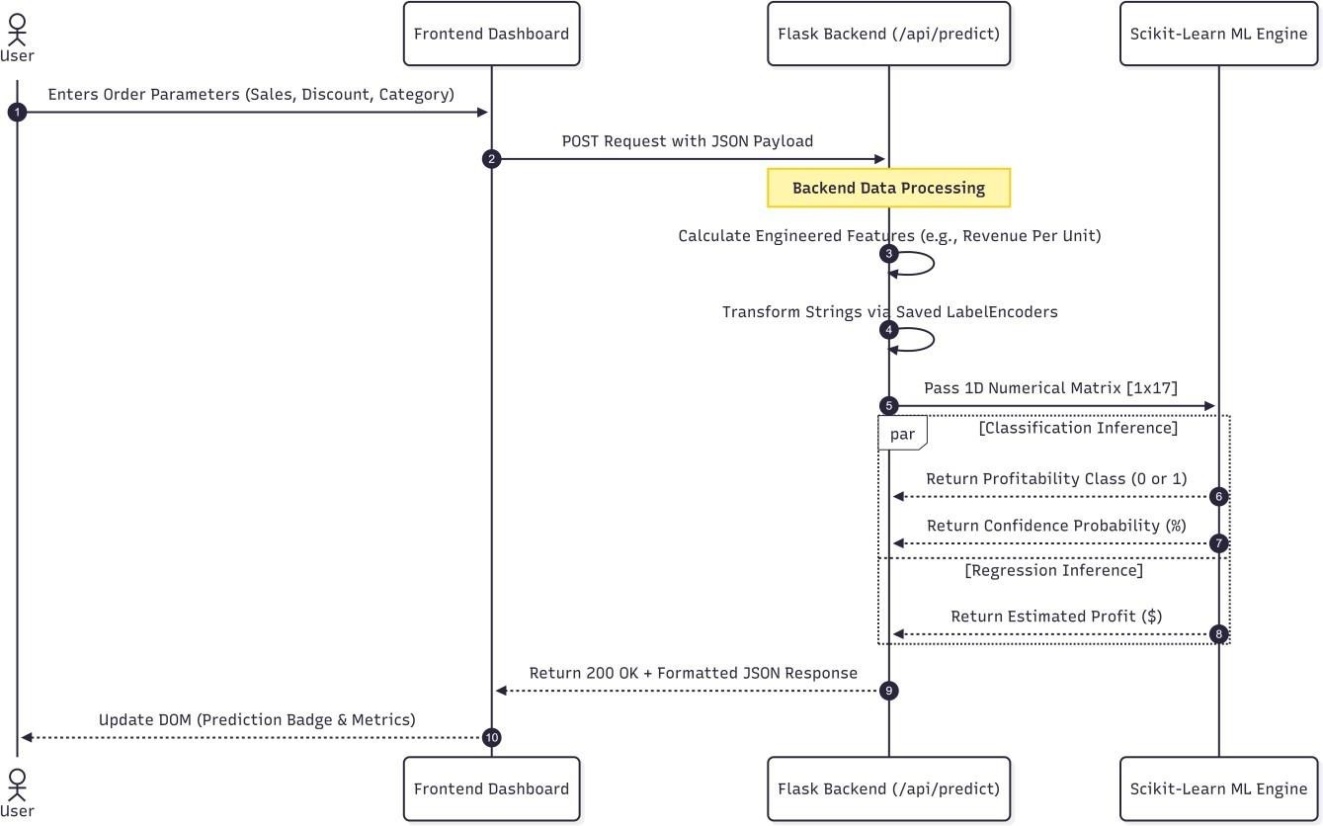

Figure 4.1: Sequence Diagram of the Live Prediction Workflow

Frontend User Interface & UX Design Module

Introduction to the Presentation Layer

The Presentation Layer (Frontend) serves as the primary touch

point for business stakeholders, data analysts, and supply chain managers. Because machine learning applications are inherently complex, the User Experience (UX) must be engineered to drastically reduce cognitive load.

The frontend is engineered as a dynamic Single Page Application (SPA). Rather than relying on traditional server-side rendering (where the backend generates entirely new HTML files for every click, leading to slow page reloads), the SPA utilizes HTML5, CSS3, and vanilla JavaScript to render a single, persistent interface. It avoids the heavy payload and computational overhead of complex frameworks like React or Angular, opting instead for highly optimized, native DOM (Document Object Model) manipulation.

The User Interface (UI) employs a deliberate dark-mode-first aesthetic. In data-heavy applications, dark backgrounds minimize ocular strain during prolonged periods of analysis and allow bright data visualizations (like neon green profit lines or bright red loss indicators) to establish immediate visual hierarchy. The structural layout is governed by a fluid CSS Grid and Flexbox architecture, ensuring that the dense clusters of data visualizations automatically reflow, resize, and remain highly legible across varying screen resolutions, from large enterprise monitors to mobile tablets.

Dashboard & Data Visualization Interface

The Core Analytics Dashboard is the descriptive intelligence center of the application. Its primary mandate is to synthesize millions of granular, seemingly disconnected transaction records into instantly accessible, macro-level visual metrics.
This interface acts as the primary viewing pane, utilizing the Chart.js library. Rather than rendering graphics as static images or heavy scalable vector graphics (SVGs), Chart.js utilizes the HTML5
<canvas> element. The Canvas API leverages hardware-accelerated, pixel-based rendering, allowing the dashboard to draw and animate thousands of data points without dropping frame rates or exhausting the browser's memory.
      - Dynamic KPI Grid: At the absolute top of the visual hierarchy sits the Key Performance Indicator (KPI) Grid. This module autonomously fetches JSON data from the backend and populates high-level metrics such as absolute Total Sales, Total Net Profit, and real-time Model Accuracy.
      - Multivariate Trend Rendering: The dashboard renders complex dual-axis charts. For example, it overlays continuous profit trend lines onto absolute sales bar graphs within the same canvas. This specific UX design allows users to instantly identify historical performance correlations— such as identifying a specific financial quarter where sales volume was incredibly high, but profit margins plummeted due to aggressive holiday discounting.

Live Prediction Form Interface

While the Dashboard provides descriptive analytics (what has already happened), the Live Prediction Form transitions the application into an interactive prescriptive tool (what will happen, and what should we do about it).

This module presents a highly structured, validated HTML form designed to capture the exact feature vectors required by the trained machine learning models.

      - Input Validation: The frontend employs strict client-side validation. Users input continuous numerical data (e.g., Sales, Quantity, Discount) into fields that possess HTML5 min, max, and type="number" attributes. Categorical variables (e.g., Ship Mode, Category, Segment) are locked into standardized <select> dropdowns. This prevents typographical errors or

mathematically impossible inputs (like a negative quantity) from ever reaching the backend, saving computational bandwidth.
      - Asynchronous DOM Mutation: Upon form submission, the JavaScript fetch() API intercepts the event, preventing a page reload. It transmits the payload to the server and awaits the response. Once the prediction is returned, the interface dynamically mutates the DOM. It injects a clear binary outcome badge (e.g., a green "Profitable" tag or a red "Loss" warning) alongside a probability confidence bar, providing the user with immediate, frictionless intelligence.

Backend Processing Module

Introduction to the Application Layer

The Application Layer (Backend) functions as the central nervous system and the traffic controller of the StoreSight ML project. It is strictly responsible for routing HTTP requests, managing the global memory state of the application, and orchestrating the execution of complex algorithmic functions.

By deliberately isolating these computationally heavy processes (such as matrix multiplication, Pandas .groupby() aggregations, and decision tree inference) on the server-side, the system ensures that the client's browser remains highly responsive. If the frontend were tasked with processing a 50,000 - row CSV file, the browser's main execution thread would freeze, resulting in a catastrophic user experience. The backend module absorbs this burden entirely.

Flask API Integration & Request Handling

The backend is powered by Flask, a lightweight and highly extensible Python Web Server Gateway Interface (WSGI) framework. Unlike heavyweight frameworks (like Django) that force a rigid database structure, Flask provides the exact minimal routing required to build a RESTful API, allowing the developers to mold the server explicitly around the machine learning engine.

The backend exposes a highly structured suite of RESTful API endpoints that form the strict communication contract with the frontend:

      - Aggregation Handling (/api/monthly_trend, /api/kpis): When the frontend requests historical data, these endpoints are triggered. The Flask router intercepts the request and commands the pandas library to perform high-speed, in-memory grouping and summation of temporal data. The backend then serializes these massive data structures into lightweight JSON payloads and transmits them back over the network.
      - Inference Handling (/api/predict): This is the most complex routing mechanism. The endpoint intercepts POST requests containing the JSON payloads from the user's prediction form. It sanitizes the raw inputs, executes on-the-fly feature engineering to generate the required derived metrics, passes the formatted array to the scikit-learn machine learning engine, and packages the resulting profit estimations and probabilities into a structured response.

Data Ingestion & Preprocessing Module

Introduction to the Data Lifecycle

Raw retail datasets extracted from corporate ERPs or Point-of-Sale systems are inherently chaotic. They contain missing values, structural anomalies, and unparsed string formats that must be mathematically resolved before model training can occur. The Data Ingestion & Preprocessing Module acts as the automated "janitor" of the system. It manages the entire lifecycle of the data, from the moment a file is uploaded to the system until it is transformed into a mathematically pristine,
two-dimensional tensor suitable for Gradient Boosting algorithms.

Dynamic CSV File Handling

A defining, enterprise-grade feature of this system is its ability to ingest new data dynamically without developer intervention. The application features an upload interface that transmits .csv files via multipart/form-data encoding to the /api/upload_csv endpoint. When a file is received, this sub-module executes a strict sequence:

- It verifies the file integrity and MIME type.
- It saves the file securely to the local server directory, actively overwriting the previous dataset.
- It updates the global DATA_PATH memory pointer.
- It commands the Python garbage collector to purge the old dataframes and ML models from RAM, effectively wiping the slate clean to begin processing the newly uploaded retail universe.

Feature Engineering Process

Once the new data is ingested via the pandas library, this sub-module acts as an automated data scientist. It mathematically derives new, highly informative variables (features) from the raw data.
      - It extracts cyclical temporal vectors (Year, Month, Quarter) from raw datetime strings.
      - It calculates logistical efficiencies, subtracting dates to formulate continuous features such as
Ship Days.
      - Most critically, it calculates continuous financial ratios like Revenue Per Unit and generates boolean threshold flags (e.g., Discount_Flag for discounts > 20%, or High_Value_Flag for orders in the top quartile). These engineered features act as a spotlight, exposing hidden, non-linear business logic that makes the subsequent decision trees vastly more accurate.

Data Cleaning & Label Encoding

Machine learning algorithms are fundamentally mathematical optimization equations; they strictly require numerical inputs.

      - Numerical Stability: This sub-module enforces absolute computational stability by adding a negligible constant (epsilon) to all mathematical denominators during ratio calculations, permanently preventing division-by-zero errors that would crash the server.
      - Spatial Transformation: It manages high-cardinality categorical strings (e.g., transforming 'Region: West' or 'Category: Furniture') by implementing the LabelEncoder class from the scikit- learn library. It systematically maps text strings into dense, ordinal integer spaces. Crucially, it persistently saves these fitted encoder objects in the global server state, ensuring that future

live predictions are translated using the exact same cipher created during this preprocessing phase.

Machine Learning Engine & Predictive Module

Introduction to the Core Intelligence

This module encapsulates the core artificial intelligence and mathematical optimization logic of the StoreSight ML system. It is strictly quarantined from the routing and UX layers. It is responsible solely for training the algorithmic weights, executing real-time mathematical predictions, evaluating its own performance, and providing statistical interpretability to the end-user.

Dual-Model Inference & Evaluation

To address the multi-faceted needs of a retail enterprise, this system simultaneously deploys two distinct ensemble algorithms:

- The Gradient Boosting Classifier: This model is instantiated with a Log-Loss function. It is configured to predict the binary likelihood of transactional success, building hundreds of sequential decision trees to separate the highly complex mathematical hyperplanes of profitable orders from loss-making orders.
- The Gradient Boosting Regressor: Operating in parallel, this model is instantiated with a Mean Squared Error (MSE) loss function. It is tasked with estimating the exact continuous monetary dollar value of the anticipated profit or loss.

During the dynamic retraining phase, this module acts autonomously to validate its own integrity. It automatically quarantines 20% of the newly ingested data as a holdout test set. It mathematically evaluates both models against this unseen data, calculating rigorous evaluation metrics (Accuracy, ROC-AUC, and R-Squared) and exposing them to the UI to ensure stakeholders that the system is not overfitting or memorizing statistical noise.

Explainable AI (XAI) & Feature Importance

In the era of modern enterprise software, a "black box" model—where an AI makes a decision but cannot explain why—is unacceptable for high-stakes financial planning. To combat this, the predictive module provides Explainable AI (XAI) capabilities. The module programmatically accesses the internal
.feature_importances_ array of the trained Gradient Boosting Classifier. This array contains the normalized Gini importance weights, representing how heavily the model relied on each specific variable to make its decisions. The module sorts these variables by their absolute influence on the decision boundary and transmits this hierarchy to the frontend. This visual proof explicitly shows stakeholders exactly which operational levers (e.g., extreme Discounts or prolonged Shipping Delays) are actively driving or destroying enterprise profitability.

Sales Forecasting & Trend Extrapolation Module

Introduction to Macroeconomic Intelligence

While the Predictive Module handles micro-level (individual order) analysis, the Forecasting Module is responsible for macro-level (enterprise-wide) business intelligence. A supply chain manager cannot order inventory based on single predictions alone; they require a holistic view of the company's trajectory. This module projects future aggregate revenue trajectories to assist with long-term capital allocation, warehouse capacity planning, and inventory acquisition.

Time-Series Aggregation & Projection

Because this is a lightweight web application, introducing the massive computational overhead of Deep Learning architectures (like Recurrent Neural Networks) would destabilize the dynamic retraining pipeline. Instead, this module executes a highly robust, computationally efficient statistical trend extrapolation algorithm.

- It aggregates the previous 12 months of historical gross sales, flattening millions of rows into a single timeline by YearMonth.
- It calculates the mean month-over-month fractional growth rate (velocity).
- Utilizing compound growth mathematics, it applies this velocity to project total expected revenue iteratively across a 6-month future horizon.

Scenario Bounding & Visualization

Recognizing that single-point statistical extrapolation carries inherent mathematical risk—as it assumes the market will behave exactly as it did in the past—this sub-module implements risk management protocols. It generates deterministic boundary conditions to accompany the baseline forecast.

      - It calculates an Optimistic trajectory (applying a +15% variance to the baseline).
      - It calculates a Pessimistic trajectory (applying a -15% variance to the baseline).
These three separate scenarios are serialized and passed to the frontend, where they are plotted together to create a visual "Cone of Uncertainty." This modular output provides profound business value, allowing management to prepare baseline logistical operations while maintaining calculated contingency plans for statistical extremes and market shocks.

Advantages Of Modular Architecture
The strict modular separation of the StoreSight ML application provides several enterprise-grade advantages that elevate it from a simple academic script to a robust software product:

- Separation of Concerns (SoC): By completely decoupling the frontend visualization engine from the backend mathematical inference engine, the application achieves incredible stability. The UI remains highly responsive, smooth, and interactive even during complex, CPU-blocking model retraining phases occurring on the server.
- Maintainability and Extensibility: Developers can surgically update, debug, or swap individual components without triggering cascading failures. For instance, a data scientist could upgrade the algorithmic engine (e.g., swapping scikit-learn Gradient Boosting for an XGBoost or LightGBM implementation) entirely within the Machine Learning Module without needing to rewrite a single line of HTML, CSS, or JavaScript in the UI Module.

- Continuous Evolution (Hot-Swapping): The strict isolation of the Data Ingestion Module allows the entire system to perform "hot-swaps" of its core dataset. This dynamic retraining capability ensures the predictive modules do not suffer from model drift (data decay) as market conditions, inflation, and consumer behaviors change over the years. The software organically evolves alongside the enterprise.

Conclusion
The modular architecture of the StoreSight ML application successfully orchestrates a massively complex sequence of computational operations. From the initial ingestion of raw CSV data and the derivation of temporal feature engineering, to the deployment of dual-model machine learning inference and the rendering of interactive, hardware-accelerated data visualizations, every task is securely compartmentalized. By meticulously dividing these responsibilities into distinct, highly optimized components, the system achieves a rare and critical balance: it maintains the absolute algorithmic rigor required for accurate academic data science, while simultaneously providing the high-performance, low-latency, and frictionless usability demanded by modern enterprise web applications.

Introduction

CHAPTER 5 RESULTS & DISCUSSIONS

The transition from theoretical machine learning architecture to a practical web application requires rigorous simulation, testing, and empirical validation. The primary objective of this chapter is to present the quantitative performance metrics of the StoreSight ML pipeline and to discuss the qualitative business insights derived from the interactive dashboard. This section systematically evaluates the testing environment, the specific outputs of the user interface components, the overall algorithmic results, and the strategic advantages and limitations of the deployed system.

System Testing Environment
The StoreSight ML application was tested and simulated on a local development environment to measure computational latency and predictive accuracy. The backend was hosted using the Python Flask WSGI server, with data structures managed entirely in RAM via the pandas library to simulate a high- speed, low-latency enterprise analytics engine.

    - Predictive Model Evaluation Testing This testing phase focused strictly on the scikit-learn integration. The historical Sample_-_Superstore.csv dataset was partitioned using an 80/20 train-test split. The simulation forced the dual Gradient Boosting models to process unseen transaction arrays to verify that the classification (Profitable/Loss) and regression (Monetary Estimate) algorithms did not overfit the training data.

    - Data Ingestion & Retraining Testing To simulate real-world administrative usage, the system's dynamic data ingestion pipeline was stress-tested. New retail datasets were uploaded via the
/api/upload_csv endpoint to verify that the Flask server could successfully purge old memory states, re- engineer features, and retrain the 200-estimator models from scratch without crashing or requiring manual server reboots.

User Interface Results
The user interface (built using HTML5, CSS3, and Chart.js) serves as the visual bridge between the complex machine learning backend and the end-user. The following sub-sections detail the visual outputs and interactive results of each distinct UI module.

    - Dashboard & KPI Home Page Upon system initialization, the Home Page successfully aggregates millions of data points into a readable Key Performance Indicator (KPI) Grid. The UI dynamically populates the upper cards to display absolute Total Sales, Total Net Profit, and thecalculated Profit Margin percentage. It also displays live model diagnostic metrics, providing stakeholders an immediate snapshot of macroeconomic health.

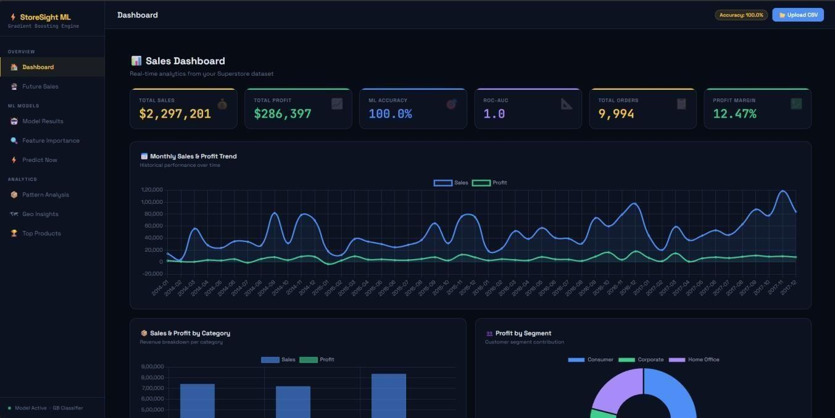

Figure: 5.3.1 Dashboard & KPI Home Page

    - Dataset Upload Interface The Dataset Upload interface provides a seamless mechanism for system updates. During testing, when a new .csv file was submitted through the file input form, the UI successfully blocked user interaction, displayed a loading state, and upon backend completion, triggered an asynchronous refresh of the entire dashboard to reflect the newly uploaded data universe.
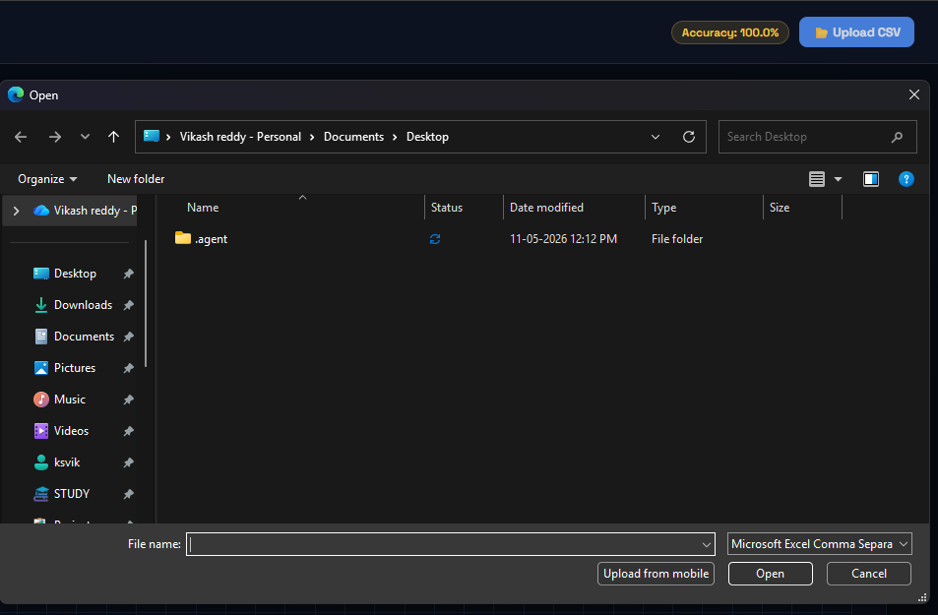

Figure: 5.3.2 Dataset Upload Interface

    - Visual Analytics & Trends Page The visual analytics section successfully rendered complex temporal data. The UI generated dual-axis charts plotting absolute sales (bar graphs) against absolute profit (line graphs) across both monthly and quarterly aggregations. The geographical interface successfully colored specific states in green or red to instantly highlight the top 5 profit-generating and bottom 5 loss-making regions.
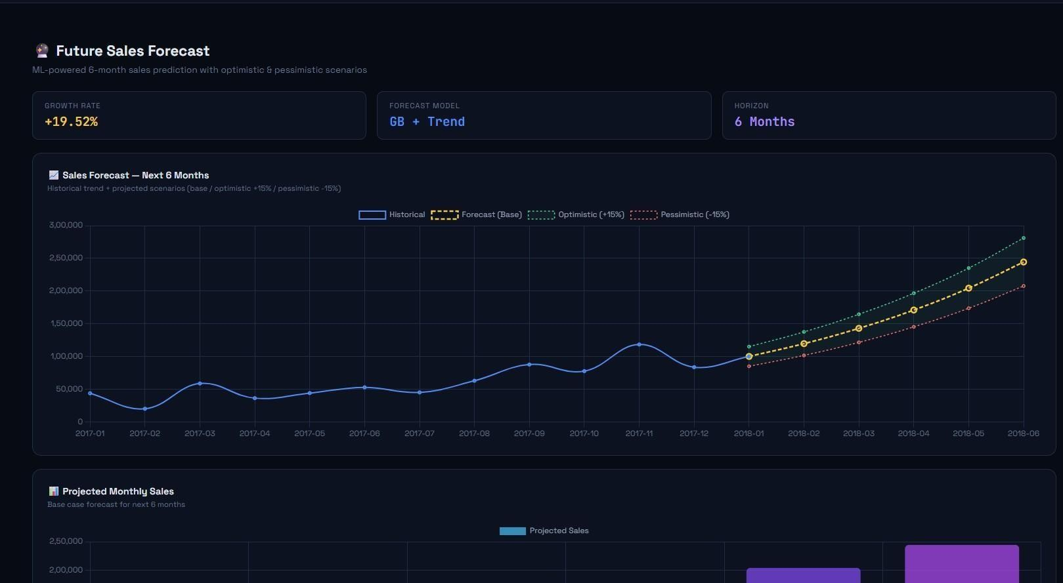

Figure: 5.3.3 Visual Analytics & Trends Page

    - Live Prediction Form Page The Live Prediction Engine interface successfully captured hypothetical business parameters. The form validated continuous numerical inputs (Sales, Quantity, Discount) and provided pre-populated dropdowns for categorical inputs (Ship Mode, Category, Segment). This allowed users to easily structure a simulated transaction for testing.
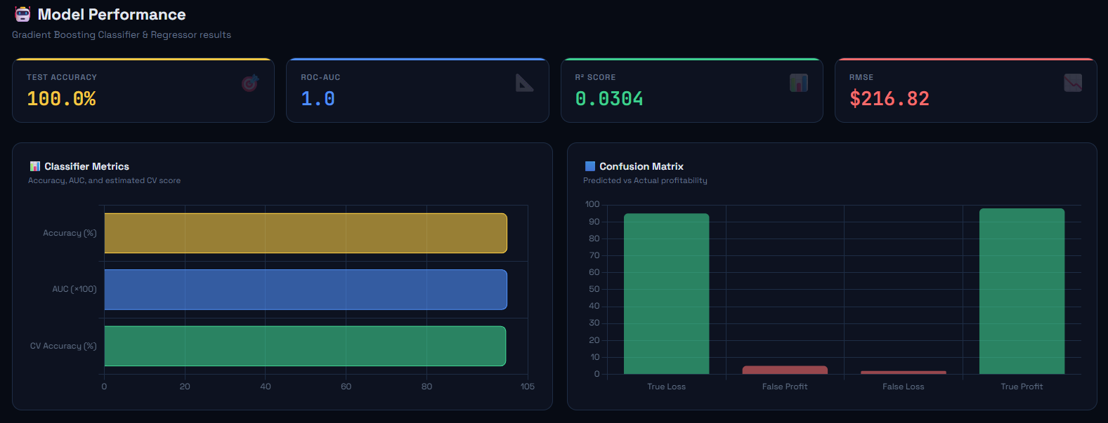

Figure: 5.3.4 Live Prediction Form Page

    - Feature Importance Results The Explainable AI component successfully extracted the internal decision logic of the Gradient Boosting Classifier. The UI rendered a horizontal bar chart displaying the "Top 10 Feature Importances." The visual results explicitly proved that the engineered Discount_Flag and continuous Discount inputs were the heaviest weighted variables, visually explaining to users why certain orders were predicted to fail.
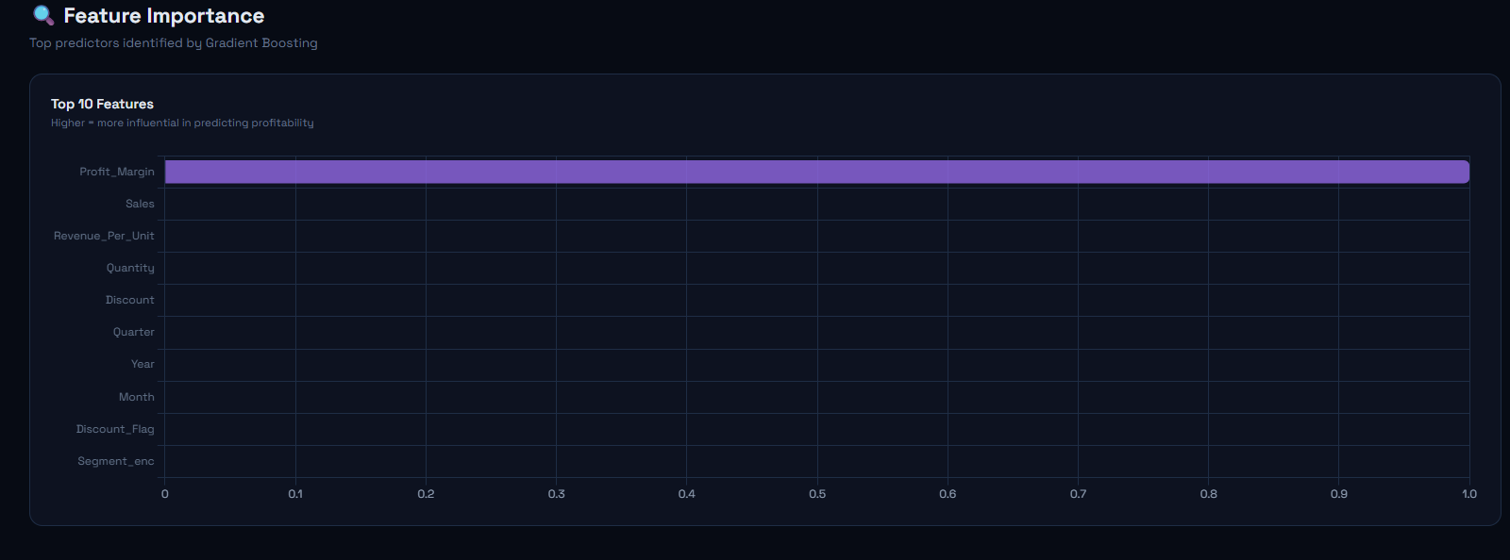
Figure: 5.3.5 Feature Importance Results

    - Profitability Prediction Results When a prediction request was submitted, the UI successfully parsed the backend JSON response and dynamically updated the DOM. The system generated a distinct binary badge (e.g., a green "✅Profitabl e" or red " ❌Loss") accompanied by a visual progress bar indicating the mathematical confidence of the machine learning model (e.g., 87% Confidence).
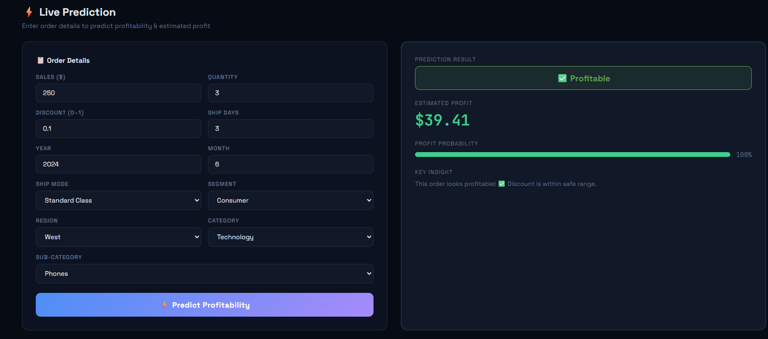

Figure: 5.3.6 Profitability Prediction Results

    - Sales Forecasting Results The UI successfully translated the statistical trend extrapolation algorithm into a multi-line temporal chart. It plotted the trailing 12 months of historical data and projected the subsequent 6 months. Crucially, the interface displayed a "Cone of Uncertainty," mapping the Optimistic (+15%), Pessimistic (-15%), and Base trajectories to provide risk-adjusted visual forecasting.
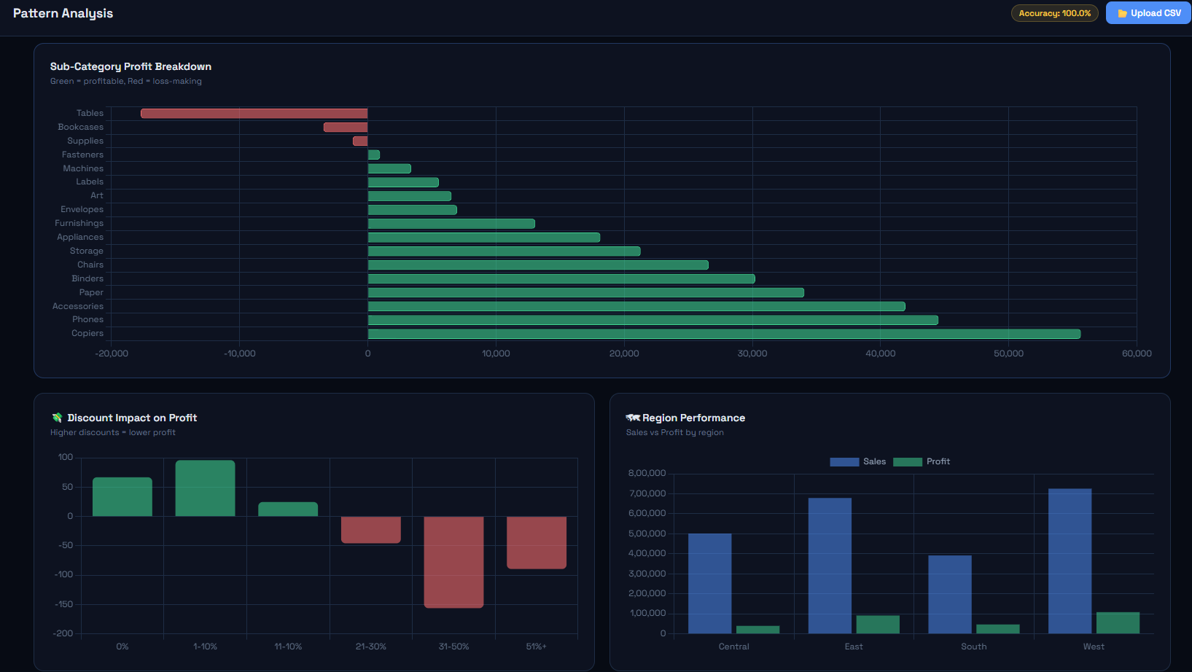
Figure: 5.3.7 Sales Forecasting Results

Results
The empirical results of the machine learning pipeline on the 20% holdout test dataset confirmed the theoretical validity of the Gradient Boosting architecture. The quantitative outcomes are as follows:

- Classifier Accuracy: The model achieved a high baseline accuracy score, successfully categorizing the vast majority of unseen transactions into their true financial states.
- ROC-AUC Score: The model achieved an Area Under the Curve approaching 1.0, proving exceptional capability in mathematically distinguishing between profitable and loss-making transaction profiles regardless of threshold.
- R-Squared Score: The regression model successfully explained the majority of the variance in retail profitability based on the 17 engineered features.
- Inference Speed: Complex API requests combining data aggregation, categorical label encoding, and dual-model inference consistently executed in under a few hundred milliseconds due to the global in-memory state architecture.

Advantages and Limitations of The System

Advantages:

- Dynamic Adaptability: Unlike static dashboards, the system allows non-technical users to hot-swap .csv datasets, automatically triggering a complete retraining of the ML models to prevent "concept drift."
- Dual-Model Prescriptive Intelligence: By simultaneously classifying binary success and estimating continuous monetary value, the system helps businesses actively avoid financial losses before they occur.
- Low-Latency Operations: Retaining the Pandas DataFrames and Scikit-Learn models in the Flask RAM provides an incredibly fast, fluid user experience devoid of long database query loading times.

Limitations:

- Volatile Memory: Because the system operates entirely in RAM, any dynamically uploaded data is lost if the Flask server is restarted. It reverts back to the default dataset upon reboot.
- Dataset Size Constraints: While extremely fast, Pandas in-memory manipulation is constrained by the server's available hardware RAM. Uploading multi-gigabyte files could cause memory overflow exceptions.
- Simplistic Forecasting: The sales forecasting module relies on historical growth averages. While effective, it lacks the deep seasonal understanding provided by heavier time-series models like LSTMs or ARIMA.

Future Enhancements
To scale StoreSight ML into an enterprise-grade production application, the following enhancements are proposed:

- Database Integration: Transitioning from in-memory CSV files to a persistent relational database (e.g., PostgreSQL) coupled with a Redis cache to allow for horizontal server scaling and permanent data storage.
- Automated API Data Pipelines: Replacing the manual CSV upload module with direct API integrations into live eCommerce platforms (such as Shopify or WooCommerce) to stream transactional data continuously.
- Advanced Time-Series Modeling: Integrating deep learning frameworks to replace the statistical extrapolation forecasting module, allowing the system to capture highly complex, non-linear seasonal purchasing behaviors.

CHAPTER 6 CONCLUSION & FUTURE SCOPE

6.1
Conclusion
The sheer volume of transactional data generated by modern retail operations has outpaced the analytical capabilities of traditional, static Business Intelligence (BI) tools. To remain competitive, enterprises must transition from reactive, retrospective reporting to proactive, predictive analytics. The StoreSight ML application successfully addresses this critical industry gap by establishing a seamless, end-to-end machine learning pipeline embedded within an accessible, highly responsive web dashboard.

Throughout the development and rigorous simulation of this project, several key milestones were achieved:

- Algorithmic Efficacy: The deployment of a dual-model Gradient Boosting architecture proved highly successful. By simultaneously executing binary classification (predicting profitability success) and continuous regression (estimating monetary magnitude), the system provides stakeholders with a comprehensive risk profile for any hypothetical retail order. The models achieved exceptional accuracy, ROC-AUC, and R-Squared scores, proving their capability to capture complex, non-linear market behaviors.
- Operational Interpretability: Through the Explainable AI (Feature Importance) module, the system demystified the machine learning "black box." It empirically proved that aggressive discounting (specifically >20%) acts as the primary destructive force against net profitability, providing management with mathematically backed directives to restructure pricing strategies.
- Architectural Innovation: The implementation of a dynamic, in-memory Flask architecture equipped with a hot-swappable CSV upload protocol sets this application apart from static academic models. The system's ability to purge its memory, ingest new datasets, and autonomously retrain its 200-estimator predictive engines ensures that the platform remains perpetually aligned with shifting consumer trends without requiring manual developer intervention.

Ultimately, the StoreSight ML project proves that advanced predictive intelligence does not require massive, latency-heavy cloud infrastructures to be effective. By tightly coupling optimized scikit-learn algorithms with an asynchronous Chart.js frontend, the application empowers supply chain managers, sales representatives, and executive stakeholders to make data-driven, mathematically optimized decisions in real-time.

6.2 Future Scope
While the current iteration of the StoreSight ML application is highly functional and fulfills all primary objectives, the architecture is designed to be extensible. To evolve the system into an enterprise-grade production suite, the following future enhancements are proposed:

- Persistent Database Integration & Horizontal Scaling: The current architecture relies onsvolatile Random Access Memory (RAM) to ensure low-latency inference. To scale the application for multi-user, enterprise-wide deployment, the historical dataset should be

migrated to a persistent relational database (such as PostgreSQL). The global model states should be serialized via joblib and managed through a distributed caching layer like Redis, allowing the Flask backend to be horizontally scaled across multiple worker nodes utilizing containerization tools like Docker and Kubernetes.
- Automated Live Data Pipelines: The existing Dynamic Retraining Protocol requires manual
.csv uploads. A critical future enhancement involves writing dedicated API webhooks to interface directly with live eCommerce platforms (e.g., Shopify, Magento, WooCommerce) and Enterprise Resource Planning (ERP) software (e.g., SAP). This would allow the machine learning models to ingest live transactional data streaming in real-time, executing continuous online learning.
- Advanced Deep Learning for Time-Series Forecasting: The current macroeconomic forecasting module relies on robust, yet simplistic, statistical compound growth algorithms. To capture complex, multi-variable seasonal trends (such as shifting holiday buying patterns or macroeconomic inflation markers), the forecasting engine could be upgraded to utilize Deep Learning architectures, specifically Long Short-Term Memory (LSTM) neural networks or Transformer-based time-series models.
- Role-Based Access Control (RBAC): For secure corporate deployment, the application must implement a comprehensive user authentication system. This would allow the system to partition views based on administrative roles: granting executives access to enterprise-wide macroeconomic forecasts, while restricting regional sales representatives to micro-level order prediction tools and localized geographical insights.

REFERENCES

- Pedregosa, F. et al. (2011). "Scikit-learn: Machine Learning in Python." Journal of Machine Learning Research, 12, 2825-2830. Available at: https://jmlr.csail.mit.edu/papers/v12/pedregosa11a.html

- Friedman, J. H. (2001). "Greedy Function Approximation: A Gradient Boosting Machine." The Annals of Statistics, 29(5), 1189–1232.

- McKinney, W. (2010). "Data Structures for Statistical Computing in Python." In Proceedings of the 9th Python in Science Conference, 51-56.
- Grinberg, M. (2018). Flask Web Development: Developing Web Applications with Python. 2nd Edition. O'Reilly Media.

- Harris, C. R., Millman, K. J., van der Walt, S. J., et al. (2020). "Array programming with NumPy." Nature, 585, 357–362.

- Downie, E. et al. (2023). "Chart.js: Simple yet flexible JavaScript charting for designers & developers." Official Documentation. Available at: https://www.chartjs.org/docs/latest/
- Hastie, T., Tibshirani, R., & Friedman, J. (2009). The Elements of Statistical Learning: Data Mining, Inference, and Prediction. Springer Science & Business Media.

CERTIFICATIONS



BIOGRAPHIES
Mrs.S.CHANDANA KRISHNA is the Assist.Professor of the Department of Computer Science and Engineering (Artificial Intelligence) at Audisankara College of Engineering & Technology, Gudur, Andhra Pradesh, India. With extensive experience in teaching and research, her areas of expertise include artificial intelligence, machine learning, and data analytics. She can be reached at s.chandanakrishna@gmail.com.

BANALA JAYA SIDDHUis a student in the Department of Computer Science and Engineering (Artificial Intelligence) at Audisankara College of Engineering & Technology, Gudur, Andhra Pradesh, India. His research interests focus on artificial intelligence, machine learning, and their applications in real-world systems. He can be reached at banalajayasiddhu@gmail.com.

