Rational

The infographic I chose is used to teach people about the different creatures used in different countries to scare children into behaving. In this interaction, you have 3 “lives” (babies), in each level. You have to correctly identify the creature from the country specified, by choosing between 6 given creatures. Choosing the correct one will save your baby and take you to the next level, choosing the wrong one will result in you losing a baby. If you lose all three your babies, you lose the game and is referred back to the home page. When you reach the 5th and final level without losing all three your babies, you win the game.

For marking purposes, this is the answers.

Level 1 Russia = Baba Yaga

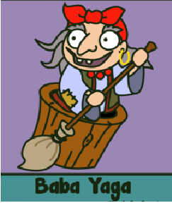

Level 2 Finland = Morko



Level 3 Brazil = Cuca

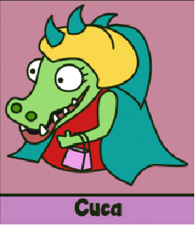

Level 4 Mexico = La Llorona

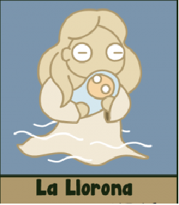

Level 5 Egypt =Abu Rigl Maslukha

