Particle Identification:
Run 1128 – 26Mg
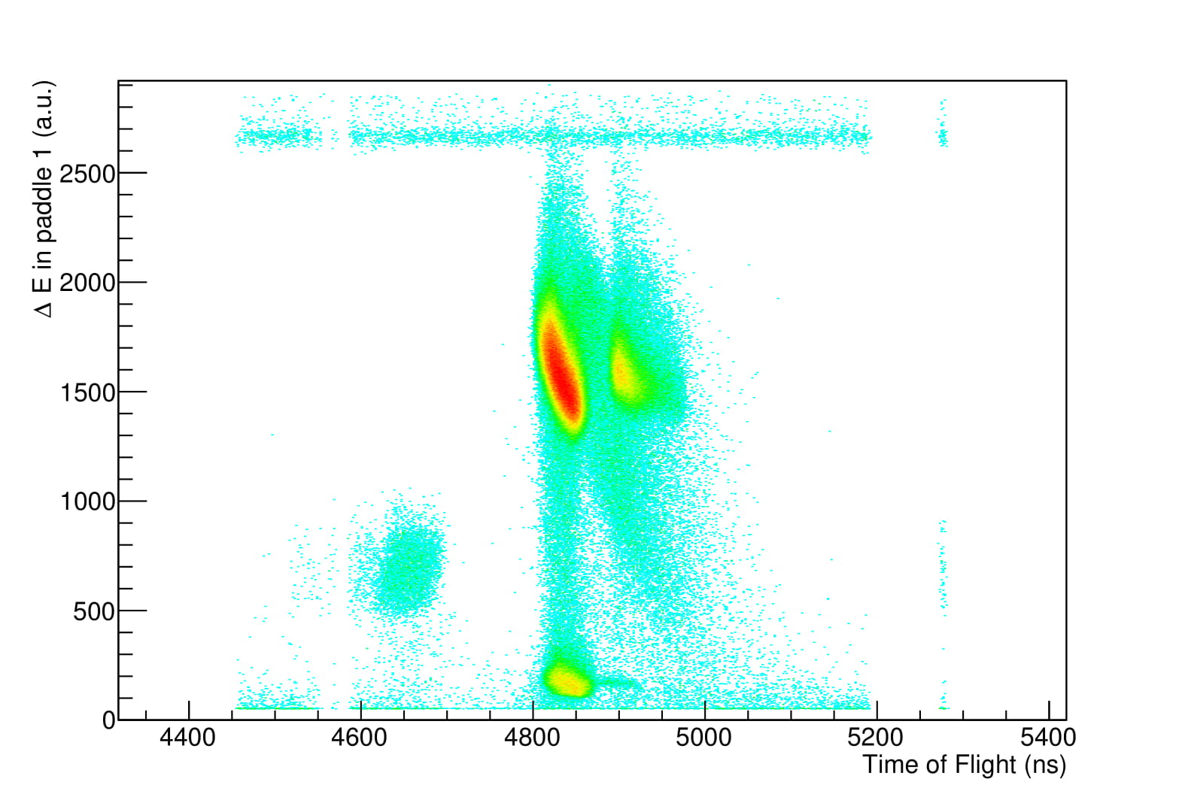
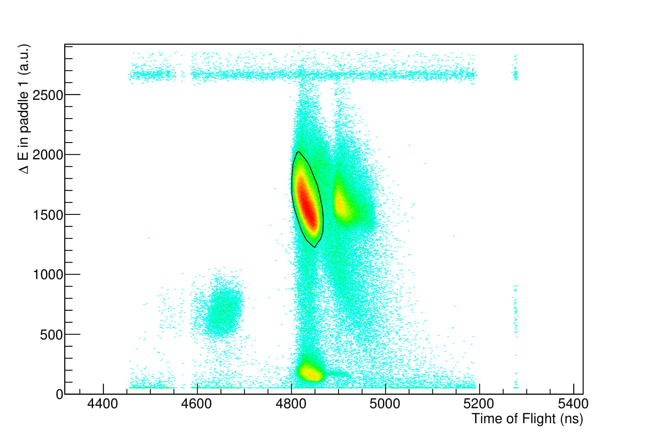
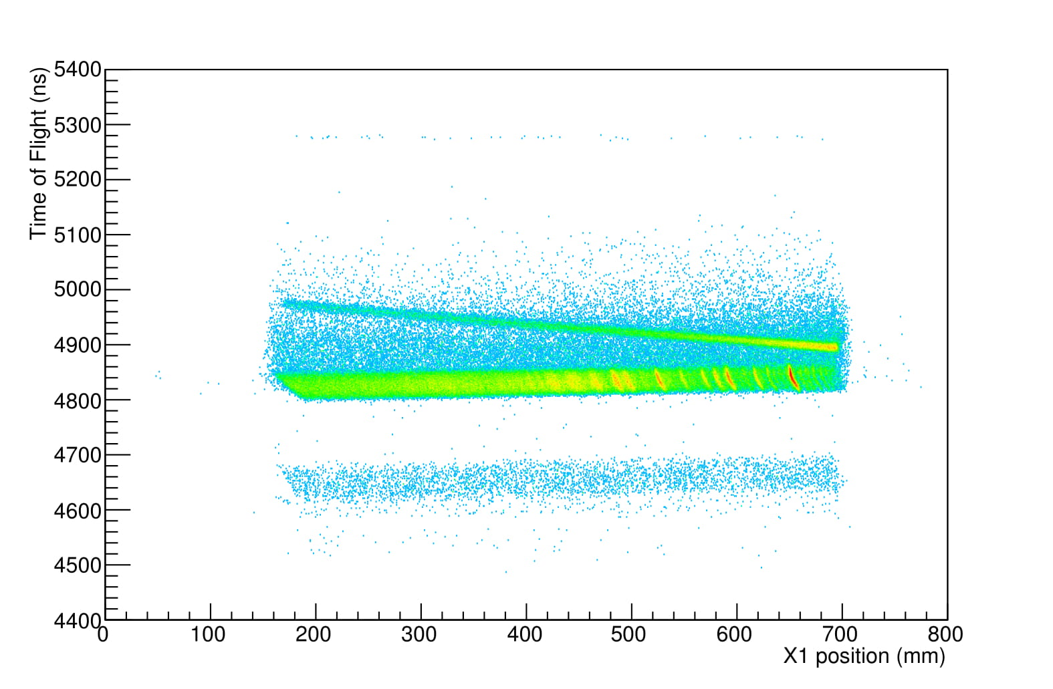
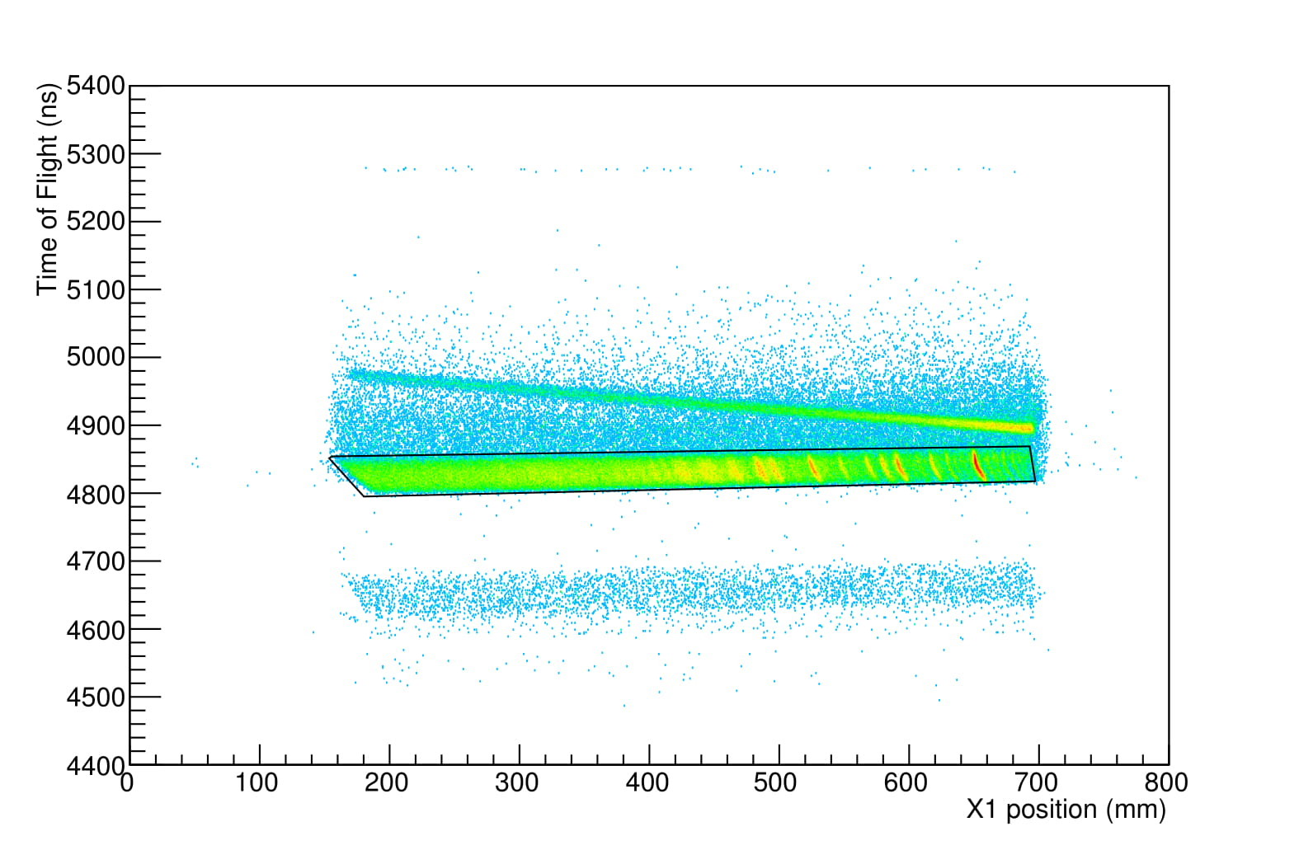

Time-of-Flight offsets:
Run nr: Offsets:
1128 0
1093 5
1100 3
1104 0
1108 0
1112 -2
1117 -1
1123 0
1097 0
1103 -3
1107 -4
1111 -6
1118 -6
1121 -4
1127 -4
1095 0
1101 -3
1106 -4
1110 -7
1116 -8
1120 -8
1126 -6

Final fit: Gaussian plus a polynomial:
Run nr: 1128 Peak position: 652.621 Peak sigma:0.889774
Run nr: 1093 Peak position: 652.688 Peak sigma:0.746134
Run nr: 1100 Peak position: 652.618 Peak sigma:0.890879
Run nr: 1104 Peak position: 652.621 Peak sigma:0.937096
Run nr: 1108 Peak position: 652.62 Peak sigma:0.925323
Run nr: 1112 Peak position: 652.622 Peak sigma:0.897904
Run nr: 1117 Peak position: 652.621 Peak sigma:0.913877
Run nr: 1123 Peak position: 652.62 Peak sigma:0.882682

Offsets 26Mg assigned: 58Ni 90Zr
0 1128 1127 1126
-0.420917 1093 1097 1095
0.1113365 1100 1101
0.2150881 1104 1103
0.49546738 1108 1107 1106
0.59647554 1112 1111 1110
0.49834908 1117 1118 1116
0.33387969 1123 1121 1120

Lineshape corrections:
0 1
1 -3.4
2 -1.4
3 +0.520678
4 +0.25651
5 -0.129682

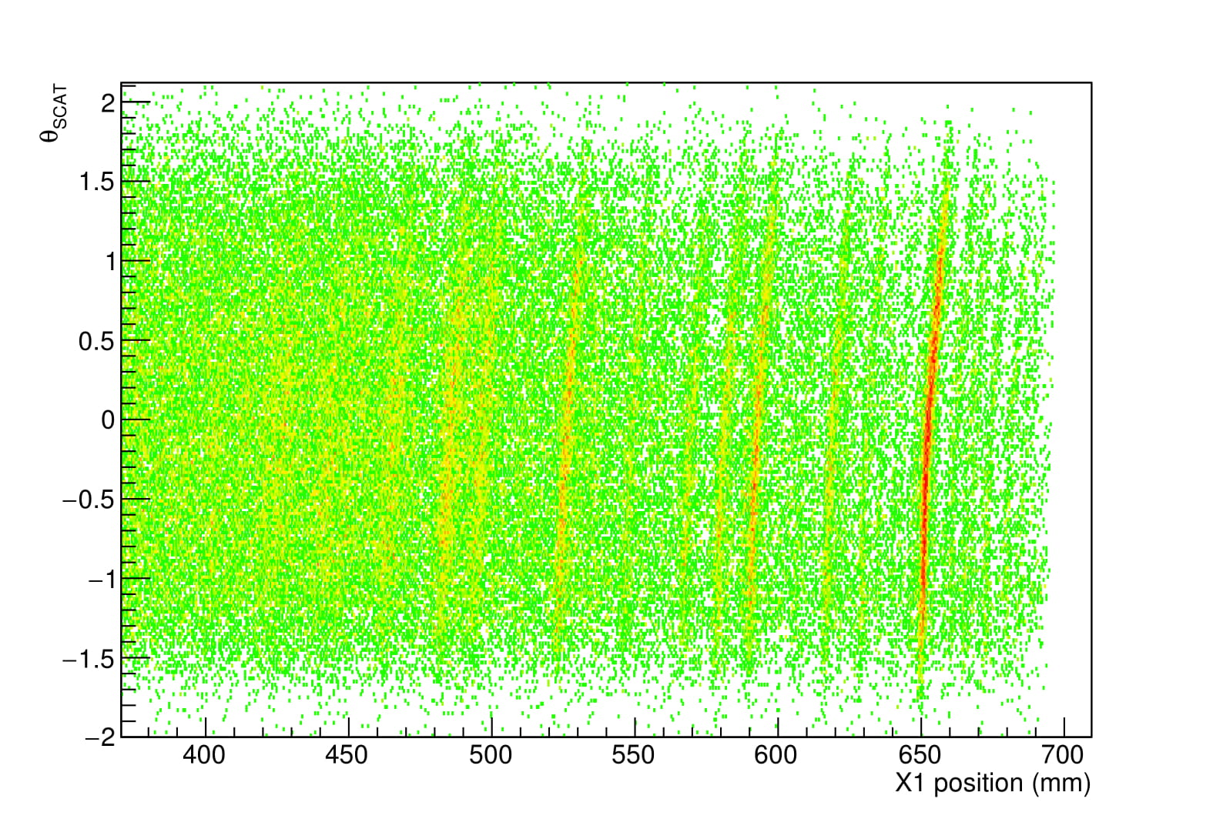
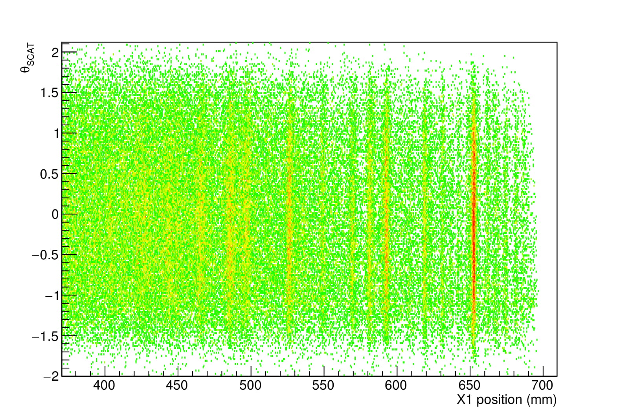

Theta FP to theta SCAT:
No corrections after lineshape
After trying out various corrections the “rectangle” appeared to be more distorted than before.
Any example calculations would help if possible, below is the best I could achieve
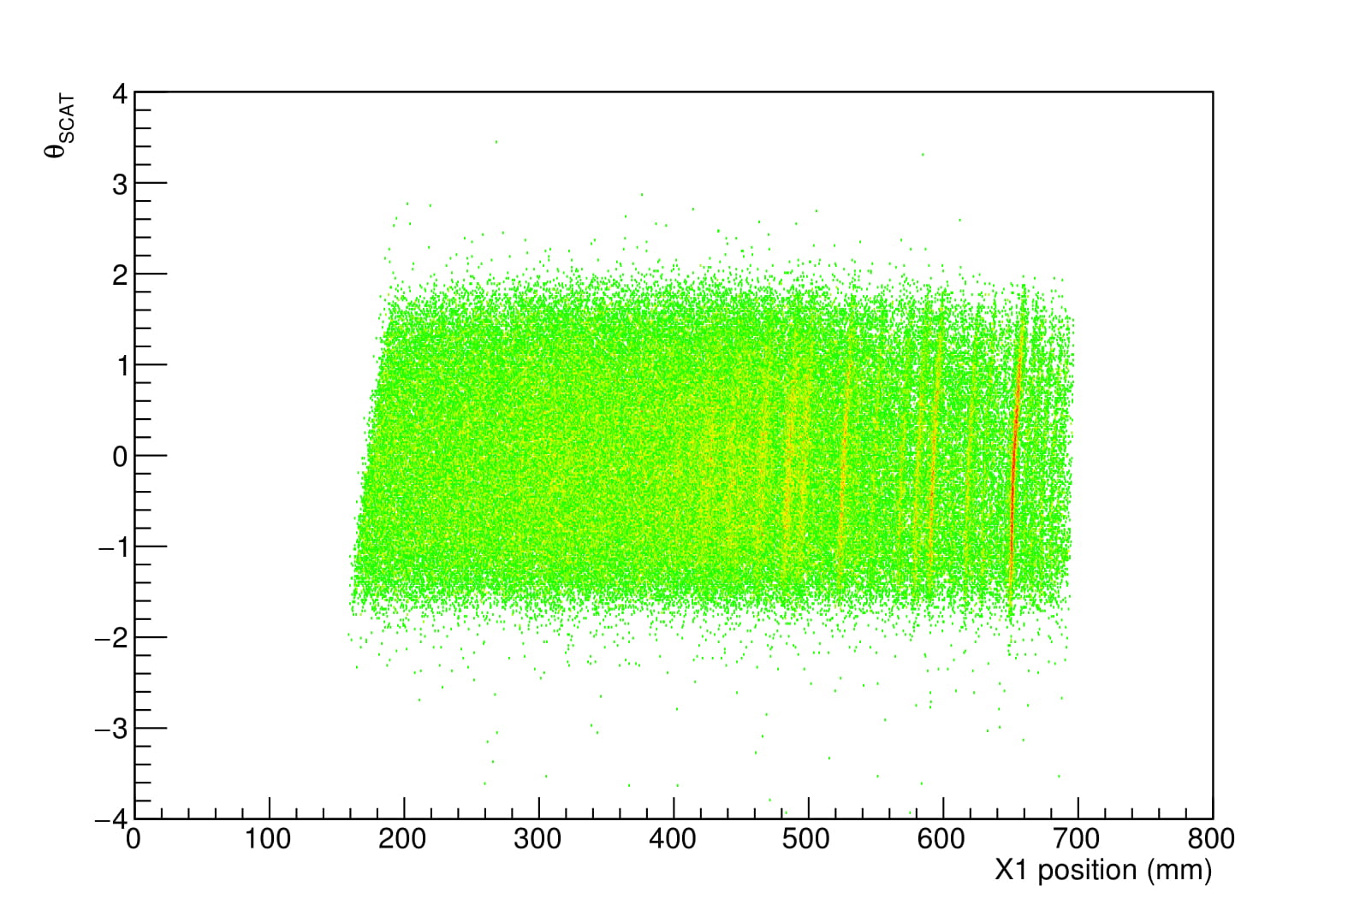
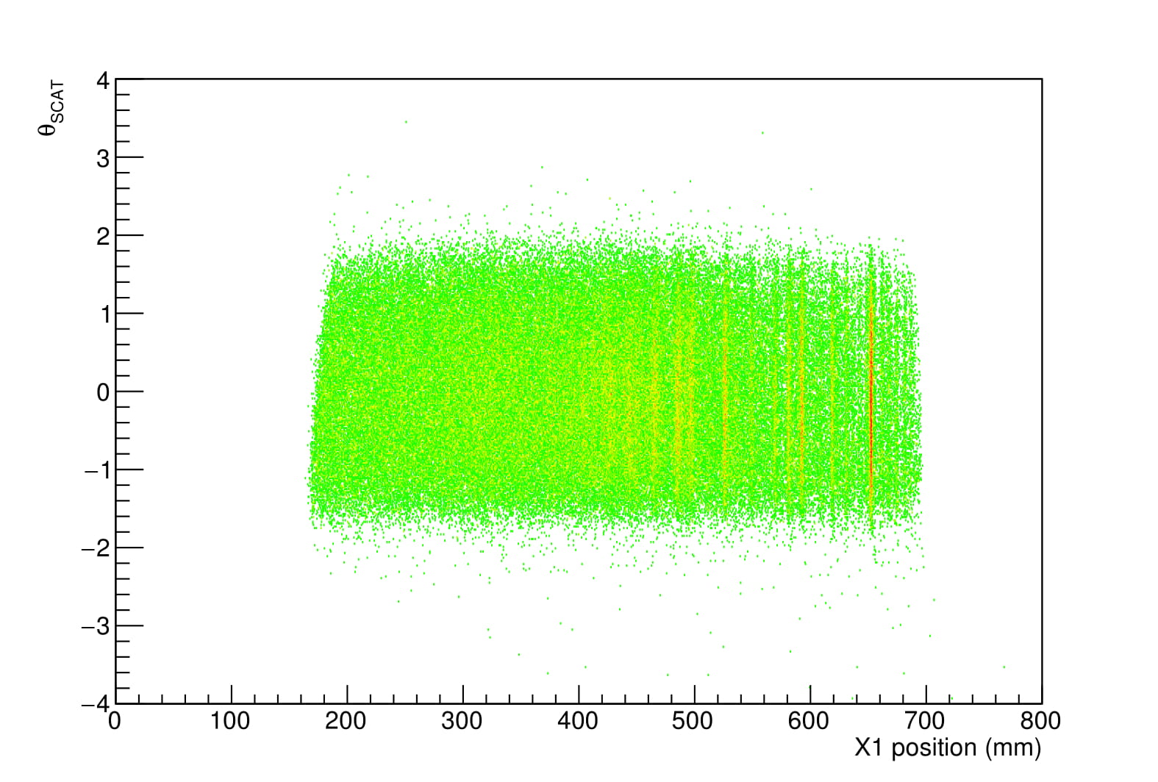

Y1 cuts
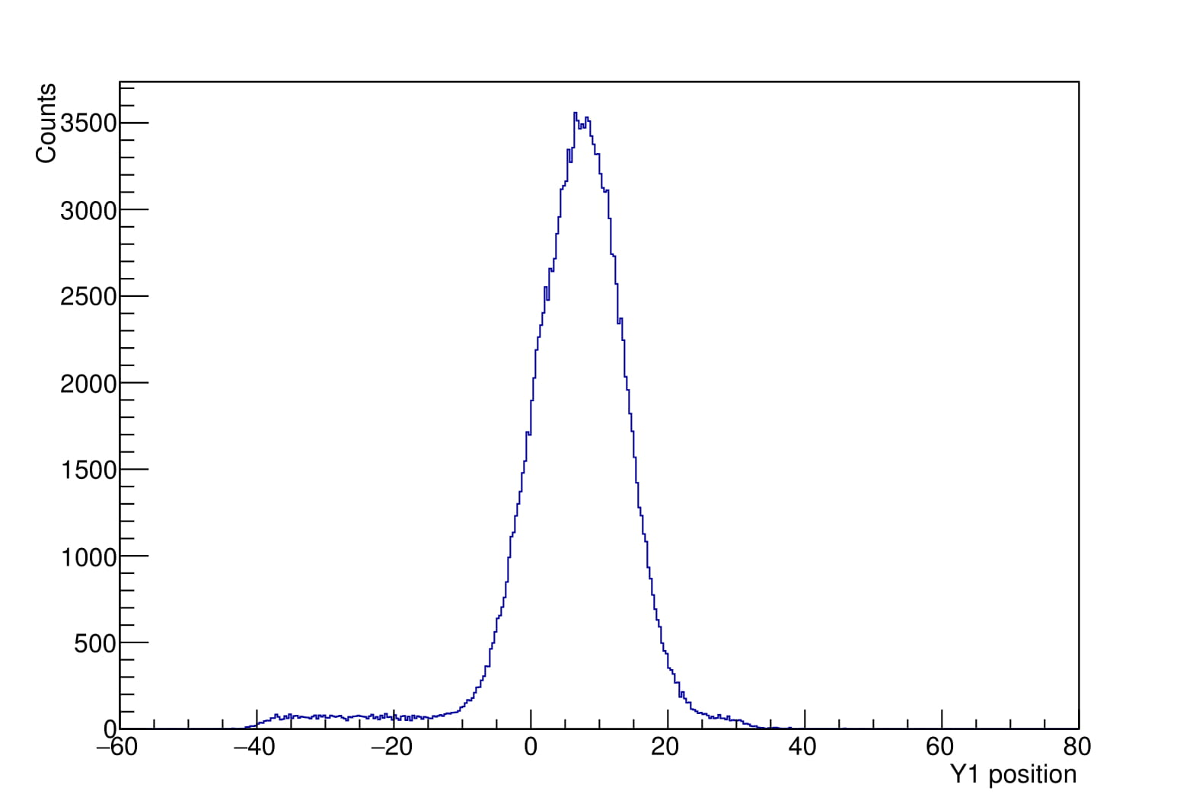
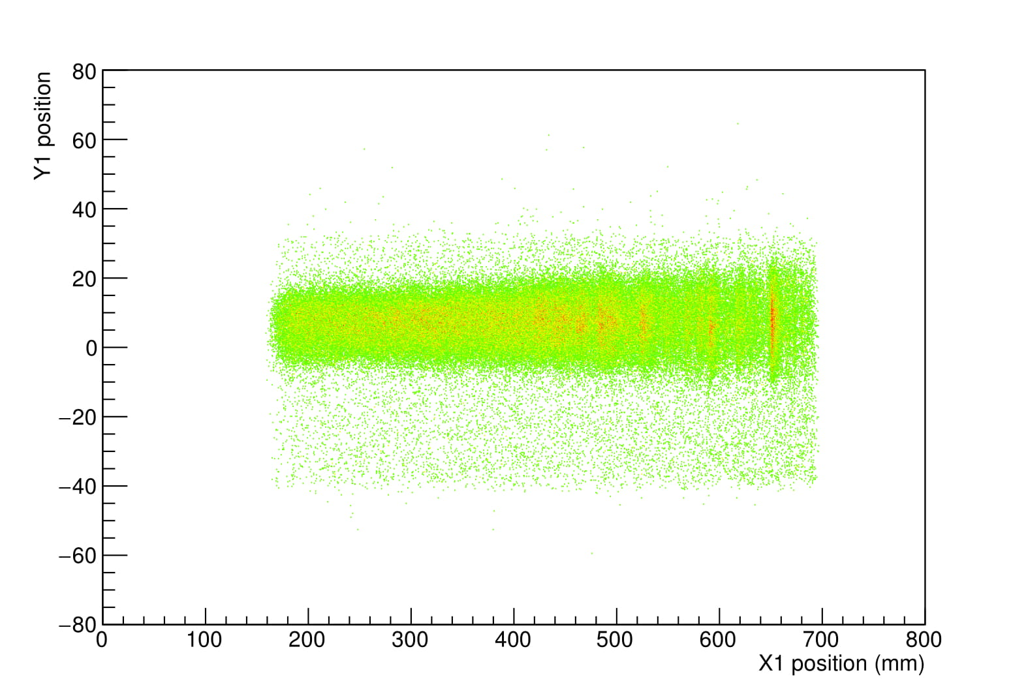

Central region: Y1>-10 && Y1<22
Background left: Y1>-40 && Y1<-10
Background right: Y1>35 && Y1<22

Central region = 32
Background left = 30
Background right = 13

Normalization factors: Right = 16/30
Leftf = 16/13

