1. 打開 Configuration Manager

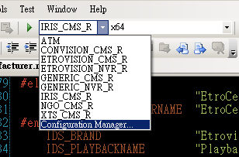

2. 建立新的Config (例：TEST_CMS_R)

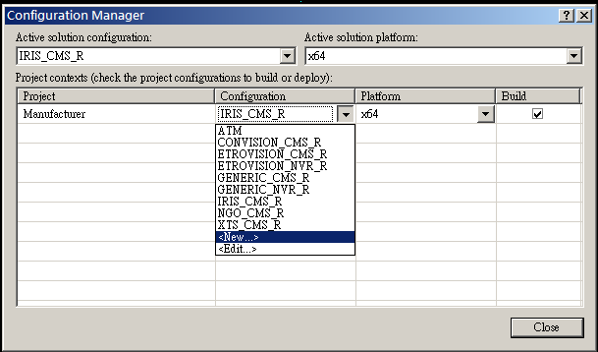

3.選擇複製Config (例：CONVISION_CMS_R)

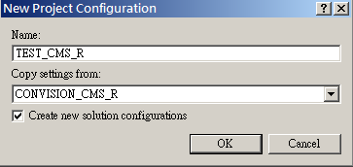

4.修改define

CONVISION --> TEST 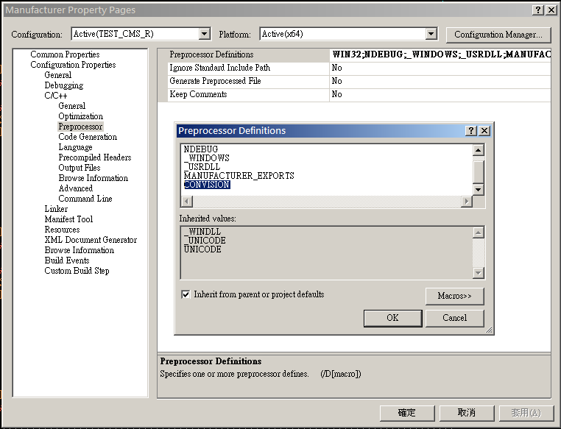

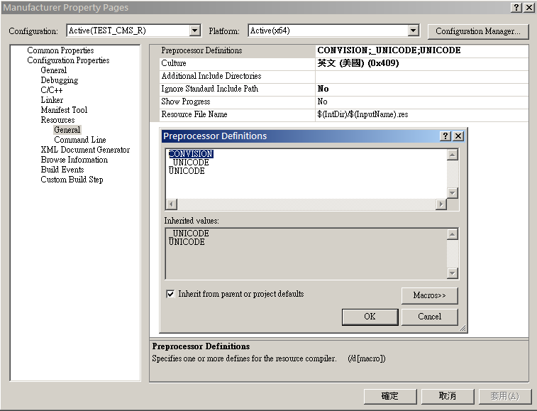

5.新增 String Table ( Manufacturer.rc )

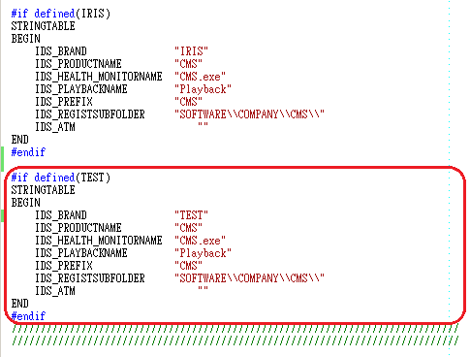

6.Resource View新增 ICON, BMP, VERSION

a. ICON, BMP

修改 Language, ID, Condition

Condition : TEST

|  |  |  |  |
| --- | --- | --- | --- |
|  | ID | Language |  |
| BMP | IDB_BITMAP_NEW_LOGO | 中文 (繁體，台灣) | CMSMVisualManager |
| BMP | IDB_LOGO | Neutral | CSystemInfo |
| ICON | IDR_MAINFRAME | Neutral |  |
| VERSION | VS_VERSION_INFO | Neutral |  |

b. VERSION (也可以用複製方式修改)

FILETYPE : VTF_DLL