R09943091 電子一 陳威旭

HW1 part2

a.

1.

2.

b.

A sequence of ABC command: logic

Then type show, you can see the SOP with each node on the picture.

Before logic picture can see in part_1:

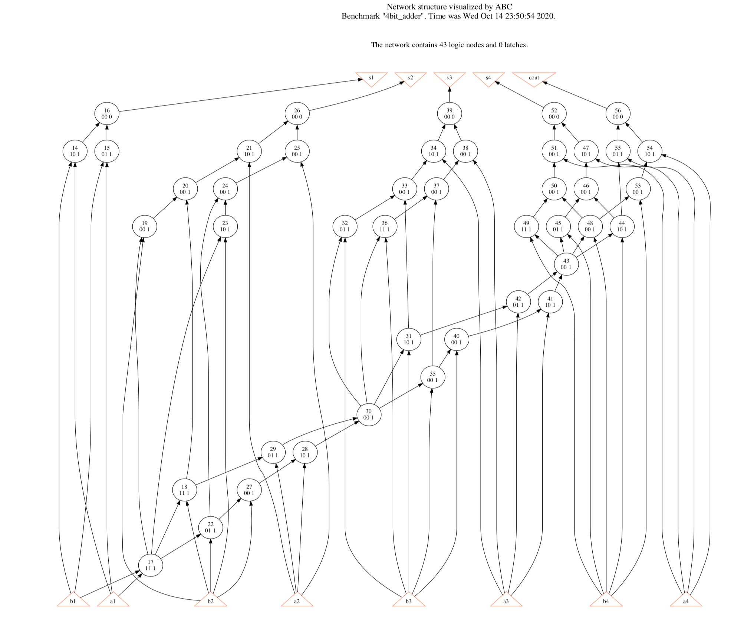After logic: