**Part 1**

visualize the network structure (command show)

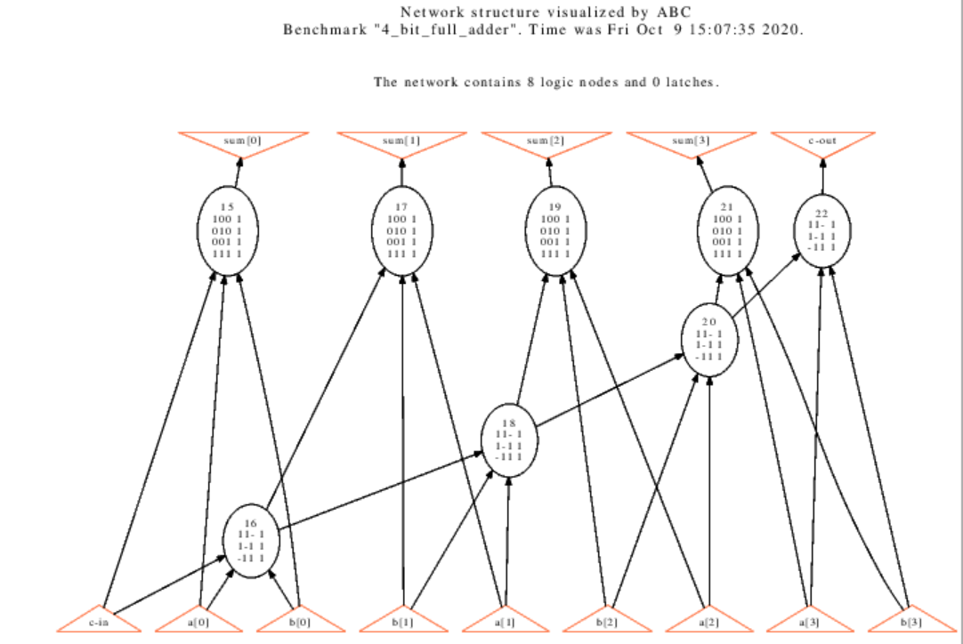

visualize the AIG (command show)

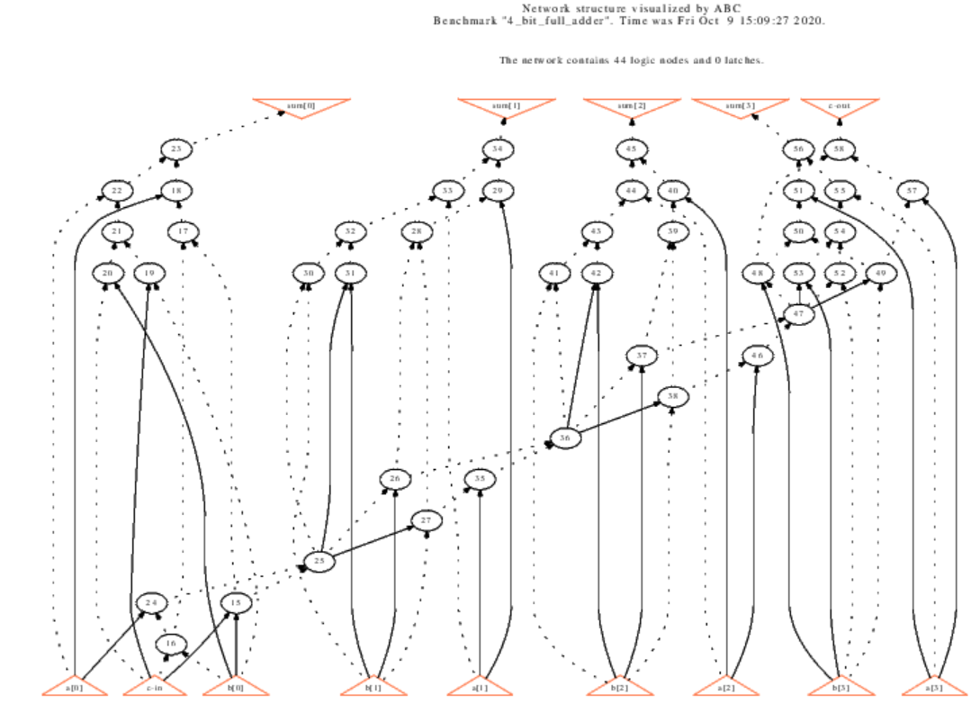

visualize the BDD (command show_bdd)

sum[0]

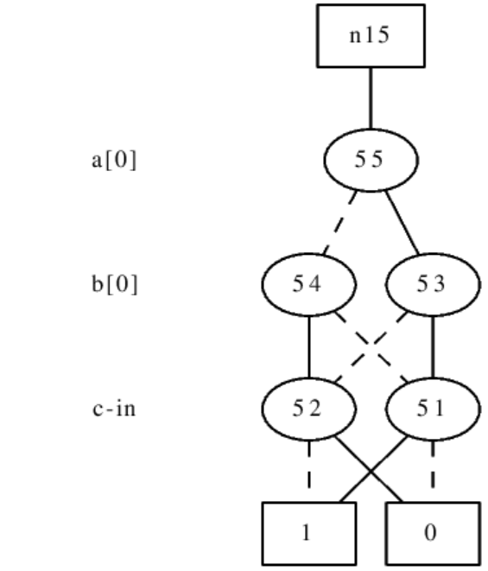

sum[1]

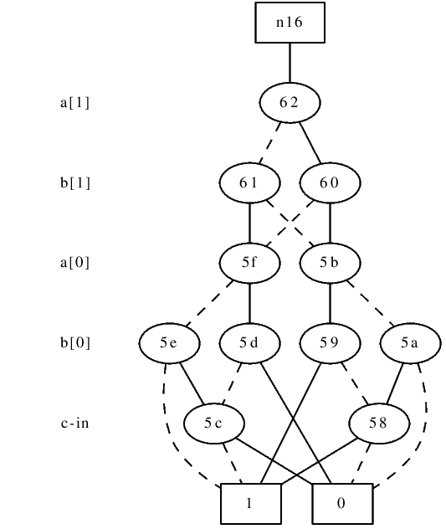

sum[2]

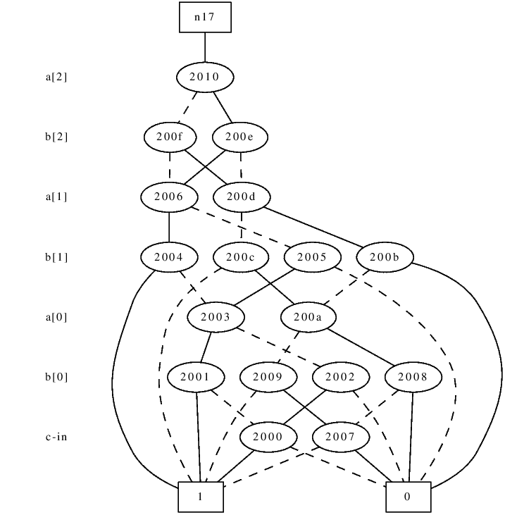

sum[3]

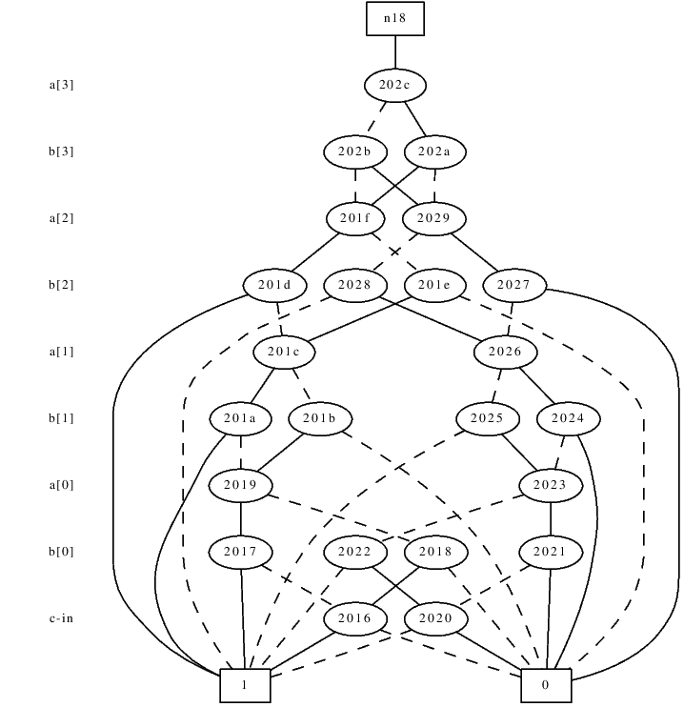

c-out

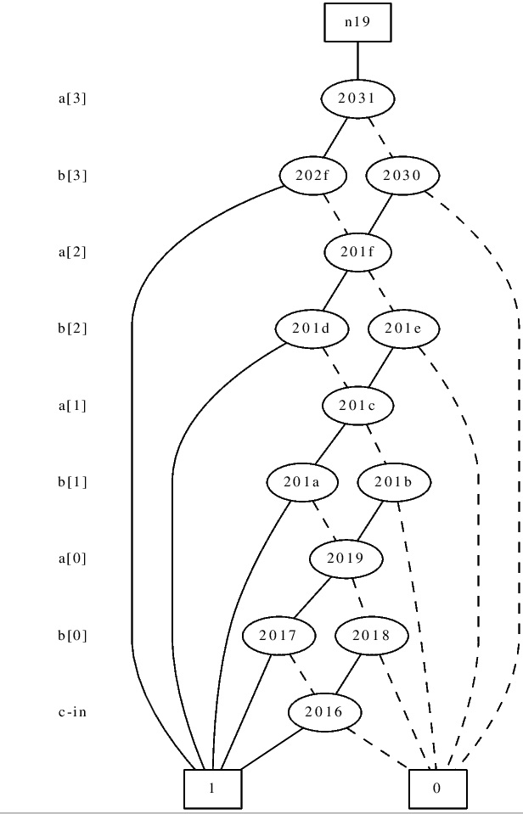

**Part 2**

(a)

1.

*aig* locally converts the representation of each node of the logic network to AIG.



*strash* globally transforms combinational logic into AIG.

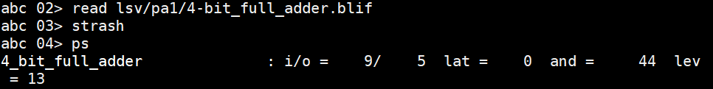

2.

*bdd* locally converts the representation of each node of the logic network to BDD.



*collapse* collapses the network by constructing global BDDs.



(b)

*logic* can convert a structurally hashed AIG to a logic network with the SOP representation of the two-input AND-gates.

