**Computer Vision HW1**

R08922a27 資工系 人工智慧碩士班 李吉昌

I use python 3.7 to implement all image processing requirements.   
Reading .bmp file by PIL, and then processing through NumPy array.

* **Part1. Write a program to do the following requirement.**

1. **Results**

(a) upside-down lena.bmp (b) right-side-left lena.bmp (c) diagonally flip lena.bmp

­­­ 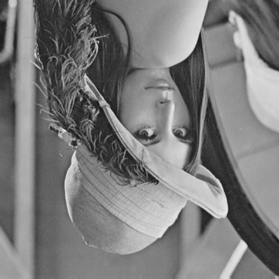 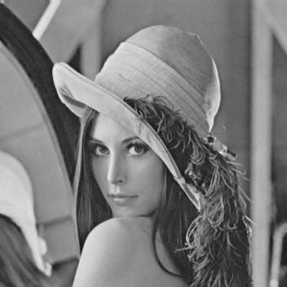 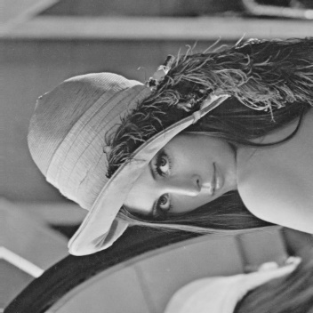

1. **Implementation**

(a) Extracting all the row indexes, and then pass all the row values in a reverse way.

(b) Extracting all the column indexes, and then pass all the column values in a reverse way.

(c) Switching all the indexes of columns and rows.

* **Part2. Write a program or use software to do the following requirement.**

1. **Results**

(d) rotate lena.bmp 45 deg (e) shrink lena.bmp in half (f) binarize lena.bmp at 128

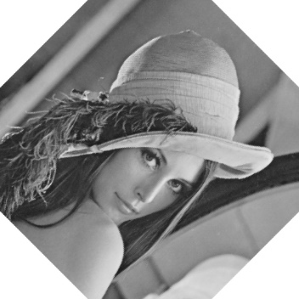 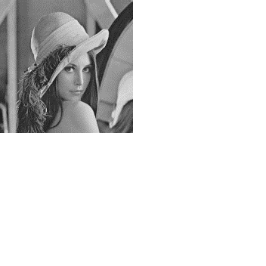 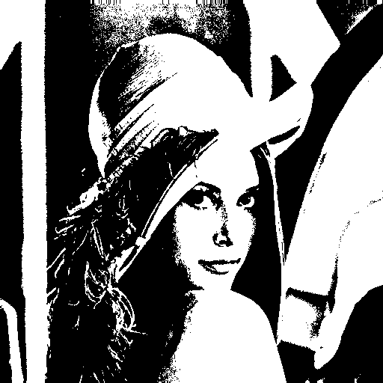

1. **Implementation**

(d) Setting all the mapping coordinates of the rotation, and then pass the level values.

(e) Scaling down the index values and then pass the level values.

(f) Using Boolean operation to find out the indexes with which level values are   
 higher/smaller than 128, assign 0/255 to those places.