**Computer Vision HW6**

R08922a27 資工系 人工智慧碩士班 李吉昌

I use python 3.7 to implement all image processing requirements. Reading .bmp file by **PIL**, and then processing through **NumPy** array.

* **1. Results**

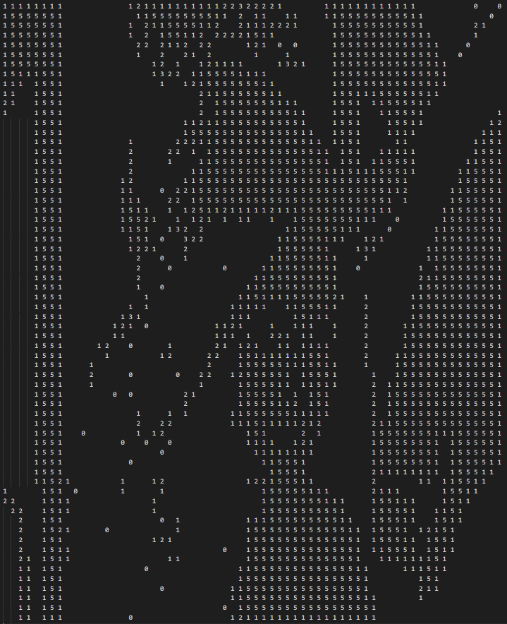

* **2. Code fragment**

def h(b, c, d, e):

if b == c and (d != b or e != b):

return 'q'

if b == c and (d == b and e == b):

return 'r'

return 's'

def YokoiConnectivityNumber(bin_img, i, j):

if i == 0:

if j == 0:

# top-left

x7, x2, x6 = 0, 0, 0

x3, x0, x1 = 0, bin_img[i][j], bin_img[i][j + 1]

x8, x4, x5 = 0, bin_img[i + 1][j], bin_img[i + 1][j + 1]

elif j == bin_img.shape[1] - 1:

# top-right

x7, x2, x6 = 0, 0, 0

x3, x0, x1 = bin_img[i][j - 1], bin_img[i][j], 0

x8, x4, x5 = bin_img[i + 1][j - 1], bin_img[i + 1][j], 0

else:

# top-row

x7, x2, x6 = 0, 0, 0

x3, x0, x1 = bin_img[i][j - 1], bin_img[i][j], bin_img[i][j + 1]

x8, x4, x5 = bin_img[i + 1][j - 1], bin_img[i + 1][j], bin_img[i + 1][j + 1]

elif i == bin_img.shape[0] - 1:

if j == 0:

# bottom-left

x7, x2, x6 = 0, bin_img[i - 1][j], bin_img[i - 1][j + 1]

x3, x0, x1 = 0, bin_img[i][j], bin_img[i][j + 1]

x8, x4, x5 = 0, 0, 0

elif j == bin_img.shape[1] - 1:

# bottom-right

x7, x2, x6 = bin_img[i - 1][j - 1], bin_img[i - 1][j], 0

x3, x0, x1 = bin_img[i][j - 1], bin_img[i][j], 0

x8, x4, x5 = 0, 0, 0

else:

# bottom-row

x7, x2, x6 = bin_img[i - 1][j - 1], bin_img[i - 1][j], bin_img[i - 1][j + 1]

x3, x0, x1 = bin_img[i][j - 1], bin_img[i][j], bin_img[i][j + 1]

x8, x4, x5 = 0, 0, 0

else:

if j == 0:

x7, x2, x6 = 0, bin_img[i - 1][j], bin_img[i - 1][j + 1]

x3, x0, x1 = 0, bin_img[i][j], bin_img[i][j + 1]

x8, x4, x5 = 0, bin_img[i + 1][j], bin_img[i + 1][j + 1]

elif j == bin_img.shape[1] - 1:

x7, x2, x6 = bin_img[i - 1][j - 1], bin_img[i - 1][j], 0

x3, x0, x1 = bin_img[i][j - 1], bin_img[i][j], 0

x8, x4, x5 = bin_img[i + 1][j - 1], bin_img[i + 1][j], 0

else:

x7, x2, x6 = bin_img[i - 1][j - 1], bin_img[i - 1][j], bin_img[i - 1][j + 1]

x3, x0, x1 = bin_img[i][j - 1], bin_img[i][j], bin_img[i][j + 1]

x8, x4, x5 = bin_img[i + 1][j - 1], bin_img[i + 1][j], bin_img[i + 1][j + 1]

a1 = h(x0, x1, x6, x2)

a2 = h(x0, x2, x7, x3)

a3 = h(x0, x3, x8, x4)

a4 = h(x0, x4, x5, x1)

if a1 == 'r' and a2 == 'r' and a3 == 'r' and a4 == 'r':

return 5

else:

return sum(np.array([a1, a2, a3, a4]) == 'q')

* **3. Brief Description**

The preprocessing processes, downsampling image from 512x512 to 64x64, and the binarization at the threshold 128 were conducted. Then, the Yokoi connectivity numbers were counted by using 4-connected. Those implementation details of the counting algorithm follow the course's lecture slides. The **h** function has been shown in the **code fragment** part.