**Computer Vision HW7**

R08922a27 資工系 人工智慧碩士班 李吉昌

I use python 3.7 to implement all image processing requirements. Reading .bmp file by **PIL**, and then processing through **NumPy** array.

* **1. Results**

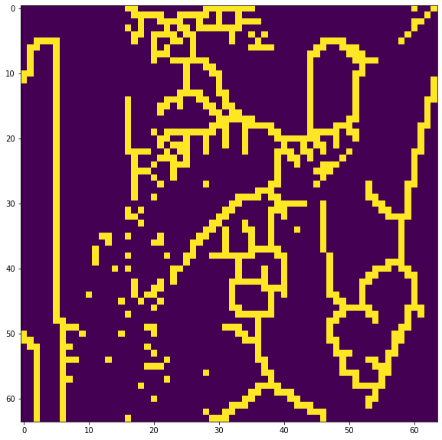

* **2. Code fragment**

def YokoiConnectivityNumberTransform(bin_img):

def h(b, c, d, e):

if b == c and (d != b or e != b):

return 'q'

if b == c and (d == b and e == b):

return 'r'

return 's'

def YokoiConnectivityNumber(bin_img, i, j):

if i == 0:

if j == 0:

# top-left

x7, x2, x6 = 0, 0, 0

x3, x0, x1 = 0, bin_img[i, j], bin_img[i, j + 1]

x8, x4, x5 = 0, bin_img[i + 1, j], bin_img[i + 1, j + 1]

elif j == bin_img.shape[1] - 1:

# top-right

x7, x2, x6 = 0, 0, 0

x3, x0, x1 = bin_img[i, j - 1], bin_img[i, j], 0

x8, x4, x5 = bin_img[i + 1, j - 1], bin_img[i + 1, j], 0

else:

# top-row

x7, x2, x6 = 0, 0, 0

x3, x0, x1 = bin_img[i, j -

1], bin_img[i, j], bin_img[i, j + 1]

x8, x4, x5 = bin_img[i + 1, j -

1], bin_img[i + 1, j], bin_img[i + 1, j + 1]

elif i == bin_img.shape[0] - 1:

if j == 0:

# bottom-left

x7, x2, x6 = 0, bin_img[i - 1, j], bin_img[i - 1, j + 1]

x3, x0, x1 = 0, bin_img[i, j], bin_img[i, j + 1]

x8, x4, x5 = 0, 0, 0

elif j == bin_img.shape[1] - 1:

# bottom-right

x7, x2, x6 = bin_img[i - 1, j - 1], bin_img[i - 1, j], 0

x3, x0, x1 = bin_img[i, j - 1], bin_img[i, j], 0

x8, x4, x5 = 0, 0, 0

else:

# bottom-row

x7, x2, x6 = bin_img[i - 1, j -

1], bin_img[i - 1, j], bin_img[i - 1, j + 1]

x3, x0, x1 = bin_img[i, j -

1], bin_img[i, j], bin_img[i, j + 1]

x8, x4, x5 = 0, 0, 0

else:

if j == 0:

x7, x2, x6 = 0, bin_img[i - 1, j], bin_img[i - 1, j + 1]

x3, x0, x1 = 0, bin_img[i, j], bin_img[i, j + 1]

x8, x4, x5 = 0, bin_img[i + 1, j], bin_img[i + 1, j + 1]

elif j == bin_img.shape[1] - 1:

x7, x2, x6 = bin_img[i - 1, j - 1], bin_img[i - 1, j], 0

x3, x0, x1 = bin_img[i, j - 1], bin_img[i, j], 0

x8, x4, x5 = bin_img[i + 1, j - 1], bin_img[i + 1, j], 0

else:

x7, x2, x6 = bin_img[i - 1, j -

1], bin_img[i - 1, j], bin_img[i - 1, j + 1]

x3, x0, x1 = bin_img[i, j -

1], bin_img[i, j], bin_img[i, j + 1]

x8, x4, x5 = bin_img[i + 1, j -

1], bin_img[i + 1, j], bin_img[i + 1, j + 1]

a1 = h(x0, x1, x6, x2)

a2 = h(x0, x2, x7, x3)

a3 = h(x0, x3, x8, x4)

a4 = h(x0, x4, x5, x1)

if a1 == 'r' and a2 == 'r' and a3 == 'r' and a4 == 'r':

return 5

else:

return sum(np.array([a1, a2, a3, a4]) == 'q')

output = np.zeros(bin_img.shape)

# compute and output Yokoi Connectivity Number ...

for i in range(bin_img.shape[0]):

for j in range(bin_img.shape[1]):

if bin_img[i, j] > 0:

output[i, j] = YokoiConnectivityNumber(bin_img, i, j)

return output

def MarkPairRelationship(bin_img, yokoi_img):

# for marking pair relationship

def PairRelationship(yokoi_img, i, j):

if yokoi_img[i, j] != 1:

return 2

x1, x2, x3, x4 = 0, 0, 0, 0

x1 = 1 if j + 1 < yokoi_img.shape[0] and yokoi_img[i, j+1] == 1 else 0

x2 = 1 if i - 1 >= 0 and yokoi_img[i-1, j] == 1 else 0

x3 = 1 if j - 1 >= 0 and yokoi_img[i, j-1] == 1 else 0

x4 = 1 if i + 1 < yokoi_img.shape[1] and yokoi_img[i+1, j] == 1 else 0

return 1 if x1 + x2 + x3 + x4 >= 1 else 2

output = np.zeros(yokoi_img.shape)

# background pixel: 0

# p: 1

# q: 2

for i in range(yokoi_img.shape[0]):

for j in range(yokoi_img.shape[1]):

if bin_img[i, j] > 0:

output[i, j] = PairRelationship(yokoi_img, i, j)

return output

def ConnectedShrinkOperator(bin_img, img_pair):

def h_cs(b, c, d, e):

if b == c and (d != b or e != b):

return 1

else:

return 0

def f_cs(a1, a2, a3, a4, x0):

if sum(np.array([a1, a2, a3, a4]) == 1) == 1:

return 0

else:

return x0

def ConnectedShrink(bin_img, i, j):

if i == 0:

if j == 0:

# top-left

x7, x2, x6 = 0, 0, 0

x3, x0, x1 = 0, bin_img[i, j], bin_img[i, j + 1]

x8, x4, x5 = 0, bin_img[i + 1, j], bin_img[i + 1, j + 1]

elif j == bin_img.shape[1] - 1:

# top-right

x7, x2, x6 = 0, 0, 0

x3, x0, x1 = bin_img[i, j - 1], bin_img[i, j], 0

x8, x4, x5 = bin_img[i + 1, j - 1], bin_img[i + 1, j], 0

else:

# top-row

x7, x2, x6 = 0, 0, 0

x3, x0, x1 = bin_img[i, j -

1], bin_img[i, j], bin_img[i, j + 1]

x8, x4, x5 = bin_img[i + 1, j -

1], bin_img[i + 1, j], bin_img[i + 1, j + 1]

elif i == bin_img.shape[0] - 1:

if j == 0:

# bottom-left

x7, x2, x6 = 0, bin_img[i - 1, j], bin_img[i - 1, j + 1]

x3, x0, x1 = 0, bin_img[i, j], bin_img[i, j + 1]

x8, x4, x5 = 0, 0, 0

elif j == bin_img.shape[1] - 1:

# bottom-right

x7, x2, x6 = bin_img[i - 1, j - 1], bin_img[i - 1, j], 0

x3, x0, x1 = bin_img[i, j - 1], bin_img[i, j], 0

x8, x4, x5 = 0, 0, 0

else:

# bottom-row

x7, x2, x6 = bin_img[i - 1, j -

1], bin_img[i - 1, j], bin_img[i - 1, j + 1]

x3, x0, x1 = bin_img[i, j -

1], bin_img[i, j], bin_img[i, j + 1]

x8, x4, x5 = 0, 0, 0

else:

if j == 0:

x7, x2, x6 = 0, bin_img[i - 1, j], bin_img[i - 1, j + 1]

x3, x0, x1 = 0, bin_img[i, j], bin_img[i, j + 1]

x8, x4, x5 = 0, bin_img[i + 1, j], bin_img[i + 1, j + 1]

elif j == bin_img.shape[1] - 1:

x7, x2, x6 = bin_img[i - 1, j - 1], bin_img[i - 1, j], 0

x3, x0, x1 = bin_img[i, j - 1], bin_img[i, j], 0

x8, x4, x5 = bin_img[i + 1, j - 1], bin_img[i + 1, j], 0

else:

x7, x2, x6 = bin_img[i - 1, j -

1], bin_img[i - 1, j], bin_img[i - 1, j + 1]

x3, x0, x1 = bin_img[i, j -

1], bin_img[i, j], bin_img[i, j + 1]

x8, x4, x5 = bin_img[i + 1, j -

1], bin_img[i + 1, j], bin_img[i + 1, j + 1]

a1 = h_cs(x0, x1, x6, x2)

a2 = h_cs(x0, x2, x7, x3)

a3 = h_cs(x0, x3, x8, x4)

a4 = h_cs(x0, x4, x5, x1)

return f_cs(a1, a2, a3, a4, x0)

bin_img = bin_img.copy()

for i in range(bin_img.shape[0]):

for j in range(bin_img.shape[1]):

if bin_img[i, j] > 0 and img_pair[i, j] != 2:

bin_img[i, j] = ConnectedShrink(bin_img, i, j)

return bin_img

* **3. Brief Description**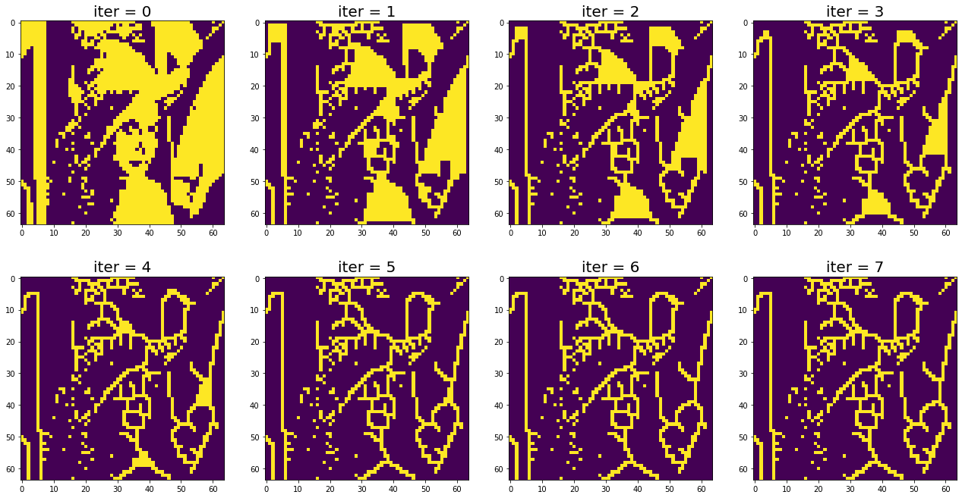

All the assigned operators ' implementation details follow the course's lecture slides. Each transformation used 4-connected, and their h function has been shown in the code fragment part.

Firstly, the preprocessing processes, downsampling image from 512x512 to 64x64, and the binarization at the threshold 128 were conducted. Then, the image would be processed by the three-step operations iteratively.