Scenario 1:
Paul is a financial manager in TSMC company. He has checked the amount balance on his Dark Springs’s account today. However, he was confused about why the balance amount is large. Thus, he wanted to check the payment detail of this month. He logged into our company’s website, and enter his bill id(7000). And the website shows the item he bought in January.

EXECUTE call_total(7000)
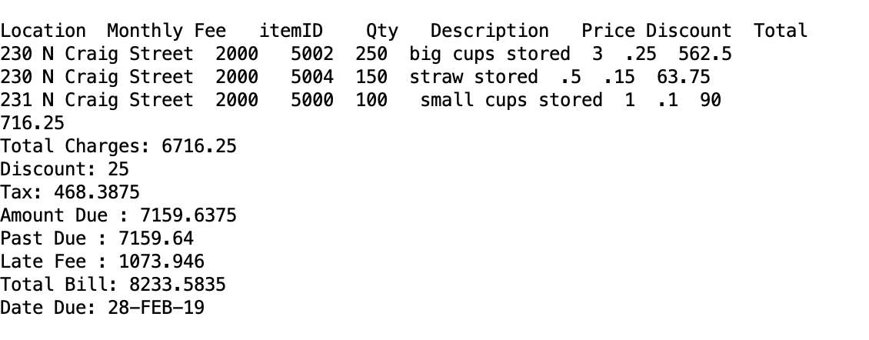
EXECUTE call_total(7001)
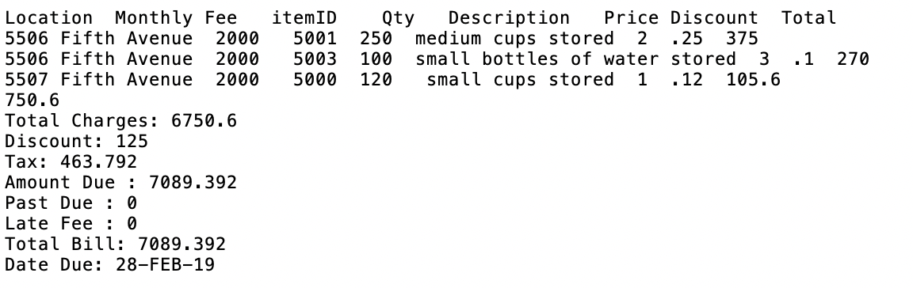
EXECUTE call_total(7002)
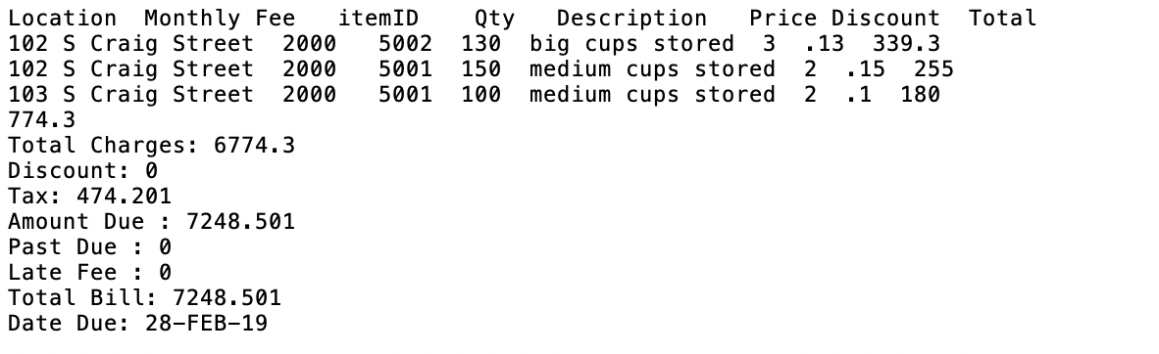
After seen the detail of the bill, he understood that his company bought lots of big cup this month. This is why the balance amount is large in January.

Scenario 2:
In every month, our company has an annual settlement. We have to report the sales amount of our products to improve and adjust the sale strategy next month.
we have a sql file that can generate the monthly sales report.

start “/report_sales.sql”

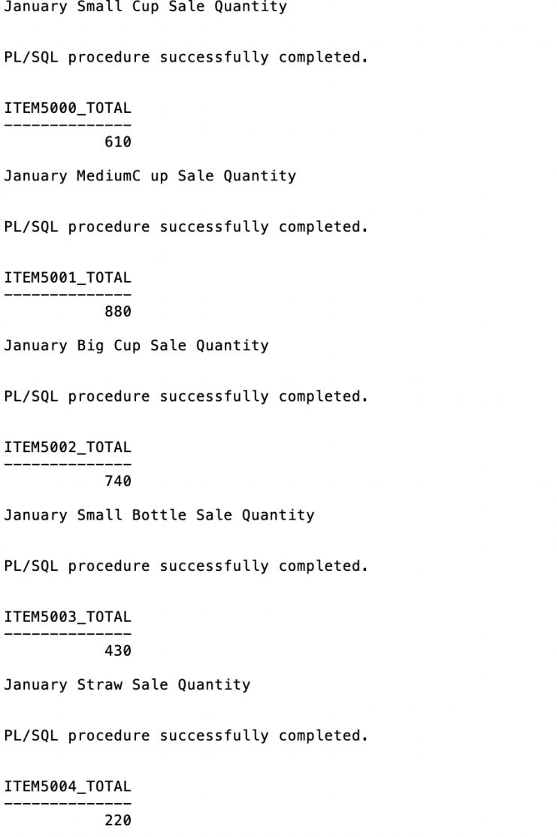

Scenarios 3:
Ensure valid transaction, in our model, we have built three triggers to make sure our transaction is valid. First, the customer cannot pay partial balance. The customer table has an attribute balance, when they pay the balance, we will update their record. However, when we generate bill for the customer, we also need to update the balance. In other words, we have to allow increase update for balance and decrease update to zero for balance, but prevent decreasing the balance to the value greater than zero. In this case, when we update customer table with balance value smaller than the current balance but not zero, we will start the trigger and show the error message.

When the customer order new item, we should check two conditions, whether the quantity the customer orders is smaller than the storage and whether the customer status is active. If we cannot meet any of the two conditions, we will prevent the insert and show the error message. If we meet both, we allow the insert and update the storage of that item.

When the customer wants to sign new contract, we need to check two conditions. (1) Current balance (2) status. Only customer with zero balance and active status can sign new contract. Otherwise, we will prevent inserting new record in contract table.

Scenarios 4:
When we want to evaluate our business discrimination situation, we can run the evaluation_report.sql file, which will give us summary statistics for different age, race and gender.

Scenarios 5:

In some business scenarios, we need to view each delivery service as an entity and it’s hard to search information from three tables. In this case, I create a new table called service_denormal to show the denormalization form of delivery service.

Scenario 6:

In every month, our sales manager wants to make sure if the sales amount average of a big company is larger than a small cooperation. He takes business size larger than 1000 employees as big company, and less than 1000 employees as small cooperation. Thus, if big companies really bought more stuffs, he can send more sales people to the big company and discuss with deliver manager about taking more stuffs to the big company when the deliver people need to deliver the customer’s items. In January, big company indeed bought more than the small cooperation.

start “/report_bill.sql”
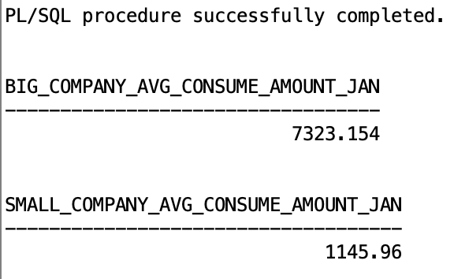

Scenario 7:
Our company need to add bill information into the table bill every month. In our database, the procedure Add_Bill which use for loop to add bill information can be applied. Together with scheduler job of ‘PTEST’, it can automatically add bill information for the ten records in the last month. The time automatically change to the next month. The Dark Spring company can use this procedure and job to manage bill table.
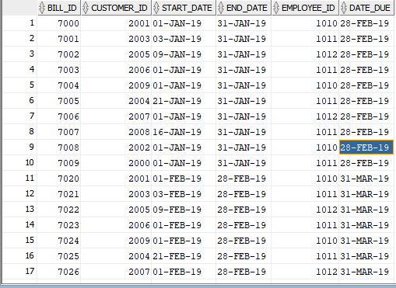
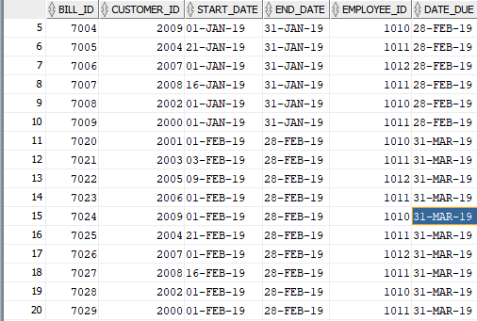
Also, you can use the following two lines of code to change interval from monthly to minutely to verify our job work properly.
exec dbms_scheduler.set_attribute('PTEST','repeat_interval','FREQ=MINUTELY;INTERVAL=1');
exec dbms_scheduler.run_job('PTEST');

