**Computer Vision HW1**

*B06902119 張原豪*

**Part1. Write a program to do the following requirement.**

Use simple for loops to transform pixels, then save the resulting image.

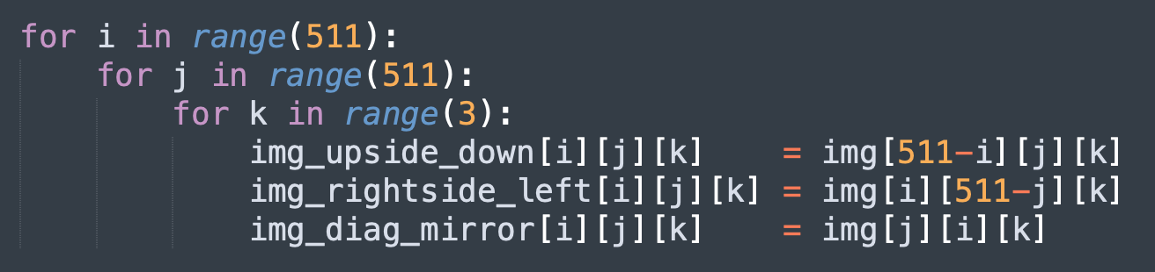

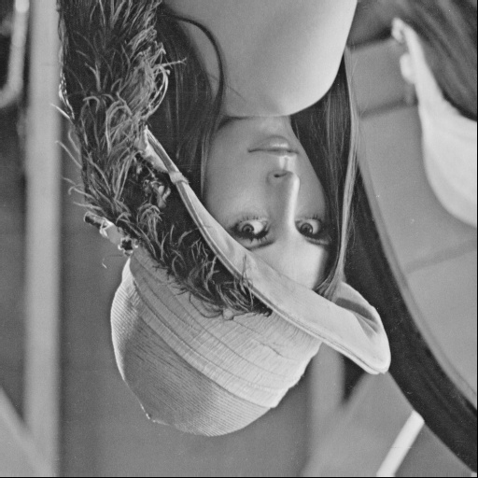(a) upside-down lena.bmp

(b) right-side-left lena.bmp

(c) diagonally flip lena.bmp

**Part2. Write a program or use software to do the following requirement.**

Complete with Photoshop

(d) rotate lena.bmp 45 degrees clockwise



(e) shrink lena.bmp in half

(f) binarize lena.bmp at 128 to get a binary image

