

**The Jackson Laboratory Colony Management System**

**JCMS Access Interface version 6.1.9**

**ReadMe.pdf**

When you installed JCMS, you specified an installation folder. At the same level of this installation folder two other folders were created, Docs and Data. Docs contains various JCMS documentation including this Read me and the User’s Guide. The data folder is used to hold the user files (referred to as documents) that are associated with the mice, mouse genotypes, samples, and/or experimental data in JCMS. JCMS does not incorporate the documents into its database. It moves a copy of the original file into this special “data” folder and maintains a link to the file in the JCMS database. (You must change the JCMS_DATA_FILE_DIRECTORY setup variable to match the path of the data directory).

(Docs) Installation Folder (Data)

|

JCMS.mdb

First time users

JCMS is a Microsoft Access application. You run JCMS by opening the file *JCMS.mdb* with MS Access 2007 or 2010 (32-bit version).

You now need to do some administrative functions. When completed, you will be ready to begin entering data. Please refer to the **user guide** for more information.

Please note that the user guide is found in the <JCMS installation folder> \docs folder. Also, check out <http://colonymanagement.jax.org> for all JCMS information and post any questions to our forum <http://community.jax.org/jcms_discussion_forum/default.aspx>.

**BEFORE BEGINNING, YOU MUST (1) Add your JCMS installation folder and subfolders as a Trusted Location in MS Trust Center, (2) Create a password for user ‘Admin’, (3) Create the user ‘mtsadmin’, and make it a member of the Admin group.**

To create the necessary passwords:

Start JCMS by double clicking *JCMS.mdb* in your installation folder:

MS Access 2007 instructions

**Give Admin a password**

* Select the “Database Tools” tab.
* Select “Users and Permissions” from the ribbon.
* Select “User and Group Accounts”.
* 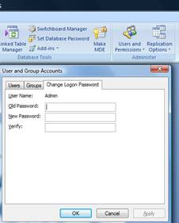Select “Change Logon Password” tab.
* Old password <blank>.
* New password “Admin” (or your choice).
* Verify (repeat your choice).
* Select “OK”.

**Add mtsadmin**

* Select the “Database Tools” tab.
* Select “Users and Permissions” from the ribbon.
* Select “User and Group Accounts”.
* Select “Users” tab.
* Select “New” button.
* Put “mtsadmin” in the Name field.
* Enter any random value in the Personal ID field.
* Select “OK”.
* Use the “Add>>” button to set user mtsadmin as a member of the *Admins* and *Users* groups.
* Close MS Access.
* Restart JCMS and logon as mtsadmin, leave password blank.
* Now give mtsadmin a password using the same procedure as described above to give the Admin user a password. This is not required, but it is very strongly encouraged.

**MS Access 2010 instructions**

The steps are the same as indicated above for Access 2007. However, some of the features have been moved. Use the red File tab to find the Users and Permissions tool (see the picture on the next page).

**Users and Permissions**

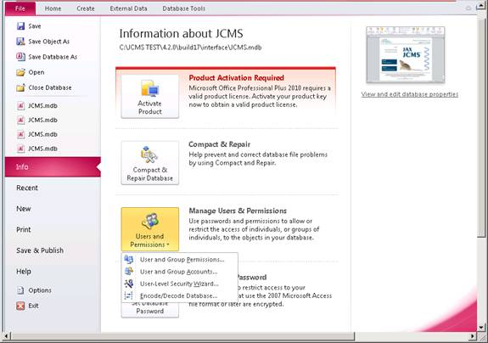

**Access 2013**

If you do not have “Manage Users & Permissions” please go to the colony management website and read FAQ 17:

<http://colonymanagement.jax.org/support-2/faqs/jcms-colony-management-system/>

**Linking the Database Tables**

If during install table linking fails for any reason follow the following steps to link tables.

**Access 2007 instructions**

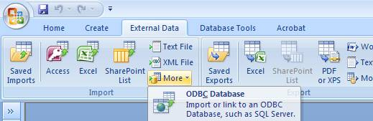

* Open JCMS
* Click the 'External Data' tab
* Click on 'More' in Import toolbar
* Click on 'ODBC Database'
* Select 'Link to the data source by creating a linked table' and click 'OK'
* Select the 'Machine Data Source' tab and click 'New...'
* Select the data source type that you desire and click 'Next>'
* Scroll down to 'MySQL ODBC 3.51 Driver', select it, and click 'Next>'
* Click 'Finish'
* Fill in the data details, the Server value will be 'localhost' if your database is on the local machine. User and password are your MySQL username and password. Click 'OK'
* Click 'Select All' and then click 'OK'

**Access 2010 instructions**

Use the External Data tab to find the Linked Table Manager.

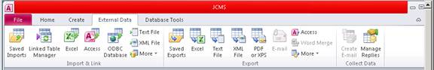

* Open JCMS
* Click the 'External Data' tab
* Click on 'ODBC Database'
* Select 'Link to the data source by creating a linked table' and click 'OK'
* Select the 'Machine Data Source' tab and click 'New...'
* Select the data source type that you desire and click 'Next>'
* Scroll down to 'MySQL ODBC 3.51 Driver', select it, and click 'Next>'
* Click 'Finish'
* Fill in the data details, the Server value will be 'localhost' if your database is on the local machine. User and password are your MySQL username and password. Click 'OK'
* Click 'Select All' and then click 'OK'

Below is a synopsis of the files distributed with the JCMS Access Interface.

| **File** | **Description** |
| --- | --- |
| ReadMe.pdf | This file |
| license.txt | The license that you agreed to when you registered to download this distribution. |
| JCMS_ReleaseNotes.pdf | Any points of user interest in this release including any issues that may not be covered in the user guide. |
| JCMS_UserGuide.pdf | A user manual, in PDF format, explaining the installation and configuration, and operation of the software. |
| JCMS.mdb | The Forms, Queries, Reports and VB modules. **This is the file you open with Microsoft Access.** |
| JCMSInstall-Upgrade-guide.pdf | The user guide for the installation and upgrade process. |