#### **Page 1 Home Page Edits**

#### 

#### 1st Section

#### 

#### **Headline** - Global e-commerce order fulfilment & logistics specialists

#### **Body Text** - We handle your fulfilment operations in the UK so your business can continue to grow!

**Feature button -** Get in touch (link to form)

2nd Section

Delete the ‘Who are we?’ and put this below

**Headline** - Vibe65 Benefits

### Client comes first - Our business is putting yours first!

# 24-72hr Turnaround times - Depending on your chosen service level, we can get goods out same-day!

# Photograph and Video updates - Never miss out on where your products are or whats happening with them!

# Operational flexibility - Bespoke is our middle name, we are happy to offer tailor-made solutions for your business.

# E-commerce Sellers - Our industry expertise uniquely positions us to offer a range of services that are tried and tested with our own e-commerce businesses.

Our Main Services

Please add to this section the following:

Container Receiving, Returns Processing, Next Day Shipping

Hyperlink all elements to the fulfilment service pricing page.

Final Section

**Headline** - FAQs

## **What is your minimum order quantity?**

Our minimum order quantity varies depending on the service but we usually specify a minimum order quantity of 1000 units for Prep services. Bespoke quotations are given on an individual client basis.

**Page 2 - Fulfilment Service Pricing**

Headline - Fulfilment Pricing Plan

Sub-headline - Basic Fulfilment Account Plan £97/month

Body - Our basic fulfilment pricing plan gives you access to our B2B and Amazon FBA services and includes the following:

* 1000 unit MOQ
* Weekly Stock Report
* Customer Service 9am - 5pm (GMT)
* Quarterly Business Strategy Call
* 72hr turnaround time on projects
* Access to all FBA Prep and B2B Prep services

Sub-headline - Premium Fulfilment Account Plan £197

Body - Our premium fulfilment plan is best suited for customers that would like us to handle all of their fulfilment needs, including D2C orders. Included as standard:

* No MOQ
* 5% discount on all services
* Weekly Stock Report
* Customer Service 7am - 11pm (GMT)
* Monthly Business Strategy Call
* 24hr turnaround time on projects
* Access to all fulfilment services

**How does our process work graphic**

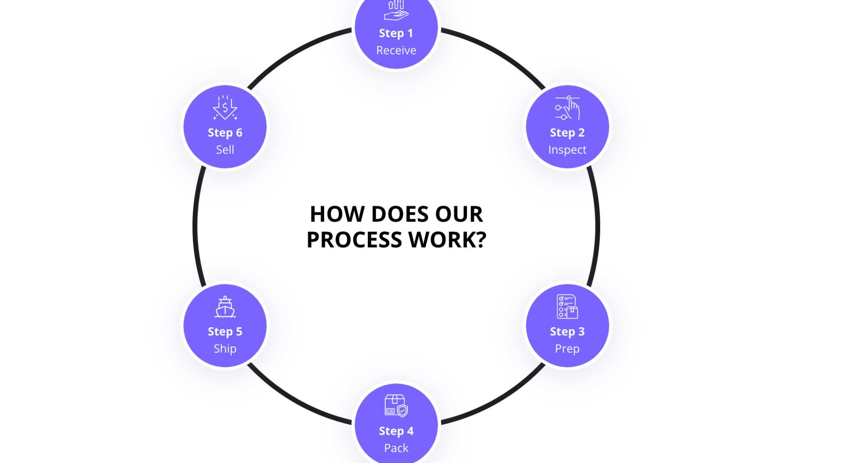

**Headline** - Pricing Example based on 1000 units

Receiving Services

* Container 40ft (handstacked) - £575
* Container 40ft (palletised) - £385
* Pallet (2m max height) - £3.75
* Carton (up to 15kg) - £0.75

Amazon FBA Prep Services (per unit)

* Standard Prep (inspection,labelling,processing,packing) - £0.40
* Oversize Prep (items 15kg and over) - £0.95
* Product Bundles - £0.55 first 2 items then £0.10 per additional item
* Bubble Wrap - £0.30
* Pallet Prep (stacking, wrapping and labelling) - £6.75

B2B & D2C Services (per unit)

* Single-item (pick,pack,ship) - £0.75
* Multi-item (pick,pack,ship) - £0.75, then £0.15 per additional item
* Box forwarding (no prep or inspection) - £2.75
* Pallet forwarding (no prep or inspection) - £4.75

Additional Services (per unit)

* Product re-work and kitting - Contact us for a quote
* Box charge - £1.75
* Polybag charge - £0.05
* Pallet movement fee - £2.15
* Pallet Charge - £6.75
* Returns processing - £0.40
* Disposal Charge - £0.75 (liquids and hazardous items quoted separately)

Storage Services (per week)

* Pallet short-term - £5
* Pallet long-term - £3
* Shelf space 185x60x60cm - £2.50

Shipping Services

* UK Mainland Next day (up to 15kg) - £6.75
* Pallet Delivery - Contact us for a quote

**Page 3 - Trusted Partner Network**

**Coming soon…**

**Page 4 - Blog**

**Page 5 - Contact Us**

**Form that is on home page**

**Footer**

## **FHDDS Number: XDFH00000100691**

## **Company Number: 13759693**

**Other all done but only contact form integration left ….i add the plugin but pro vision is require and all also api of CRM**