CS 250 Spring 2017 - Homework 01

Due 11:58pm Wednesday, January 18, 2017

**Submit your typewritten file in PDF format to Blackboard.**

The policy for all homework assignments this semester is as follows. Please sign, which you may do by typing in your name.

*In the following have not represented the work of another person as my own nor have I knowingly or actively assist another person in violating this standard.*

(Signed)_Ryan Everett________________

1. How many distinct one-input Boolean functions are there?

4.

|  |  |
| --- | --- |
| A | ~A |
| 1 | Either 1 or 0 (2 options) |
| 0 | Either 1 or 0 (2 options) |

1. 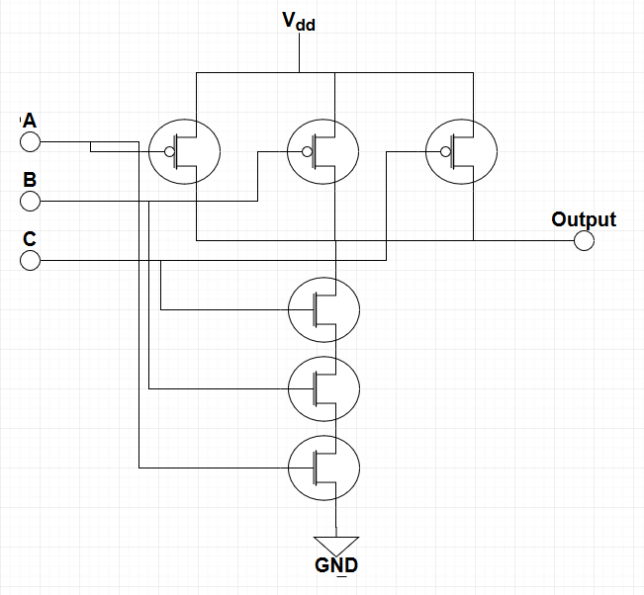What is the truth table for the three-input NAND function? Extend the two-input NAND circuit in the text Figure 2.5 to accept three inputs and draw a schematic.

|  |  |  |  |
| --- | --- | --- | --- |
| A | B | C | Output |
| 0 | 0 | 0 | 1 |
| 0 | 0 | 1 | 1 |
| 0 | 1 | 0 | 1 |
| 0 | 1 | 1 | 1 |
| 1 | 0 | 0 | 1 |
| 1 | 0 | 1 | 1 |
| 1 | 1 | 0 | 1 |
| 1 | 1 | 1 | 0 |

1. Using exactly 4 CMOS transistors, design and then draw a schematic for a NOR circuit. Comment on the relationship you see between the NAND circuit presented in class and our textbook and the NOR circuit that you develop.

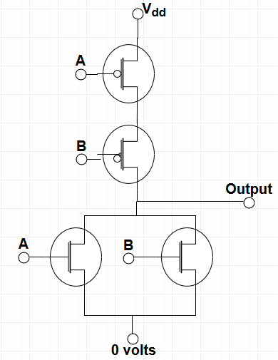

The NOR circuit is effectively the opposite of the presented NAND circuit. In the NAND implementation, the two parallel MOSFETs are the inverse transistors and connected to Vdd, but not in the NOR circuit. The NOR circuit also inverts the two series MOSFETs and connects them to Vdd.

1. Name the Boolean function that this circuit implements.

AND

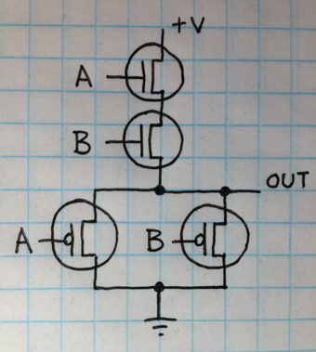

1. Let the input logic values to the following circuit be x=Don’t Care, y=0, and z=1. What is the logic value of the output f(x,y,z)?

**0** → NAND gate produces a 1, NOR gate produces a 0 from inputs 1,1.  
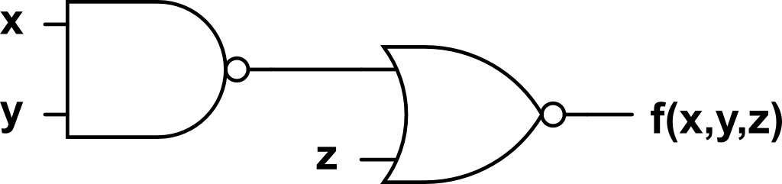

1. Under what conditions does a full adder generate Sum = 0 and Carry out = 1 from Augend, Addend, and Carry in? Show your answer in the form of a table.

|  |  |  |  |  |
| --- | --- | --- | --- | --- |
| Aug | Add | Carryin | Carryout | Sum |
| 0 | 0 | 0 | 0 | 0 |
| 0 | 0 | 1 | 0 | 1 |
| 0 | 1 | 0 | 0 | 1 |
| 0 | **1** | **1** | **1** | **0** |
| 1 | 0 | 0 | 0 | 1 |
| 1 | **0** | **1** | **1** | **0** |
| 1 | **1** | **0** | **1** | **0** |
| 1 | 1 | 1 | 1 | 1 |

1. What is the key idea that shows how to use fundamentally analog circuits so that they behave digitally?

Analog values can be made to behave digitally by using a transistor to effectively regular voltage values between two different options: 5v (HIGH) or 0v (LOW). By continually separating the voltage into these two categories, the error associated with analog values effectively vanishes. These two voltage values can be easily be used to represent digital where HIGH represents a 1 and LOW represents a 0.

1. What principle allows for the simplification of descriptions of hardware by omission of unimportant detail?

By replacing a larger more detailed point of the circuit with a less-detailed block, it is easier for a designer to work with larger and more complicated designs. Logic gates are a good example of this because the designer does not have to focus on the internal transistor layout of the gate, the designer simply has to work with the inputs and outputs of the gate. By abstracting the gate to only its I/O, the circuit becomes easier to manage.

1. You are given (zero cost of acquisition) a Cray-2 and an iPad 2 and quality places to operate them. Assume that both computers has the same application program that you wish to run. Assertion: Since these computers are equally fast, you have no preference as to which one you use. State whether you agree or disagree with the assertion and explain why.

I disagree on the basis that there are more operating considerations than execution speed and application support. For instance, the Cray-2 uses immensely more power than the iPad 2 and is, arguably, harder to maintain/replace. Ease of use could be factored in as well in a scenario where multiple people might need to operate a machine. The physical dimensions of each machine could also be considered since the Cray-2 requires reinforced flooring to store. Ecosystem could also be considered; the Cray-2 might use standardized operating cables whereas the iPad has proprietary cabling. There are more considerations to be taken in order to create a preference.