CS 250 Spring 2017 Homework 03

Due 11:58pm Wednesday, February 01, 2017

Submit your typewritten file in PDF format to Blackboard.

1. If propagation delay in a combinatorial circuit is measured in gate delays, how long before all outputs are valid for a 16-bit ripple carry adder circuit?

**By the 4-bit adder circuit presented in Lecture 4, we can see that the carry out pin has a gate delay of 16. Each bit adder has a delay of 2. So 16*2 + 16*16 = 32 + 256 = 288.**

**288**

1. The rising-edge-triggered 74163 counter chip is being clocked with an SR latch, the same as in Lab 02.
   1. What is the shortest sequence of Set and Reset operations that will advance the count from 14 to 3? Use S to mean set and R to mean reset and write your answer in the form of an ASCII character string.

**If the counter chip has a toggle on CLR, toggling the CLR will reset the counter to 0. Then you only have to count to 3, or “LF,SOH,LF,SOH,LF,SOH”**

**Else, you have to count to 16 and then count to 3, or “LF,SOH,LF,SOH,LF,SOH,LF,SOH,LF,SOH”**

* 1. Extra thought: Using a regular expression, describe all sequences of Set and Reset that will drive the count from 14 to 3.

1. Consider the schematic below for the following questions. The difference between this circuit and the circuit of Lab 02 is that the 74163 counter has been removed.   
   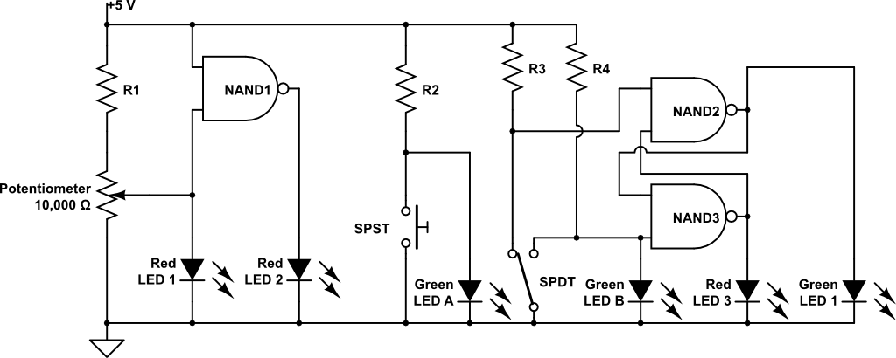  
   1. Which LED shows that it is possible to operate LEDs at half brightness rather than just fully off or fully on. Be sure to use the exact name shown in the schematic so that there is no ambiguity in your answer.

**LED1**

* 1. Name all LEDs in the schematic above that are connected to debounced clock signals. If no such LED exists, write “None.” Be sure to use the exact name shown in the schematic so that there is no ambiguity in your answer.

**None**

* 1. Let Red LED3 be the Q’ output of the S’R’ latch formed by NAND2 and NAND3. The moving pole of the SPDT switch has three positions: connected to R3 (R3, for a short name), in between the R3 and R4 contacts (B, for a short name) where the pole is connected to nothing, and connected to R4 (just called R4). Fill in the five missing entries in the following table for each time step from 0 to 5.

|  |  |  |
| --- | --- | --- |
| Time | SPDT position | Red LED 3 state |
| 0 | R3 | OFF |
| 1 | R3 | **ON** |
| 2 | B | **ON** |
| 3 | R4 | **OFF** |
| 4 | B | **OFF** |
| 5 |  | OFF |

1. Complete the table to show how the given binary strings are writing in each representational form. If a binary string is not valid for a given representation, write “error” in the table.

|  |  |  |
| --- | --- | --- |
| **Given binary string** | **Written as octal** | **Written as hexadecimal (0x)** |
| 110011011111 | 6337 | 0xCDF |
| 010111110001 | 2761 | 0x5F1 |

1. Complete the table to show how the given binary strings are interpreted in each data representation. For numerical representations write your answer in the form of a decimal number. Use care when writing a decimal number equivalent to show a sign when there is ambiguity if a sign is not shown. The table headings “1’s” and “2’s” are short for one’s complement and two’s complement, respectively. If a binary string is not valid for a given representation, write “error” in the table.

|  |  |  |  |  |  |
| --- | --- | --- | --- | --- | --- |
| **Given binary string** | **Unsigned integer** | **Sign magnitude** | **1’s** | **2’s** | **ASCII character** |
| 10110100 | 180 | -52 | -75 | -76 | error |
| 00000101 | 5 | +5 | 5 | 5 | ENQ |
| 00000000 | 0 | 0 | 0 | 0 | NUL |
| 11111111 | 255 | -127 | -1 | -1 | error |

1. What is the 16-bit representation of the 2’s complement number 11101010?  
     
   **0000000000010111**