**Embedded Processors UESTC Tutorial Assignment 2**

**Due: 13:30 on November 25, 2015**

**Submission: Hard copy to Prof. Meehan or in the Room 308 A1 mailbox**

# **Q1**. **[15 points]** You have a 10-bit DAC. Let Vout be the analog voltage in volts and D be the digital DAC input. The reference voltage is 3.6 V.

# Write a linear equation that relates Vout as a function of D.

$$Vout=\left(\frac{D}{2^{n}}\right)Vref= \left(\frac{D}{2^{10}}\right)3.6V≅3.52mV(D)$$

# What is the resolution of the DAC?

$$\left(\frac{Vref}{2^{n}}\right)=\left(\frac{3.6V}{2^{10}}\right)=3.52 mV$$

# Find D such that Vout as close as possible to 2.75 V. What is the value of Vout in this case?

$$D=Round\left[\frac{Vout}{Vref}\left(2^{10}\right)\right]=278$$

$$Vout=\left(\frac{D}{2^{n}}\right)Vref= \left(\frac{278}{2^{10}}\right)3.6V=2.74921785$$

# **Q2. [15 points]** You have a 12-bit signed ADC. Let Vin be the analog voltage in volts and N be the digital ADC output.

# The input range of -5V ≤ Vin ≤ +5V.

# The ADC digital output range is -2048 ≤ D ≤ +2047.

# Write a linear equation that relates Vin as a function of D.

$$D =Floor\left[\left(\frac{Vmax}{2^{n-1}}\right)Vin\right]= Floor\left[\left(\frac{5V}{2^{11}}\right)Vin\right]=Floor\left[\frac{Vin}{2.441mV}\right]$$

$$or$$

$$D=Floor\left[\left(\frac{Vin}{2^{n}}\right)Vrange\right]= Floor\left[\left(\frac{Vin}{2^{12}}\right)10V\right]=Floor\left[\frac{Vin}{2.441mV}\right]$$

# What are the possible input voltages when D = 0?

$$Vin= +/-1.2205 mV$$

**Q2**. **[20 points]** The following program produces a sine waveform through the DAC of a mbed development board. Sketch the output waveform.

# include “mbed.h”

AnalogOut Aout (p18);

float i;

int main()

{

while (1)

{

For (i=0; i<2; i=i+0.25)

{

Aout = 0.5 + 0.5*sin(i*3.14159);

wait (0.001);

}

}

}

**Q4 [20 points]** You need to set up a serial peripheral interface (SPI) network, which will have one Master and four Slaves. In every second, data is sent between the Master to the Slaves in the following sequence:

* one byte is sent to Slave 1, which then sends two bytes of data back to the Master,
* four bytes are sent to Slave 2, which then sends one byte of data back to the Master,
* three bytes are sent to Slave 3, which does not send any data back to the Master
* and four bytes are sent to Slave 4, which then sends two bytes of data the Master.
  1. Draw a block diagram that shows how the Master and two of the Slaves will be connected and label the pins on the Master.

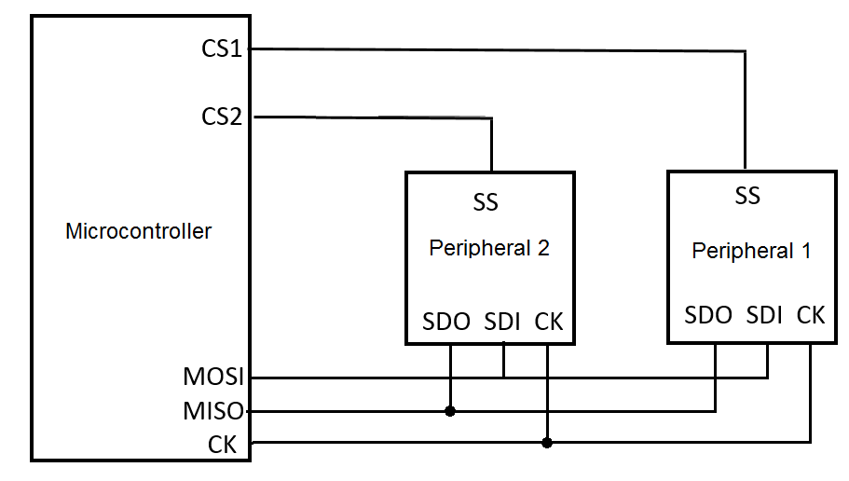

* 1. If the complete data transfer must take not more than 200 us, estimate the minimum clock frequency which is allowable for SPI. Assume nothing else contributes to the time required to transmit the data.

Total number of bytes transfer = 1 + 2 + 4 + 1 + 3 + 0 + 4 + 2 = 17 bytes

Minimum clock frequency = $\frac{17 bytes \left(8\frac{bits}{byte}\right)}{200 μs}$ = 680 KHz