7. [d]

8. [b]

9. [e]

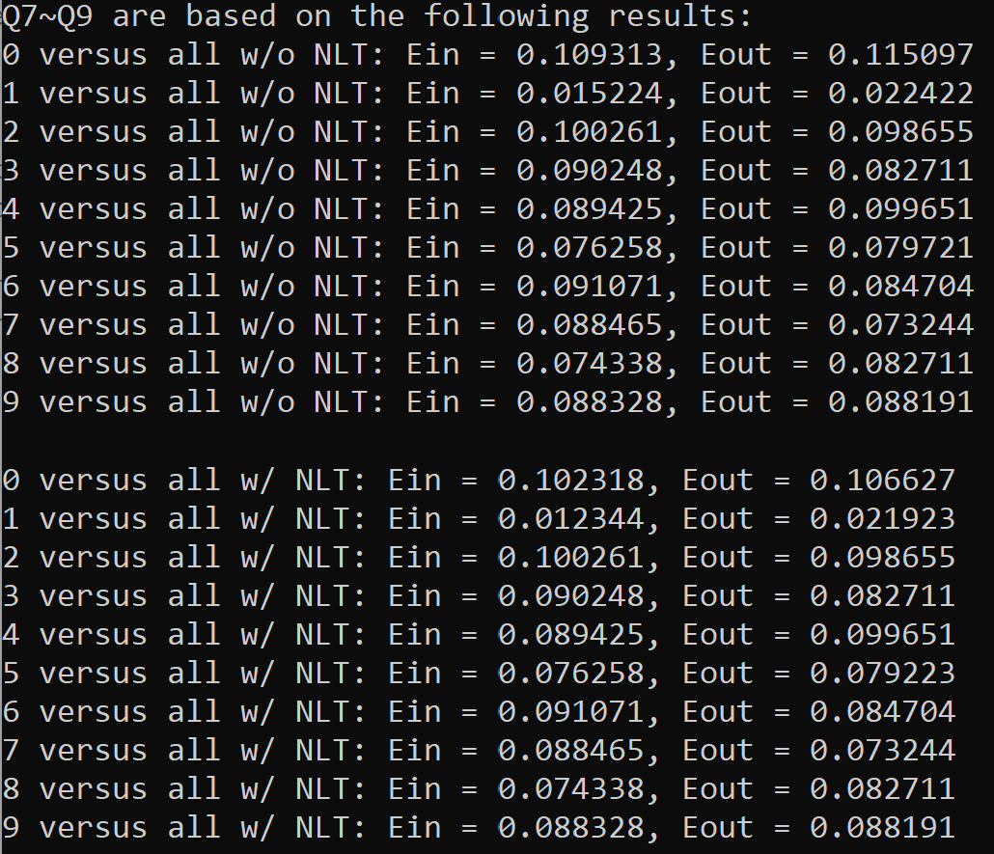

For ‘1 versus all’ with and without nonlinear transform, Eout is small (no overfitting observed, 9[a] wrong);

For ‘9 versus all’ with and without nonlinear transform, Eout is of the same, 9[b] wrong;

For ‘0 versus all’ before and after nonlinear transform, Eout becomes smaller, 9[c][d] wrong;

For ‘5 versus all’, Eout w/o NLT =0.079721, Eout w/ NLT = 0.079223, improvement = 0.6%, 9[e] correct.

10. [a]

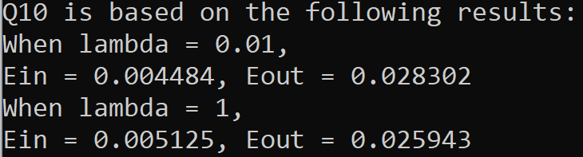

Q7~Q10 are based on the following codes:

import numpy as np

class RegularizedLinearRegression:

def __init__(self, dim, lamda):

self.weights = np.zeros((dim + 1,1))

self.lamda = lamda

def X_new(self,X):

examples = X.shape[0]

X_new = np.c_[np.ones(examples), X]

return X_new

def train_regularization(self, X,Y): # training with regularization: (ZT*Z + lambda*I)^-1 * ZT*y

X_new = self.X_new(X)

xTx = np.dot(X_new.T, X_new)

lI = np.multiply(self.lamda, np.identity(xTx.shape[0])) # lambda*I

inv_X = np.linalg.inv(np.add(xTx, lI))

self.weights = np.dot(inv_X, np.dot(X_new.T, Y))

def predict(self,X):

X_new = self.X_new(X)

h = np.matmul(X_new, self.weights)

return h

def calc_error(self, X,Y):

examples = X.shape[0]

predict = np.sign(self.predict(X))

num_error = np.sum(np.not_equal(predict, np.sign(Y)))

error = float(num_error)/float(examples)

return error

class NonlinearTrans(RegularizedLinearRegression):

def __init__(self, dim, lamda):

self.dim = (2*dim + 1) # 1, x1, x2, x1^2, x2^2, x1*x2

self.weights = np.zeros((self.dim + 1, 1))

self.lamda = lamda

def change_lambda(self, lamda):

self.lamda = lamda

def X_new(self,X):

examples = X.shape[0]

X_multiply = np.prod(X, axis=1) # x1*x2

X_subtract = np.c_[X[:,0],-X[:,1]] # x1 -x2

X_new = np.c_[np.ones(examples), X, X_multiply, np.square(X)]

return X_new

def set_labels_all(x, Y): # x = desired digit in 'x versus all'

Y_labeled = np.array([])

for i in np.arange(Y.shape[0]):

if Y[i] == x:

Y_labeled = np.append(Y_labeled, 1)

else:

Y_labeled = np.append(Y_labeled, -1)

return Y_labeled

def set_labels_one(x1, x2, X, Y): # x1, x2 = desired digits in 'x1 versus x2'

X_labeled = np.array([])

Y_labeled = np.array([])

for i in np.arange(Y.shape[0]):

if Y[i] == x1:

X_labeled = np.concatenate((X_labeled, X[i,:]))

Y_labeled = np.append(Y_labeled, 1)

if Y[i] == x2:

X_labeled = np.concatenate((X_labeled, X[i,:]))

Y_labeled = np.append(Y_labeled, -1)

X_labeled = X_labeled.reshape((Y_labeled.shape[0], X.shape[1]))

return X_labeled, Y_labeled

def load_data(filename_train, filename_test):

data_train = np.loadtxt(filename_train)

X_train = data_train[:, 1:] # delete 1st digit term (Y)

Y_train = data_train[:, :1] # extract 1st digit term (Y)

data_test = np.loadtxt(filename_test)

X_test = data_test[:, 1:] # delete 1st digit term (Y)

Y_test = data_test[:, :1] # extract 1st digit term (Y)

# data = np.r_[data_train, data_test]

return X_train, Y_train, X_test, Y_test

def main():

X_train, Y_train, X_test, Y_test = load_data('features.train','features.test')

print("Q7~Q9 are based on the following results:")

RegLR = RegularizedLinearRegression(X_train.shape[1], 1) # lambda = 1

for x in range(10):

Y_train_all = set_labels_all(x, Y_train)

Y_test_all = set_labels_all(x, Y_test)

RegLR.train_regularization(X_train, Y_train_all)

print("%d versus all w/o NLT: Ein = %f, Eout = %f" % (x, RegLR.calc_error(X_train, Y_train_all), RegLR.calc_error(X_test, Y_test_all)))

print("")

NLT = NonlinearTrans(X_train.shape[1], 1) # lambda = 1

for x in range(10):

Y_train_all = set_labels_all(x, Y_train)

Y_test_all = set_labels_all(x, Y_test)

NLT.train_regularization(X_train, Y_train_all)

print("%d versus all w/ NLT: Ein = %f, Eout = %f" % (x, NLT.calc_error(X_train, Y_train_all), NLT.calc_error(X_test, Y_test_all)))

print("")

print("Q10 is based on the following results:")

X_train_one, Y_train_one = set_labels_one(1, 5, X_train, Y_train)

X_test_one, Y_test_one = set_labels_one(1, 5, X_test, Y_test)

print("When lambda = 0.01,")

NLT.change_lambda(0.01) # lambda = 0.01

NLT.train_regularization(X_train_one, Y_train_one)

print("Ein = %f, Eout = %f" % (NLT.calc_error(X_train_one, Y_train_one), NLT.calc_error(X_test_one, Y_test_one)))

print("When lambda = 1,")

NLT.change_lambda(1) # lambda = 0.01

NLT.train_regularization(X_train_one, Y_train_one)

print("Ein = %f, Eout = %f" % (NLT.calc_error(X_train_one, Y_train_one), NLT.calc_error(X_test_one, Y_test_one)))

if __name__== "__main__":

main()

11. [c]

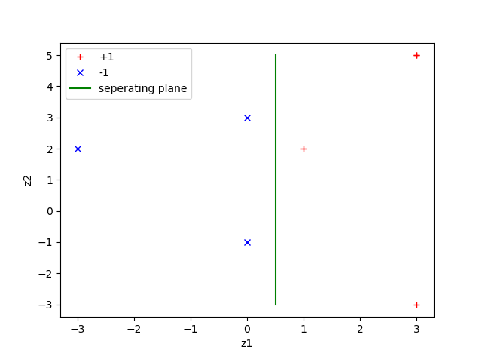

From the figure we can see that z1 = 0.5 is the separating plane in Z space.

In this case, let w1 = 1, w2 = 0. Then b = -0.5. [c] correct

12. [c]

Number of support vectors = 5.

Q11~Q12 are based on the following codes:

import numpy as np

from sklearn import svm

import matplotlib.pyplot as plt

X_train = np.array([[1,0],[0,1], [0,-1], [-1,0], [0,2],[0,-2], [-2,0]])

Y_train = np.array([-1,-1,-1,1,1,1,1])

x1 = X_train[:, :1]

x2 = X_train[:, 1:]

z1 = pow(x2,2.0) - 2 * x1 - 1

z2 = pow(x1,2.0) - 2 * x2 + 1

z1p = np.array([z1[i] for i in np.where(Y_train == 1)]).flatten()

z2p = np.array([z2[i] for i in np.where(Y_train == 1)]).flatten()

z1n = np.array([z1[i] for i in np.where(Y_train == -1)]).flatten()

z2n = np.array([z2[i] for i in np.where(Y_train == -1)]).flatten()

plt.plot(z1p, z2p, 'r+', label='+1')

plt.plot(z1n, z2n, 'bx', label='-1')

plt.plot([0.5, 0.5], [-3.0, 5.0], 'g-', label='seperating plane')

plt.xlabel('z1')

plt.ylabel('z2')

plt.legend()

plt.show()

clf = svm.SVC(C = np.inf, kernel = 'poly', degree = 2, coef0 = 1, gamma = 1) # C = infinite for hard-margin SVM with 2nd order polynomial kernel with intercept coef0 = 1

# For simplicity, take gamma = 1, same in Lecture 15 page 7

Z = np.c_[z1, z2]

clf.fit(Z, Y_train)

print("number of support vectors: ", sum(clf.n_support_))

13. [a]

14. [e]

15. [d]

16. [d]

17. [c]

18. [a]

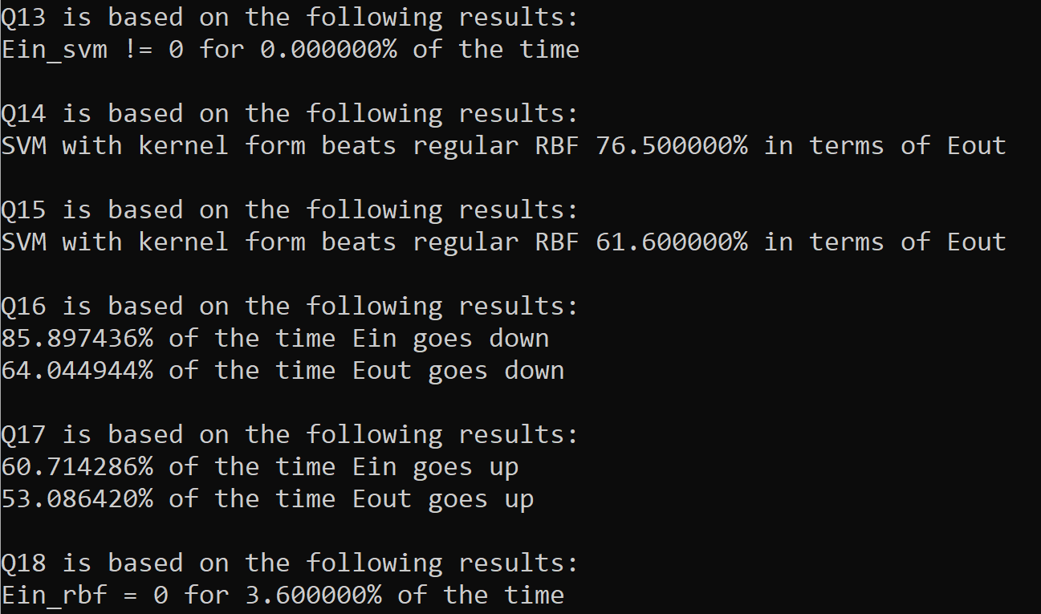

Q13~Q18 are based on the following codes:

import numpy as np

from sklearn import svm

def rb_func(x, mu, gamma):

return np.exp(-gamma * np.linalg.norm(x - mu) ** 2)

def rb_matrix(X, mu, gamma, row, column):

rb_matrix = np.zeros((row, column))

for i in range(row):

for k in range(column):

rb_matrix[i,k] = rb_func(X[i], mu[k], gamma)

return rb_matrix

class kmeans_RBF:

def __init__(self, num_clusters = None, gamma = None):

self.K = num_clusters # K = number of clusters

self.mu = None

self.cluster_x = None # for each point x the cluster it belongs to

self.weights = None

self.gamma = gamma

def k_means(self, N_train, X_train):

centers = np.random.uniform(-1,1,(self.K,2)) # initial random cluster centers

cluster_empty = False

cluster_of_x = -1 * np.ones(N_train)

previous_cluster = -1 * np.ones(N_train) # differentiate no change from iteration to iteration

for i in range(100000): # Lloyd, take maximum iterations as 100000

S = [[] for _ in range(self.K)] # initialize clusters

for index, x in enumerate(X_train): # for a given cluster center, assign all points to cluster

min_dist = np.inf

min_clst = -1

for mu_index, mu in enumerate(centers):

dist = np.linalg.norm(x - mu)

if dist < min_dist:

min_dist = dist

min_clst = mu_index

S[min_clst].append(x)

cluster_of_x[index] = min_clst

for cluster in S:

if not cluster:

cluster_empty = True

if cluster_empty or (cluster_of_x == previous_cluster).all():

break

previous_cluster = cluster_of_x

# [cluster_index for cluster_index in cluster_of_x]

for index, cluster in enumerate(S):

mu = sum(cluster) / len(cluster) # for a given cluster, assign new cluster centers

centers[index] = mu

return centers, cluster_of_x, cluster_empty

def fit(self, X_train, y):

while True:

N_train = X_train.shape[0]

centers, cluster_of_x, cluster_empty = self.k_means(N_train, X_train)

if (cluster_empty == True): # if cluster empty, repeat iterations

continue

self.mu = centers

self.cluster_x = cluster_of_x

phi = rb_matrix(X_train, self.mu, self.gamma, N_train, self.K)

phi_new = np.c_[np.ones(N_train), phi] # add 1st column for bias

pinv_phi = np.linalg.pinv(phi_new) # pseudo inverse

self.weights = np.dot(pinv_phi,y)

break

def predict(self, X_test): #Takes points X, Returns predicted y

N_test = X_test.shape[0]

phi = rb_matrix(X_test, self.mu, self.gamma, N_test, self.K)

phi_new = np.c_[np.ones(N_test), phi] # add 1st column for bias

y_predicted = np.sign(np.dot(phi_new, self.weights))

return y_predicted

def f(x1, x2):

return np.sign(x2 - x1 + 0.25 * np.sin(np.pi * x1)) # target function

def data_set(num_pts):

x1 = np.random.uniform(-1,1,num_pts)

x2 = np.random.uniform(-1,1,num_pts)

X_train = np.c_[x1, x2]

Y_train = f(x1, x2)

return X_train, Y_train

def compare_svm_with_rbf(K, gammaa):

count = 0

for num_run in np.arange(1000): # run 1000 times to make sure stable

X_train, Y_train = data_set(100) # each time generate 100 points

X_test, Y_test = data_set(100) # each time generate 100 points

clf = svm.SVC(C = np.inf, kernel = 'rbf', gamma = gammaa)

clf.fit(X_train, Y_train)

Ein_svm = sum(clf.predict(X_train) != Y_train) / 100

if Ein_svm > 0:

continue

Eout_svm = sum(clf.predict(X_test) != Y_test) / 100

rbf = kmeans_RBF(num_clusters = K, gamma = gammaa)

rbf.fit(X_train, Y_train)

Eout_rbf = sum(rbf.predict(X_test) != Y_test) / 100

if Eout_svm < Eout_rbf:

count += 1

print("SVM with kernel form beats regular RBF %f%% in terms of Eout" % (count / 1000 * 100))

def compare_regular_rbf(K, gammaa):

Ein_down = 0

Ein_up = 0

Eout_down = 0

Eout_up = 0

for num_run in np.arange(100): # run 100 times

X_train, Y_train = data_set(100) # each time generate 100 points

X_test, Y_test = data_set(100) # each time generate 100 points

Ein = [None, None] #compare regular RBF with K = 9 and K = 12

Eout = [None, None]

for i in np.arange(2):

rbf = kmeans_RBF(num_clusters = K[i], gamma = gammaa[i])

rbf.fit(X_train, Y_train)

Ein_rbf = sum(rbf.predict(X_train) != Y_train) / 100

Eout_rbf = sum(rbf.predict(X_test) != Y_test) / 100

Ein[i] = Ein_rbf

Eout[i] = Eout_rbf

if (Ein[0] > Ein[1]):

Ein_down += 1

if (Ein[0] < Ein[1]):

Ein_up += 1

if (Eout[0] > Eout[1]):

Eout_down += 1

if (Eout[0] < Eout[1]):

Eout_up += 1

if (Ein_down > Ein_up):

print("%f%% of the time Ein goes down" % (Ein_down / 100 * 100))

elif (Ein_down < Ein_up):

print("%f%% of the time Ein goes up" % (Ein_up / 100 * 100))

else:

print("Ein remains the same")

if (Eout_down > Eout_up):

print("%f%% of the time Eout goes down" % (Eout_down / 100 * 100))

elif (Eout_down < Eout_up):

print("%f%% of the time Eout goes up" % (Eout_up / 100 * 100))

else:

print("Eout remains the same")

print("")

def main():

print("Q13 is based on the following results:")

Ein = np.array([])

for num_run in np.arange(1000): # run 1000 times to make sure stable

X_train, Y_train = data_set(100) # each time generate 100 points

clf = svm.SVC(C = np.inf, kernel = 'rbf', gamma = 1.5)

clf.fit(X_train, Y_train)

Ein = np.append(Ein, sum(clf.predict(X_train) != Y_train) / 100)

Ein_svm = sum(Ein[i] != 0 for i in np.arange(1000)) / 100

print("Ein_svm != 0 for %f%% of the time" % (Ein_svm * 100))

print("")

print("Q14 is based on the following results:")

compare_svm_with_rbf(9, 1.5)

print("")

print("Q15 is based on the following results:")

compare_svm_with_rbf(12, 1.5)

print("")

print("Q16 is based on the following results:")

compare_regular_rbf([9, 12], [1.5, 1.5])

print("Q17 is based on the following results:")

compare_regular_rbf([9, 9], [1.5, 2])

print("Q18 is based on the following results:")

count = 0

for num_run in np.arange(1000): # run 1000 times to make sure stable

X_train, Y_train = data_set(100) # each time generate 100 points

X_test, Y_test = data_set(100) # each time generate 100 points

rbf = kmeans_RBF(num_clusters = 9, gamma = 1.5)

rbf.fit(X_train, Y_train)

if sum(rbf.predict(X_train) != Y_train) / 100 == 0:

count += 1

print("Ein_rbf = 0 for %f%% of the time" % (count / 1000 * 100))

if __name__== "__main__":

main()