**Q2 and Q3 are based on the following codes:**

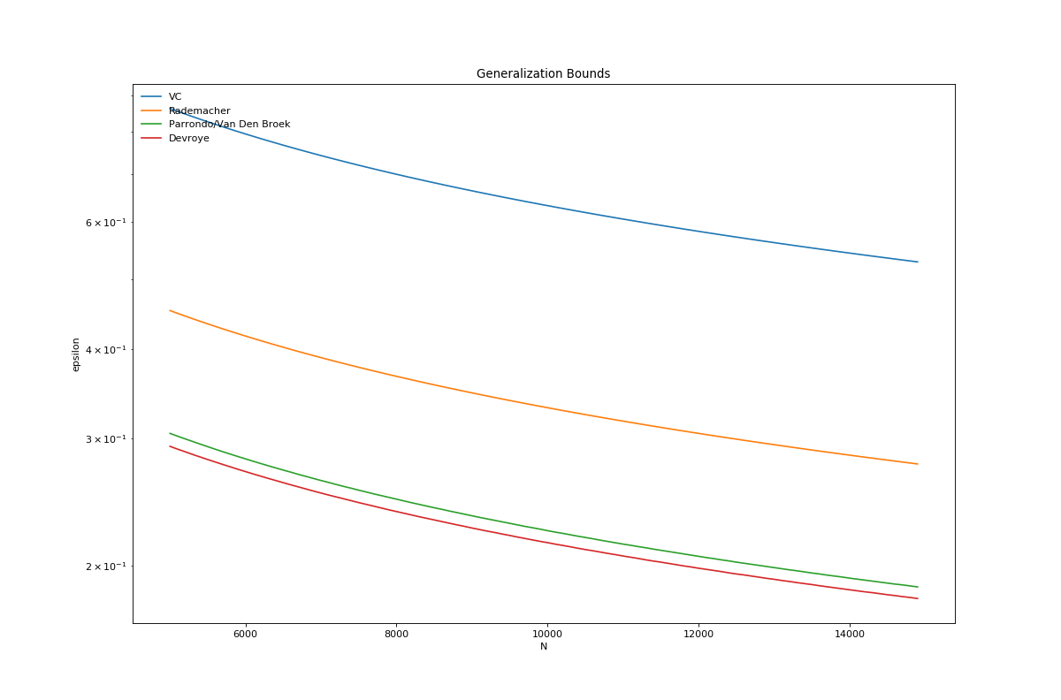

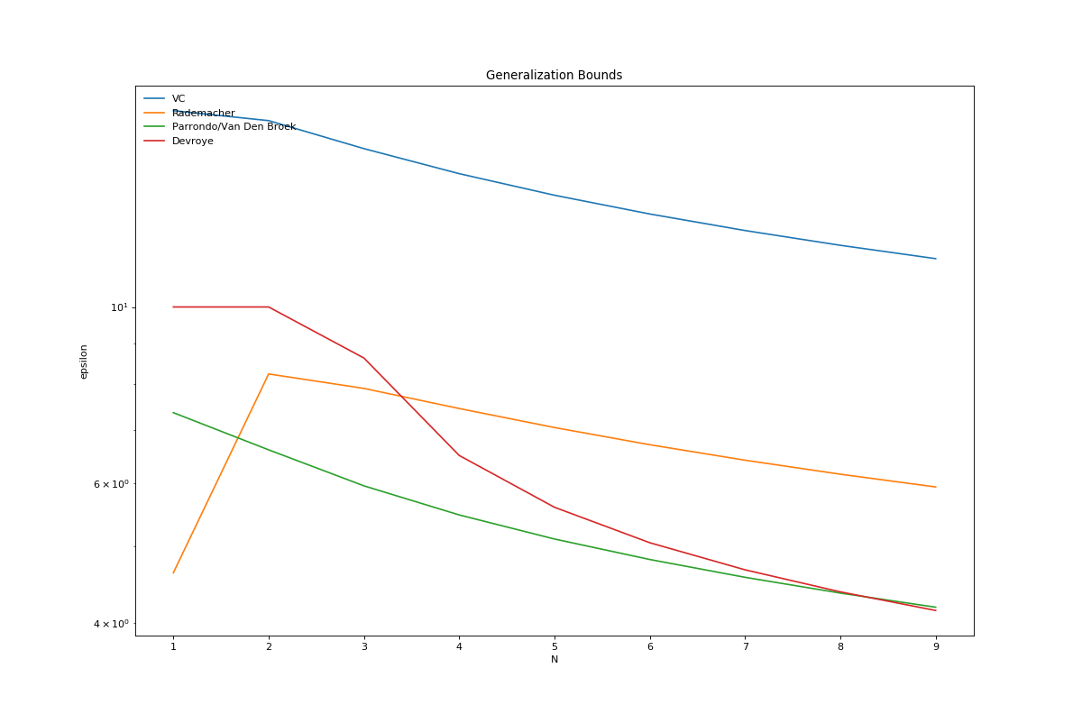

import numpy as np

import matplotlib.pyplot as plt

import math

def vc_eps(delta, N, dvc):

return math.sqrt((8.0/N)*((dvc*math.log(2.0*N))-math.log(delta/4.0)))

def rademacher_eps(delta, N, dvc):

cur_eps = math.sqrt((2.0/N)*(math.log(2.0*N)+(dvc*math.log(N)))) + math.sqrt((2.0/N) * math.log(1.0/delta)) + (1.0/N)

return cur_eps

eps_range = np.arange(0.0,10, 0.0001)

def parrondo_eps(delta, N, dvc):

last_true = False

last_eps = eps_range[0]

for cur_eps in eps_range:

cur_rightside = (1.0/N) * ((2.0*cur_eps) + math.log(6.0/delta) + (dvc*math.log(2.0*N)))

cur_rightside = math.sqrt(cur_rightside)

cur_true = cur_eps <= cur_rightside

if cur_true == False and last_true == True:

break

elif cur_true == True:

last_true = True

last_eps = cur_eps

return last_eps

def devroye_eps(delta, N, dvc):

last_true = False

last_eps = eps_range[0]

for cur_eps in eps_range:

cur_rightside = (1.0/(2.0*N))*(((4.0*cur_eps)*(1.0+cur_eps)) + math.log(4.0/delta) + ((2.0*dvc)*math.log(N)))

cur_rightside = math.sqrt(cur_rightside)

cur_true = cur_eps <= cur_rightside

if cur_true == False and last_true == True:

break

elif cur_true == True:

last_true = True

last_eps = cur_eps

return last_eps

def main():

vc_func = np.vectorize(vc_eps)

rademacher_func = np.vectorize(rademacher_eps)

parrondo_func = np.vectorize(parrondo_eps)

devroye_func = np.vectorize(devroye_eps)

prob2 = {}

prob2["N"] = np.arange(5000,15000, 100)

prob2["vc"] = vc_func(0.05, prob2["N"], 50)

prob2["rad"] = rademacher_func(0.05, prob2["N"], 50)

prob2["par"] = parrondo_func(0.05, prob2["N"], 50)

prob2["dev"] = devroye_func(0.05,prob2["N"],50)

prob2["plot"] = plt.figure(figsize=(15,10), dpi=80)

prob2["ax"] = prob2["plot"].add_subplot(111)

prob2["ax"].set_title("Generalization Bounds")

prob2["ax"].set_xlabel("N")

prob2["ax"].set_ylabel("epsilon")

prob2["ax"].set_yscale("log", basey=10)

prob2["ax"].plot(prob2["N"], prob2["vc"], label="VC")

prob2["ax"].plot(prob2["N"], prob2["rad"], label="Rademacher")

prob2["ax"].plot(prob2["N"], prob2["par"], label="Parrondo/Van Den Broek")

prob2["ax"].plot(prob2["N"], prob2["dev"], label = "Devroye")

prob2["ax"].legend(loc='upper left', frameon=False)

plt.show()

if __name__== "__main__":

main()

**Q4 and Q7 are based on the following codes:**

f = @(x) sin(pi*x);

N = 10000; % Number of runs

% Average a

a = 0;

for i=1:N

x = unifrnd([-1 -1], [1 1]);

a_hat = (f(x(1))*x(1) + f(x(2))*x(2))/(x(1)^2 + x(2)^2);

a = a + a_hat;

end

a = a/N;

% Bias

b = 0;

for i=1:N

x = unifrnd(-1, 1);

b = b + (a*x - f(x))^2;

end

b = b/N;

% Variance

v = 0;

N = 150;

for i=1:N

x = unifrnd([-1 -1], [1 1]);

a_hat = (f(x(1))*x(1) + f(x(2))*x(2))/(x(1)^2 + x(2)^2);

t = 0;

for j=1:N

x = unifrnd(-1, 1);

t = t + (a_hat*x - a*x)^2;

end

v = v + t/N;

end

v = v/N;

%%

% Target function

f = @(x) sin(pi*x);

% Average a

a = 0;

% Number of runs

N = 20000;

% All of the given hypothesis are polynomials of degree 2

% We provide different learning algorithms for each type

fprintf('expected E_out A: %f\n', expectedOutOfSampleError(@learnA, f, N));

fprintf('expected E_out B: %f\n', expectedOutOfSampleError(@learnB, f, N));

fprintf('expected E_out C: %f\n', expectedOutOfSampleError(@learnC, f, N));

fprintf('expected E_out D: %f\n', expectedOutOfSampleError(@learnD, f, N));

fprintf('expected E_out E: %f\n', expectedOutOfSampleError(@learnE, f, N));

function e = expectedOutOfSampleError(learn, f, N)

% Approximates the expected out-of-sample error

%

% PARAMETERS

% learn - [function] The training function

% f - [function] The target function

% N - [1x1] Number of runs

%

% RETURN

% e - [1x1] Expected out-of-sample error

a = [0 0 0];

% Determine the average hypothesis

for i=1:N

% Sample two points

x = unifrnd([-1 -1], [1 1]);

% Determine a

a_hat = learn(x, f);

a = a + a_hat;

end

a = a/N;

% Compute the variance

v = 0;

for i=1:floor(sqrt(N))

% Sample two points

x = unifrnd([-1 -1], [1 1]);

% Determine a

w = learn(x, f);

t = 0;

for j=1:floor(sqrt(N))

x = unifrnd(-1, 1);

bx = [x^2; x; 1];

t = t + (a*bx - w*bx)^2;

end

v = v + t/floor(sqrt(N));

end

v = v/floor(sqrt(N));

% Compute the squared bias

% Compute the bias

b = 0;

for i=1:N

x = unifrnd(-1, 1);

bx = [x^2; x; 1];

b = b + (a*bx - f(x))^2;

end

b = b/N;

e = b+v;

end

function w = learnA(x, f)

% Trains the parameters for the hypothesis h(x) = c

%

% PARAMETERS

% x - [2x1] The training points

% f - [function] The target function

%

% RETURN

% w - [1x3] The weight vector

A = [1;1];

b = [f(x(1)); f(x(2))];

w_hat = A\b;

w = [0, 0, w_hat(1)];

end

function w = learnB(x, f)

% Trains the parameters for the hypothesis h(x) = bx

%

% PARAMETERS

% x - [2x1] The training points

% f - [function] The target function

%

% RETURN

% w - [1x3] The weight vector

A = [x(1);x(2)];

b = [f(x(1)); f(x(2))];

w_hat = A\b;

w = [0, w_hat(1), 0];

end

function w = learnC(x, f)

% Trains the parameters for the hypothesis h(x) = bx + c

%

% PARAMETERS

% x - [2x1] The training points

% f - [function] The target function

%

% RETURN

% w - [1x3] The weight vector

A = [x(1), 1;x(2), 1];

b = [f(x(1)); f(x(2))];

w_hat = A\b;

w = [0, w_hat(1), w_hat(2)];

end

function w = learnD(x, f)

% Trains the parameters for the hypothesis h(x) = ax^2

%

% PARAMETERS

% x - [2x1] The training points

% f - [function] The target function

%

% RETURN

% w - [1x3] The weight vector

A = [x(1)^2;x(2)^2];

b = [f(x(1)); f(x(2))];

w_hat = A\b;

w = [w_hat(1), 0, 0];

end

function w = learnE(x, f)

% Trains the parameters for the hypothesis h(x) = ax^2 + b

%

% PARAMETERS

% x - [2x1] The training points

% f - [function] The target function

%

% RETURN

% w - [1x3] The weight vector

A = [x(1)^2, 1;x(2)^2, 1];

b = [f(x(1)); f(x(2))];

w_hat = A\b;

w = [w_hat(1), 0, w_hat(2)];

end