实验3

校正前

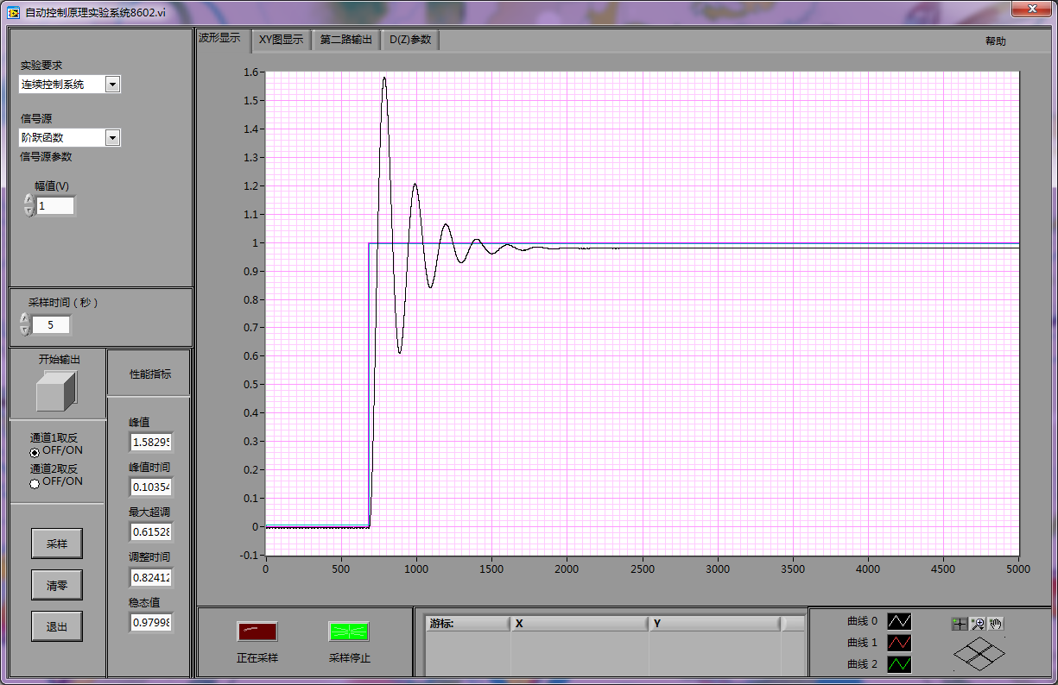

校正

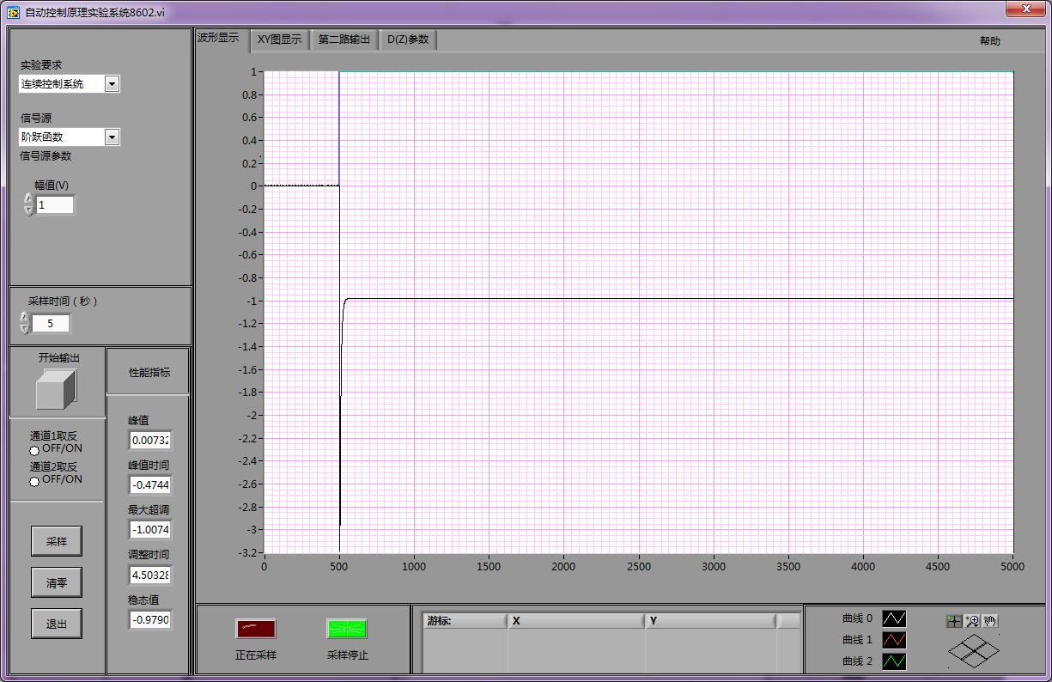

校正后

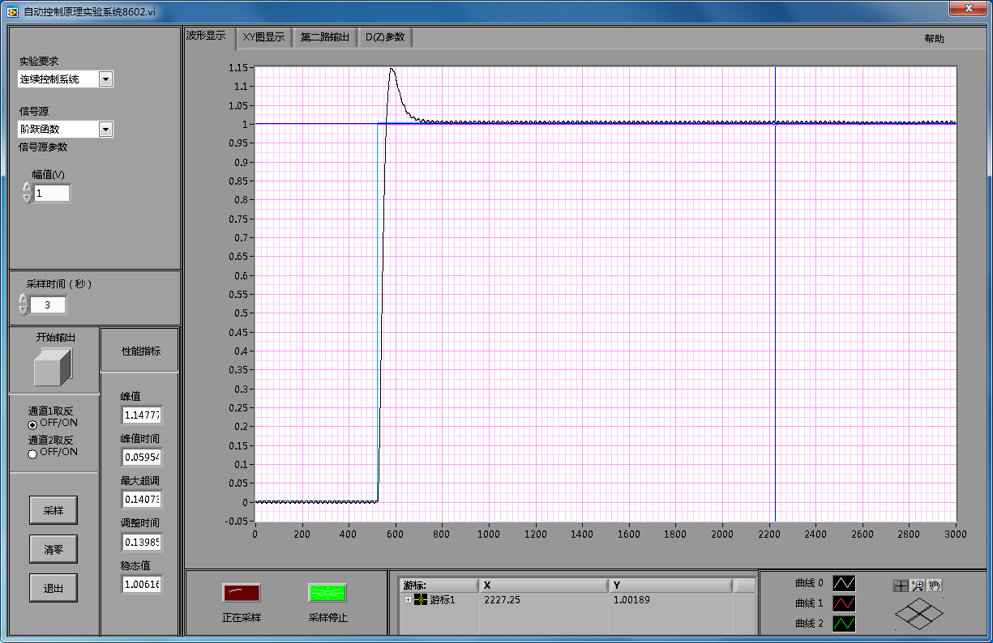

实验8

校正前

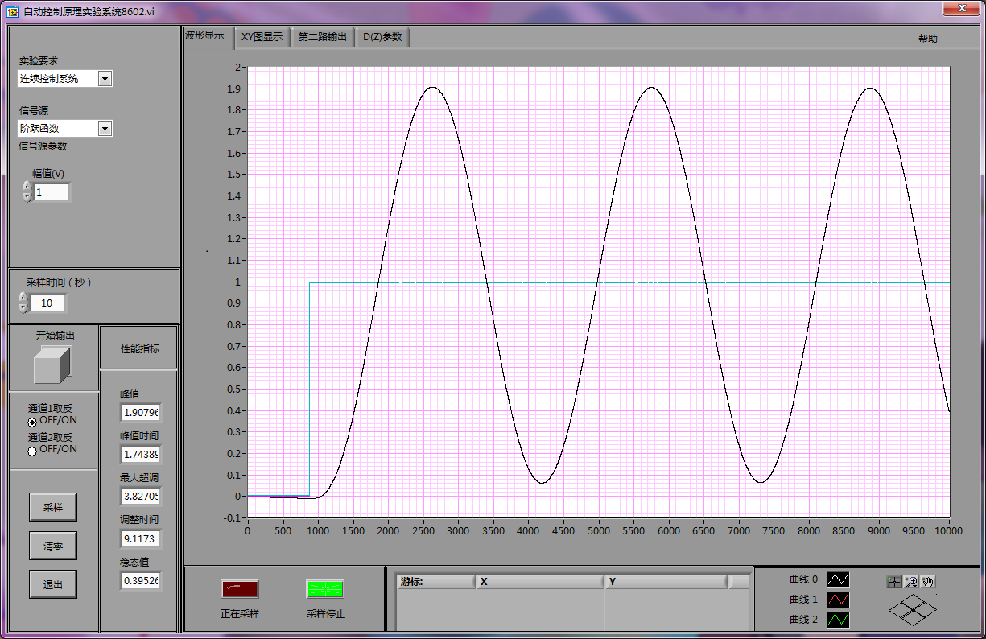

校正

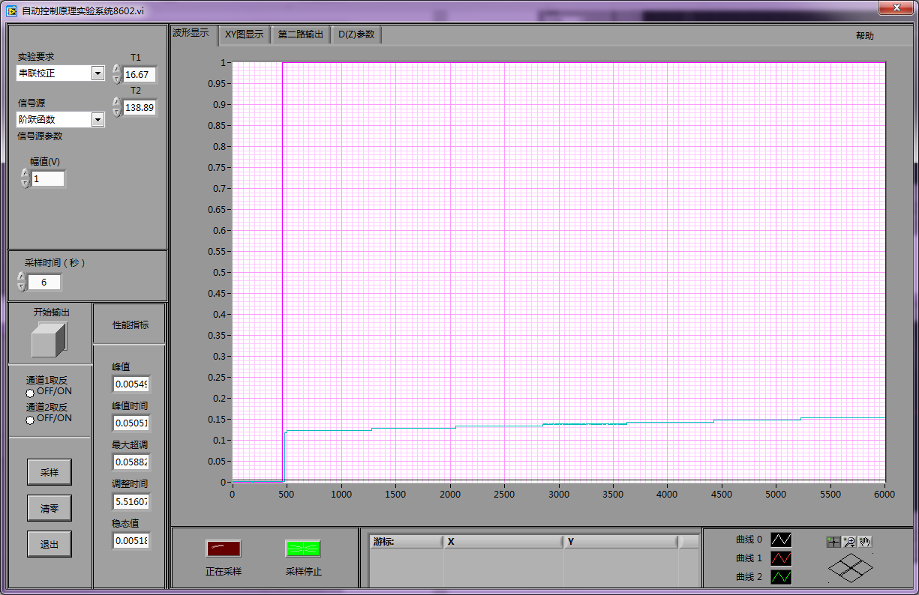

校正后

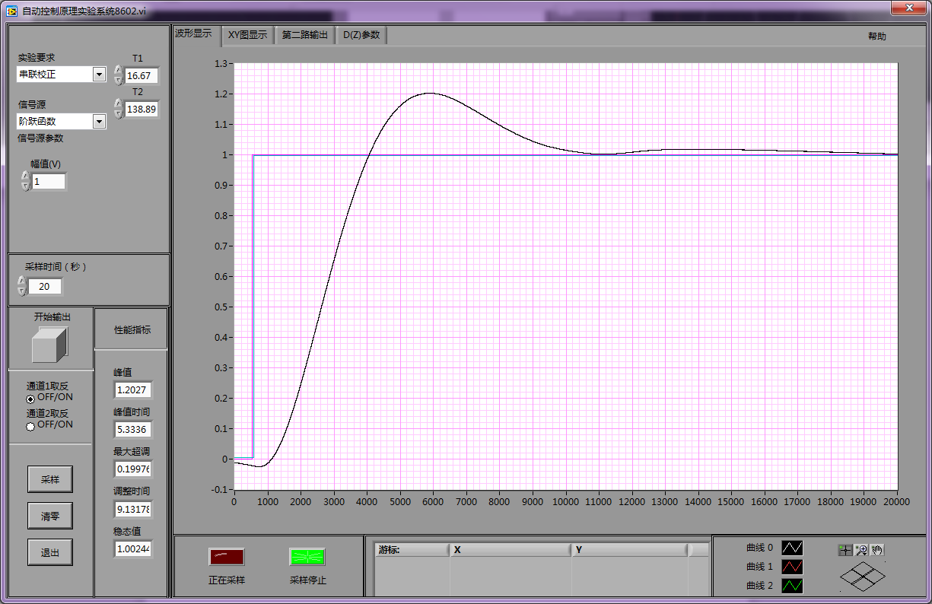

Simulink仿真

实验3

校正前

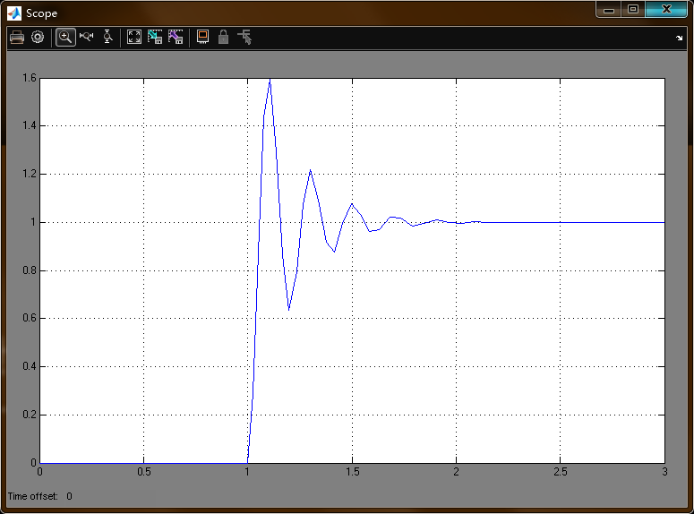

校正

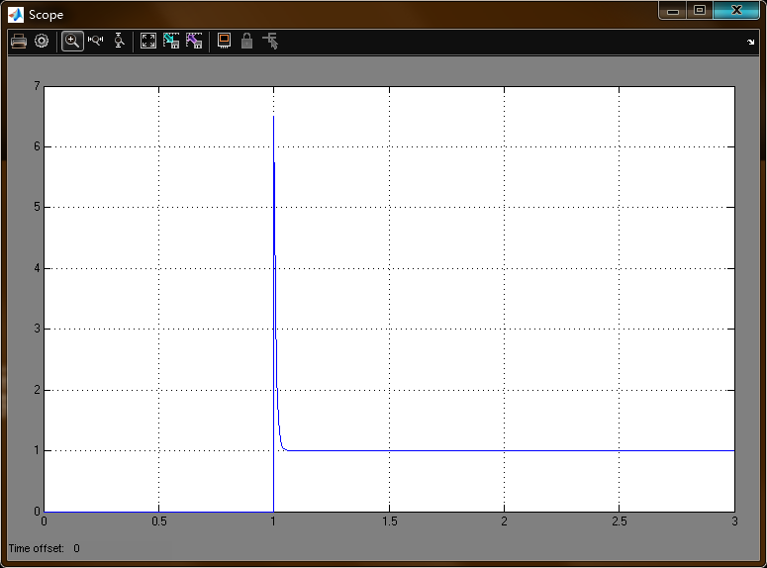

校正后

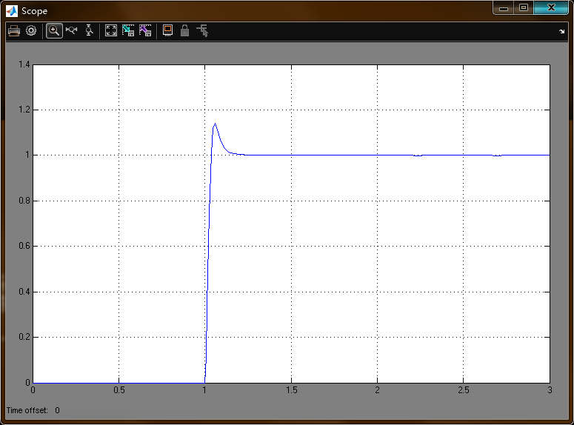

实验8

校正前

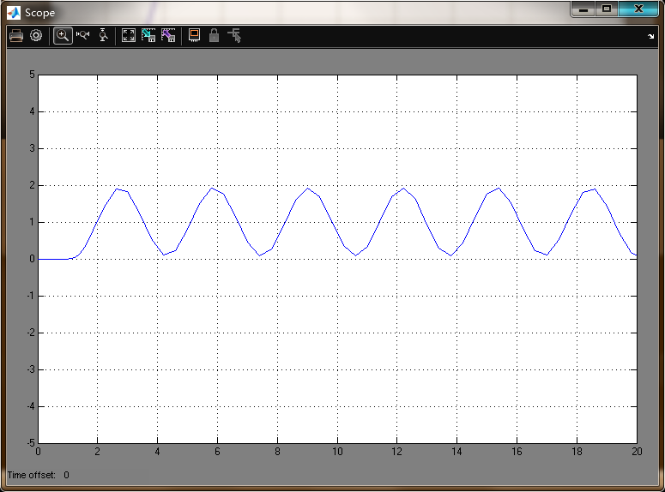

校正

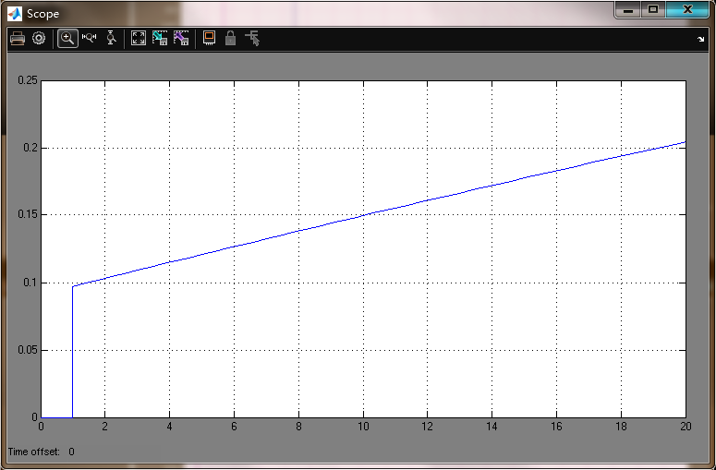

校正后

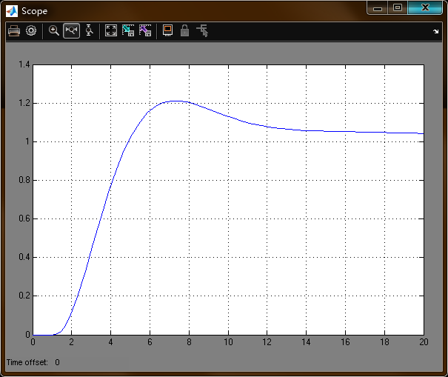

Matlab求时域性能指标代码

num=[0,0,5,100];

den=[0.0008,0.108,6,100];

%num=[0,0,0,250/3,5];

%den=[1/0.0288,6259/36,5045/36,253/3,5];

sys=tf(num,den);

t=0:0.0005:20;

[y,t]=step(sys,t);

r1=1;

while y(r1)<1.00001

r1=r1+1;

end

rise_time=(r1-1)*0.0005;

[ymax,tp]=max(y);

peak_time=(tp-1)*0.0005;

max_overshoot=ymax-1;

s=20/0.0005;

while y(s)>0.98&y(s)<1.02

s=s-1;

end

settle_time=(s-1)*0.0005;

Matlab求Bode图代码

%num=[0,0,100];

%den=[0.1,1,0];

%num=[0,0,5,100];

%den=[0.0008,0.108,6,100];

%num=[0,0,0,5];

%den=[0.25,1.25,1,0];

num=[0,0,0,250/3,5];

den=[1/0.0288,6259/36,5045/36,253/3,5];

G=tf(num,den);

figure(1);

bode(G);

[gm1,pm1,wcg1,wcp1]=margin(G);