Params

String leftSymbol("c9000.DCE");// //左腿合约，排队单(主力)("c2207.DCE");//"rb888.SHFE"au000.SHFE

String realSymbol("c9888.DCE");

Numeric cost (1.2); //每手交易费

Numeric broker_rate (1.3); //券商平台费率(%)

Numeric back_days(60000); //回溯天数

Vars

Global array<Numeric> save;

Global Numeric ti(0);

Global Numeric i;

Global Numeric pos;

Plot my_plot;

Series<Numeric> Spread;//小幅趋势

Series<Numeric> CUSUM;

Events

OnInit()

{

SubscribeBar(leftSymbol,"1h",DateAdd(CurrentDate(),-back_days)+0.095000);

SubscribeBar(realSymbol,"1h",DateAdd(CurrentDate(),-back_days)+0.095000);

SetCommissionRate(Enum_Rate_AmountPerHand,cost*broker_rate);

SetSlippage(Enum_Rate_AmountPerHand, 0);

my_plot.figure(0);

my_plot.setOption("xx","x-format","time"); //画坐标轴

my_plot.setOption("xx","y-format","Numeric"); //画坐标轴

data0.AddDataFlag(Enum_Data_RolloverBackWard);

data1.AddDataFlag(Enum_Data_RolloverBackWard);

}

OnBarClose(ArrayRef<Integer> indexs)

{

Spread=(Ln(c)-Ln(data1.c))*1000;

CUSUM=A_CUSUM_test(c,30);

if (CUSUM>1 and MarketPosition!=1){buy(1,c);}

if (CUSUM<-1 and MarketPosition!=-1){SellShort(1,c);}

//if (abs((c-LastEntryPrice)/c)>0.01){BuyToCover();sell();}

my_plot.line ("0", date+time,CUSUM);

For i=0 To GetArraySize(indexs)-1

{

if (indexs[i]==0 and CurrentBar>800)

{

ArrayInsert(save,GetArraySize(save),date+time);//指数价格，用于交易

ArrayInsert(save,GetArraySize(save),c);//真实价格，用于尾数

}

}

if (date+time>=20230406.2258 and ti==0)

{

ArrayInsert(save,GetArraySize(save),2);

//ti=1;print(TextArray(save));

}

}

**策略1：cusum顺势：**

cusum顺势000信号。非888交易。888用日线可盈利。

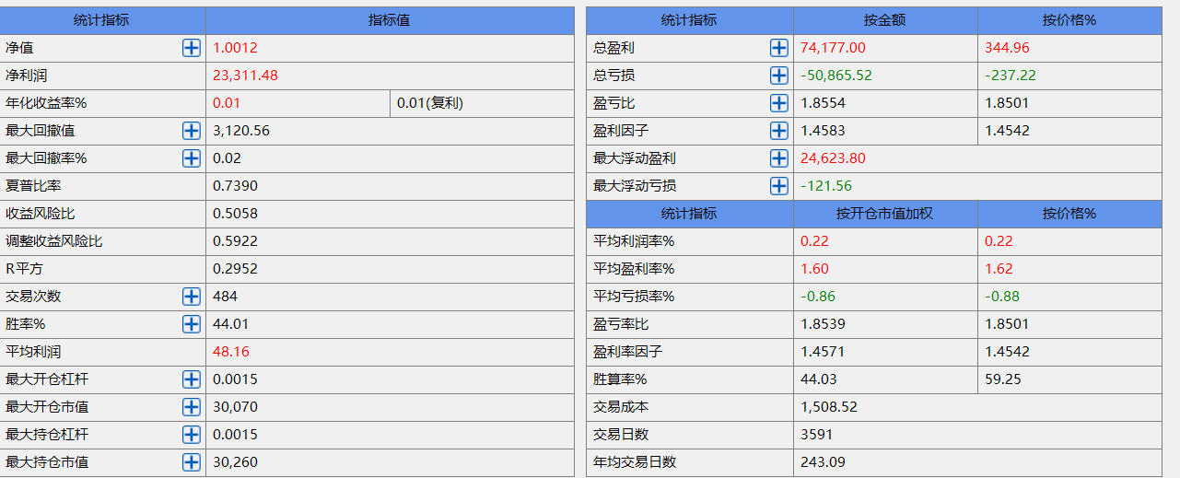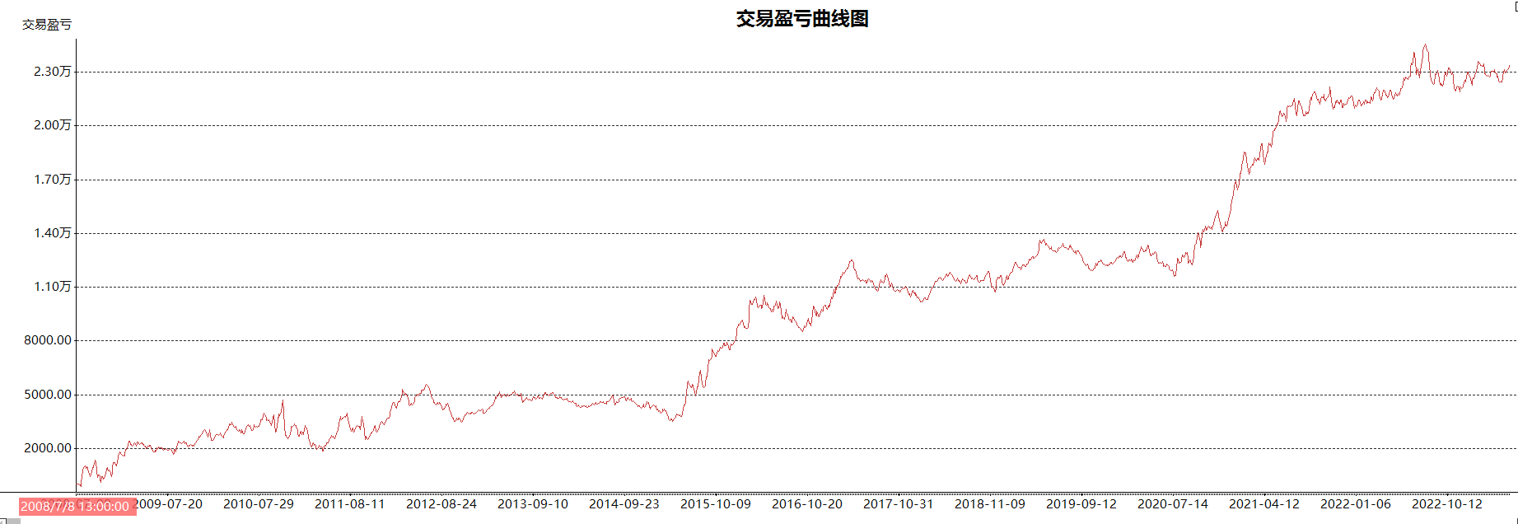

Params

String leftSymbol("c9000.DCE");// //左腿合约，排队单(主力)("c2207.DCE");//"rb888.SHFE"au000.SHFE

String realSymbol("c9888.DCE");

Numeric cost (1.2); //每手交易费

Numeric broker_rate (1.3); //券商平台费率(%)

Numeric back_days(60000); //回溯天数

Numeric perid (3600); //周期单位秒，0为tick

Vars

String perid_str;

Global array<Numeric> save;

Global Numeric ti(0);

Global Numeric i;

Global Numeric pos;

Plot my_plot;

Series<Numeric> Spread;//小幅趋势

Series<Numeric> CUSUM;

Series<Numeric> CUSUM_1;

Events

OnInit()

{

perid_str=IIFString(perid==0,"tick",text(perid)+"s");

SubscribeBar(leftSymbol,perid_str,DateAdd(CurrentDate(),-back_days)+0.095000);

SubscribeBar(realSymbol,perid_str,DateAdd(CurrentDate(),-back_days)+0.095000);

Range[0:DataCount-1]

{

SetCommissionRate(Enum_Rate_AmountPerHand,cost*broker_rate);

SetSlippage(Enum_Rate_AmountPerHand, 0);

}

my_plot.figure(0);

my_plot.setOption("xx","x-format","time"); //画坐标轴

my_plot.setOption("xx","y-format","Numeric"); //画坐标轴

data0.AddDataFlag(Enum_Data_RolloverBackWard);

data1.AddDataFlag(Enum_Data_RolloverBackWard);

}

OnBarClose(ArrayRef<Integer> indexs)

{

Spread=(Ln(c)-Ln(data1.c))*1000;

CUSUM=A_CUSUM_test(c,30);

CUSUM_1=A_CUSUM_test(data1.c,30);

if (CUSUM<1 && CUSUM_1>1 and data1.MarketPosition!=-1){data1.SellShort(1);}

if (CUSUM>-1 && CUSUM_1<-1 and data1.MarketPosition!=1){data1.buy(1);}

//if (CUSUM>1 and data1.MarketPosition!=1){data1.buy(1);}

//if (CUSUM<-1 and data1.MarketPosition!=-1){data1.SellShort(1);}

//if (abs((data1.c-data1.LastEntryPrice)/data1.c)>0.01){data1.BuyToCover();data1.sell();}

my_plot.line ("0", date+time,CUSUM);

For i=0 To GetArraySize(indexs)-1

{

if (indexs[i]==0 and CurrentBar>800)

{

ArrayInsert(save,GetArraySize(save),date+time);//指数价格，用于交易

ArrayInsert(save,GetArraySize(save),c);//真实价格，用于尾数

}

}

if (date+time>=20230406.2258 and ti==0)

{

ArrayInsert(save,GetArraySize(save),2);

//ti=1;print(TextArray(save));

}

}

**策略2：假突破整治**

CUSUM888突破而CUSUM000没突破，则回归888

