# Sign My Guestbook!

Imagine that you want a page that allows you to stay in touch with your professional contacts. For this assignment, you will create a page that allows people to sign your "Guestbook” so that you can communicate more easily with those contacts.

Create a page called guestbook.html in your 305 directory. Your page should include:

* a favicon
* a page title
* a jumbotron

Design a form that contains at least the following groupings and fields. You may add additional fields if you wish.

* Contact Info
  + First name
  + Last name
  + Job Title
  + Company
  + LinkedIn URL
  + Email address
* How we met
  + How did we meet?  (A drop down list with options such as Meetup, Job Fair, Other, We haven't met yet, etc.)
  + A text box for "Other (please specify)"
  + Message (a text area)
* 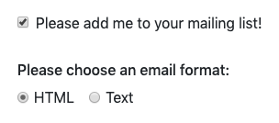Mailing list
  + "Please add me to your mailing list" (checkbox)
  + Choose an email format  (HTML or Text radio buttons)
* A submit button

Define at least three styles of your own in a separate stylesheet, and link to it from your guestbook page.

Use Bootstrap 4 for form layout, and ensure that your form contains valid HTML and is professional.

You do not need to implement any validation... yet!