**Git work flow:**

**cd your_local_directory**

**git init**

git status : check current state

**git add .   or  git add file_name**

**git commit -m “commit message"**

git log : see the list of your commits

**git remote add origin** [**https://github.com/ChangtongZhou/github_creation_demo.git**](https://github.com/ChangtongZhou/github_creation_demo.git)**(any url here)**

**git push -u origin master**

e.g.

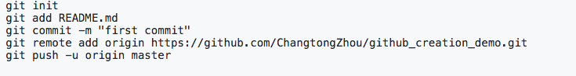

Vim commands on Mac:

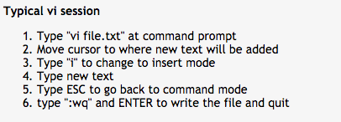

Further info:

Git revert:

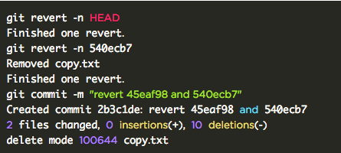

Git reset:

