  For office use only
  T1 | ________________
  T2 | ________________
  T3 | ________________
  T4 | ________________
  Team Control Number
  91528
  Problem Chosen
  B
  For office use only
  F1 | ________________
  F2 | ________________
  F3 | ________________
  F4 | ________________

2018 MCM Summary Sheet
There are over 7000 languages spoken in the world, however, half of them may die out because of fierce language competition. While at the same time, 26 of them are estimated to have over 5 million users all over the world. The total speakers of languages can be influenced by many factors. Those factors include spatial distribution of languages, birth rate, language status, international relationships, migration and transnational tourism, etc. Many scholars have established various models to study language competitions, which are greatly beneficial to our work.
In this paper, we put forward a new Multi-language competition model with agent-based social circles network. This model helps to solve the first three problems in Part I. Based on our new multi-languages competition model, we predict the number of native speakers and total speakers of various languages in the next 50 years. Based on data collected from Wikipedia, Ethnologue, UN database and so on, we simulate the geographical distribution of different language users all over the world. In order to simplify our model, we have made some reasonable assumptions and give justifications.
Based on our model, we choose 22 cities as candidates from various language areas. By studying comprehensive scores of those cities, we make considerations of important factors including language index, GDP, geographical location, political influence and population. We combine all the factors above into a single evaluation formula, with the method of simulation and simulated annealing algorithm, those cities are graded and ranked, the top-six cities are our choice. We use divide and conquer algorithm to comprehensively analyze the geographical distribution, economic benefits, language abundances and strengths. The result tell us that the optimal number of offices is 5.
In order to figure out how sensitive factors mentioned contribute to the final results, we make a sensitivity analysis of the model. We find that, with the increase of social radius in social networks, relatively weak languages tend to die out, and the number of speakers of people with strong language use will continue to grow and the language may become dominant. We use similar method to study the influence of languages status. With the increase of language status, the proportion of speakers will grow accordingly.
Near the end of the article, we analyze the strengths and weaknesses of the model and give some possible methods to optimize the model. After that, we write a letter to the COO of our client company, where we summarize our model and give some suggestions.

Contents

1. Introduction 1
1) Background 1
2) Restatements of problems 1
3) Our work 1
2. General assumptions and justifications 2
3. The model 3
1) Review of Literature 3
2) Model overview 3
3) Language transmission 4
4) Agent-based social circles network 7
5) Initial state of the model 9
4. Results 10
1) the distribution of various language speakers over time. 10
2) Predicted number of total speakers of various languages 11
3) Top-ten list 13
4) the optimal number of new offices and their locations 15
5. Sensitivity analysis 16
1) Social radius r 16
2) Language status s 17
6. Conclusions 18
7. Strengths and weaknesses 18
1) Strengths 18
2) Weaknesses 19
Memo 20
References 21
Appendixes 22

Multi-language Competition Model with Agent-based Social Circles Network

Introduction
- Background
It is estimated that there are over 7000 languages used by humans on Earth in the 2017 edition of Ethnologue[1]. 26 of them are estimated to have over 5 million users all over the world, while at the same time, half of them may die out because of the lack of protections and their small numbers of users. The total number of speakers of one certain language could be calculated by add its native speakers and its second or third speakers (if existed). As we know, the total number of users of a language may increase or decrease during a period of time. Some influences following behind may have a significant influence on it, the government’s promotions, language taught and used in school, migration, international NGOs and culture groups. Moreover, we are living in a globalized world, thanks to factors like international business relations, cross-border tourism, instant communication tools and social media, the use of instant translators which help to learn another language and so on, the total number of users of one certain language changes according to them. International companies want to expand and set up new offices in new cities based on language use of people to satisfy its consumers’ requirements and company’s development blueprints.
- Restatements of problems
According to the description of the problems, we are required to
- Model the distribution of various language speaks over time. We should consider the influences and factors mentioned in the background. Use the model to predict what will happen to the numbers of native speakers and total language speakers in the next 50 years. And predict if the total number of speakers of any of language listed as current top-ten will be surpassed. Look up information about the global population and human migration patterns predicted for the next 50 years, and describe the change of the geographic distributions of these languages over this same period of time.
- Help our client company to locate six new international offices and find out the languages spoken in those cities. Based on our model, and offer our client company short term and long term recommendations as well as reasons respectively. In an effort to save resources for our client company, we are supposed to find out the optimal numbers of offices to establish. Rank those alternative options for our company based on scientific analysis.
- Summarize all the requirements above and work we’ll do, write a memo to the COO of the service company.
- Our work
According to the spatial distribution patterns of different languages and the diversity of population flow, this paper puts forward a new multi-language competition model of population spatial distribution based on agent-based social circles theory. This model constructs spatial distribution network of populations within their own social circles to simulate the problem of multi-language competition. This model takes the influence of the social networks dynamics into consideration. The social networks dynamic includes factors like tourism, migration, social media, international business relationships and so on, this model also makes considerations of language status and attractiveness. The interactions of all these factors mentioned above contributes to the increase or decrease of total speakers of languages over time.
Based on our new multi-languages competition model, we simulate the trend of the number of speakers of various languages over time. Also, it’s easy to predict the number of native speakers and total speakers in the next 50 years. We find that no languages listed as current top-ten will be replaced by another languages. At the same time, making use of data collected from Wikipedia, Ethnologue, UN database and so on, we simulate the geographical distribution of different language users all over the world and model its change over time.
In the third part, by studying comprehensive scores of those cities, we make considerations of important factors including language index, GDP, geographical location, political influence and population. We choose 20 possible cities from various language areas, where the language have a significant influence.
We combine all the factors above into a single evaluation formula, with the method of optimization and maximization, those cities are graded and ranked, the top-six cities are our choice. From this formula, the score varies with cities we choose, in order to get the maximum benefit, we find the optimal number of offices and list them.

General assumptions and justifications
To simplify our model, we make the following assumptions, each of which is properly justified.
- The new born could only master one language.
Justifications；If his/her parents are monolingual speakers and speaks the same languages, the new born master it. In other cases, the language mastered by new-born is decided by its place as well as the languages that his/her parents master.
- The coefficient of one certain language status s is constant, but it varies among various languages.
Justification: our study subjects are those languages with the most users, its language status could be seen as invariant parameter.
- Social radius r is constant
Justification: From a global perspective, the impact of the differences in individual behavior can be ignored, their social radius can take a reasonable mean.
- Every agent move one unit a year.
Justification: This can simulates the change of their social circles, for the agents within in their social circles changes when moving from one unit to another randomly.
- The birth rate and death rate are decided by countries where agents live.

The model
- Review of Literature
In 2003, Abrams and Strogatz put forward a deterministic mathematical model of language competition to describe the language change patterns caused by language competition in a crowd[2]. According to this model, the proportions of each languages and their relative language status is different, which leads to the extinct of one language in a longtime simulation. Under the influence of their work and A-S model, In 2008, Kandler and Steve put forward an ecological model of language competition[3]. In 2009, Patriarca and Heinsalu studied the influence of geography of language competition[4]. The results indicate that the combination of geographical environment and population diffusion contributes to the coexistence of languages. Minett and Wang[5] made considerations of two monolingual speakers and one bilingual speakers in their paper published on famous magazine Lingua. Language competition system is a complex adaptive system. Language competition and evolution problem is actually the problem of the spread of language in a complex network. Establishing a mathematical model based on agent social circles network is an important method to study complex dynamic of language competition. Language can be vertically inherited from parents and spread horizontally under the influence of near agents. Wang and Bi [6] analyzed the dynamic characteristics of language competition on the global network with social community structure proposed by Li and Chen [7]. The model distinguished the vertical and horizontal transmission of language, and considered the impact of the behavior of speakers with the help of the structure of language community, it also makes considerations of the spatial variations of language status to study the problem of language competition and protection in a complex real social network.
In terms of language competition model, scholars' work is getting deeper and deeper, but they focus on at most two languages and can't be directly applied to the field of multi-language competition.
- Model overview
In this section, we will discuss all the details of our model. In this paper, we extends the AS model to multiple languages and put forward a new agent-based multi-language competition model of population spatial distribution. In a complex network, everyone lives in his own social circle. The priority connection mechanism is that everyone communicates with agents within his own social circle instead of the whole network. We make considerations of the role of bilingual speakers and multilingual speakers on the basis of the local world network, and introduce horizontal and vertical transmission of multiple languages. On the one hand, language is transmitted vertically from parents to children, that is, the parents pass on their language to their children. The language acquired by the children is determined by the vertical transmission model. Language spread between adults is determined by horizontal transmission model, the model allows adults to learn another language and became bilinguals, or keep the original language, but they don't completely switch to another language or forget the original language. At the same time, the influence of migration, tourism, birth rate and death rate are taken into account in our model, which helps to increase the rationality and robustness of our model.
- Language transmission
First, the symbols we use and their description are listed below,
Symbols | Explanations
$$P_{X,Y}$$ | The probability of transmission from language X to Y
$$P_{Z,X}$$ | The probability of transmission from bilingual Z to language X
$$c_{V}$$ | The maximum value of vertical transmission rate
$$c_{H}$$ | The maximum value of horizontal transmission rate
$$s_{X}$$ | The language status of language X
$$a$$ | A parameter associated with the proportion of language and language transmission rate
$$μ$$ | Death rate
$$x$$ | The proportion of monolingual speakers of X
$$y$$ | The proportion of monolingual speakers of Y
$$z$$ | The proportion of bilingual speakers
- Vertical transmission
If the language of the adjacent parent individuals are monolingual (X or Y), they learn their parents’ language, From X to X or from Y to Y.
$P_{X,X}=1$ (1)
$P_{Y,Y}=1$ (2)
If the language of the adjacent parent individuals are bilingual (Z), the individuals learn one of the languages or both languages from parent individuals, from Z to X，from Z to Y or from Z to Z.
$P_{Z,X}=c_{V}s_{X}x^{a}$ (3)
$P_{Z,Y}=c_{V}s_{Y}y^{a}$ (4)
$P_{Z,Z}=1-c_{V}s_{X}x^{a}-c_{V}s_{Y}y^{a}$ (5)
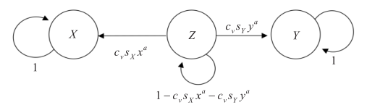
Vertical transmission rates for the monolingual model
- Horizontal transmission
In the language network, all bilingual adult individuals still retain the state of the bilingual, from Z to Z.
$P_{Z,Z}=1$ (6)
In the language network, adult individuals who only master one language may become bilingual speakers under the influence of other adult individuals who could speak another language within their social circles, from X to Z or from Y to Z.
$P_{X,Z}=c_{H}s_{Y}y^{a}$ (7)
$P_{Y,Z}=c_{H}s_{X}x^{a}$ (8)
In the language network, all of the adult individuals (X or Y) who master one of the two languages, eventually retain the status of mastering only one language, from X to X or from Y to Y.
$P_{X,X}=1-c_{H}s_{Y}y^{a}$ (9)
$P_{Y,Y}=1-c_{H}s_{X}x^{a}$ (10)
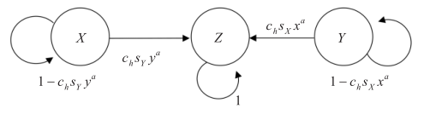
Horizontal transmission rates for the monolingual model
Assuming that individuals can't completely abandon the native language and learn another language, it will leads to inability to communicate.
On the basis of vertical and horizontal transmission model, for each language, we can derive the following formula to describe the change of the number of users in each language.
$\frac{dx}{dt}=μP_{Z,X}\left(1-x-y\right)-\left(1-μ\right)xP_{X,Z}=μc_{V}s_{X}x^{a}\left(1-x-y\right)-\left(1-μ\right)xc_{H}s_{Y}y^{a}$ (11)
In the same way,
$\frac{dy}{dt}=μc_{V}s_{Y}y^{a}\left(1-x-y\right)-\left(1-μ\right)yc_{H}s_{X}x^{a}$ (12)
For two language competition, it is obvious that
$x+y+z=1$ (13)
$s_{X}+s_{Y}=1$ (14)
- Multi-language
$\frac{dx}{dt}=\frac{dNa}{dt}+\frac{dNon}{dt}=\frac{dNa}{dt}+c_{H}s_{X}x^{a}(1-x)$ (15)
Na for the proportion of native speakers, Non for the proportion of non-native speakers, x for the proportion of total speakers. The change of Na is decided by the population of countries and areas where X is the mother language and the number of non-native speakers is far less than native speakers. In this formula, we ignore the death of non-native speakers, so the change of non-native speakers approximately equals to the number of population who newly master the language.
- Maximum value of transmission rate
According to the work of Wang and Bi[6], experiment and analysis showed that in order to achieve stable coexistence of two languages: the maximum value of vertical transmission rate is 1, the maximum value of horizontal transmission rate is 0.035.
$c_{V}=0.035$ (16)
$c_{H}=1$ (17)
- Language status
According to Abrams and Strogatz’s language competition model published on Nature, language status is determined by factors as follows: the prestige, wealth and power of its speakers.
From above, we already know the relationship between language status and the number of people who use it, described by equation
Making use of data obtained from UN database[8] and Ethnologue over a long time, we can simulate the relationship between these two variate. With the method of linear regression, we obtain the value of language status for each language.
- Parameter “a”
In the model, a is a parameter associated with the proportion of language and the probability of language transmission. If a is equal to one, the probability of language transmission is positively proportional to the proportion of language users. If a is greater than 1, the probability of language transmission and proportion of users are exponentially related. In Minett and Wang’s paper, a is approximately equals to 1, proved by a large number of experiments and simulations.
$a=1$ (18)
- Agent-based social circles network
- Social radius
The network of social circles can reflect the characteristics of complex social networks, and the language competition network belongs to a typical social network. Therefore. The social network model can be used to study the language competition network model.
The network model of social circle originates from the idea of social space and social distance, which was first proposed by Park in 1924 and later developed by Heider[9]. The social network model can be seen as a social map showing how people are distributed and connected in society.
Individuals have connection with other individuals in their own social circles, and a social circle can be described by the size of social radius. The size of the social radius of each individual in the social network is different. The closer the individuals are to each other, the closer relationships they share with each other.
When creating an individual connection, both agents are required to know each other. Only if they live in each other’s circles, they create a connection between the two, as shown in figure 2.
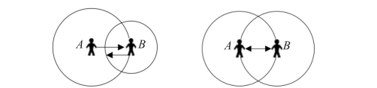
A is disconnected with B A is connected with B
- The influence of individual behavior
The behavior of social individual can cause changes in social network structure.
The changes of agents’ social circles could be described by moving a distance during a period of time inside the whole social network, assuming that moving distance is a unit of length (in the network, a grid). If the moving distance is small, the movement of the population may not change the individual network structure, only when the individual moves outside the circles, will the social individual network structure change, shown on figure below.
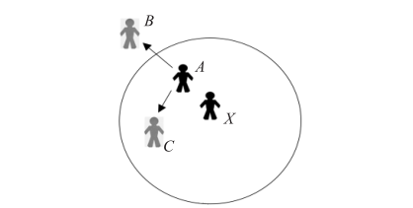
In our model, social radius is constant for agents, 30 grids in the whole social network, Every individual moves a unit a year, to describe the change of its own social circle.
- Multi-language model
All the language competition models before us consider at most two languages. In the model, the top-ten languages with most speakers were taken into account. Based on the real world map and geographical distribution of those languages, we divided the map into 9 pieces. A multi-language competition model can better simulate their users and geographical distribution over time.
Consider a system of n languages competing with each other in one of these nine areas. Each individual in the region use one or two of those n languages. There are five assumptions:
  - An individual who uses only one language may learn a new language from the neighbors (people in his social circle).
  - A new-born baby can learn language from its parent.
  - Initially there’s no individual who speaks two different languages.
  - The relationship between persons may change through time.
  - Some people may migrate (move to another area), but a person will only migrate at most once.
- The influence of social media and language translators
To consider these factors, some agents from one country may have connections with agents from another country. Adjusting the social radius of some agents could solve this problem well, the method we use and reasons could be seen in the appendixes.
- The influence of migration and tourism
When individual move from one country to another country, its social circle changes sharply. Due to the migration between the two areas, mobile distance is greater than their social radius. The initial social individual network structure breaks up, when a new social relations circle is set up.
These factors of population mobility can lead to the disconnection of old relationships and the establishment of new relationships, thus leading to the dynamic evolution of social communication networks and mapping the dynamic performance of the network.
- Initial state of the model
In our model, we divide the world as nine parts according to language, culture, geographical position and population growth mode. These parts and their shared features are shown on the table. We initialize birth rate and death rate according to the population expectation of each area 50 years later[10]. The initial language spoken in each part is set according to the data collected in 2007[11].
Country/Region | Shared features
China | Main part of Mandarin
Russia | Main part of Russian
Europe Union | Similar geographical position; Similar culture, Similar population growth mode
India | Growing population, An important region of using English and Hindi
Japan | Shrinking population, Main part of Japanese
America + Australia | Two English-speaking countries; Similar population growth mode
Africa | Huge and growing population; Multiple language
Latin America | Shared geographical position
Canada | Using English and French
In our experiment, we simulate the activities of the individuals. Each individual is settled in one of the nine parts. The number of the population of each part is set according to the real-world population distribution. The whole state will be updated 50 times in total, calculating the status of the world in the future 50 years.
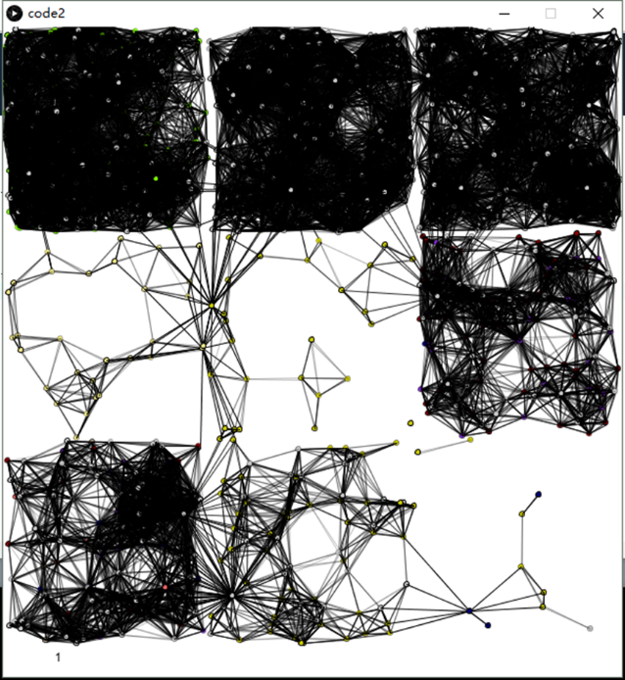
An example of people and language distribution in our model. The whole picture (real world) is divided into 9 parts. The nodes represent individuals. When there’s an edge between two nodes, these two individuals are neighborhoods and may learn new language from each other.
When updating, the activity of an individual can be described as below:
  - Move: An individual may move to another place nearby randomly each time. A person cannot move to a place outside its region.
  - Dead: An individual may die according to death rate. The death rate follows the death rate of the region in which the person lives.
  - Born: An individual may give birth to a baby each year. The rate follows the birthrate of the region. The language which is spoken by the baby is calculated randomly according the formula of the second pattern above.
  - Learn: A person may learn a new language from the neighbor, as described in the first pattern.
  - Migrate: A person may migrate to another region. A person can only migrate once during his lifetime.

Results
- the distribution of various language speakers over time.
We use a picture to describe the geographical distribution of languages and their total speakers. In the picture, the square represents the whole world, and colorful nodes represent various language speakers.
The languages each color represents are shown in the following figure.
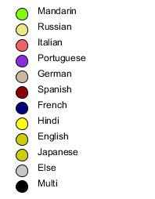
Here are the results of the geographical distribution simulations
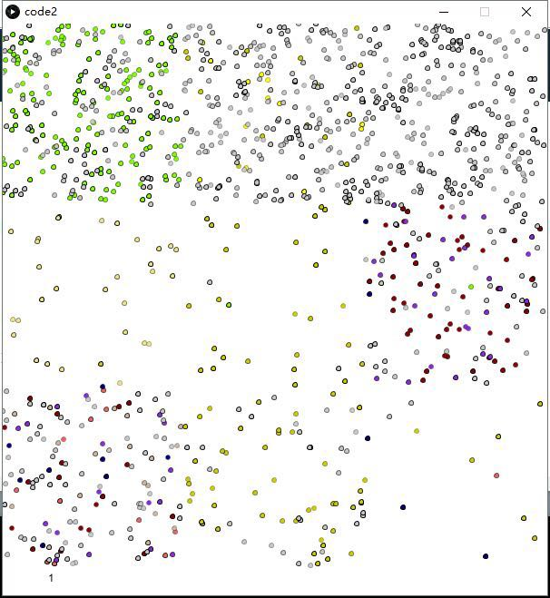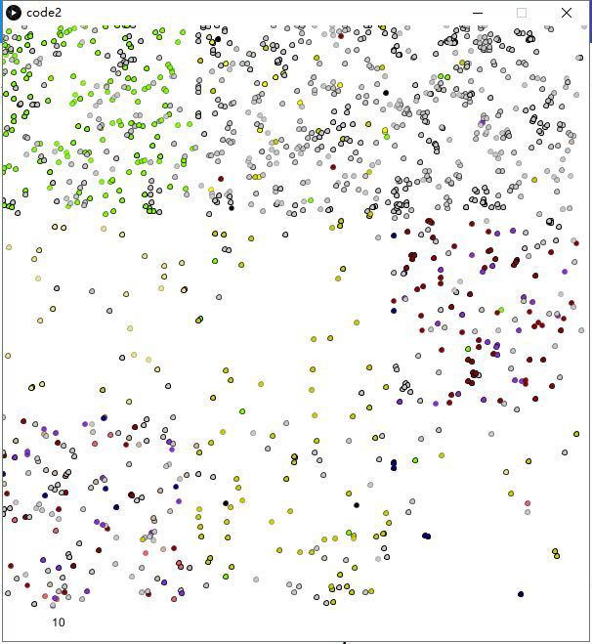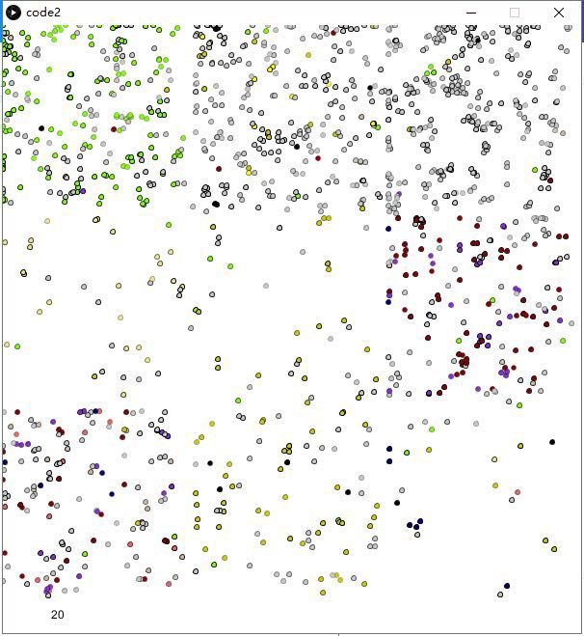
The year of 2019 the year of 2029 the year of 2039
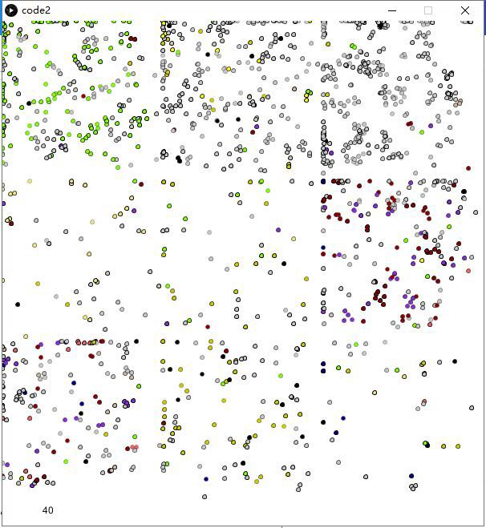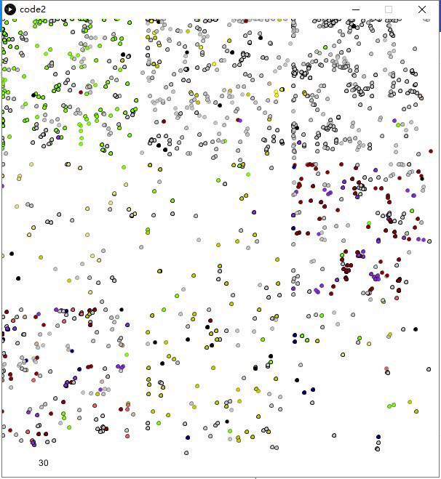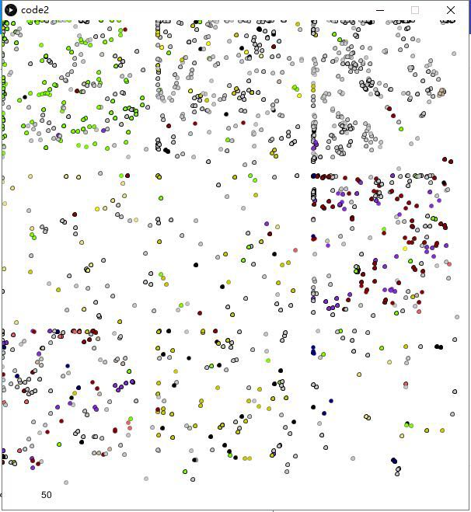
The year of 2049 the year of 2059 the year of 2069
If projected on the real map, we get the geographical distribution of major languages in the next 50 years.
- Predicted number of total speakers of various languages
Ethnologue recorded the number of native speakers and total speakers in a long period of time. Taking all factors mentioned above into account, based on our multi-language competition model, we can predict the number of total speakers in the next 50 years. The results are shown in the table below.
Line graphs can better show the changes of the number of total speakers.

- Top-ten list
- native language speakers
Our model gives a list of the top 10. By contrast of the ranking of 2019 and 2067, we find some constants and changes. The Chinese language continues to be the first. Portuguese, Russian, Japanese and Italian also retain their ranking, respectively, their rankings are 4,5,6,10. English will surpass Spanish to be the second, while Spanish will drop to the third place. French will arise from the ninth to the sixth by surpassing German and Hindi, causing German to be the eighth and Hindi to be the ninth.
Top-ten of 2019
Top-ten of 2067
- Total languages speakers
Considering second languages speaks and, the proportion of total language speakers will change overtime

changes of proportions of major languages overtime
The top-ten list of 2020 and 2068 are as follows,
The year of 2020 The year of 2068
Comparing these two charts, we can find out that Hindu exchanges its place with English while Portuguese exchanges its place with Bengali. However, they are still on the list of top-ten. The ranking of German drops out of top-ten and French takes the place of it.
- the optimal number of new offices and their locations
We choose 22 cities as candidates from various language areas, covering zones of Chinese, English, French, Spanish, Portuguese, Toronto, Russian, Japanese and Arabic. The list of cities contains Beijing, Mexico City, Buenos Aires, Madrid, Bogotá, Lima, Sao Paulo, Belo Horizonte, Rio de Janeiro, Porto Alegre, London, HongKong, Singapore, Sydney, Melbourne, Toronto, L.A., Paris, Moscow, Kiev, Tokyo and Dubai.
We use the N-Search Algorithm to find out the optimal number of new offices as well as their locations. As the number of cities varies from 1 to 22, we could find out the maximum benefits for each number.
Symbols | Explanations
$$n$$ | The number of new offices
$$λ_{1}$$ | Coefficient related to distance
$$λ_{2}$$ | Coefficient related to regularization
$$ω_{1}$$ | Coefficient related to GDP
$$ω_{2}$$ | Coefficient related to population
$$k$$ | Language index
$$N_{i}$$ | The number of cities listed that share the same native language with i
$$L$$ | Total number of language speakers
$$i or j$$ | One of the cities
All the coefficients are presented in the appendixes.
The formula we use are as follows,
$Benefit(n)=λ_{1}\sum{{Distance}_{i,j}+} \sum{{Score}_{i}-λ_{2}}\sum{N_{i}}$ (19)
Refer to the definition of comprehensive national strength[12][13], similarly,
$Score=\left(ω_{1}*GDP+ ω_{2}*population+ω_{2}*L\right)*k$ (20)
According to the results, if our client company wants to open six new offices, our recommendations are Beijing, Lima, Singapore, Toronto, L.A. and Dubai. Chinese, Spanish, English, French and Arabic and spoken in those cities. The optimal number we recommend is five, those cities are Beijing, Lima, Singapore, Toronto, L.A.

Sensitivity analysis
- Social radius r
In our model, social radius r is constant, it equals to the length of 30 grids in the social network.
$r=30$ (21)
Change the value of social radius from 30 to 300 and from 300 to 3000, the total number of language speakers change.(The result is the average of ten experiments.) The total speakers of strong languages like Chinese, English and Spanish grow with the increase of social radius. However, when social radius is 3000, that is when everyone has connected with much of the population in the social network, the speakers of all languages tend to be even.

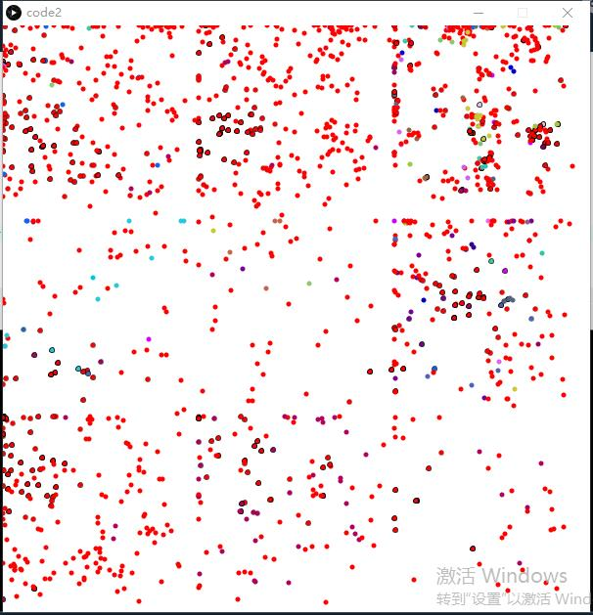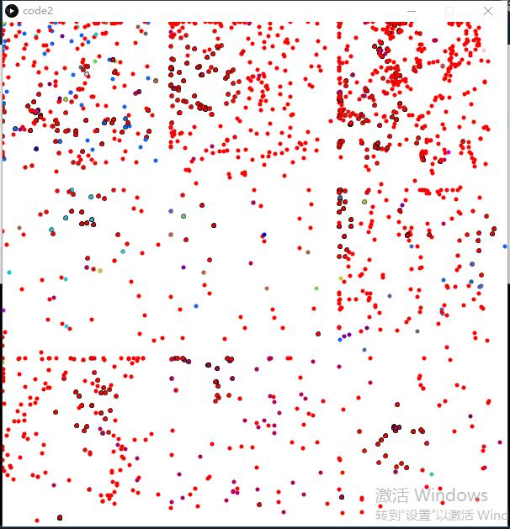
- Language status s
In this paper, we have discussed the importance of language status in section 2. Here, we study the sensitivity of languages status by changing the language status of Russian, respectively from 0.0002 to 0.002, from 0.002 to 0.02, from 0.02 to 0.2. In this case, the number of Russian speakers is expected to increase, and the results below are consistent with our expectations. ( The result is the average of ten experiments.)

Conclusions
A Multi-language competition model with agent-based social circles network is effective to simulate the geographical distribution of native and total language speakers and predict the number of various language speakers.
In terms of native speaker, English will surpass Spanish to be the second, while Spanish will drop to the third place. French will arise from the ninth to the sixth by surpassing German and Hindi, causing German to be the eighth and Hindi to be the ninth.
In terms of total language speakers, Hindu will exchange its place with English while Portuguese will exchange its place with Bengali. However, they are still on the list of top-ten. The ranking of German drops out of top-ten and French will take the place of it.
Making considerations of GDP, geographical location, population, language index and number of total language speakers, we recommend that six new offices should be opened in Beijing, Lima, Singapore, Toronto, L.A. and Dubai. Actually, the optimal number of new offices is 5. In this case, our recommendations are Beijing, Lima, Singapore, Toronto, and L.A.
Since we have made some assumptions before, we made sensitivity analysis before drawing a conclusion.

Strengths and weaknesses
- Strengths
The Multi-language competition model with agent-based social circles network successfully reflects the geographic distribution of population and language.
This model takes birth rate and migration into consideration.
This model takes the influence of agent’s behavior into consideration to describe the social networks dynamics.
- Weaknesses
The precision of the predicted answer is not very satisfying. Since it is impossible to simulate every person in the world, in our experiment, one node represents 10,000,000 persons in reality. That means that the answer from a single experiment only predicts the language usage by 10 million. We have to average the results from multiple experiments to make the answers more precise.
Another problem is that since the number of nodes is not big enough, the variance of population and language usage is relatively large.
Some more features, such as the financial statement of each area, can be applied to optimize the model.
In order to simplify our model, these factors are ignored.

Memo
To : Chief Operating Officer of the service company
Subject: Optimal Number and Places to Locate New Offices
Dear XXX,
It’s our great honor to participate in the site selection of the new offices. We have put forward a multi-language competition model which helps to simulate the geographical distribution and language speakers over time. Our model in testified to be effective although some simplification are made. Based on the model, we recommend Beijing, Lima, Singapore, Toronto, L.A. and Dubai if our company will open six offices. However, we find that 5 offices located in Beijing, Lima, Singapore, Toronto, L.A. may be a better choice in order to balance the cost and consumers’ requirements. Obviously, we could save resources and become international at the same time.
Three main features are especially important when we locate our office: good economic environment, great language diversity and the number of speakers of popular languages.
According to our model, Chinese will still have the most native speakers and total speakers in a long period of time. Thus, we choose Beijing as one of the candidates when selecting office locations. Also, there is no doubt that English is the most widely-used language and more and more non-native speakers are tend to learn English. At the same time, the number of Spanish speakers is increasing rapidly largely thanks to the increment of population in South America. Russian is rather popular among non-native speakers and it will have one place both in the top10 of total speakers and non-native speakers. Arabic has been widely-spread in recent years, so we also consider the famous Arabic city Dubai as one of the candidates. We choose Tokyo, Paris, and other famous cities as candidates not only because language but also economy.
We believe that open new offices in those cities can bring great benefits to our company, we do hope that our company will become more and more international.
Yours sincerely,
A group of modelers who are enthusiastic about mathematical modeling
13/2/2018

References
- https://www.ethnologue.com/browse/names.
- Abrams D M，Strogatz S H. Modeling the dynamics of language death[J].Nature，2003，424：900-901.
- Kandler A，Steele J. Ecological models of language competition[J].Journal of Biological Theory，2008，3（2）：164-173.
- Patriarca M，Heinsalu E.Influence of geography on language competition[J].Physica A：Statistical Mechanics and its Applications，2009，388（2/3）：174-186.
- Minett J W，Wang W S Y.Modeling endangered languages：The effects of bilingualism and social structure[J].Lingua，2008，118（1）：19-45.
- WANG Chao, BI Guihong, ZHANG Shouming. Language competition model of population spatial distribution with Agent-based social circles network. Computer Engineering and Applications, 2016, 52（7）：1-8.
- Li X，Chen G.A local-world evolving network model [J]. Physica A：Statistical Mechanics and its Applications，2003，328（1/2）：274-286.
- https://unstats.un.org/unsd/databases.htm
- Heider F.The psychology of interpersonal relations [M]. [S.l.]：Psychology Press，1982：1-317.
- https://www.populationpyramid.net/
- https://en.wikipedia.org/wiki/List_of_languages_by_number_of_native_speakers
- Hu A G, Men H , The Rising of Modern China: Comprehensive National Power and Grand Strategy
- https://myweb.rollins.edu/tlairson/china/chigrandstrategy.pdf.

Appendixes
Code 1
#include<iostream>
#include<cstring>
#include<cstdio>
#include<math.h>
using namespace std;
bool ans[30][30];
double aas[30];
bool help[30];
int select[30];
double info[30][10];
double score[30];
char name[30][100];

void compute_score()
{
FILE *fp = fopen("Candidates.txt","r");
int i,j,k;
char s[100];
int lines;
double ltt;
int count = 0;
for(i = 0;i < 8;i ++)
{
fscanf(fp,"%s%lf%d",s,&ltt,&lines);
for(j = 0;j < lines;j ++)
{
info[count][5] = i;
//input language language_index GDP population latitude longitude
score[count] = (info[count][1]/20+info[count][2]/10+ltt)*info[count][0];
count ++;
}
}
fclose(fp);
}
double judge(int a)
{
int selected_language[8]={0};
double benef = 0;
int i,j;
for(i = 0;i < a;i ++)
{
selected_language[(int)info[select[i]][5]] += 1;
}
for(i = 0;i < a;i ++)
{
benef += score[select[i]];
benef -= selected_language[(int)info[select[i]][5]];
for(j = 0;j < a;j ++)
{
double lat = (info[select[i]][3]-info[select[j]][3]);
double lon = (info[select[i]][4]-info[select[j]][4]);
benef += sqrt(lat*lat+lon*lon)/100 ;
}
}
return benef;
}
void find(int now,int sum,int ma)
{
if(now == ma){
int jj = 0;
memset(select,0,sizeof(select));
for(int ii = 0;ii < ma;ii ++)
if(help[ii])select[jj++] = ii;
double kk = judge(sum);
if(kk>aas[sum])
{
aas[sum] = kk;
for(int i = 0;i < ma;i ++)
ans[sum][i] = help[i];
}
return;
}
help[now] = 0;
find(now + 1,sum,ma);
help[now] = 1;
find(now + 1,sum + 1,ma);
}

int main()
{
int suma = 22;
compute_score();
find(0,0,suma);
output(suma);
}

