Mục Lục
2. Working with method overloading 2
2.1 Overloading by differing types of parameter 2
2.2 Overloading by differing the number of parameters 2
3. Passing parameter 3
3.1 Question: 4
4. Debug and Run 4
4.2.1. Setting, deleting & deactivate breakpoints. 4
4.2.2. Run in Debug mode: 5
4.2.3. Step Into, Step Over, Step Return, Resume: 5
4.2.4. Investigate value of variables: 6
4.2.4. Change value of variables: 7
5. Classifier Member and Instance Member 8
6. Open the Cart class 9
7. Implement the Store class 12
8. Re-organize your projects 14
9. String, StringBuilder and StringBuffer 15

Figure 1 2.1 Overloading by differing types of parameter 2
Figure 2 2.2 Overloading by differing the number of parameters 2
Figure 3 3. Passing parameters 3
Figure 4 4.2.1. Setting, deleting & deactivate breakpoints. 4
Figure 5 4.2.2. Run in Debug mode: 5
Figure 6 4.2.3. Step Into, Step Over, Step Return, Resume 5
Figure 7 4.2.4. Investigate value of variables 6
Figure 8 4.2.4. Change value of variables 7
Figure 9 5. Classifier Member and Instance Member 8
Figure 10 6.1 toString() method for the DigitalVideoDisc class 9
Figure 11 6.2 Method printCart / searchById / searchByTitle 10
Figure 12 6.3 Class CartTest 11
Figure 13 7.1 Class Store 12
Figure 14 7.2 StoreTest 13
Figure 15 8. Re-organize your projects 14
Figure 16 9.1 class ConcatenationInLoops 15
Figure 17 9.2 class GarbageCreator 16
Figure 18 9.3 class NoGarbage 17

Lab 03: Basic Object-Oriented Techniques

2. Working with method overloading

2.1 Overloading by differing types of parameter
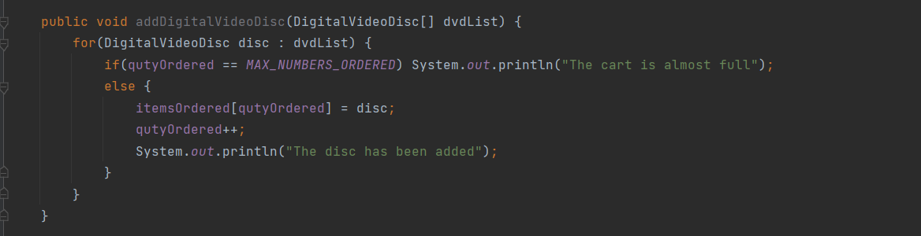
Figure 1 2.1 Overloading by differing types of parameter

2.2 Overloading by differing the number of parameters
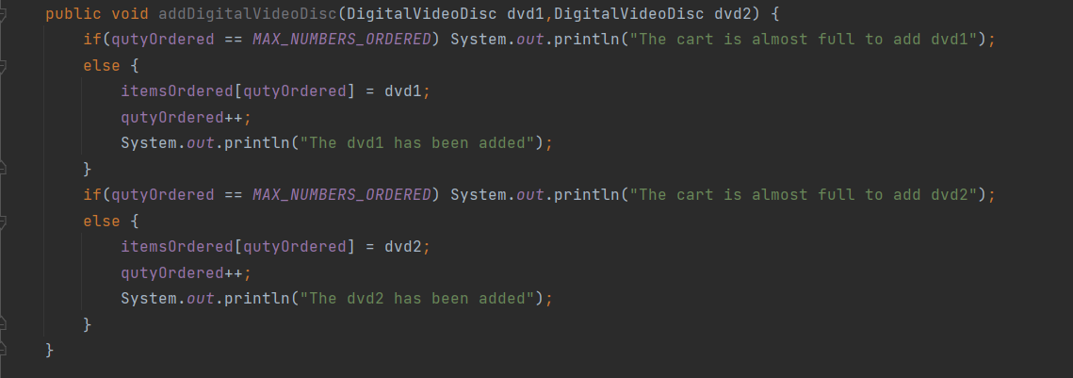
Figure 2 2.2 Overloading by differing the number of parameters

3. Passing parameter
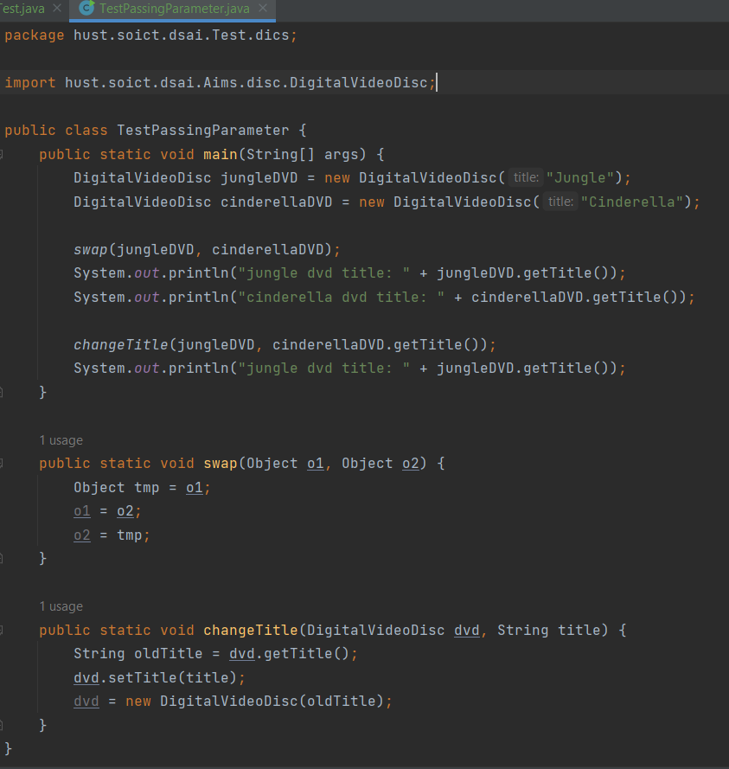
Figure 3 3. Passing parameters
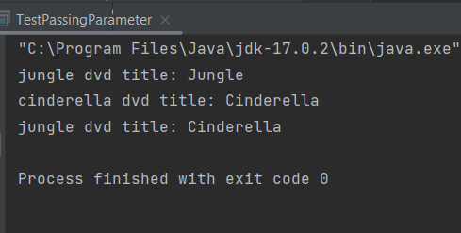

3.1 Question:
Java is a pass-by-value language. This means that when a value is passed to a method, a copy of the value is made and passed to the method. Any changes made to the value inside the method will not affect the original value.
However, there is a special case in Java where pass-by-reference is used. This is when a reference to an object is passed to a method. In this case, the method will receive a copy of the reference, but the reference will still point to the same object in memory. This means that any changes made to the object inside the method will be visible outside the method.

4. Debug and Run

4.2.1. Setting, deleting & deactivate breakpoints.
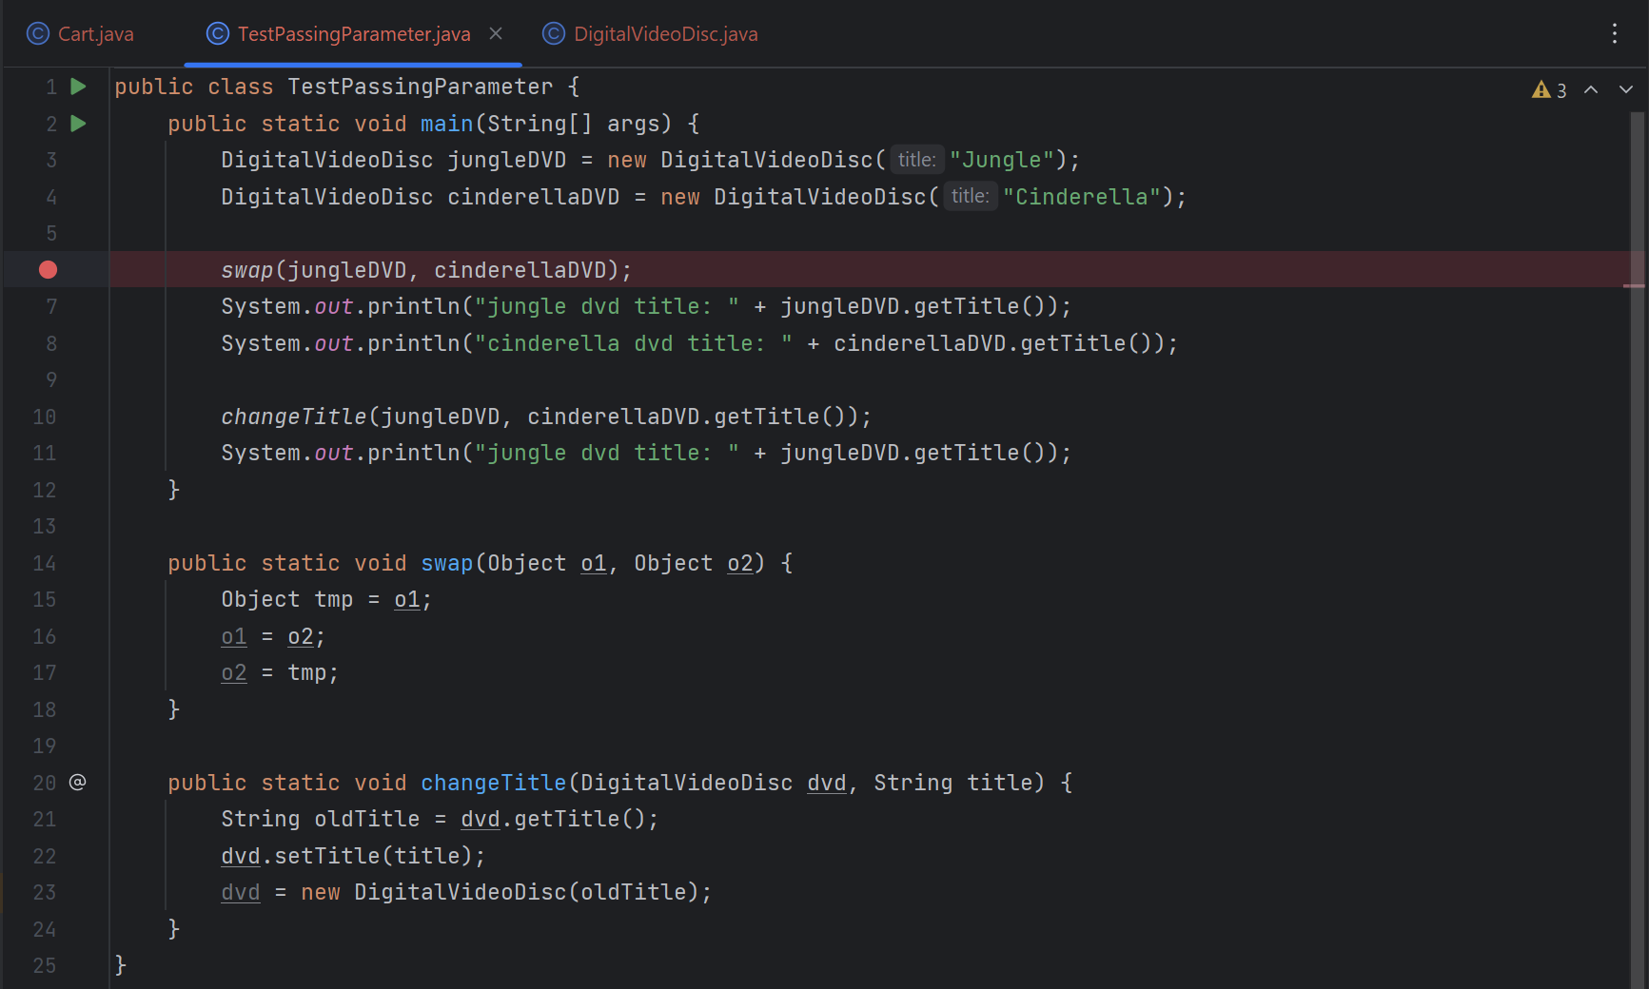
Figure 4 4.2.1. Setting, deleting & deactivate breakpoints.

4.2.2. Run in Debug mode:
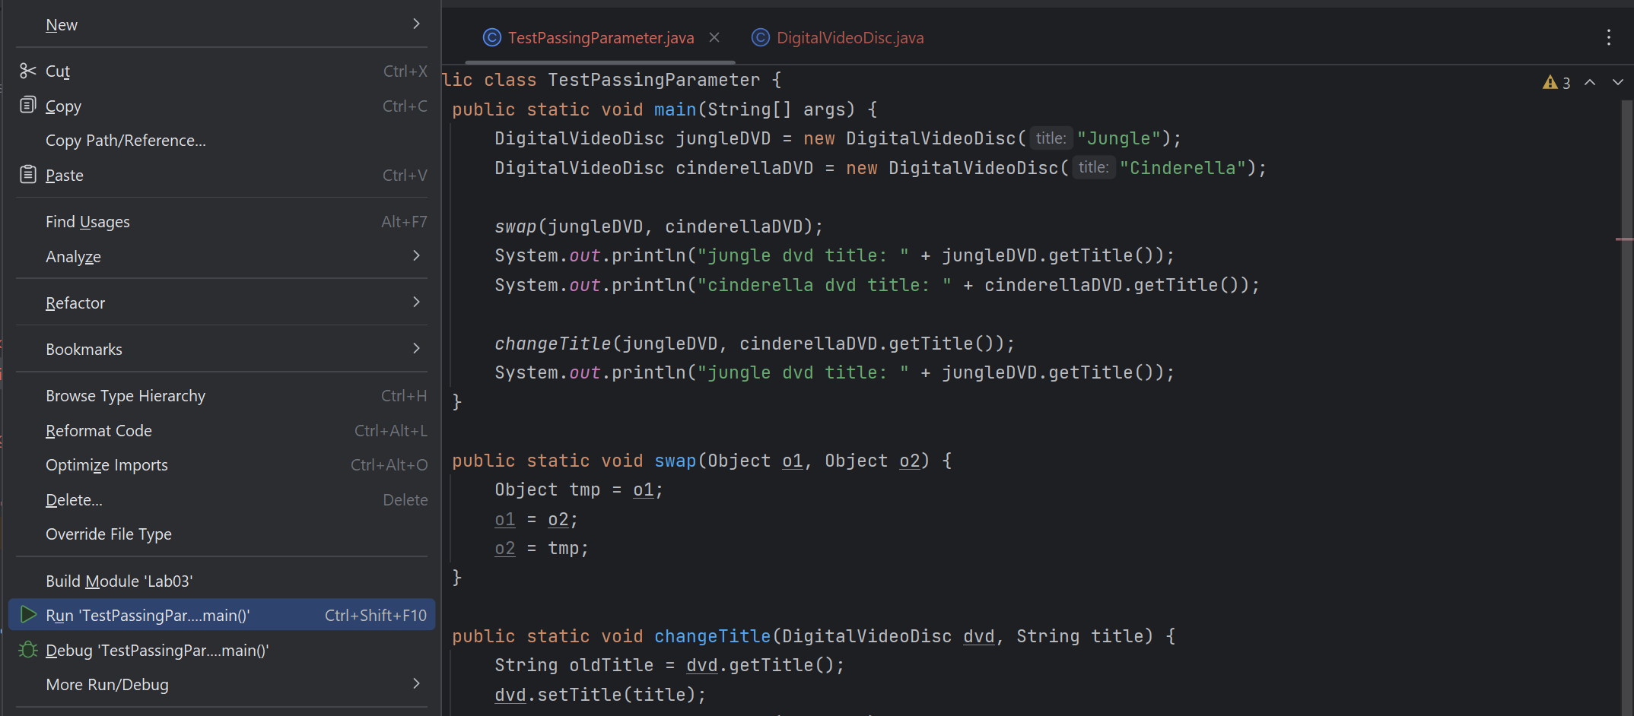
Figure 5 4.2.2. Run in Debug mode:

4.2.3. Step Into, Step Over, Step Return, Resume:
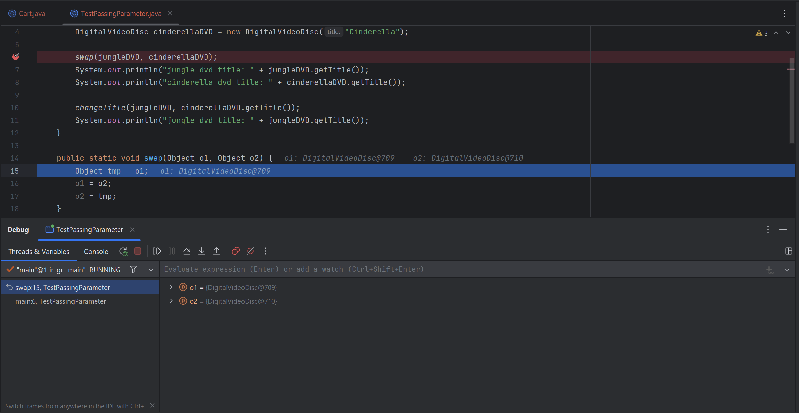
Figure 6 4.2.3. Step Into, Step Over, Step Return, Resume

4.2.4. Investigate value of variables:
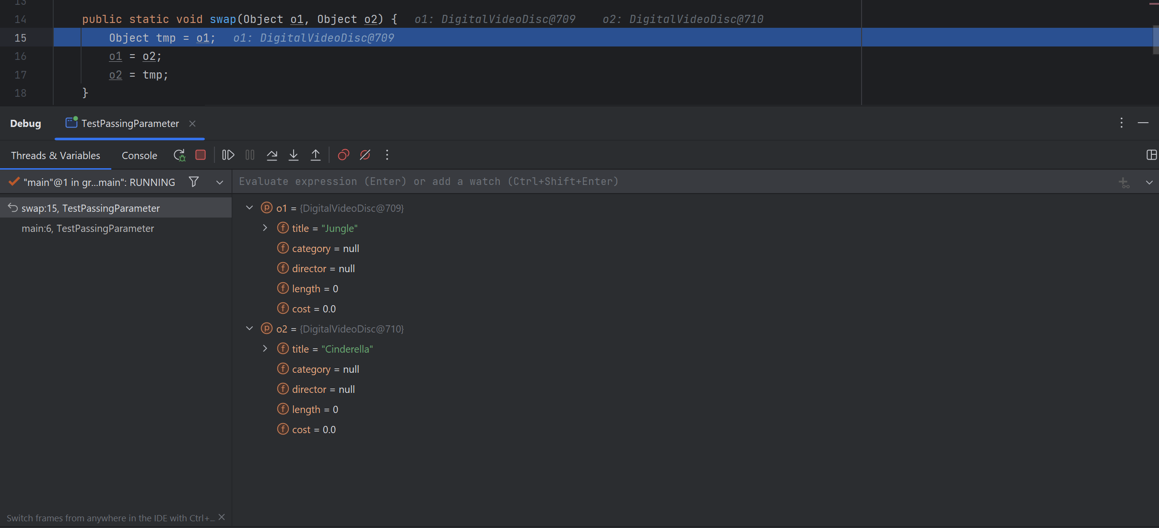
Figure 7 4.2.4. Investigate value of variables
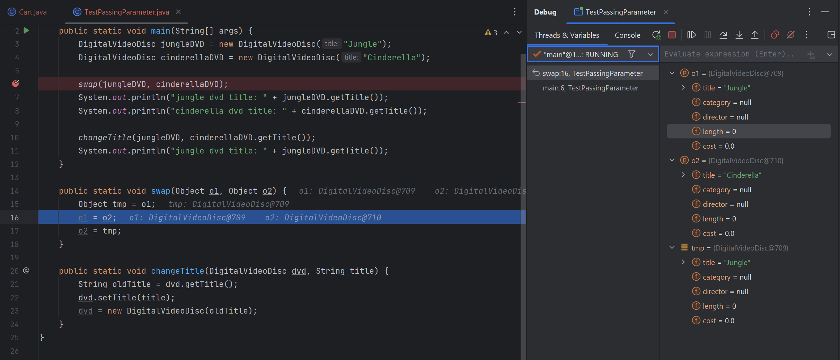
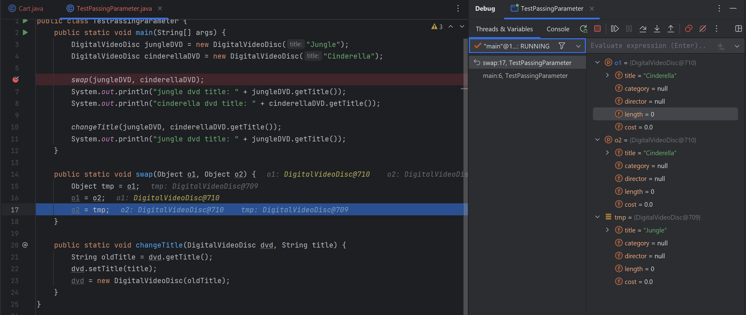
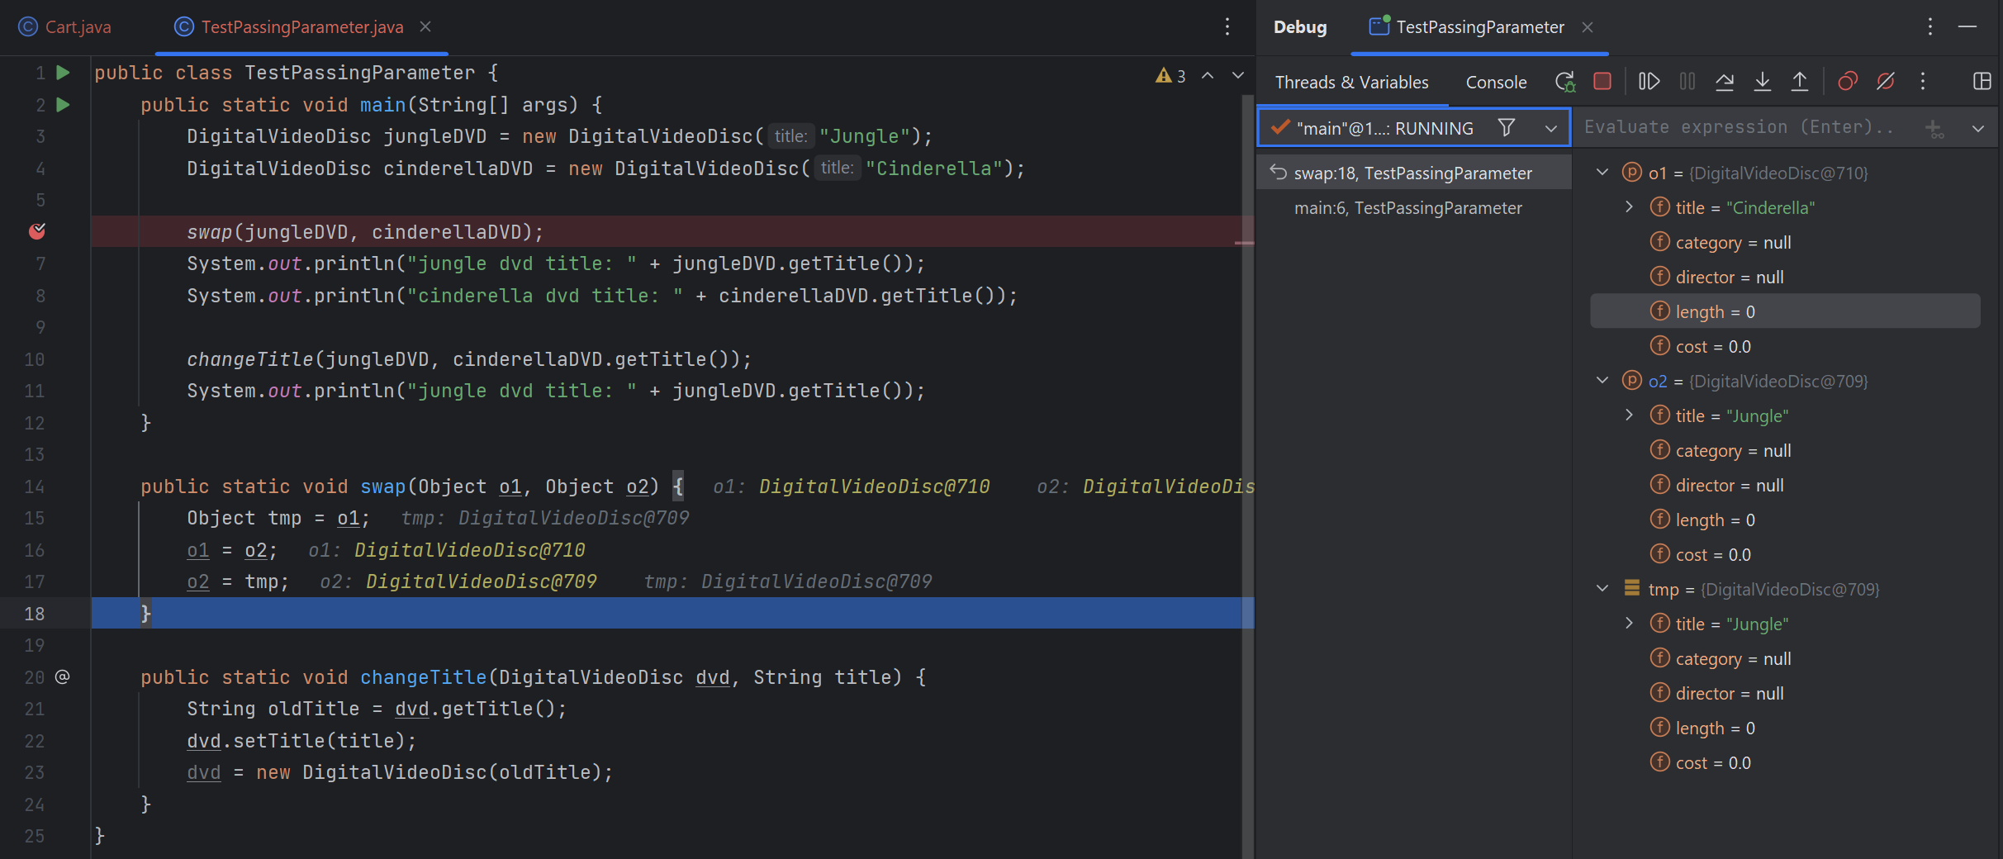

4.2.4. Change value of variables:
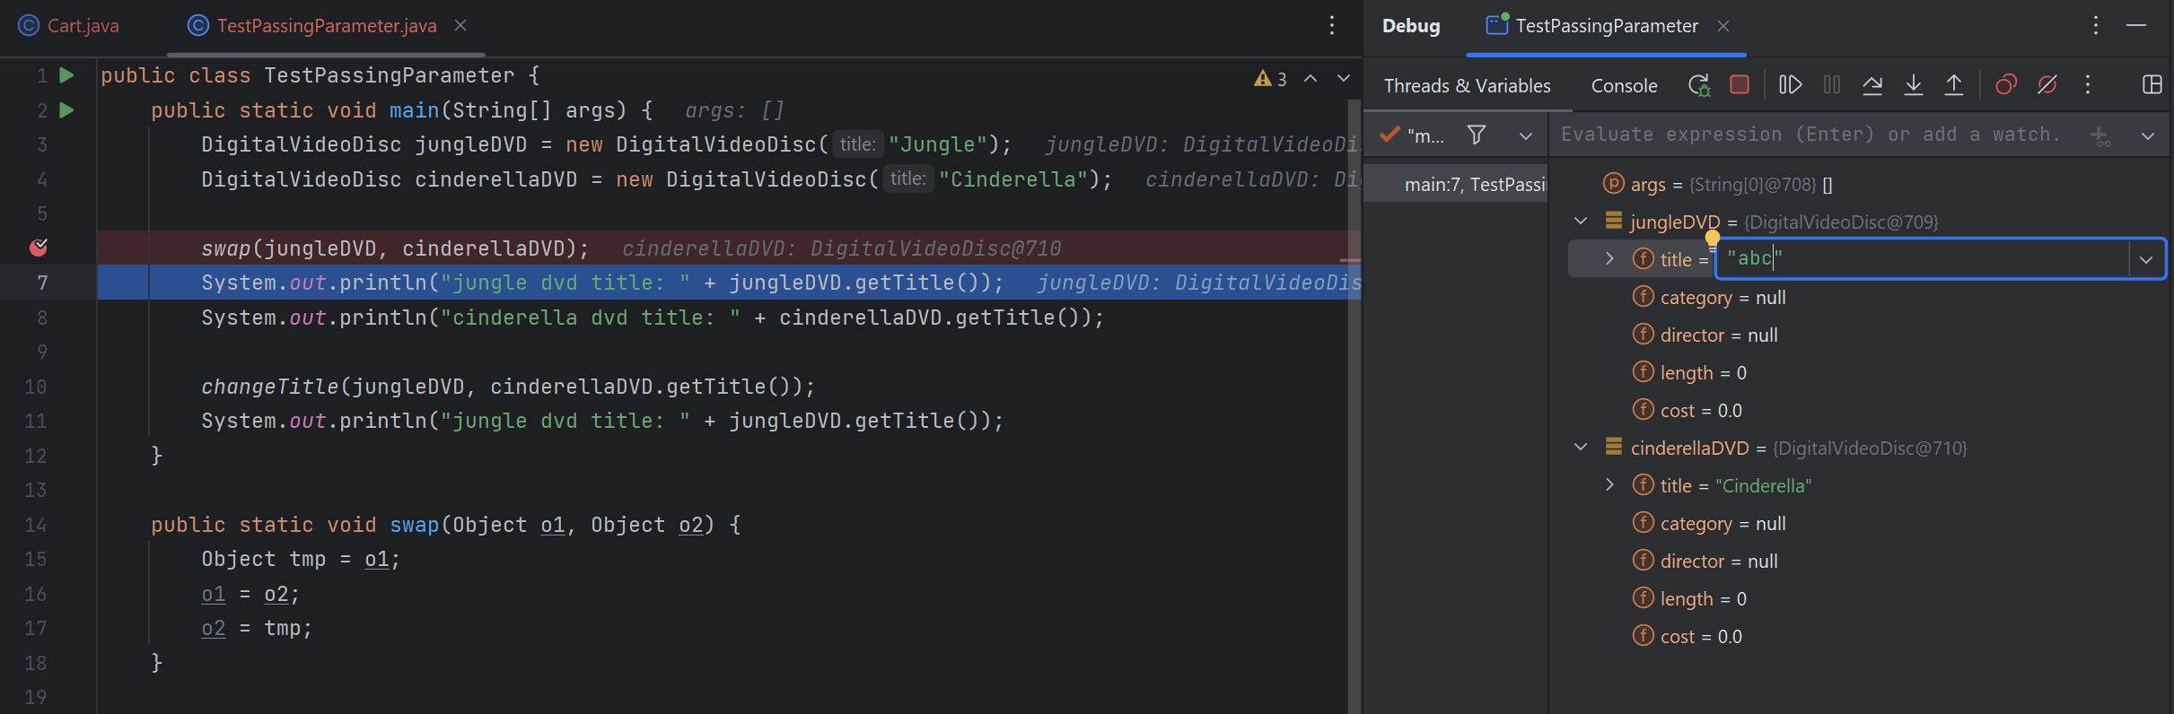
Figure 8 4.2.4. Change value of variables
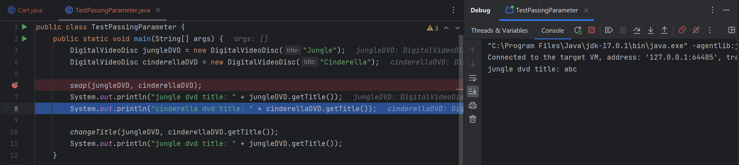

5. Classifier Member and Instance Member
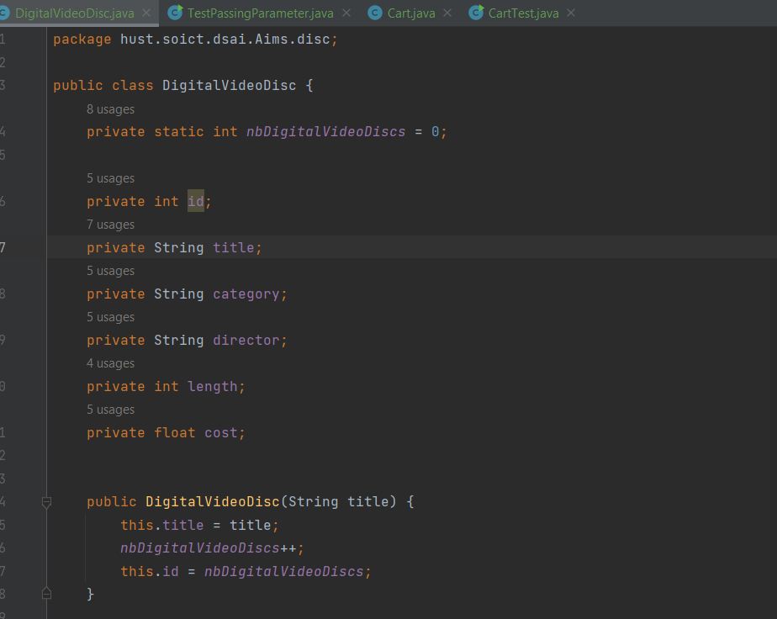
Figure 9 5. Classifier Member and Instance Member
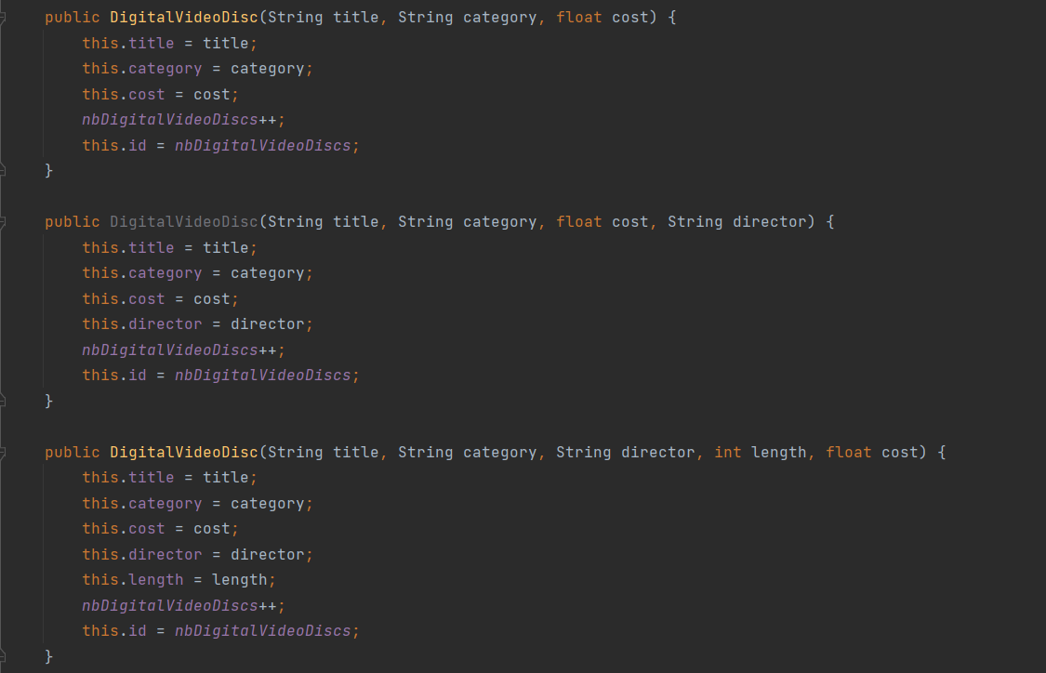

6. Open the Cart class
Write a toString() method for the DigitalVideoDisc class
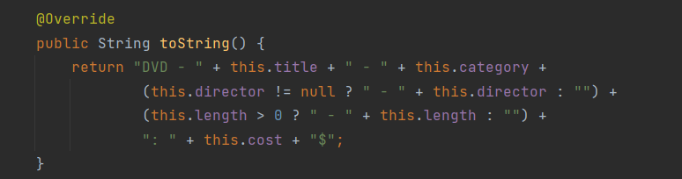
Figure 10 6.1 toString() method for the DigitalVideoDisc class

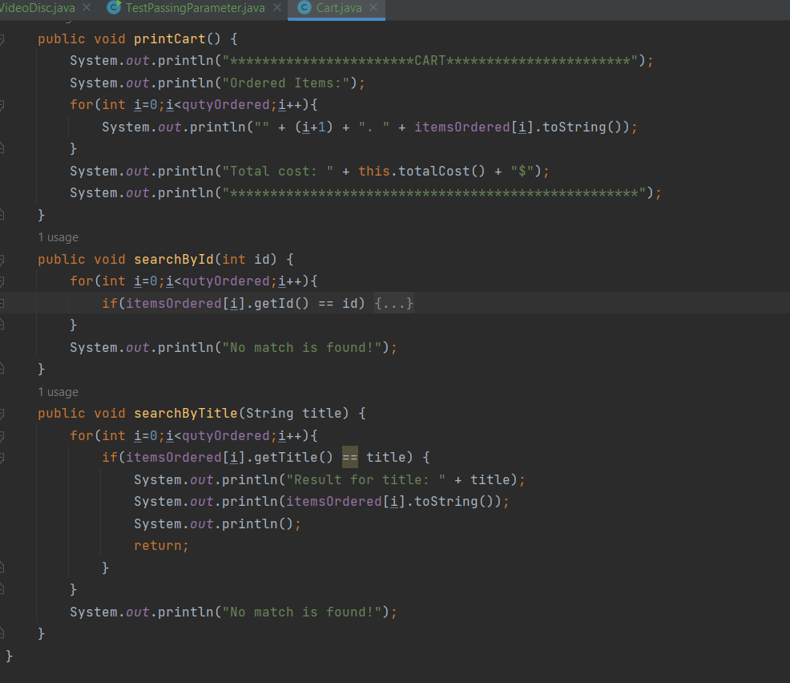
Figure 11 6.2 Method printCart / searchById / searchByTitle

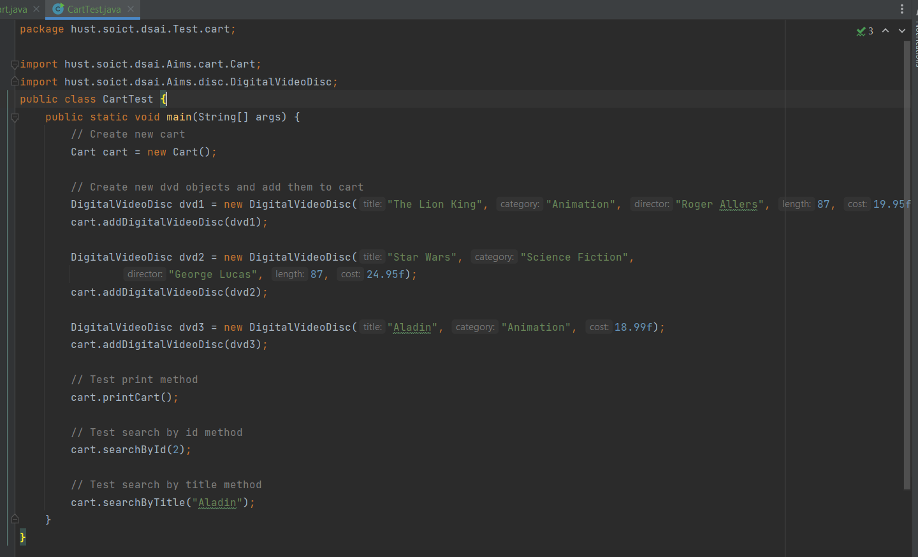
Figure 12 6.3 Class CartTest
Result:
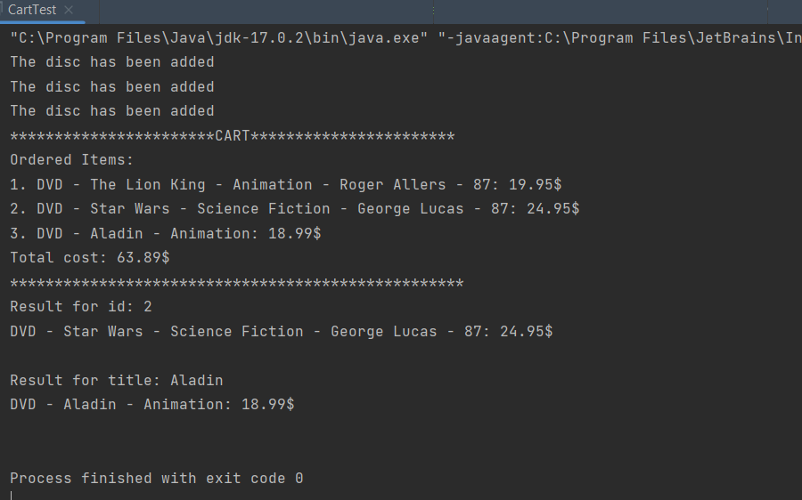

7. Implement the Store class
Class Store:
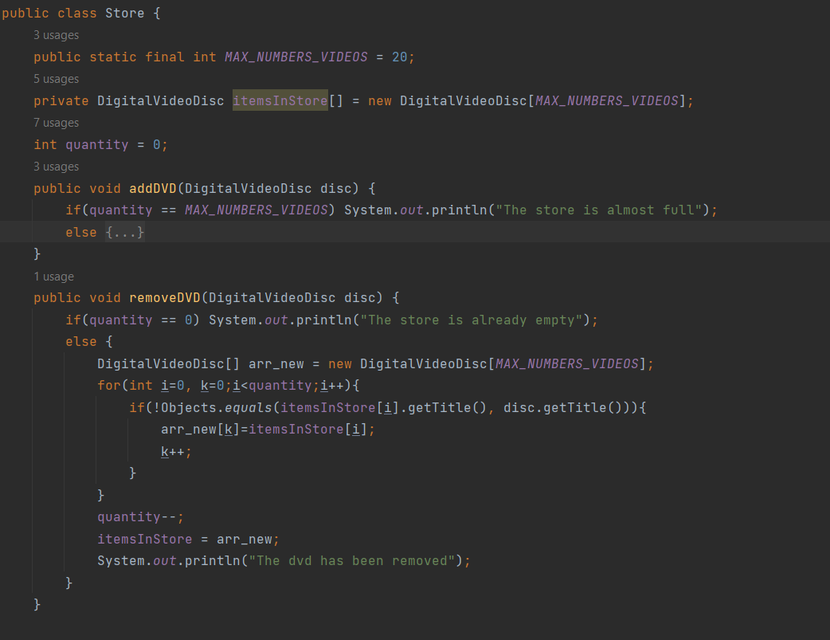
Figure 13 7.1 Class Store
StoreTest :
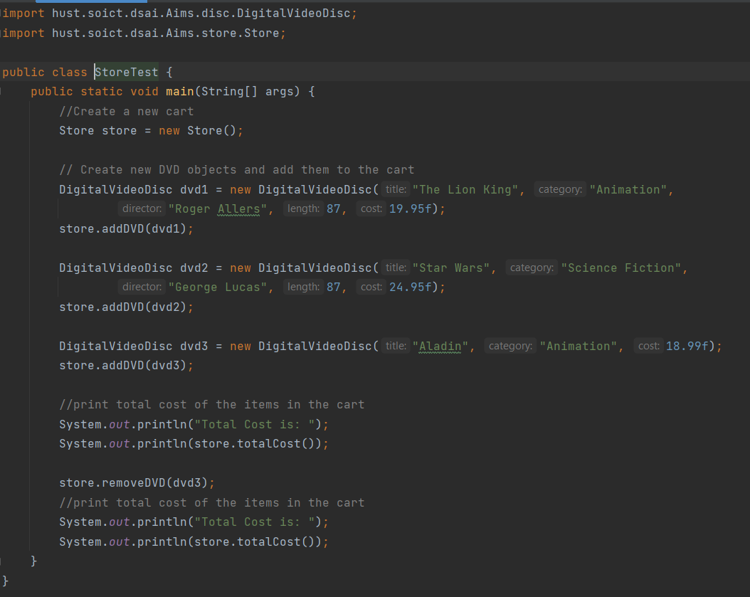
Figure 14 7.2 StoreTest

8. Re-organize your projects
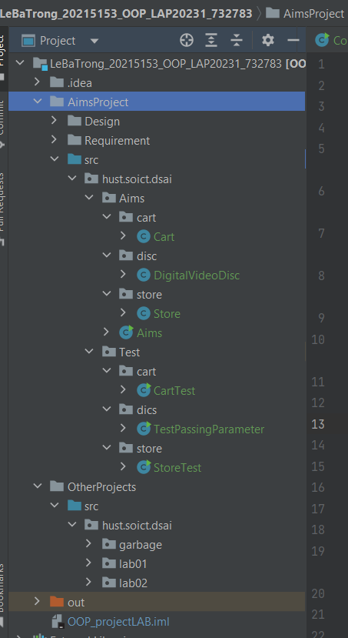
Figure 15 8. Re-organize your projects

9. String, StringBuilder and StringBuffer
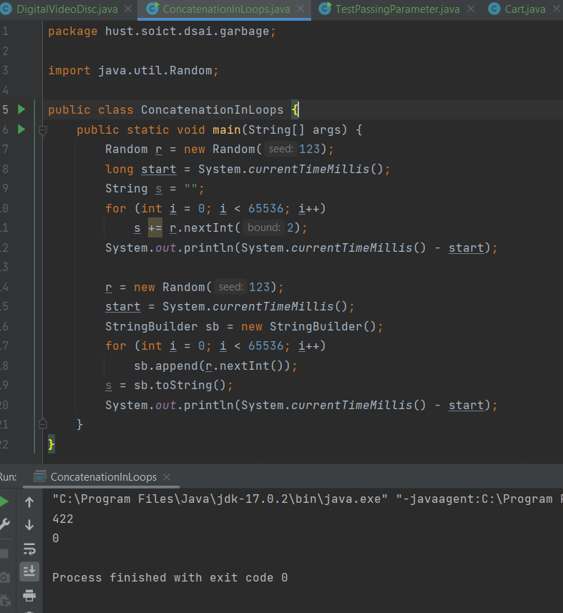
Figure 16 9.1 class ConcatenationInLoops
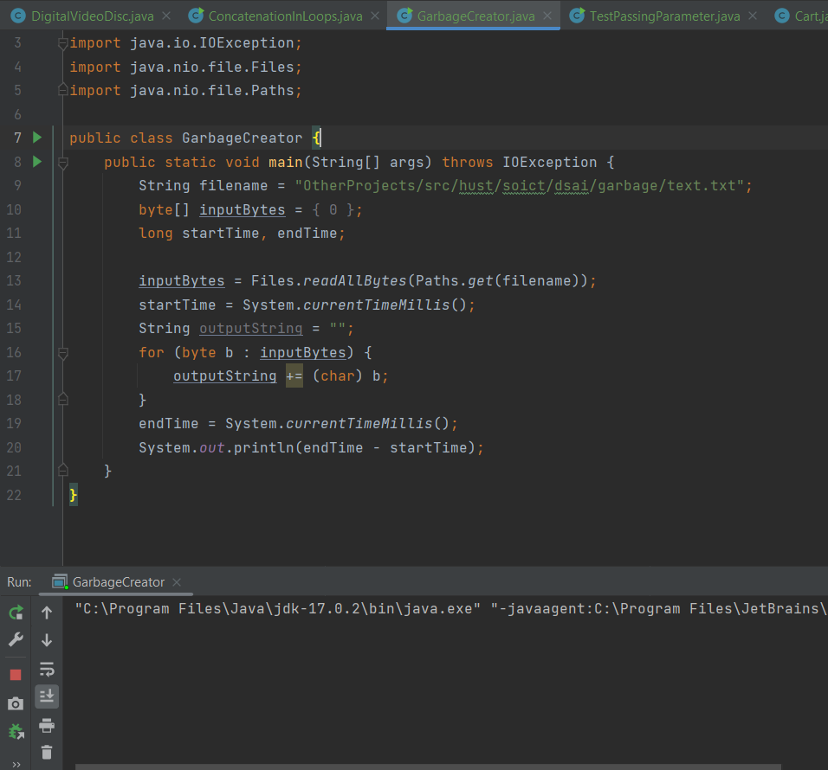
Figure 17 9.2 class GarbageCreator
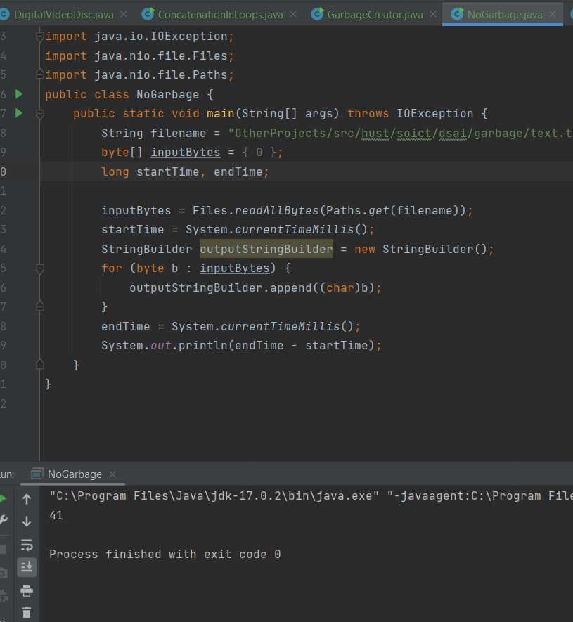
Figure 18 9.3 class NoGarbage

