# Introduction

Problem identification and solution with timeline, and brief on the scope of the project.

# Requirement Analysis

Stakeholder identification with requirements and Use case diagram with the descriptions.

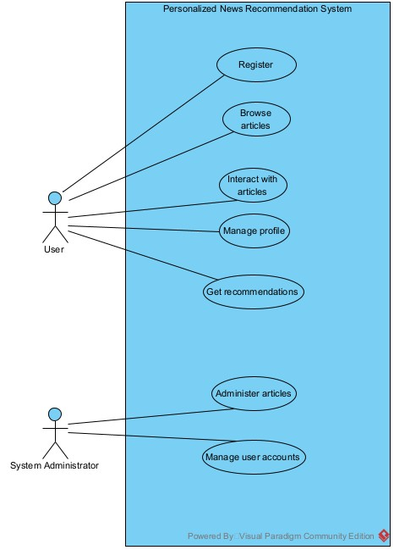

# Activity Diagrams

# A single class Diagram

# Sequence Diagrams

# Testing and evaluation

# References

# Appendix