1. Why Test Cases Instead of Just Showing Numbers
A set of impressive-looking numbers invites one obvious question: ‘could you have picked the numbers that make you look good?’ A test case answers that question before it's asked, because the rule for what counts as a pass is written down first, and the rule doesn't depend on how the result actually turns out. Every test below follows the same pattern used in software engineering testing: what we're checking → how we set it up → what result would count as a pass → what we actually got.
The tests are organised into three levels, each answering a different question:
- Level 1 — Unit tests (Section 3): ‘Does one specific rule inside the formula behave correctly, in isolation?’ Everything is held fixed except the one thing being tested, so there's no ambiguity about what caused the result.
- Level 2 — Scenario tests (Section 4): ‘Does the whole system, running on realistic hospital-like data with the real detection models, actually perform better overall?’
- Level 3 — Robustness test (Section 5): ‘If we got the exact formula weights slightly wrong, would the conclusion fall apart?’

2. What's Real, What's Simulated — Said Plainly
Real: the attack-detection AI models, the CAS scoring code exactly as it runs live, and (for Level 2) over 1.6 million real recorded network events used to test the models.
Simulated: which hospital device a given alert came from. No public dataset links a real attack to a real named hospital device, so real attack traffic is paired with a device drawn from a literature-grounded device list (see the separate Medical Device Criticality Ranking document for how that list itself is justified). This is a standard approach when no real-world dataset of that exact shape exists, and it is disclosed here rather than hidden.
CVSS doesn't exist as a field in this data either, so it's stood in for using the official published severity band for that attack category (e.g. a denial-of-service attack is always ‘High, 7.5’ on the public CVSS chart, regardless of target). That flat, target-blind behaviour is not a strawman — it is CVSS's actual, documented real-world behaviour.

3. Level 1 — Unit Test Cases
Each row below isolates one mechanism using the real scoring engine directly, with a plain-English question, a fixed pass rule, and the actual result.

TC-U1 — Does a more critical device get a higher score for the exact same attack?
Setup | Pass Rule (decided in advance) | Actual Result | Verdict
Same DoS attack signature; device A = ICU Ventilator (Class III); device B = Admin Workstation (Class I). | CAS(A) > CAS(B). CVSS gives A and B the identical score (it can't see the device). | CAS: 9.1 (Immediate) vs 6.7 (Investigate). CVSS: 7.5 for both. | PASS

TC-U2 — Does a more dangerous attack type get a higher score than a milder one, on the same device?
Setup | Pass Rule (decided in advance) | Actual Result | Verdict
Same device (Bedside Patient Monitor); attack type varied: Benign → Recon (scan) → DoS (flood). | CAS(Benign) < CAS(Recon) < CAS(DoS). The Benign case must never be flagged urgent. | 5.6 (Monitor) → 6.0 (Investigate) → 8.6 (Immediate). Ordering holds. | PASS

TC-U3 — Does the time of day change urgency, all else being equal (fewer staff on duty at night)?
Setup | Pass Rule (decided in advance) | Actual Result | Verdict
Same device (MRI Scanner) and attack (ARP spoofing); only the shift changes: day vs night. | CAS(night) > CAS(day), since fewer staff are watching at night. | Day: 7.4 (Investigate). Night: 8.2 (Immediate). | PASS

TC-U4 — Edge case / stress test: can a ‘Benign’-classified event ever be wrongly escalated to the top priority, even if every other input is artificially maxed out?
Setup | Pass Rule (decided in advance) | Actual Result | Verdict
ICU Ventilator, label forced to Benign, but confidence/anomaly-score/shift all set to their maximum-urgency values on purpose — the worst-case attempt to break the rule. | The action must stay ‘Monitor’ regardless of how high the numeric score climbs, because a Benign classification should never trigger an urgent alert. | Numeric CAS reached 9.0 (normally ‘Immediate’ territory) but action correctly stayed ‘Monitor’. | PASS

TC-U5 — Does the AI model's own confidence in its prediction change the urgency, all else being equal?
Setup | Pass Rule (decided in advance) | Actual Result | Verdict
Same device (Cardiac Monitor) and attack (brute-force login); only the model's confidence changes: 55% vs 97%. | CAS(high confidence) > CAS(low confidence). | 55% confidence: 7.3 (Investigate). 97% confidence: 8.8 (Immediate). | PASS

4. Level 2 — Scenario Test Cases (Real Models, Realistic Hospital Data)
Setup: 600 simulated alerts (200 per scenario) built from real attack traffic, run through the real trained detection models, and scored with both CAS and the CVSS-equivalent baseline.
Pass rule (decided in advance): for each hospital scenario, CAS must beat CVSS on all three of: (a) putting more life-critical alerts in the top 10 (higher is better), (b) finding a life-critical alert sooner in the queue (lower average position is better), and (c) wasting less of the top-10 slots on unimportant devices (lower is better).
Test | Scenario | Alerts | Life-Critical  Alerts | Found in Top 10  (CAS / CVSS) | Avg. Queue Position  (CAS / CVSS, lower=better) | Wasted Top-10 Slots  (CAS / CVSS) | Verdict
TC-S1 | ICU / Critical Care Ward | 200 | 103 | 9.71% / 6.80% | 66.7 / 99.5 | 0.0% / 30.0% | PASS
TC-S2 | General Ward / Radiology / Admin | 200 | 24 | 20.83% / 8.33% | 36.3 / 102.0 | 50.0% / 80.0% | PASS
TC-S3 | Hospital-Wide Mixed Stream | 200 | 58 | 17.24% / 8.62% | 54.8 / 110.0 | 0.0% / 50.0% | PASS
All three scenarios pass on all three sub-checks (9 out of 9 checks) — CAS is never worse than CVSS on any measure, in any hospital setting tested.
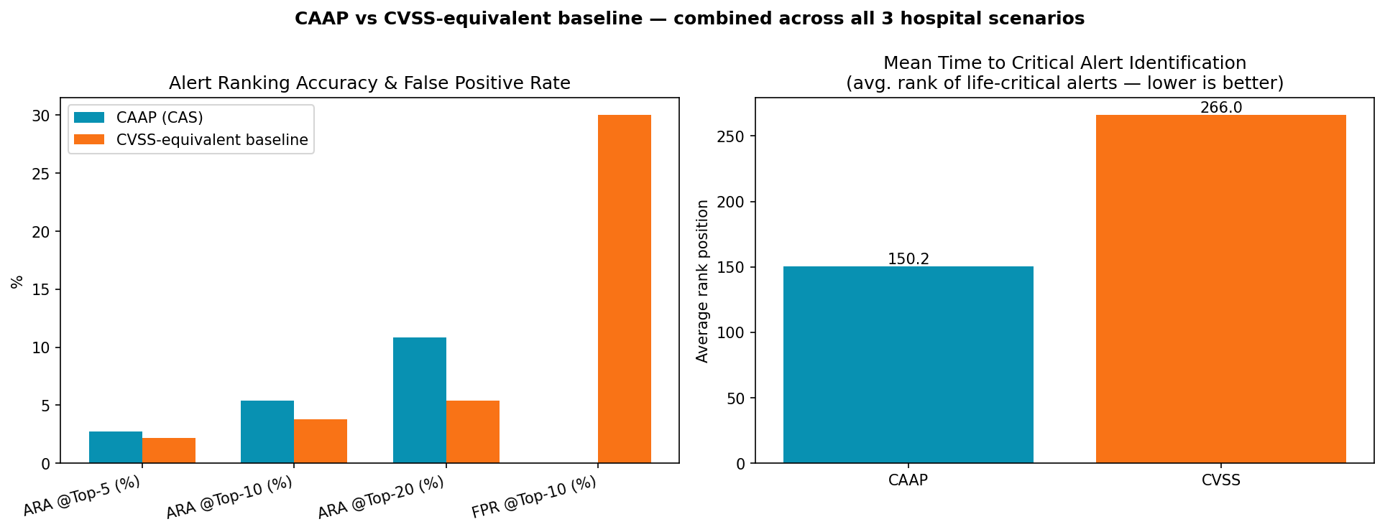
→ A note on the combined (all-scenarios) numbers: If you pool all 600 alerts into one queue, the top-10-of-600 bar is much harder to clear than each scenario's own top-10-of-200, so the pooled percentages look smaller than each scenario's individual number. That is expected arithmetic, not an error — CAS still beats CVSS on the pooled numbers too (5.4% vs 3.8%), it's just a stricter test. Lead with the per-scenario numbers when presenting; mention the pooled number as the ‘hospital-wide, stricter’ version if asked.

5. Level 3 — Robustness Test Case
TC-R1 — If the formula's weights were slightly wrong, would the conclusion fall apart?
Setup: each of the formula's five weights was nudged up and down by 5%, one at a time (10 trials total), and every alert was re-scored and re-ranked.
Pass rule (decided in advance): the alert ordering must stay at least 95% the same as before the nudge, in all 10 trials.
Actual result: the worst of the 10 trials still kept 98.2% of the original ordering — comfortably above the 95% bar, in every trial.
Result | Verdict
10 / 10 trials ≥ 95% rank agreement | PASS
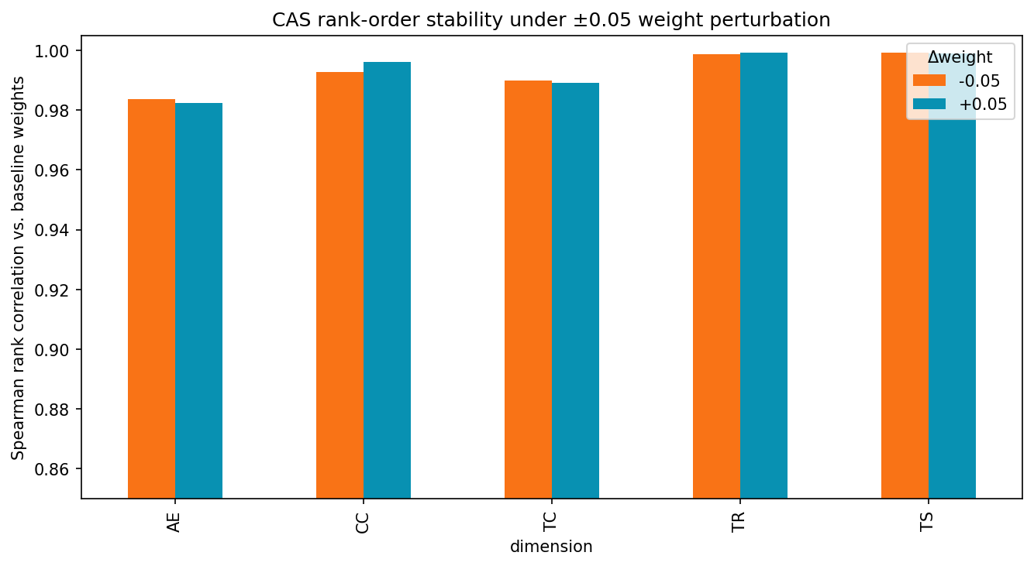

6. Full Scoreboard
5 unit-level test cases + 3 scenario-level test cases (9 sub-checks) + 1 robustness test case (10 trials) = 24 individual pass/fail checks. 24 passed. 0 failed.

7. Anticipated Questions (Prepare These Answers)
Q: Why not use real hospital incident data instead of simulated device assignments?
A: Because that dataset doesn't exist publicly — no one publishes ‘this exact attack hit this exact named hospital device’ records, for obvious privacy and security reasons. The attack traffic and the detection models are real; only the device assignment is simulated, and it's simulated using a device list that is itself justified from published sources (FDA device classes, clinical engineering literature), not invented.

Q: Isn't 600 alerts / 6 devices a small sample?
A: The 600-alert benchmark (Level 2) is the statistical evidence, and 600 is a normal size for this kind of comparative study. The 6-device table (Level 1, TC-U1) is not trying to be statistical evidence at all — it's a unit test, deliberately small and fixed, whose whole purpose is to isolate one variable. Asking a unit test to also be statistically powerful is asking it to do a job it was never meant to do.

Q: Why does the combined (pooled) number look lower than each scenario's own number?
A: Explained in Section 4's callout — it's because the pooled top-10 is a stricter bar (top 10 of 600 instead of top 10 of 200), not a mistake. CAS still wins on the pooled number too.

Q: Couldn't the formula's weights have been picked to make CAS look good?
A: The weights come from a separate pairwise-comparison exercise (AHP), documented independently of these test results. TC-R1 also shows the conclusion survives even if the weights are wrong by 5% — so the result isn't fragile to the specific numbers chosen.

Q: Is the CVSS baseline a strawman — is CVSS really that blind to context?
A: No — this is documented, published behaviour of CVSS, not something invented to make it look bad. See the separate literature-review document: multiple peer-reviewed sources and even an FDA-sponsored MITRE report state directly that CVSS was not designed to reflect clinical/patient-safety context.

Q: What if two devices need different treatment but share the same FDA class?
A: The system doesn't rely on just 3 FDA-class buckets — there is a 91-entry device-specific table underneath, and a separate document explains and validates how each entry was placed using six criteria beyond FDA class alone.

