MediSIEM / CAAP
The Machine Learning Pipeline, End to End
From Raw Packet Captures to a Production Clinical Alert Score
(A Complete A-to-Z Reference)

Project: MediSIEM — Clinical Alert Awareness Platform (CAAP) for Hospital IoMT Security
Research reference: SLIIT R26-CS-008
Scope of this document: Dataset → preprocessing → model training → evaluation → explainability → the Clinical Alert Score (CAS) domain layer → live inference API → real-time capture pipeline → SIEM/dashboard integration → MLOps (versioning, drift, retraining) → production hardening roadmap
Generated: 23 August 2026

Table of Contents
(In Microsoft Word: right-click the field below → Update Field → Update entire table.)
Right-click here and choose “Update Field” to build the table of contents.

1. Executive Summary
MediSIEM's AI layer — internally called CAAP (Clinical Alert Awareness Platform) — is an Intrusion Detection System purpose-built for hospital IoMT (Internet of Medical Things) networks. It does not stop at “is this traffic malicious?”. It combines three trained machine learning models with a rule-based clinical-context engine to answer the question a hospital SOC analyst actually needs answered: “how urgently does a human need to look at this, given which device it hit, which patients depend on it, and what time of day it is?”
This document walks through the entire pipeline exactly as it is implemented in this repository today — from the raw pcap-derived training data, through feature engineering, model training and calibration, offline evaluation, the Clinical Alert Score (CAS) formula, the live Flask inference API, the real-time packet-capture-to-dashboard pipeline, and the operational (MLOps) mechanisms for versioning, drift detection and analyst-driven retraining. It closes with a candid list of current limitations and a concrete roadmap for hardening the system to a fully mature production MLOps posture.
At a glance — what is real vs. what is planned:
- Real, trained, and serving today: Random Forest classifier, one-class Isolation Forest anomaly detector, K-Means traffic clustering, the CAS scoring engine, a Flask /predict API, SHAP explainability, live packet-capture feature extraction, drift checking, and an analyst feedback-export path for retraining.
- Deliberately manual (human-in-the-loop) today: retraining is analyst-triggered (export verdicts → drop CSV → rerun train.py), not an automated CI/CD loop.
- Not yet built (see Section 16): containerized deployment, automated canary/rollback releases, an automatic drift-triggered retrain trigger, and per-device-type anomaly baselines (the mechanism exists in code but no per-device model has been trained yet).

2. System Overview & Architecture
The ML system is deliberately split into an offline research/training side and a live serving side, joined by a single shared configuration file so the two can never silently disagree about scoring rules.

2.1 The Three ML Models
Model | Type | Trained on | Job in the system
Random Forest | Supervised multi-class classifier | All labeled flows (attack + benign) | Classifies each flow into one of 6 traffic types and produces the confidence used for Threat Risk (TR)
Isolation Forest | Unsupervised, one-class anomaly detector | Benign flows only | Flags behavior that deviates from normal traffic — feeds Time Sensitivity (TS)
K-Means (k=2) | Unsupervised clustering | All flows (unlabeled) | Groups traffic into idle/active behavioral clusters — contextual signal shown to analysts

2.2 High-Level Data Flow
Raw pcap captures (research) Live hospital network (production)
| |
train.py (offline) live_feature_extractor.py (packet sniff)
| |
models/*.pkl + model_meta.json flow_consumer.py --/predict--> Flask :5001
| | |
+----------------- same artifacts ---------+ |
| |
Wazuh/OpenSearch 'caap-alerts' <---+
|
Node backend :5000 (poll + fallback)
|
Socket.IO --> React SOC dashboard :5173
The offline branch (top-left) trains and evaluates the models. The production branch (top-right) captures live traffic, extracts the same feature schema the models were trained on, and pushes every flow through the identical scoring logic. Both branches load the exact same pickled model artifacts and the exact same shared/cas_config.json scoring configuration — there is only one copy of “what a Benign flow looks like” or “what weight Clinical Criticality gets” in the whole system.

2.3 Single Source of Truth for Scoring Config
shared/cas_config.json is loaded by three independent runtimes: ai_server/src/cas_config.py (used by the live Flask server and the offline research notebook/scripts) and backend/services/caapService.js (Node). It holds the CAS dimension weights, the FDA-device-class port lookup table, the attack-type severity (AE) table, the CVSS-equivalent comparison baseline, shift-based Temporal Context (TC) values, and department-to-scenario weight profiles. This was a deliberate refactor: earlier versions kept independent copies of these tables in Python and JavaScript, which drifted apart. Now every consumer reads the one file.

3. The Dataset
Training data lives in ai_server/data/train/ and ai_server/data/test/ as pcap-derived CSV files following the CICIoT2023 / CIC IoMT-2024 feature schema (Neto et al., “CICIoT2023”, Sensors 2023) — 45 numeric network-flow columns per row, no free-text fields.

3.1 Classes
Labels are derived automatically from filenames (see Section 4.1) and collapsed to six canonical classes actually used by the deployed model:
Class | Represents
Benign | Normal device/network traffic
ARP_Spoofing | ARP cache poisoning / MITM setup
DoS_TCP | TCP/ICMP/UDP/SYN flooding (DoS and DDoS variants merged)
MQTT_Publish_Flood | MQTT broker flooding via excessive publish traffic
MQTT_Brute_Force | MQTT malformed-data / brute-force / connect-flood attacks
Recon | Port scans, OS scans, ping sweeps, vulnerability scans

3.2 Scale (last successful training run)
Split | Rows | Feature columns
Train | 7,160,831 | 45
Test | 1,614,182 | 45

3.3 Data Hygiene Note
ai_server/data/train/ currently also contains eight large files from the unrelated, public CIC-IDS2017 dataset (Monday-WorkingHours.pcap_ISCX.csv through the Friday variants, ≈880MB). CIC-IDS2017 uses a completely different ~80-column schema (e.g. “Flow Duration”, “Total Fwd Packets”) with zero column-name overlap against the 45-column CICIoT2023 schema train.py expects. Because train.py's loader concatenates every CSV in the folder and then drops rows with missing feature values, mixing both schemas in the same run would corrupt or empty the merged training set. This has been flagged to the project owner and intentionally left untouched pending a decision on where to relocate those files — the results in this document reflect the last clean run (single schema, 45 features, 6 classes, exactly matching the row counts above).

4. Data Loading & Preprocessing (train.py, Steps 1–2)

4.1 Label Derivation
Raw pcap CSVs have no label column of their own — one label is derived per file from its filename via a small regex table (LABEL_MAP), unanchored on “benign” so protocol-prefixed names like WiFI_and_MQTT-Benign-train.pcap.csv are still caught, and pattern-ordered so specific matches (e.g. mqtt.*flood) are tried before generic fallbacks. A CSV that already carries its own per-row label column (for example an admin's training-feedback export — see Section 14.3) keeps those labels untouched instead of being overwritten with one filename-derived label.

4.2 Merge, Clean, Encode
- Load & merge: every CSV in data/train/ and data/test/ is read and concatenated; column whitespace is stripped and fully-empty rows dropped.
- Column typing: each non-label column is coerced to numeric; any column that fails (non-numeric/text) is dropped and logged — this is how FEATURE_COLS (45 columns) is actually derived, rather than being hardcoded.
- Row cleaning: rows with any remaining NaN in the surviving numeric columns are dropped.
- Label safety checks: the script hard-fails if no “Benign” class is found (Isolation Forest needs it) and drops any test-set label that never appeared in training.
- Label encoding: scikit-learn's LabelEncoder is fit across the union of train+test labels.
- Feature scaling: a single StandardScaler is fit on the training features only, then applied to both train and test — this exact fitted scaler is what the live Flask API loads and reuses for every real-time prediction.
- Class-weight balancing: sklearn's compute_sample_weight("balanced") is computed on the training labels and passed into the Random Forest fit, so the far more common Benign/DoS rows don't drown out rarer classes like ARP_Spoofing.

4.3 Isolation Forest's Special Split
Because Isolation Forest is a one-class model, it must never see attack traffic during fitting. The benign portion of the training set is further split 80/20: the 80% “fit” split is what IsolationForest.fit() actually sees; the held-out 20% — combined with every attack row already in the training set — becomes a labeled calibration set the model has never touched, used purely to pick a good decision threshold afterward (Section 6.2).

5. Feature Engineering — Offline & Live

5.1 The 45-Column CICIoT2023 Schema
Every model is trained on the same 45 numeric flow-level features, grouped here by what they describe:
Group | Example columns
Packet-header stats | Header_Length, Protocol Type, Duration, Min, Max, AVG, Std, Tot size, Tot sum
Rate / volume | Rate, Srate (forward rate), Drate (backward rate), Number, Weight
TCP flags | fin/syn/rst/psh/ack/ece/cwr_flag_number, ack_count, syn_count, fin_count, rst_count
Application protocol indicators | HTTP, HTTPS, DNS, Telnet, SMTP, SSH, IRC, TCP, UDP, DHCP, ARP, ICMP, IGMP, IPv, LLC
Flow shape statistics | IAT (inter-arrival time), Magnitue, Radius, Covariance, Variance

5.2 Why Live Capture Reconstructs Features From Scratch
The original plan was to use the standard CICFlowMeter tool to produce live flow CSVs. That tool was verified (ai_server/verify_feature_cols.py) to produce a completely different ~80-column schema with zero name overlap against the 45 columns the trained model actually expects — installing it as-is would have silently zero-filled every real feature at inference time. Instead, Extra_Material/ml-pipeline/live_feature_extractor.py sniffs raw packets with scapy and computes the CICIoT2023 columns directly, following the formulas in the paper's Table 4:
- Flow keying: packets are grouped by an unordered {src_ip, dst_ip} pair, so both directions of one conversation land in the same flow window.
- Tumbling windows: once a flow accumulates N packets (default 100, configurable per attack type per the source paper), its statistics are computed once and the window resets.
- Derived stats: means/variances/std-devs of packet length by direction, TCP flag presence and per-flag counts, protocol/application indicators from port and IP-protocol-number heuristics, inter-arrival times, and composite features like Magnitue (sqrt of combined fwd/bwd mean length), Radius (sqrt of combined variance) and Covariance between forward/backward lengths.
- Sequence-awareness (recent_flow_count): a rolling count of how many flow-windows the same source device has completed in the last 5 minutes is captured on every row as a step toward detecting slow, multi-stage attacks — written to the live CSV but not yet part of FEATURE_COLUMNS, so it is not yet scored by the deployed Random Forest (adding it requires retraining with it present in data/train/).
Column names match the trained model exactly by construction. Whether the reconstructed values' distributions match the original training data as closely as CICFlowMeter's would have is a from-first-principles implementation of a published spec, not a byte-for-byte port — the module's own docstring recommends sanity-checking captured benign traffic against ai_server/data/train/Benign_train.pcap.csv before trusting live accuracy claims.

6. Model Training (train.py, Step 3)

6.1 Random Forest — the main classifier
Hyperparameter | Value | Why
n_estimators | 300 | Enough trees for a stable OOB estimate on a multi-million-row set
max_depth | None (unrestricted) | Let trees fully separate the six well-populated classes
max_features | "sqrt" | Standard RF decorrelation heuristic
class_weight | "balanced" | Combined with per-sample balanced weights, so rare attack classes aren't swamped by Benign/DoS volume
bootstrap / oob_score | True / True | Free, honest internal validation (OOB) alongside the held-out test set
random_state | 42 | Reproducibility

The Random Forest is the sole source of the predicted attack label and of the confidence used as the CAS engine's Threat Risk (TR) dimension.

6.2 Isolation Forest — one-class anomaly detector
Fit only on the benign “fit” split (Section 4.3) with n_estimators=300, contamination="auto" (deliberately not relied upon for the actual decision boundary — see below), max_samples="auto", random_state=42.
Isolation Forest's built-in predict() threshold is derived purely from the training score distribution and a guessed contamination rate — it has never seen a real attack, so there's no reason to trust it. Instead, train.py scores the labeled calibration set (held-out benign + real attacks, both untouched during .fit()) and picks the operating point on the resulting ROC curve using Youden's J statistic (the threshold maximizing True-Positive-Rate minus False-Positive-Rate) — this is the value saved to models/if_threshold.pkl and is what the live app.py actually compares each flow's anomaly score against.
A target-FPR lookup table is also printed at training time (1%/5%/10%/15%/20% target false-positive rates and the corresponding detection rate) so a future retrain can trade recall for a tighter false-positive budget deliberately, instead of accepting Youden's balance point by default.

6.3 K-Means — behavioral clustering
k=2, k-means++ initialization, n_init=20, max_iter=500, random_state=42. Empirical testing during an earlier phase found k=2 separated the data better than the originally planned k=3, so a “routine” middle cluster was dropped. Cluster identities are assigned by inspecting the fitted centroids after training (cluster 0 — near-zero volume/duration across ~98.7% of samples — is labeled “idle”; cluster 1, several standard deviations above the mean, is “active”) and this mapping is kept byte-identical between train.py and the live app.py so cluster labels never flip between offline evaluation and production.

6.4 Saved Artifacts
File | Purpose
random_forest.pkl / isolation_forest.pkl / kmeans.pkl | The three fitted models
scaler.pkl | StandardScaler fitted on training features — reused identically at inference
label_encoder.pkl | Class name ↔ integer mapping
feature_cols.pkl | Authoritative ordered list of the 45 feature names every consumer must match
if_threshold.pkl | The Youden-tuned Isolation Forest decision threshold
model_meta.json | Training timestamp, feature hash, classes, per-model accuracy, and the per-feature mean/std baseline used later for drift detection (Section 14.2)

7. Model Evaluation & Results
Metrics below are computed on the held-out real test set (1,614,182 rows, never used in training or Isolation Forest calibration), reproduced from ai_server/reports/model_accuracy_summary.txt.
Model | Metric | Train | Test | Overall
Random Forest | Classification accuracy | 100.00% | 99.87% | 99.97%
Isolation Forest | Binary Normal/Attack accuracy | 98.81% | 98.54% | 98.76%
K-Means | Majority-vote cluster purity | 92.28% | 92.24% | 92.27%

- Random Forest AUC-ROC (macro, one-vs-rest): 0.9993
- Random Forest OOB score: 99.92%
- Isolation Forest — False Positive Rate (benign flagged anomalous): 28.26%
- Isolation Forest — Attack Detection Rate (attacks flagged anomalous): 99.18%
- K-Means Silhouette score: 0.8406
The Isolation Forest's 28% false-positive rate paired with 99% detection is a deliberate high-recall operating point, appropriate for a screening layer feeding into a broader clinical score rather than acting as a standalone verdict (see Section 15.2).

7.1 Confusion Matrix
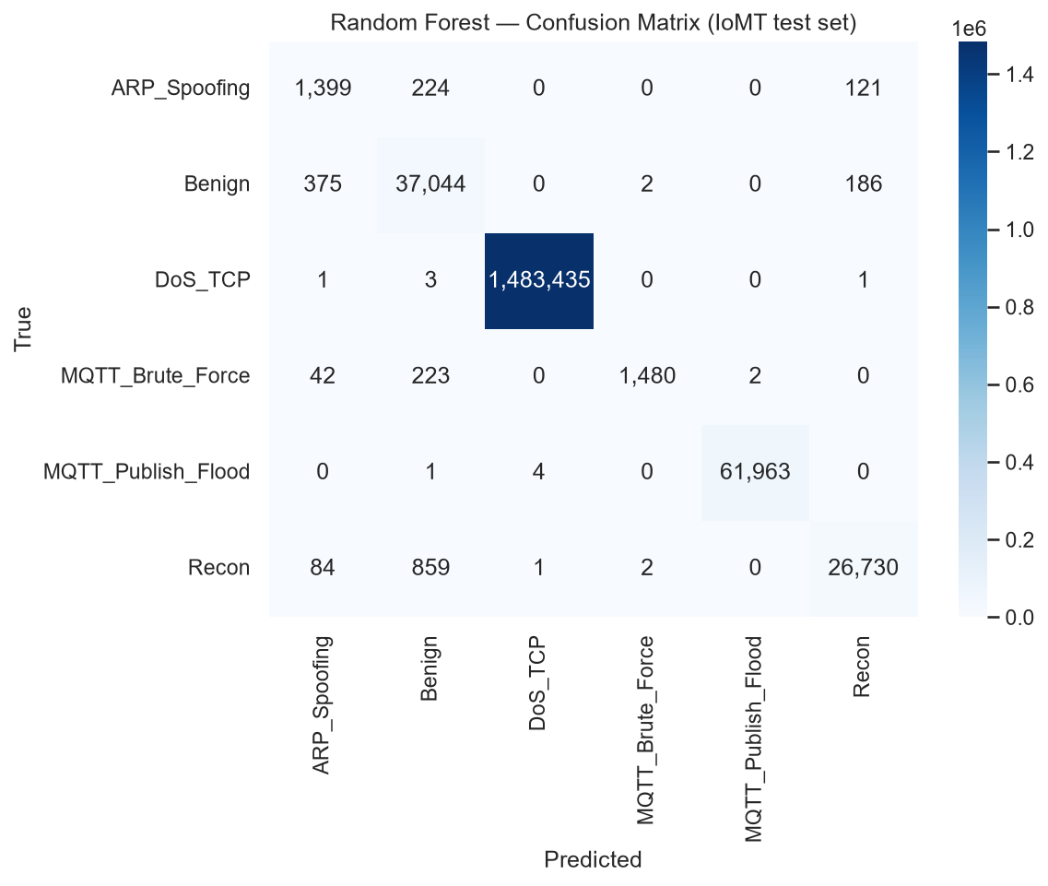
Random Forest confusion matrix on the held-out test set.

7.2 ROC Curves
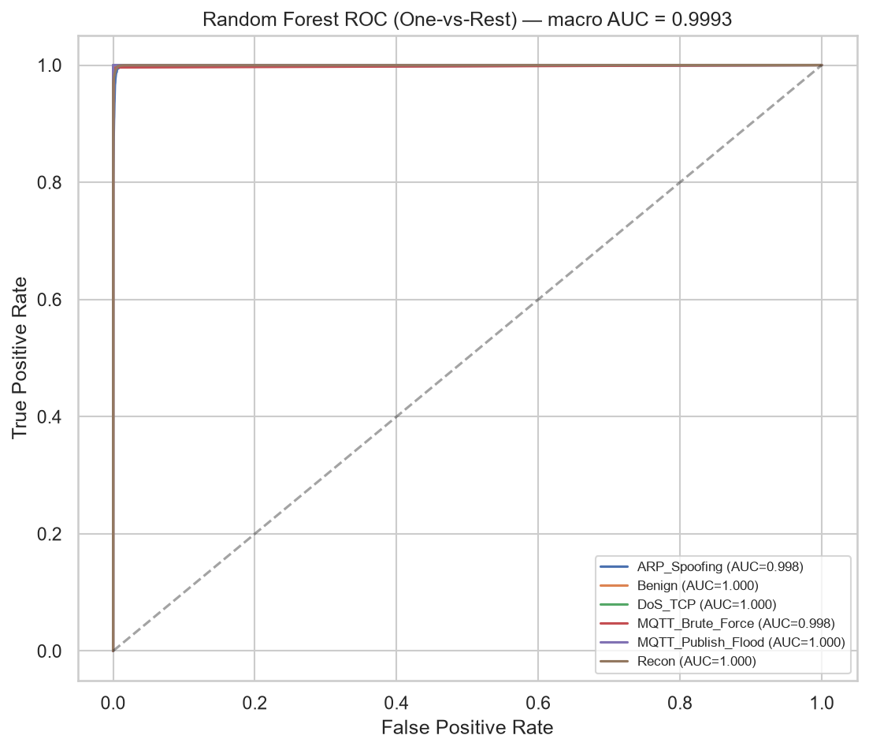
Random Forest ROC (macro one-vs-rest).
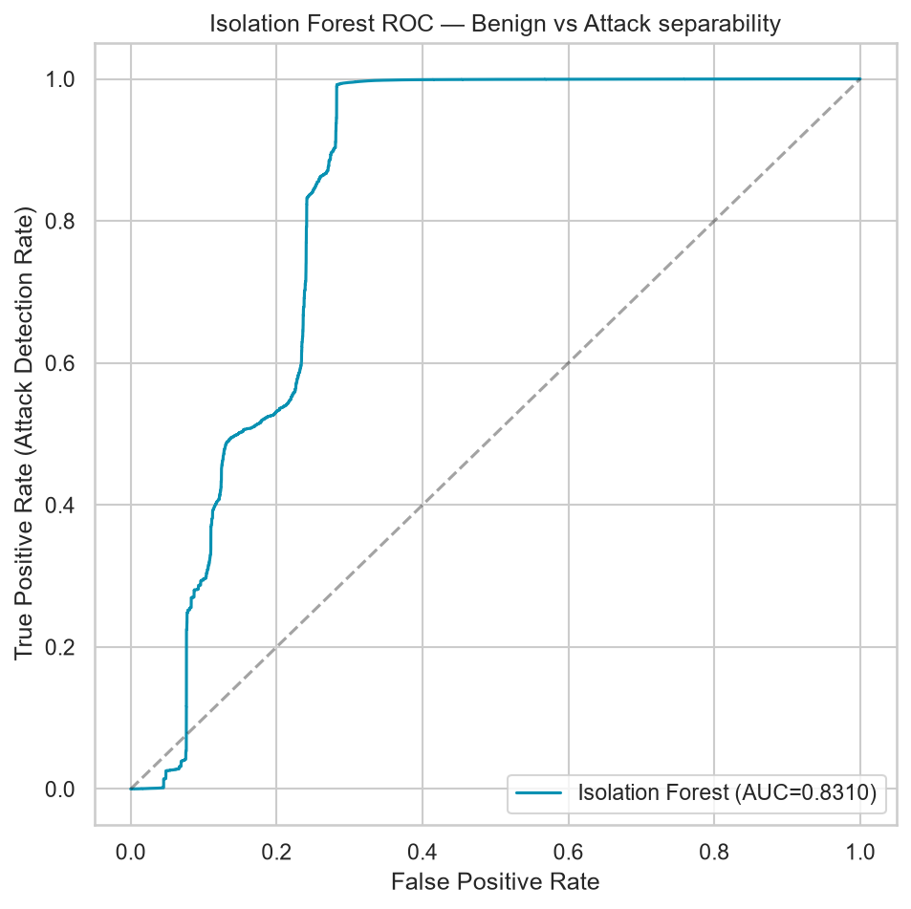
Isolation Forest ROC — anomaly flag vs. ground-truth Benign/Attack, used to select the Youden-optimal threshold.

7.3 Feature Importance
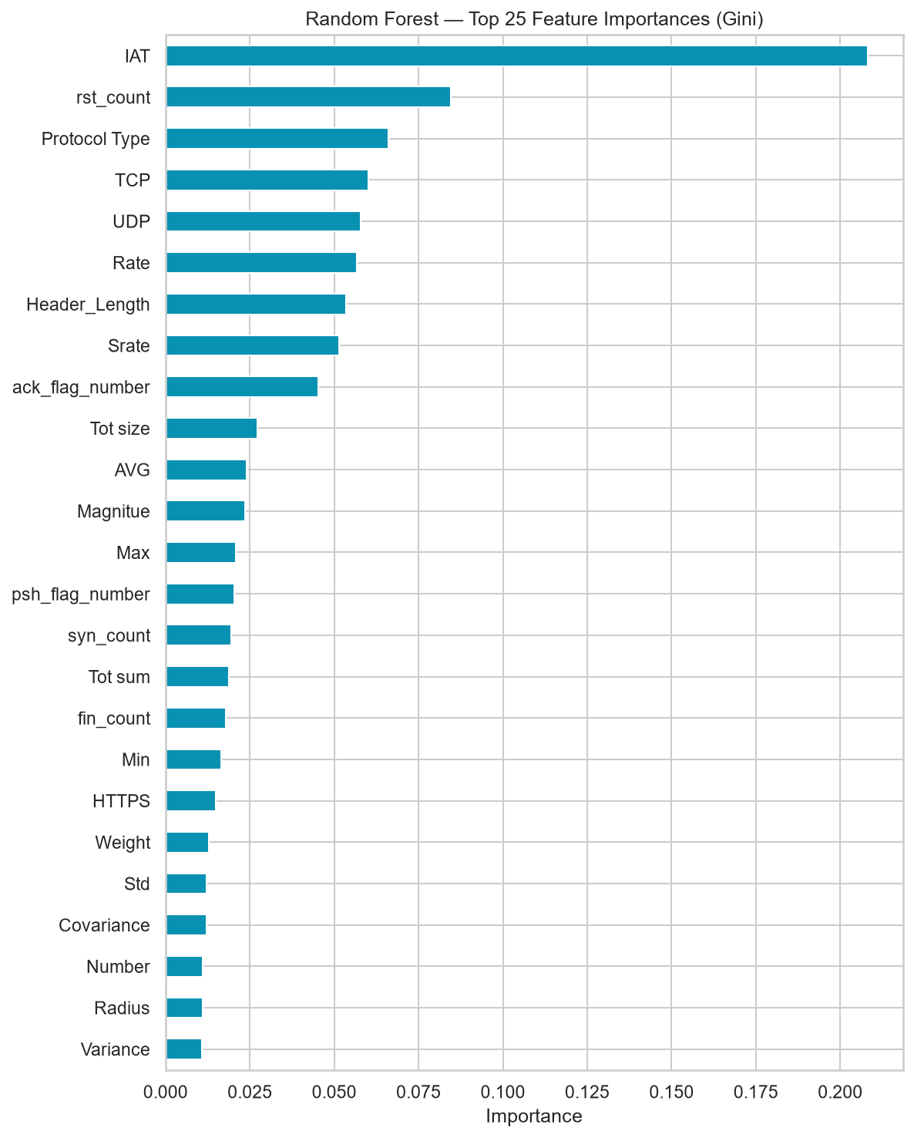
Top 20 Random Forest feature importances.

7.4 Model Comparison Summary
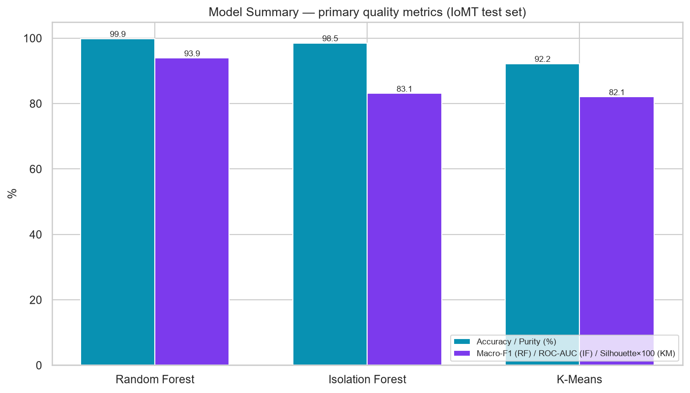
Side-by-side comparison across all three models' key metrics.

8. Explainability — SHAP
Every live prediction is accompanied by a SHAP (SHapley Additive exPlanations) breakdown, not just a bare label. A shap.TreeExplainer is built once at Flask startup over the fitted Random Forest (fast for tree ensembles). For each request, the top 3 features driving the predicted class are returned both as a human-readable sentence and as a structured list (feature / SHAP value / direction — “increases” or “decreases” the predicted class), which the dashboard renders as a bar chart in the alert-details view. This turns “the model says DoS_TCP” into “the model says DoS_TCP because Rate and Srate are far above normal and Duration is unusually low” — the difference between a black box and something a SOC analyst can act on and trust.
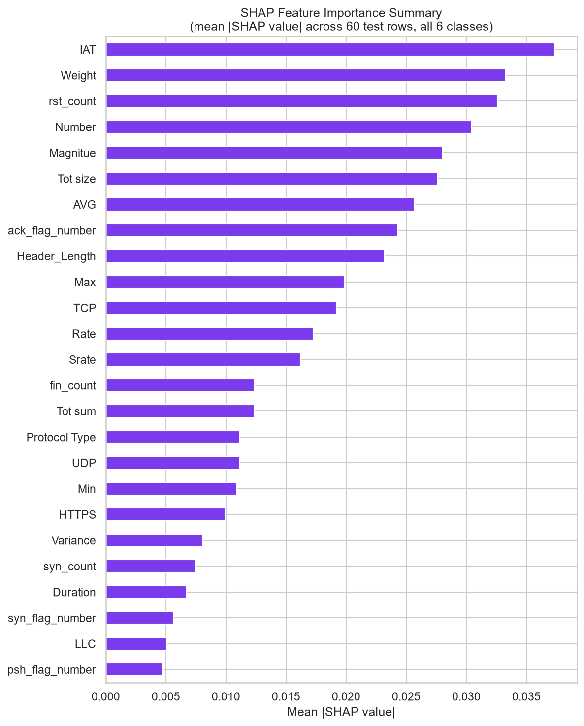
SHAP summary plot — feature impact distribution across the test set.

9. From ML Scores to Clinical Decisions — The Clinical Alert Score (CAS)
Raw model output (“92% confidence this is MQTT_Brute_Force”) doesn't tell a hospital SOC how urgently to react. The same attack against a nurse's admin workstation and against an ICU ventilator warrants very different urgency. CAS is the domain layer that fuses ML output with clinical/operational context into one 1–10 score and a concrete recommended action.

9.1 The Five Dimensions
Dimension | Weight | Source | What it captures
TR — Threat Risk | 0.25 | Random Forest confidence | How sure the classifier is about the predicted attack type
CC — Clinical Criticality | 0.30 | FDA 21 CFR §860.3 device class, via destination-port lookup (or an admin-set device criticality field when available) | How life-critical the affected device/patient dependency is
TS — Time/Threat Sensitivity | 0.25 | Isolation Forest anomaly score + hour of day | Whether the flow is behaviorally anomalous, weighted higher off-hours
AE — Active Exploitation | 0.10 | Attack-type base severity table, boosted to the ceiling by a known-exploited-CVE or malicious-IP-reputation hit | Whether this is a technique with a real, currently-exploited weakness behind it
TC — Temporal Context | 0.10 | Shift lookup: day / evening / night | Fewer staff on duty overnight → higher weight at night

CAS = 0.25·TR + 0.30·CC + 0.25·TS + 0.10·AE + 0.10·TC (all dimensions on a 1–10 scale)

9.2 Clinical Criticality — not a guess
CC is grounded in FDA 21 CFR Part 860 §860.3 device-class definitions (Class III life-sustaining devices score highest, Class I lowest) plus the FDA's 2023 medical-device-cybersecurity guidance's risk-based approach. Resolution order at inference time: (1) an admin-configured MedicalDevice.criticality field for this specific hospital's real device, if set; (2) a destination-port/protocol lookup against a real device profile table (e.g. port 4000 range → specific ICU equipment, FDA Class III); (3) a small device_type name table; (4) a conservative Class-I default. All four sources ultimately read from the same shared/cas_config.json.

9.3 Actions & Thresholds
CAS | Action
≥ 8.0 | Immediate
≥ 5.0 | Investigate
< 5.0 | Monitor

A flow the Random Forest itself classified as Benign is always capped at “Monitor”, regardless of how high CC/TS/TC push the raw CAS number — without this guard, a high-criticality device at night could misfire into “Investigate” purely on context, even with a confidently benign classification.

9.4 Configurable, Not Fixed
The default weight vector above is AHP-justified (documented separately in CAAP_Weight_Justification.html), but it is not hardcoded as the only option. An admin can set a global override, or per-department “scenario” weight profiles (e.g. an ICU/critical-care profile that leans harder on Clinical Criticality than a general-ward/admin profile) via SystemSettings; the Flask /predict endpoint, the offline research engine, and the Node backend's fallback path all resolve the same posted/scenario/default weight vector identically.

9.5 CAS vs. a CVSS-style Baseline
To demonstrate the value of clinical context, every prediction also carries a CVSS-equivalent score — a representative CVSS v3.1 base-severity band for the attack technique's general vulnerability class (e.g. DoS/flood → CWE-400 resource exhaustion → High/7.5), which by design depends only on attack type, never on device or time. The offline evaluation (hospital_scenarios.py + 05_evaluation.ipynb) simulates three hospital-ward traffic mixes (ICU/critical care, general ward/admin, and a blended hospital-wide profile) and statistically compares CAS's ranking of alerts against this CVSS baseline (Spearman correlation, plus a sensitivity analysis perturbing each weight by ±0.05) to show how much of CAS's prioritization value comes from clinical context rather than from the ML classification alone.
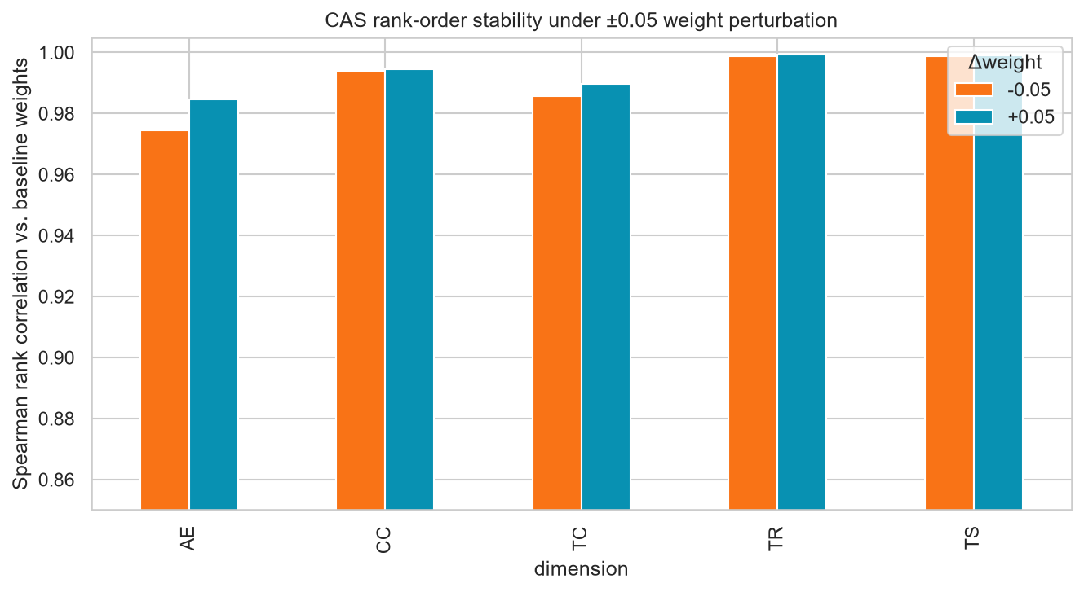
CAS weight sensitivity analysis — mean score shift per dimension when perturbed ±0.05.

10. Model Serving — the Flask Inference API
ai_server/src/app.py is the single production entry point for real-time scoring: a Flask service that loads every artifact from Section 6.4 once at startup and exposes it over HTTP.

10.1 Endpoints
Route | Method | Purpose
/health | GET | Liveness check — reports models_loaded and model_version (from model_meta.json)
/predict | POST | The full pipeline: feature frame → scale → RF classify → IF anomaly → K-Means cluster → CAS → SHAP explanation, returned as one JSON response
/ | GET | A built-in dark-themed test console — buttons to fire /health and a pre-filled /predict payload, so the API can be sanity-checked without curl or Postman

10.2 What a /predict Response Contains
- label, confidence, confidence_level (high/medium/low badge)
- TR_score, TS_score, CC_score, AE_score, TC_score, CAS, CVSS, action, cluster
- scenario and weights_used (which weight vector actually produced this score)
- explanation (plain text) and shap_top_features (structured, for the dashboard chart)
- model_version (the training timestamp from model_meta.json)

10.3 Resilience Details
- Missing features → zero-filled, loudly: a live payload missing a feature column is scored anyway (zero-filled) rather than rejected — a real-time system can't simply refuse to answer — but every occurrence is logged as a warning so it's visible, not silent.
- Per-device-type Isolation Forest baselines (opt-in): a single global IF judges a ventilator's “normal” against the same boundary as a nurse workstation's “normal”, which is a natural false-positive source. The server will pick up a per-device model automatically if one is dropped into models/isolation_forest_by_device/<device_type>.pkl — none have been trained yet, so today every device type uses the one global baseline.
- Automatic feature-set adaptation: at startup the server checks whether the Isolation Forest/K-Means were actually fit on the full 45-column set vs. a hand-picked behavioral subset, and adjusts which columns it feeds them accordingly — removing a class of retrain-time bugs where a hardcoded feature subset silently goes stale.

10.4 Security Posture (current)
- Bound to 127.0.0.1 by default — this is an internal service the Node backend calls, not directly internet-facing.
- CORS restricted to the Node backend's origin by default (overridable via AI_SERVER_CORS_ORIGINS).
- Flask debug mode (Werkzeug's interactive debugger, which allows arbitrary code execution if ever reachable) is off unless FLASK_DEBUG=1 is explicitly set — development-only, never production.

11. The Real-Time Production Pipeline
Getting from “packets on a wire” to “alert on the analyst's screen” is a four-hop chain, each hop a separate, independently runnable process.
attack_simulator.py --target <victim>
| traffic
v
live_feature_extractor.py --sniffs packets, computes the 45 CICIoT2023 columns,
writes rows to cicflowmeter_output/live_flows.csv
|
v
flow_consumer.py --watches that CSV (watchdog), on each new row:
1. looks up device metadata by source IP (device_map.json)
2. POSTs the flow + metadata to Flask /predict
3. indexes the enriched result as a JSON doc into
Wazuh/OpenSearch's 'caap-alerts' index
|
v
Node backend :5000 --polls 'caap-alerts', applies assignment/closure/snooze state
|
v
React dashboard :5173 <-- Socket.IO push, CAS-ranked alert feed

11.1 Deployment Topology
Raw packet capture and attack simulation deliberately run on an isolated lab VM (host-only/NAT network), never against the real hospital network. The host machine runs everything else: the real Wazuh Indexer stack (managed separately, not by this repo), the Flask AI server, the Node backend, and the React dashboard. start-caap-pipeline.ps1 checks the indexer is reachable, starts the other three host-side services in order, and prints the exact lab-VM-side commands (pre-filled with the host-only adapter's IP and the real backend/.env indexer credentials) needed to point the capture pipeline at the host.
Runs on | Processes
Host machine (Windows) | Wazuh Indexer stack (external), Flask AI server, Node backend, React dashboard
Isolated lab VM | attack_simulator.py, live_feature_extractor.py, flow_consumer.py

11.2 Timeout Discipline
flow_consumer.py's call to /predict uses a 30-second timeout, not the more typical few seconds — computing a full SHAP explanation over the whole Random Forest genuinely takes about 20 seconds on typical development hardware. A shorter timeout was previously silently dropping ~5 seconds worth of live predictions with the failure invisible (Python's stdout is block-buffered under systemd), so the timeout was deliberately widened rather than the explanation being made lossy.

12. Backend Integration & Graceful Degradation
backend/services/caapService.js bridges raw Wazuh alerts to the AI layer for the cases that don't already arrive as a pre-enriched caap-alerts document (flow_consumer.py's direct path, Section 11, is the primary route and bypasses this module entirely). It implements a three-tier degradation ladder so the system always returns a usable score — clearly labeled by how trustworthy it is.
Tier | Condition | What happens
1 — Full ML | Real flow features are attached to the alert and the Flask server is reachable | Genuine RF + Isolation Forest + K-Means scoring, exactly as in Section 10
2 — Rule-derived TR | Flask is reachable but the alert carries no real flow data | CC/AE/TS/TC still resolved from Flask's response, but TR is derived from the Wazuh rule.level instead of RF confidence, and the response is explicitly flagged "NOT a real ML classification"
3 — Fully offline | The Flask AI server itself is unreachable | Falls back to rule.level + admin-set device criticality + independent CVE/IP-reputation signals only — no RF/IF/K-Means involved at all, again explicitly labeled in the response

Every fallback tier still reuses the same CAS formula, the same action thresholds, and the same shared/cas_config.json tables as the full-ML path — only the inputs degrade, never the scoring logic itself. The dashboard's alertPipeline.js also logs a loud warning whenever it has to use these fallback paths, so “all alerts should come from real ML” degradations are visible to operators rather than silently blending rule-based guesses into what should be an all-ML result set.

13. MLOps — Versioning, Drift, and the Feedback Loop

13.1 Model Versioning
Every training run writes models/model_meta.json containing: an ISO-8601 UTC training timestamp, the ordered feature-column list plus a SHA-256 hash of it (so a consumer can detect a schema change without diffing 45 column names by eye), the class list, per-model train/test/overall accuracy, and a per-feature mean/std baseline. This file's trained_at value is surfaced directly in /health and every /predict response as model_version, so any alert can be traced back to exactly which trained model produced it.

13.2 Drift Detection (check_drift.py)
An ad hoc, analyst-run script that compares a batch of recently captured live flows against the training-set baseline stored in model_meta.json, using two independent signals per feature:
- Z-score drift: how many training-set standard deviations the live batch's mean sits from the training mean — flagged at |z| ≥ 3.
- Out-of-range fraction: the share of individual live rows that fall more than 3 training-stdevs from the training mean — flagged at ≥ 20% — catches a shape/spread shift (e.g. a new bimodal cluster of outliers) that a mean-only z-score can average away.
It writes a dated JSON report (reports/drift_report_<date>.json) and prints a recommendation to retrain if 20%+ of features are flagged, but it does not itself trigger a retrain — a human reviews the report and decides. This is intentionally a diagnostic tool, not an automated gate (see Section 16 for what a fully automated version would add).

13.3 The Feedback Loop — Analyst Verdicts → Retraining
SOC analysts close alerts in the dashboard with a verdict: true_positive, false_positive, or benign. GET /api/alerts/training-feedback-export (admin-only) pulls every closed, verdict-tagged alert that captured real flow data and exports it as a CSV in exactly the shape train.py expects: confirmed true positives keep the model's original predicted label; everything else (false positives, confirmed benign) is relabeled Benign. This closes the loop from “model made a call” to “human confirmed or corrected it” back into training data — but the loop is currently manual: an admin downloads the CSV, drops it into ai_server/data/train/, and reruns train.py by hand. There is no automatic scheduling, validation gate, or rollback if a retrain regresses accuracy.

13.4 Offline Research Evaluation Assets
Beyond the production-facing artifacts above, ai_server/05_evaluation.ipynb and hospital_scenarios.py produce the thesis-level evaluation set referenced in Section 9.5: the CAS-vs-CVSS comparison across three simulated hospital-ward scenarios, the CAS weight sensitivity analysis, a PCA scatter of the K-Means clusters, and a consolidated model-comparison table (reports/model_comparison_table.csv, cluster_pca_scatter.png, caap_vs_cvss_results.csv, and related files). A schema-compatibility check in the same notebook explicitly documents and skips attempting to evaluate the model against the CIC-IDS2017 files noted in Section 3.3, for the same zero-column-overlap reason.

14. Known Limitations & Engineering Notes
A candid list of what an evaluator or a future maintainer should know before treating any number in this document as a final, unconditional claim:
- Stray CIC-IDS2017 files in data/train/ (Section 3.3): an unrelated, incompatible-schema dataset sits alongside the real training data, pending relocation. Anyone re-running train.py must move or exclude these files first.
- Isolation Forest's 28% false-positive rate: a deliberate high-recall trade-off appropriate for a screening signal feeding into CAS, not a standalone verdict — but it does mean the raw IF anomaly flag alone is a noisy final answer.
- Live feature reconstruction is unvalidated at the distribution level: column names match the trained schema exactly by construction; whether captured real-world value distributions match training data as closely as the original CICFlowMeter-based pipeline would have has only been sanity-checked at an order-of-magnitude level, not statistically validated.
- recent_flow_count is collected but unused: the sequence-awareness signal is written to every live-captured row but is not yet part of the deployed model's feature set — it requires a retrain with the column present in data/train/ first.
- Per-device-type Isolation Forest baselines are opt-in but empty: the loading mechanism exists in app.py; no per-device model has actually been trained, so every device type still shares one global “normal traffic” baseline today.
- Retraining is manual: the analyst-feedback export (Section 13.3) and check_drift.py (Section 13.2) are both human-triggered tools, not an automated retrain-on-drift or retrain-on-schedule pipeline.
- No containerized deployment yet: the AI server, Node backend, and dashboard currently run as plain OS processes orchestrated by a PowerShell script, not Docker/Kubernetes.

15. Roadmap to Full Production Maturity
The system already implements the hard part — real trained models, a defensible domain-scoring layer, a live inference API, explainability, and a genuine (if manual) feedback loop. The gap to a fully mature MLOps posture is mostly operational hardening rather than new ML work:

15.1 Deployment & Release Engineering
- Containerize the AI server: a Dockerfile for ai_server (pinned Python + dependency versions, baked-in model artifacts or a mounted volume) removes “works on this machine” risk and makes the per-service topology in Section 11.1 reproducible with docker-compose.
- Canary / shadow deployment for retrains: route a small percentage of live traffic (or mirror 100% in shadow mode without acting on it) to a newly retrained model before fully promoting it, so a regression is caught before it reaches every alert.
- A model registry with rollback: today model_meta.json versions one model in place; a registry (even a simple versioned folder + “current” symlink convention) would let a bad retrain be rolled back in seconds instead of requiring a manual re-run of train.py on old data.

15.2 Automation
- Scheduled or drift-triggered retraining: wire check_drift.py's drift_rate output into an actual trigger (a scheduled job, or an alert to the ML owner) instead of a report a human has to remember to open.
- Automated retrain pipeline: turn the manual export → drop CSV → rerun train.py loop (Section 13.3) into a scripted job with a validation gate — e.g. block promotion if the new model's test accuracy regresses beyond a threshold versus model_meta.json's stored metrics.
- CI for reproducibility: run train.py (or a fast subset) in CI on every change to feature engineering or model code, so a schema-breaking change is caught before it reaches data/train/ in production.

15.3 Model Quality
- Clean the training directory and retrain: resolve the stray CIC-IDS2017 files (Section 3.3), then retrain with the recent_flow_count sequence-awareness feature included.
- Train per-device-type Isolation Forest baselines: the loading mechanism already exists (Section 10.3) — fitting even a handful of device-class-specific baselines (e.g. “ICU ventilator” vs. “admin workstation”) should directly reduce the current 28% global false-positive rate.
- Statistically validate live-captured feature distributions: go beyond the order-of-magnitude sanity check and formally compare captured benign traffic distributions against the training set (e.g. via check_drift.py itself, run against a large “known benign” live capture).

15.4 Operational Hardening
- Add authentication/rate-limiting to the Flask API even though it's loopback-bound today, as defense in depth if the deployment topology ever changes.
- Load-test /predict's throughput ceiling (SHAP's ~20s/request cost, noted in Section 11.2, is the likely bottleneck for high-traffic hospital networks) and consider a queue or a lighter-weight explanation mode for high-volume periods.
- Add automated tests around the feature-engineering pipeline (live_feature_extractor.py's reconstructed formulas) and the CAS engine's scoring logic, beyond the existing test.py/test_cas_config.py scripts, to catch a schema or config drift before it reaches production.

Appendix A — Key File Reference
File | Role
ai_server/train.py | Offline training script for all three models; writes models/*.pkl and reports/*
ai_server/check_drift.py | Ad hoc drift-detection tool comparing live captures to the training baseline
ai_server/src/app.py | Flask production inference API (/predict, /health)
ai_server/src/cas_config.py | Python loader for shared/cas_config.json
ai_server/src/cas_engine.py | Offline research CAS engine (1–5 dimension convention) used by notebooks/scripts
ai_server/src/hospital_scenarios.py | Simulated hospital-ward scenarios for the CAS-vs-CVSS evaluation
ai_server/05_evaluation.ipynb | Full offline evaluation notebook (Phase 9): metrics, charts, CAS-vs-CVSS, sensitivity analysis
ai_server/models/ | Trained artifacts: *.pkl models, scaler, label encoder, feature list, IF threshold, model_meta.json
ai_server/reports/ | Generated charts, classification reports, and evaluation CSVs
ai_server/data/train/, data/test/ | Training and test pcap-derived CSVs (CICIoT2023/CIC IoMT-2024 schema)
shared/cas_config.json | Single source of truth for CAS weights, device profiles, AE/CVSS/TC tables — shared by Python and Node
Extra_Material/ml-pipeline/live_feature_extractor.py | Live packet-capture feature extraction (replaces CICFlowMeter)
Extra_Material/ml-pipeline/flow_consumer.py | Watches live flow CSVs, calls /predict, indexes results into Wazuh/OpenSearch
Extra_Material/ml-pipeline/attack_simulator.py | Generates attack traffic on an isolated lab VM for live-pipeline testing
Extra_Material/ml-pipeline/device_map.json | IP → device_type/department lookup for the live pipeline
backend/services/caapService.js | Node-side bridge to /predict plus the graceful-degradation fallback ladder
backend/routes/alerts.js | Includes GET /api/alerts/training-feedback-export (the analyst feedback loop)
start-caap-pipeline.ps1 | Orchestrates startup of the host-side services in order

Appendix B — Metrics at a Glance
Metric | Value
Training rows | 7,160,831
Test rows | 1,614,182
Feature columns | 45
Classes | 6 (Benign, ARP_Spoofing, DoS_TCP, MQTT_Publish_Flood, MQTT_Brute_Force, Recon)
Random Forest test accuracy | 99.87%
Random Forest AUC-ROC (macro OvR) | 0.9993
Random Forest OOB score | 99.92%
Isolation Forest binary accuracy (test) | 98.54%
Isolation Forest attack detection rate | 99.18%
Isolation Forest false positive rate | 28.26%
K-Means cluster purity (test) | 92.24%
K-Means silhouette score | 0.8406
CAS action thresholds | ≥8 Immediate, ≥5 Investigate, else Monitor

End of document.

