**Info. Security and Assurance**

**Assignment-1**

By Chanikya Merugu(16229774)

Password cracking using dictionary attack

**1.What is the password of the login account ‘student’?**

**A:** By using the command ***hydra –l student –V –P /usr/share/john/password.lst*** [**ftp://192.168.2.77**](ftp://192.168.2.77)the password for the login account ‘student’ obtained is **‘iris’.** It is shown below:

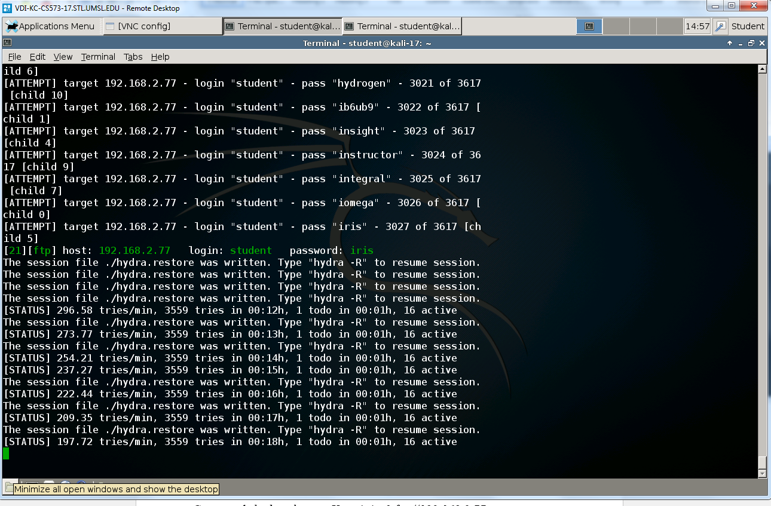

Password cracking using bruteforce attack

**2.** What is the password of the login account ‘user?

**A:** By using the command ***hydra –l user –V –x 4:4:a1*** [***ftp://192.168.2.77***](ftp://192.168.2.77)the password for the login account ‘user’ obtained is: ***ace4.*** It is shown below:

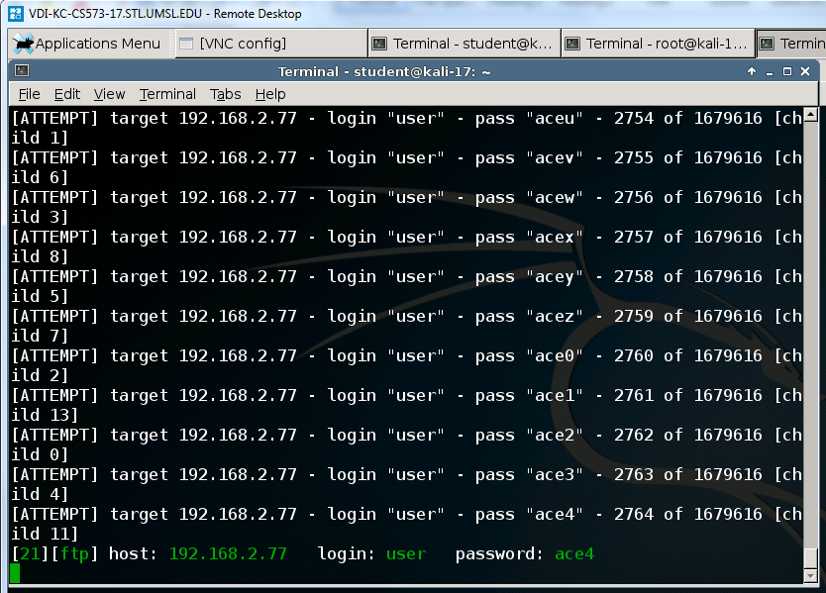

**3.** Explain the process of hashing and storing the passwords in Ubuntu/Linux and Windows 7 operating systems.

**A:**

**4.** Mention the salt value and hashed password value of the user account ‘student’ of your Kali Linux system. (Open the shadow file in your kali linux and locate the username ‘student’ and provide the above details)

**A:** The salt value and hashed password of the user account ‘student’ are shown below and the syntax is $6$saltvalue$hashedpassword



