**VTAF EXECUTION USER GUIDE**

**WSO2 API MANAGER**

Contents

1. Prerequisites for the execution 3

2. How to start execution 3

1. How to change Run time properties 7

**Before The Start Execution You Should Have Install Eclipse Juno Including TestNG & ASPECTJ In Your Machine.**

# Prerequisites for the execution

Edit the data sheets to update data (if required)

1. Open the respective xml data sheet. TestResaults\gen\seleniumwebdriver\TestResaults\src\main\resources\data\dataTables.xml
   1. Please refer “Data table Column Guide.xlsx” document for data descriptions.
2. Save the data sheets before closing.

# How to start execution

1. **Open the Eclipse Juno.**

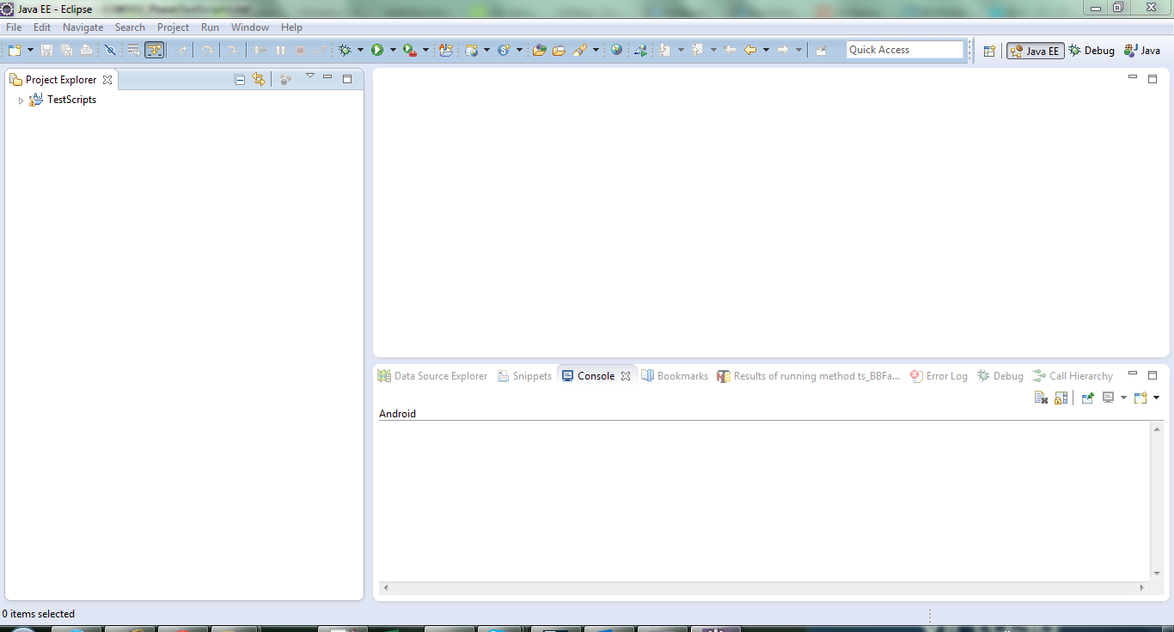

ii.**Click on the “Import Project”.**  a) Generated project will open in Project Explorer.

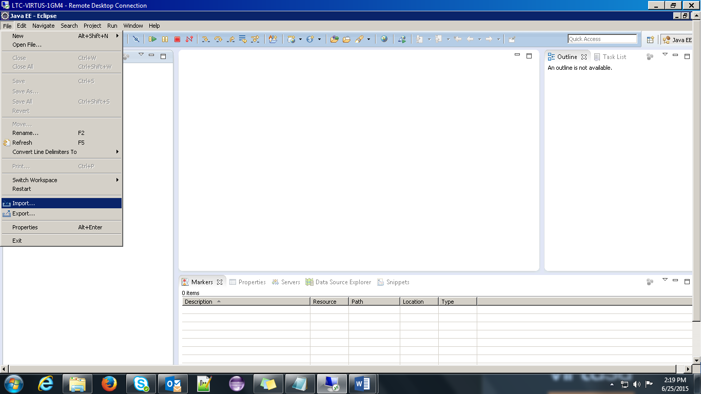

**iii. Expand the test cases (Executable test cases (scenarios) Highlighted in yellow color).**

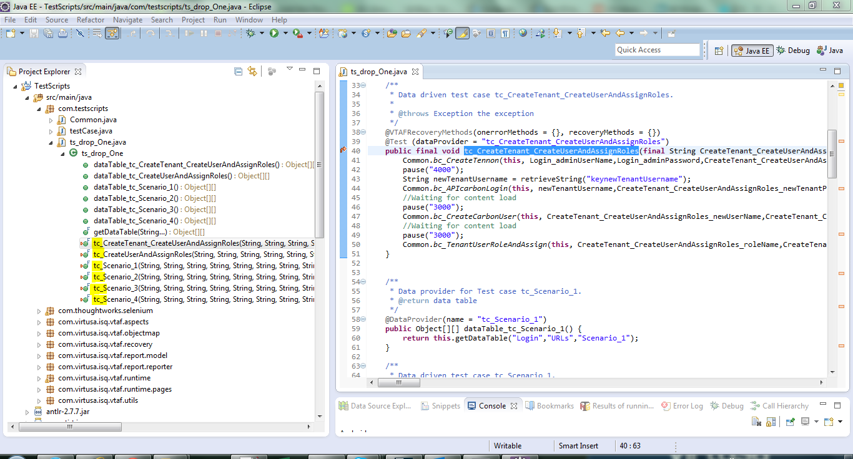

**iv.Run the scripts using TestNG**

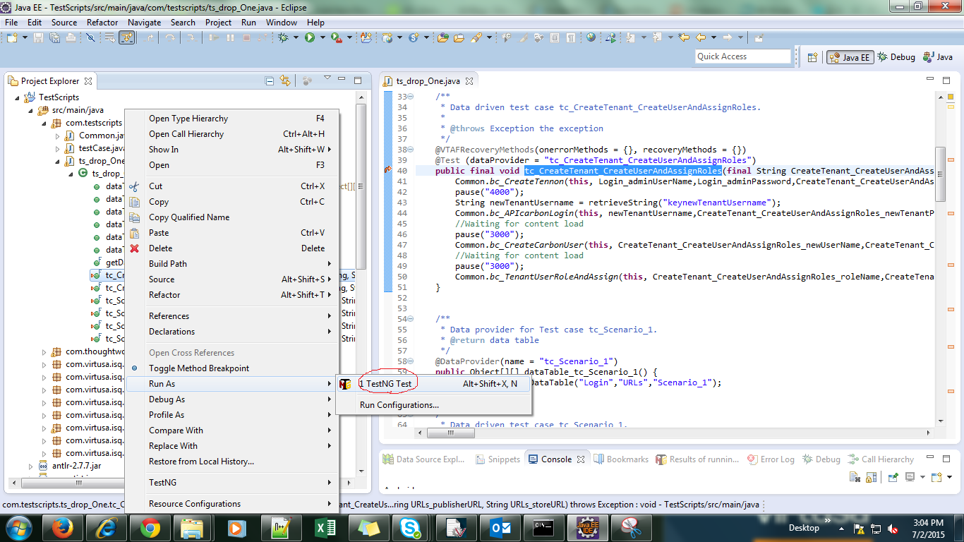

### How to change Run time properties

I. Double click on **Run Time Properties**

a) Edit MAX REG QUAITY and MIN REG QUAITY as 0.7(For image verification)

b)Edit the browser will to execute

1)*firefox

2)*iexplore

3)*chrome

