Low Level Design

**Analyzing Amazon Sales data**

**Technologies: Business Intelligence**

**Domain: E-commerce**

|  |  |
| --- | --- |
| **Written By** | CHANNABASAV ANGADI |
| **Document Version** | 1 |
| **Last Revised Date** | 13/3/2022 |

# DOCUMENT CONTROL

**Change Record:**

|  |  |  |  |
| --- | --- | --- | --- |
| **VERSION** | **DATE** | **AUTHOR** | **COMMENTS** |
| 0.1 | 13/03/2022 | Channabsav Angadi | Introduction and architecture defined |
| 0.2 | 13/03/2022 | Channabasav Angadi | Architecture & Architecture description appended and updated. |
|  |  |  |  |
|  |  |  |  |

**Reviews:**

|  |  |  |  |  |  |  |  |  |
| --- | --- | --- | --- | --- | --- | --- | --- | --- |
| **VERSION** | **DATE** |  | **REVIEWER** |  | **COMMENTS** | | |  |
|  |  |  |  |  |  | | |  |
| **Approval Status:** | |  |  |  |  | | |  |
| **VERSION** | **REVIEW DATE** |  | **REVIEWED BY** |  |  | **APPROVED BY** |  | **COMMENTS** |
|  |  |  | |  | |  |  | |

# Contents

## 1. Introduction………………………………………………………………………………………………………… 04

* + **What is Low-Level Design Document? …………………………………………………….. 04**
  + **Scope ……………………………………………………………………………………………………... 04**

## 2. Architecture ……………………………………………………………………………………………………….. 05

## 3. Architecture Description …………………………………………………………………………………… 08

* + **3.1 Data Description ……………………………………………………………………………………… 08**
  + **3.2 Data Transformation ……………………………………………………………………………… 08**
  + **3.3 Deployment …………………………………………………………………………………………… 12**

**4. Unit test cases ………………………………………………………………………………………………………15**

# 1. Introduction

**1.1 What is Low-Level design document?**

The goal of the LDD or Low-level design document (LLDD) is to give the internal logic design of the actual program code for the Analyzing Swiggy: Bangalore delivery outlet data. LDD describes the class diagrams with the methods and relations between classes and programs specs. It describes the modules so that the programmer can directly code the program from the document.

## 1.2 Scope

Low-level design (LLD) is a component-level design process that follows a step-by-step refinement process. The process can be used for designing data structures, required software architecture, source code and ultimately, performance algorithms. Overall, the data organization may be defined during requirement analysis and then refined during data design work.

Top rated Product

* Least rated product
* Top sales by year
* Top sales by region
* Search by region and year
* Top 2 product by Region

# 2. Architecture

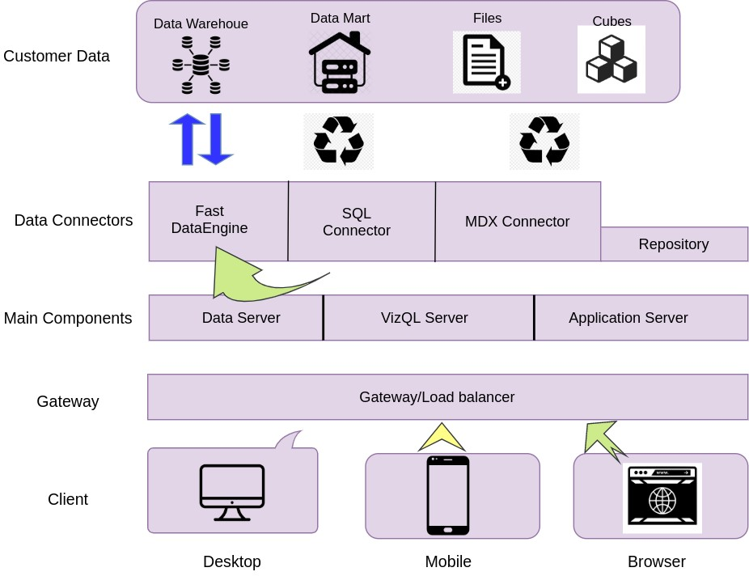

# Power BI Server Architecture

|  |  |
| --- | --- |
| Power BI has a highly scalable, n-tier client-server architecture that serves mobile clients, web clients, and desktop-installed software. Power BI Server architecture supports fast and flexible deployments. | |
| The following diagram shows Power BI Server’s architecture: |  |

Power BI Server is internally managed by the multiple server processes.

## 1. Gateway/Load Balancer

It acts as an Entry gate to the POWER BI Server and also balances the load to the Server if multiple Processes are configured.

## 2) Application Server:-

Application Server processes (wgserver.exe) handle browsing and permissions for the Power BI Server web and mobile interfaces. When a user opens a view in a client device, that user starts a session on Power BI Server. This means that an Application Server thread starts and checks the permissions for that user and that view.

## 3) Repository:-

Power BI Server Repository is a PostgreSQL database that stores server data. This data includes information about Power BI Server users, groups and group assignments, permissions, projects, data sources, and extract metadata and refresh information.

## 4) VIZQL Server:-

Once a view is opened, the client sends a request to the VizQL process (vizqlserver.exe). The VizQL process then sends queries directly to the data source, returning a result set that is rendered as images and presented to the user. Each VizQL Server has its own cache that can be shared across multiple users

**5) Data Engine:-**

It Stores data extracts and answers queries.

## 6) Backgrounder:-

The backgrounder Executes server tasks which include refreshes scheduled extracts, tasks initiated from tabcmd, and manages other background tasks.

## 7) Data Server:-

Data Server Manages connections to Power BI Server data sources

It also maintains metadata from Power BI Desktop, such as calculations, definitions, and groups.

# 3. Architecture Description

## 3.1. Data Description

Sales management has gained importance to meet increasing competition and the need

for improved methods of distribution to reduce cost and to increase profits. Sales

management today is the most important function in a commercial and business

enterprise.

**Step 2: Configuring Data Source**

The data source page loads up after configuring the Power BI connector and successfully signing in. This is what the page looks like:

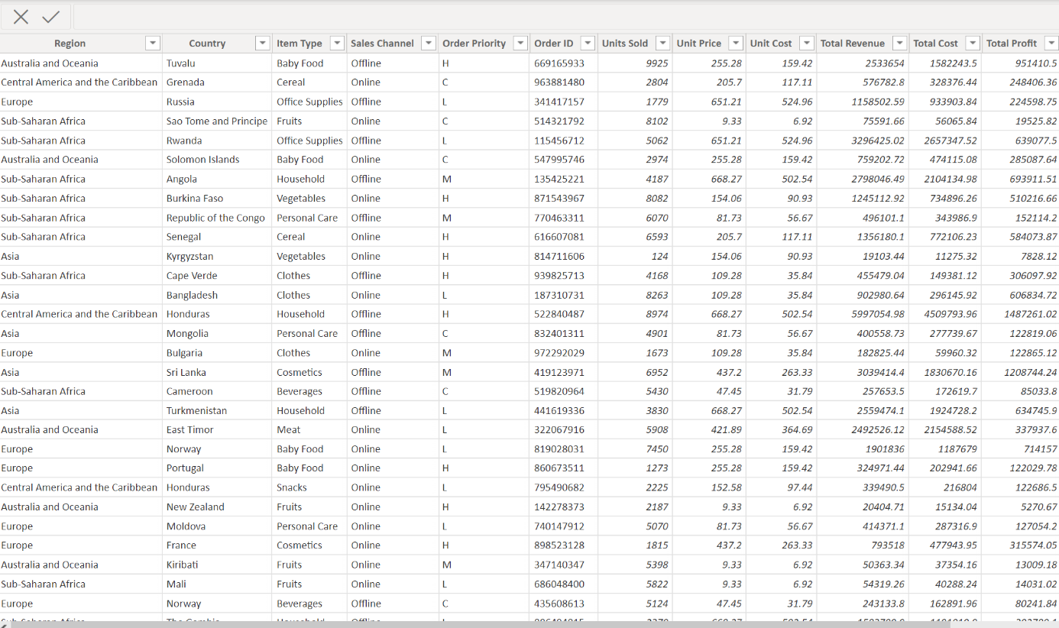

Select the data source name option and give a unique name to the database you are using. It’s considered a good practice to have a unique name as it makes it much easier for users to identify the database from which data is being fetched.

To select the desired schema, you can use the schema drop-down list from the column on the left. You can also perform a text-based search to find the desired option. Now similarly find and select the desired table and drag it onto the canvas.

This is how you can connect SQL Server with Power BI. Now click on the sheets tab to begin the analysis.

Custom SQL features can be used to focus on specific SQL statements, rather than querying the entire database. Click on the Custom SQL option from the panel on the left. A new dialogue box will now open up, where you can provide the query you want to execute.

**3.6 Deployment.**

Once you’ve completed your dashboard, follow these steps:**- Server, Power BI Public, Save to Power BI Public As**

You may be prompted to log into your Power BI Public profile first if this is your first time publishing.

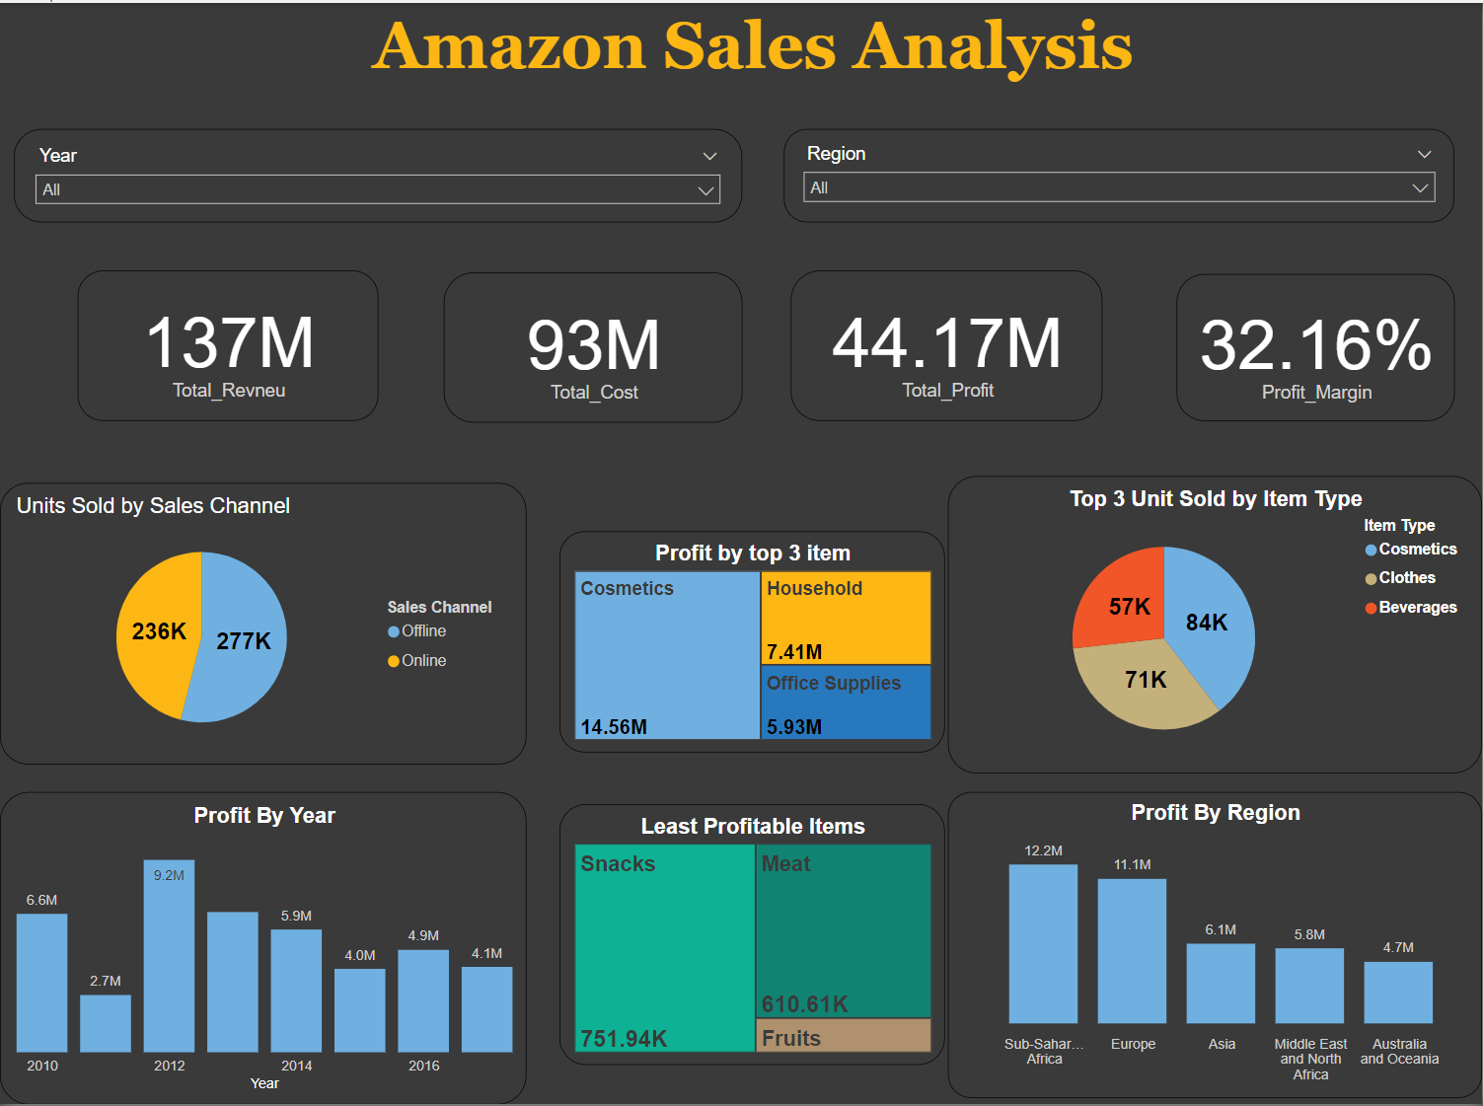

Next, fill out the title you want your viz to have and click “save”.

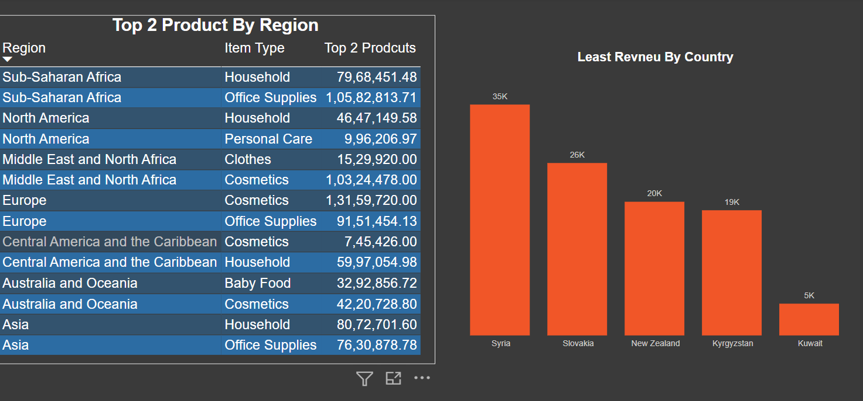

# 4. Unit Test Cases

|  |  |
| --- | --- |
| **Test case** | **Results** |
| Drop Down | You can Region ,Year |
| Click on Bar Chart | See Other Result Filter based on that |
|  |  |