***Wireframe Documentation***

**Analyzing Amazon Sales data**

**Technologies: Business Intelligence**

**Domain: E-commerce**

**By:**

**Channabsav Angadi**

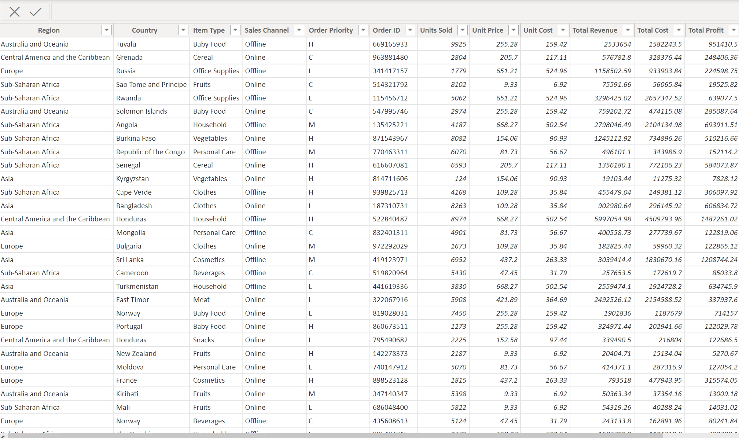

In this section we designed our first dashboard and tried to interpret the followings

• Top rated Product

• Least rated product

• Top sales by year

• Top sales by region

• Search by region and year

• Top 2 product by Region

