Architecture Design

# Analyzing Swiggy: Bangalore delivery

# outlet data

|  |  |
| --- | --- |
| **Written By** | Channabasav Angadi |
| **Document Version** | 1 |
| **Last Revised Date** |  |

# DOCUMENT CONTROL

**Change Record:**

|  |  |  |  |
| --- | --- | --- | --- |
| **VERSION** | **DATE** | **AUTHOR** | **COMMENTS** |
| 0.1 | 07/03/2022 | Channabasav Angadi | Introduction and architecture defined |
| 0.2 | 07/03/2022 | Channabasav Angadi | Architecture & Architecture description appended and updated. |
|  |  |  |  |
|  |  |  |  |

|  |  |  |  |  |  |  |  |  |
| --- | --- | --- | --- | --- | --- | --- | --- | --- |
| **Approval Status:** | |  |  |  |  | | |  |
| **VERSION** | **REVIEW DATE** |  | **REVIEWED BY** |  |  | **APPROVED BY** |  | **COMMENTS** |
|  |  |  | |  | |  |  | |

# Contents

## 1. Introduction………………………………………………………………………………………………………… 04

**1.1 What is Architecture Design Document? …………………………………………………. 04**

**1.2 Scope ……………………………………………………………………………………………………... 04**

## 2. Architecture ……………………………………………………………………………………………………….. 05

* **2.1 Power BI Architecture ………………………………………………………………………………. 05**
* **2.2 ` Power BI Server Architecture…………………………….…………………….………………… 05**
* **2.3 Gateway/Load Balancer ………………………………………………………………………… 06**
* **2.4 Application Server ……………..…………………………………………………………………... 06**
* **2.6 Data Engine …………………….………………………………………………………………………. 07**
* **2.7 Backgrounder …………………….…………………………………………………………………… 07**
* **2.8 Data Server …………………….………………………………………………………………………. 07**
* **2.9 Power BI Communication Flow …………………………………………………………………. 07**

## 3. Deployment …………………………………………………………………………………………………………08

* **3.1 Deployment Options in Power BI……………………………………………………………….09**
* **3.2 Single-Node Architecture ………………………………………………………………………… 10**
* **3.3 Three Node Architecture ………………………………………………………………………….11**
* **3.4 Five Node Architecture …………………….………………………………………………………12**

# 1. Introduction

**1.1 What is an Architecture design document?**

Any software needs the architectural design to represent the design of the software. IEEE defines architectural design as “the process of defining a collection of hardware and software components and their interfaces to establish the framework for the development of a computer system.” The software that is built for computer-based systems can exhibit one of these many architectures.

Each style will describe a system category that consists of :

* A set of components (eg: a database, computational modules) that will perform a function required by the system.
* The set of connectors will help in coordination, communication, and cooperation between the components.
* Conditions that how components can be integrated to form the system.
* Semantic models that help the designer to understand the overall properties of the system.

## 1.2 Scope

Architecture Design Document (ADD) is an architectural design process that follows a step-by-step refinement process. The process can be used for designing data structures, required software architecture, source code, and ultimately, performance algorithms. Overall, the design principles may be defined during requirement analysis and then refined during architectural design work.

# 2. Architecture

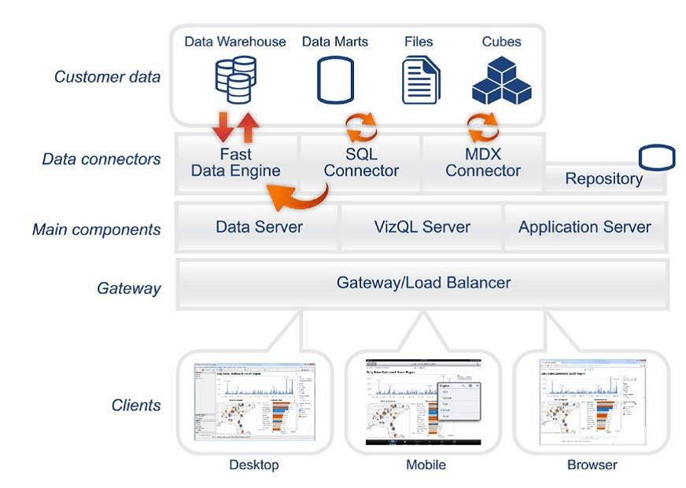

# Power BI Server Architecture

Power bi has a highly scalable, n-tier client-server architecture that serves mobile clients, web clients and desktop-installed software. Power server architecture supports fast and flexible deployments.

The following diagram shows Power BI Server’s architecture:

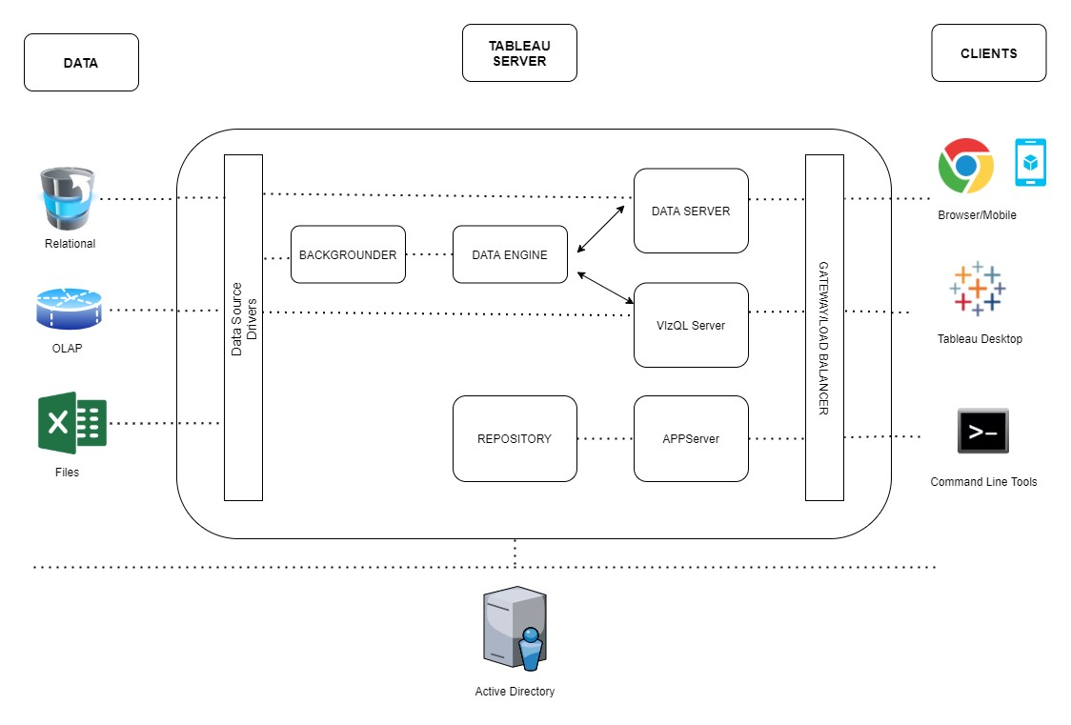

Power BI Server is internally managed by multiple server processes.

## 1. Gateway/Load Balancer

It acts as an Entry gate to the Power BI Server and also balances the load to the Server if multiple Processes are configured.

## 2) Application Server:-

Application Server processes (wgserver.exe) handle browsing and permissions for the Power BI Server web and mobile interfaces. When a user opens a view in a client device, that user starts a session on Power BI Server. This means that an Application Server thread starts and checks the permissions for that user and that view.

**5) Data Engine:-**

It Stores data extracts and answers queries.

## 6) Backgrounder:-

The backgrounder Executes server tasks which include refreshes scheduled extracts, tasks initiated from tabcmd, and manages other background tasks.

## 7) Data Server:-

Data Server Manages connections to Power BI Server data sources

It also maintains metadata from Power BI Desktop, such as calculations, definitions, and groups.

## 8) Power BI Communication Flow

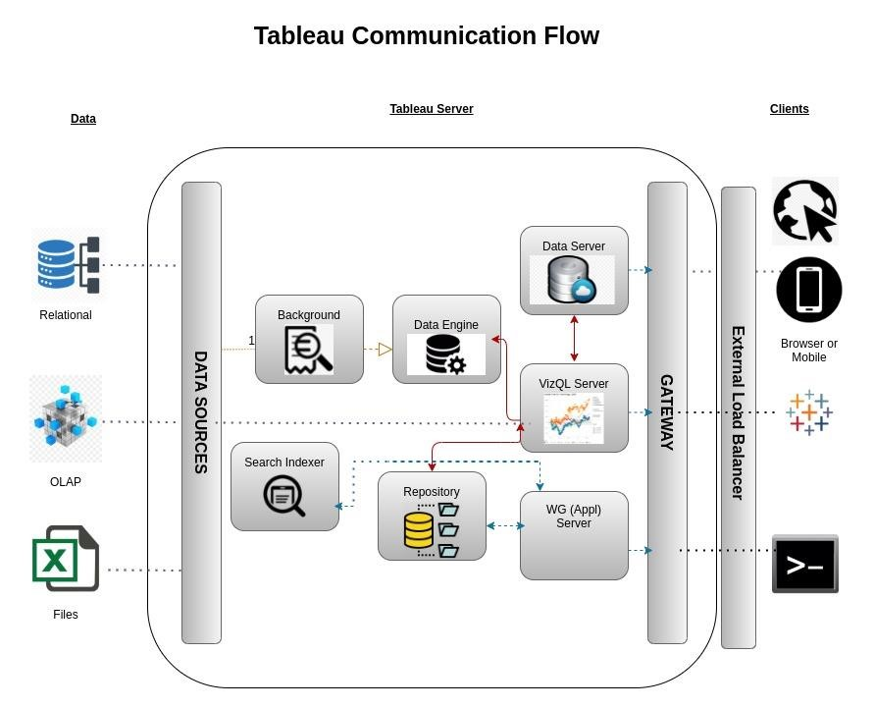

# 3. Deployment Description

## 3.1 Deployment options in Power BI

Tableau’s analytics platform offers three different deployment options depending on your environment and needs. The below graphic shows each option at a glance:

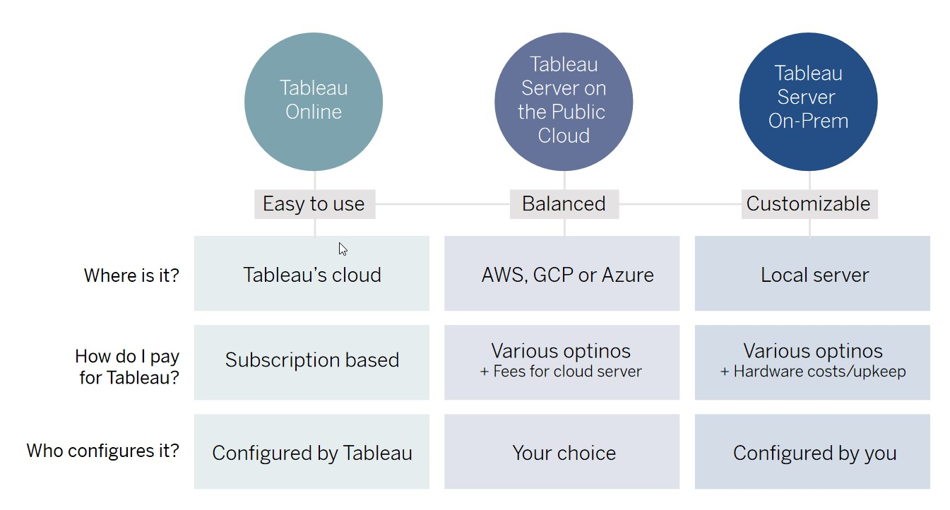

1. **Power BIOnline** Get up and running quickly with no hardware required. Power BIOnline is fully hosted by Power BIso all upgrades and maintenance are automatically managed for you.
2. **Power BIServer** deployed on public cloud: Leverage the flexibility and scalability of cloud infrastructure without giving up control. Deploy to Amazon Web Services, Google Cloud Platform, or Microsoft Azure infrastructure to quickly get started with Power BIServer (on your choice of Windows or Linux). Bring your own license or purchase on your preferred marketplace.
3. **Power BIServer deployed on-premises**: Manage and scale your own hardware and software (whether Windows or Linux) as needed. Customize your deployment as you see fit.

## 3.2 Single-Node Architecture

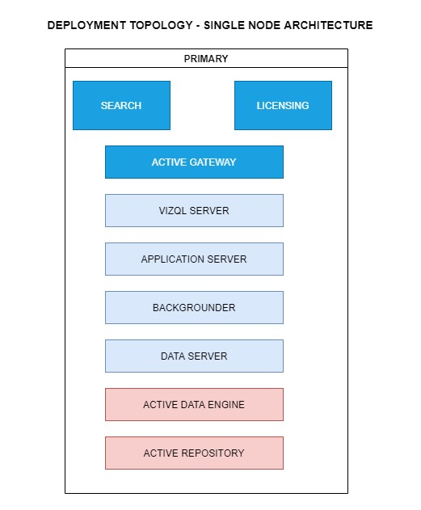

This architecture is a single node architecture. This is the most simple deployment topology.

## 3.3) 3 Node Architecture

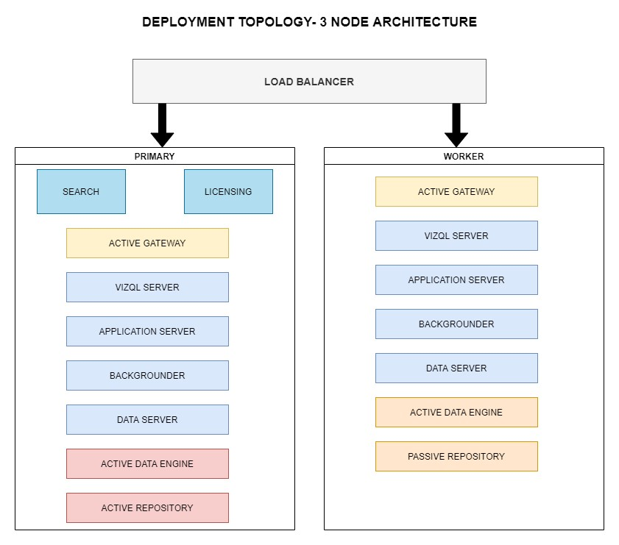

This architecture is a 3 Node Architecture which is more capable to handle concurrent requests.

If we need failover or high availability, or want a second instance of the repository, we must install Power BIServer on a cluster of at least three computers. In a cluster that includes at least three nodes, you can configure two instances of the repository, which gives our cluster failover capability.

## 3.4) 5 Node Architecture

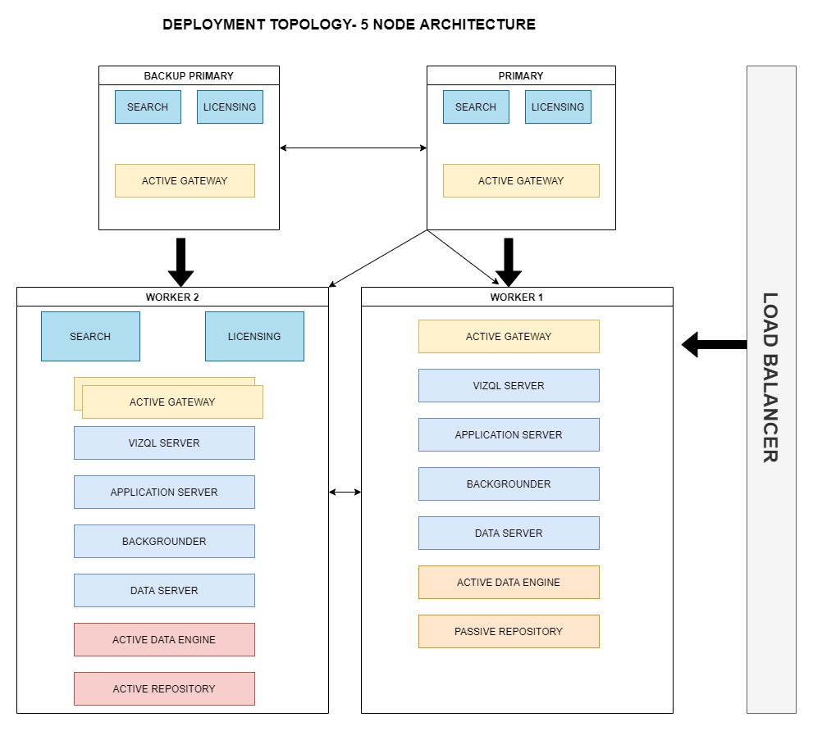

When we install Power BI Server on a Five-node cluster, we can install server processes on one or both nodes. A five-node cluster can improve the performance of the Power BI Server because the work is spread across multiple machines.

Note the following about five-node clusters:

* A five-node cluster does not provide failover or support for high availability.
* You can't install more than one instance of the repository on a two-node cluster, and the repository must be on the initial node.