**Analyzing Swiggy: Bangalore delivery**

**outlet data**

***Wireframe Documentation***

**By: Channabsav Angadi**

# Homepage

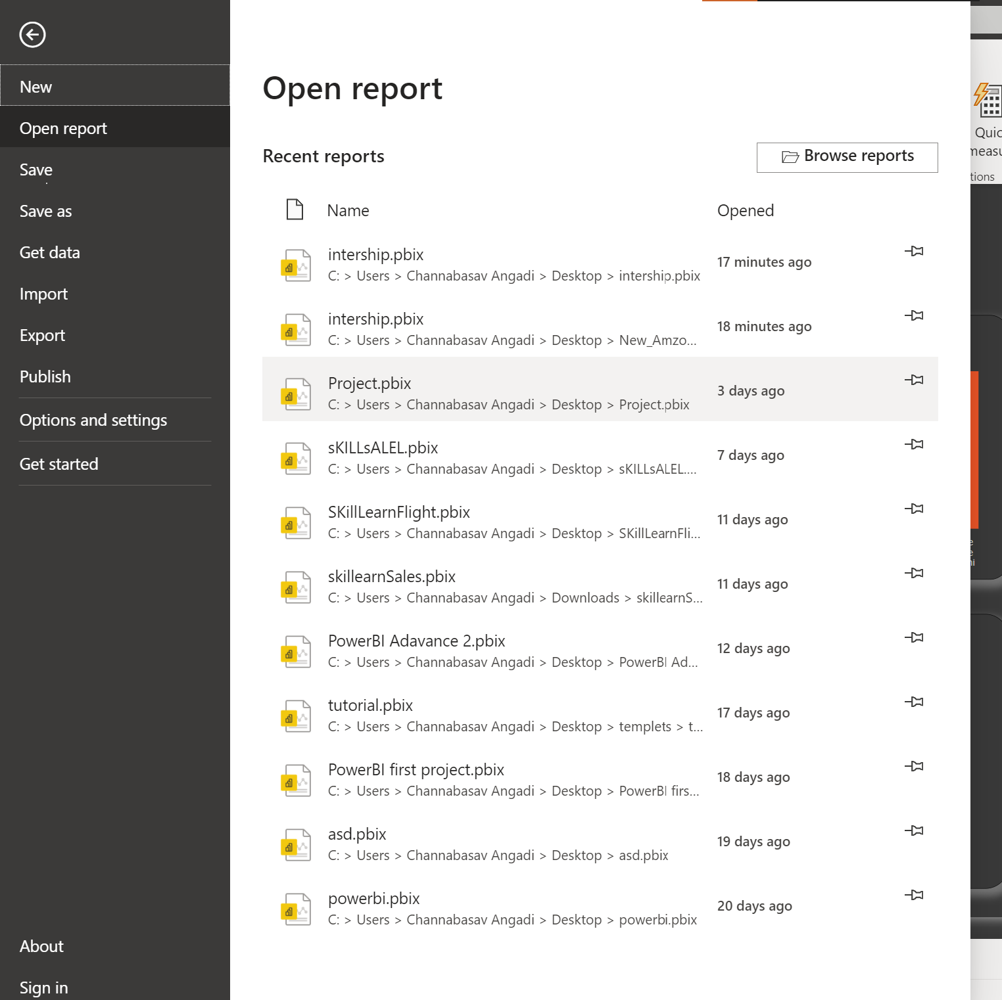

In this section we designed our first dashboard and tried to interpret the followings

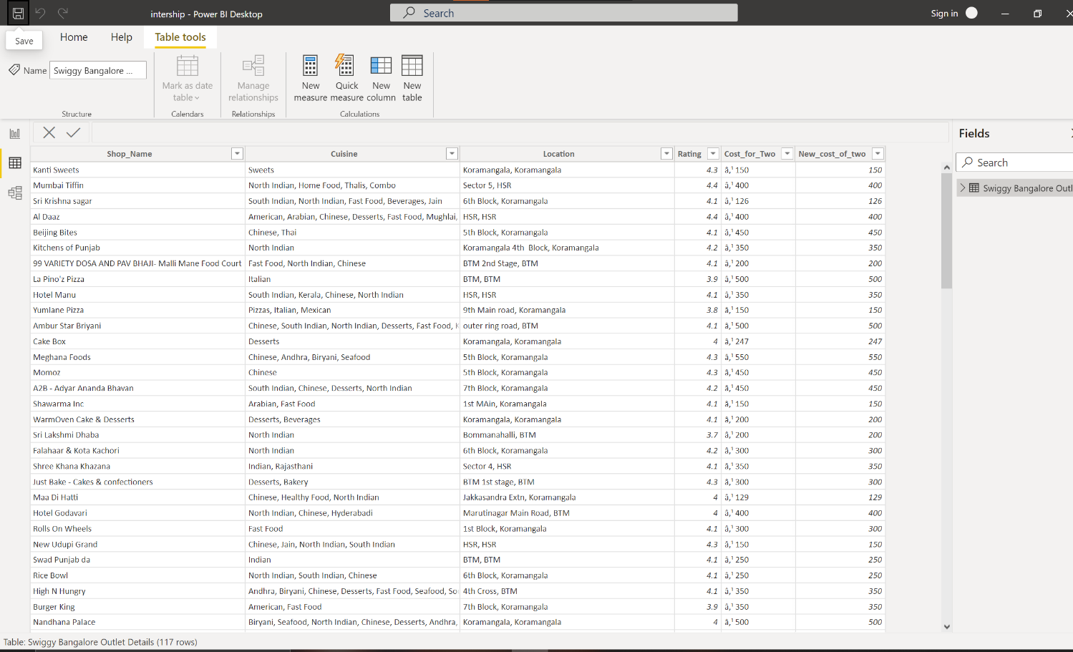

See Top / Low Rated Hotels

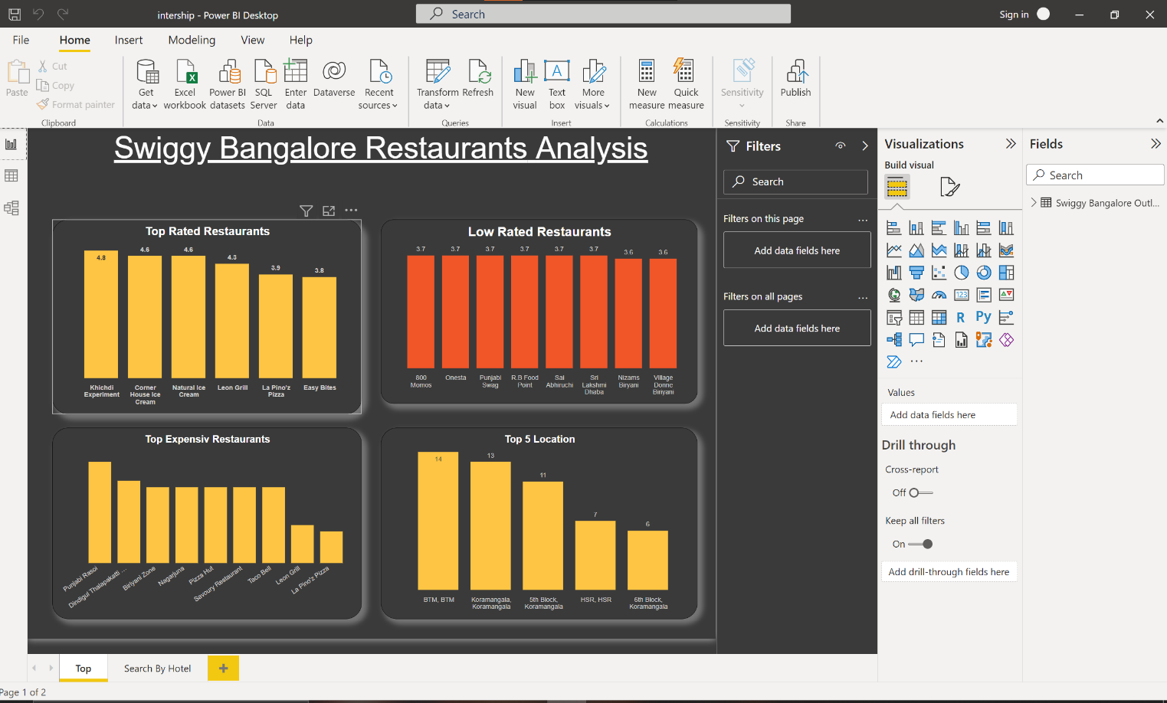

Seach By Hotel

