**PES INSTITUTE OF TECHNOLOGY AND MANAGEMENT**

**Shivamogga-577204**



**Department of Information Science and Engineering**

***“Project Synopsis”***

**Project Title: CLASSIFICATION OF MELANOMA FROM DERMOSCOPIC DATA USING MACHINE LEARNING TECHNIQUES**

**Domain**: Machine learning

**Programming Language:** Python

**Internal Guide:** Mr. Amit Kumar K

**Project Members:**

**SANDHYA S HEGDE (4PM17IS038)**

**CHANNABASAVA (4PM17IS011)**

**SHAMANTH DINESH THELKAR (4PM17IS041)**

**NIHAL M R (4PM17IS031)**

**Signature of:**

|  |  |  |
| --- | --- | --- |
| **Project Guide** | **Project Coordinator** | **Head of the Department** |
| **Mr. Amit Kumar K** | **Dr. Pramod** | **Dr. Prasanna Kumar H R** |
| **Assistant Professor** | **Associate Professor** | **Professor & Head** |

**ABSTRACT:**

Dermatological Diseases are one of the biggest medical issues in 21st century due to its highly complex and expensive diagnosis with difficulties and subjectivity of human interpretation. In cases of fatal diseases like Melanoma diagnosis in early stages play a vital role in determining the probability of getting cured. We believe that the application of automated methods will help in early diagnosis especially with the set of images with variety of diagnosis. A novel method can be used to which includes a completely automated system of dermatological disease recognition through lesion images, a machine intervention in contrast to conventional medical personnel-based detection. Our model is designed into three phases compromising of data collection and augmentation, designing model and finally prediction. We have used multiple AI algorithms like Convolutional Neural Network and Support Vector Machine and amalgamated it with image processing tools to form a better structure, leading to higher accuracy.

# INTRODUCTION:

# The skin cancer occurrence, melanoma and non-melanoma, has increased over the last decades. Currently, the World Health Organization (WHO) estimates that 2-3 million nonmelanoma cancers and 132,000 melanomas occur every year in the world. According to the Brazilian Cancer National Institute (INCA), one in every three cancer diagnosis is a skin cancer. The presence of skin cancer is strongly related to the incidence of ultraviolet radiation caused by sunlight exposure [1].

# Melanoma is a skin disorder, occurring in melanocytes. They are classified as Benign and Malignant. The cure of melanoma is effective, if it can be recognized early. The most crucial part in the cure of melanoma is the exact classification and determining the group of melanoma [2].

# Machine learning is an application of artificial intelligence that provides the system ability to learn and improve from past experience without being explicitly programmed. Machine learning studies consist of different challenges [3]. Several computer-aided diagnoses (CAD) have been proposed to automated skin cancer detection [4-7].

# [machine learning algorithms](https://d2h0cx97tjks2p.cloudfront.net/blogs/wp-content/uploads/sites/2/2019/08/Types-of-Machine-Learning-algorithms.jpg)

Fig 1: Types of Machine Learning

When aiming to build a high-performance predictive model, it is crucial to select the right algorithm to solve the problem at hand and the underlying platforms need to be capable of handling the volume of data. The prediction is done by using Multiple Linear Regression Algorithm. SVM (Support Vector Machine) is a supervised machine learning algorithm which is mainly used to classify data into different classes. Unlike most algorithms, SVM makes use of a hyperplane which acts like a decision boundary between the various classes. SVM can be used to generate multiple separating hyperplanes such that the data is divided into segments and each segment contains only one kind of data.

In this project we have used SVM to classify the malignant and benign skin cancer images, this done by passing the segmented and feature extracted images into SVM where SVM write the hyperplane and groups all the nearby similar features into different classes.

Melanoma remains the most harmful form of skin cancer. The cure of melanoma is effective, if it can be recognized early. The most crucial part in the cure of melanoma is the exact classification and determining the group of melanoma. A comparative study for classifying the group of melanoma using the supervised machine learning algorithms is discussed in this proposed work. Classification of melanoma from dermoscopic data is proposed to help the clinical utilization of dermatoscopy imaging methods for skin sores classification. The images were enhanced using anisotropic diffusion filter and unsharp masking.

Classifiers such as knearest neighbour, support vector machine, multi-layer perceptron, decision tree and random forest were used. To test the performance of the classifiers.

**PROBLEM STSTEMENT:**

To develop an efficient image classification system of melanoma which classifies the skin lesions into benign and malignant. The input image is pre-processed by anisotropic diffusion filter and unsharp masking and to apply different types of segmentation algorithm.

**LITERATURE SURVEY:**

This section describes about the method which is utilized to detect the melanoma and provides a detailed modeling. In recent time, the number of melanoma patients has been drastically enhanced across all over the globe due to extensive global warming. The melanoma skin cancer especially found in United States and Australia and a major part of these countries are affected with melanoma skin cancer. According to a survey of World health Organization (WHO), around 13 million people become affected each and every year by deadly melanoma skin cancer. Therefore, due to extensive mortality rate across the globe and higher medical diagnosis cost, the detection of melanoma skin cancer at earliest stages is becomes a mandatory requirement. Therefore, to efficiently detect melanoma in early stages and to diagnose the melanoma skin cancer, various steps is shown below.

**BASE PAPER**

**Title of the Paper:** Malignant Melanoma Classification Using Deep Learning: Datasets, PerformanceMeasurements, Challenges and Opportunities

**Authors:**

[**Ahmad Naeem**](https://ieeexplore.ieee.org/author/37088427445)

University of Management and Technology, Lahore, Pakistan

[**Muhammad Shoaib Farooq**](https://ieeexplore.ieee.org/author/37085997492)

University of Management and Technology, Lahore, Pakistan

**Publisher**

IEEE

**Year of Publication**

**June 10, 2020**

Received May 23, 2020, accepted June 7, 2020, date of publication June 10, 2020, date of current version June 25, 2020.

The microscopic examination for cancer by pathologist is very tedious process as well as it suffers from inter as well as intra observer variability. The techniques such as biopsy are invasive technique and thus painful and risky. Dermoscopy is one the imaging technique used for detection of melanoma. It is a non-invasive imaging technique. Dermoscopic image has improved the recognition performance by 50% and the absolute accuracy lies between 75%–84%. A computer based classification between benign and malignant will be an alternative for reducing inter as well as intra observer variability.

**RELATED PAPERS**

* Classification of melanoma from Dermoscopic data using machine learning techniques

**Authors**: Bethanney Janney.J & S.Emalda Roslin

**Published online**: 24/november/2018

Received: 13 September 2018 / Revised: 31 October 2018 / Accepted: 19 November 2018 # Springer Science, Business Media, LLC, part of Springer Nature 2018

One typical and commonly used clue for melanoma diagnosis is the ABCDE signs which is a useful indicator for melanoma. This feature can differentiate a malignant melanoma from a benign skin lesion based on five characteristics, namely asymmetry (A), border irregularity (B), color variability (C), diameter greater than 6 mm (D), and evolution (E) or any kind of change. Melanoma detection typically involves several processes: image acquisition and preprocessing, lesion segmentation, lesion characterization and finally lesion classification. The exact order in which these processes are applied varies from one method to another, however, some of them can skip or add other processes, or use some of them in a hybrid way.

* Deep learning for image-based cancer detection and diagnosis—A survey **Authors**: R. L. Siegel, K. D. Miller, and A. Jema vol. 83, pp. 134–149, Published in Nov. 2018.
* Image detection based on an adaptive automatic thresholding technique. Am J Intell Syst 7:107–112 Andre E, Brett K, Novoa Roberto A, Justin K, Swetter Susan M, Blau Helen M, Sebastian T (2017).

Dermoscopy is one of the major imaging modalities used in the diagnosis of melanoma and other pigmented skin lesions. Due to the difficulty and subjectivity of human interpretation, computerized analysis of dermoscopy images has become an important research area. One of the most important steps in dermoscopy image analysis is the automated detection of lesion borders.

* A. G. C. Pacheco and R. A. Krohling, “The impact of patient clinical information on automated skin cancer detection,” Computers in Biology and Medicine, vol. 116, p. 103545, 2020.

# PROJECT OBJECTIVES:

* To determine the accurate prediction of skin cancer and also to classify the skin cancer as malignant or non-malignant melanoma.
* To develop an automated diagnosis procedure for precise and steady determination of skin malignancy with a incredible capability for noninvasively image supported treatment strategies.
* To improve the accuracy in identifying the skin cancer depth because based on the depth of the primary tumor the stage of melanoma is identified.

**EXISTING METHODOLOGY:**

* Computer aided decision support tools are important in medical imaging for diagnosis and evaluation. Predictive models are used in a variety of medical domains for diagnostic and prognostic tasks. These models are built based on experience which constitutes data acquired from actual cases. The data can be preprocessed and expressed in a set of rules, such as that it is often the case in knowledge-based expert systems, and consequently can serve as training data for statistical and machine learning models.
* The general approach of developing a CAD system for the diagnosis of skin cancer is to find the location of a lesion and also to determine an estimate of the probability of a disease

**PROPOSED METHODOLOGY**

1. Research dataset
2. Enhancement of images
3. Segmentation of melanoma and validation
4. Feature extraction
5. Classification of benign and malignant

Five classifiers, namely KNN, SVM, DT, MLP and RF were used for training the handcrafted features.To measure the accuracy of the five classifiers we have to compute sensitivity, specificity, and accuracy. Receiver operating characteristics curve shows both sensitivity and specificity of the test. The comparison of True Positive Rate and False Positive Rate is defined as ROC bend. The Sensitivity, Specificity, and Accuracy of these classifiers were computed using four parameters such as true positive (TP), false positive (FP), false negative (FN) and true negative (TN).

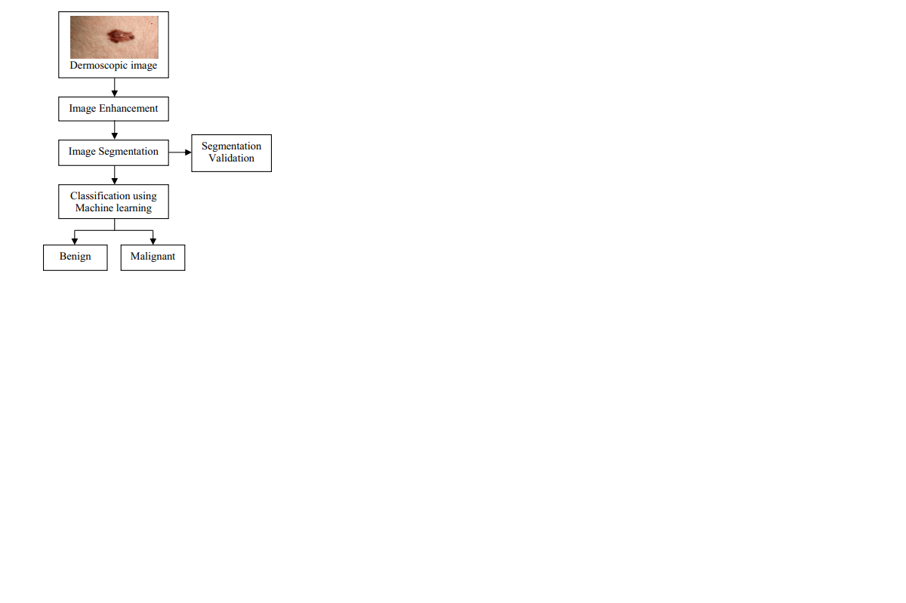

aim of this project is to determine the accurate

prediction of skin cancer and also to classify the skin cancer

as malignant or non-malignant melanoma. To do so, some

pre-processing steps were carried out which followed Hair

removal, shadow removal, glare removal and also

segmentation. SVM and Deep Neural networks will be used

to classify. classifier will be trained to learn the features and

finally used to classify. The novelty of the present

methodology is that it should do the detection in very quick

time hence aiding the technicians to perfect their diagnostic

skills. The dataset used is from the available ISIC

(International Skin Image Collaboration) dataset, hence any

dataset can be used to find the efficiency.

The aim of this project is to determine the accurate

prediction of skin cancer and also to classify the skin cancer

as malignant or non-malignant melanoma. To do so, some

pre-processing steps were carried out which followed Hair

removal, shadow removal, glare removal and also

segmentation. SVM and Deep Neural networks will be used

to classify. classifier will be trained to learn the features and

finally used to classify. The novelty of the present

methodology is that it should do the detection in very quick

time hence aiding the technicians to perfect their diagnostic

skills. The dataset used is from the available ISIC

(International Skin Image Collaboration) dataset, hence any

dataset can be used to find the efficiency.

Fig 2: Block diagram of melanoma classification process

**3D LESION SURFACE RECONSTRUCTION**

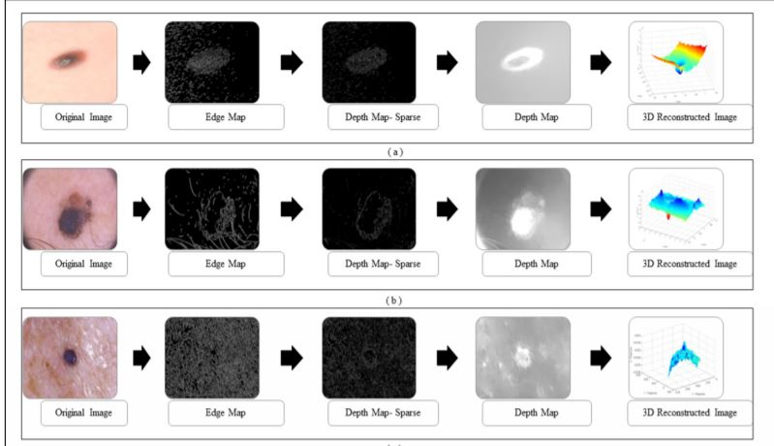

Fig 3: 3D Lesion Surface Reconstruction Process

3D reconstruction is essential to estimate depth of the skin lesions. Techniques like stereo vision, structure from motion, depth from focus, depth from defocus etc. are used to estimate depth considering multiple images. Using constrained image acquisition techniques like active illumination and coded aperture method’s, depth can be estimated using single images. The varying or unknown dermoscopic data acquisition parameters/settings used and the non-availability of multiple images render these mechanisms ineffective. In a novel technique to estimate depth, considering a single image obtained from unconstrained image data acquisition techniques is described.

**DIFFERENT TYPES OF DATASETS:**

* PH2 - 200 images
* ATLAS - 63 images
* ISIC - 2357 images

**ACTION PLAN:**

|  |  |  |
| --- | --- | --- |
| **Sl. No.** | **Steps** | **No. of days** |
| 1. | Literature Survey | **20** |
| 2. | Analysis and Design | **20** |
| 3. | Coding | **30** |
| 4. | Result analysis | **10** |
| 5. | Documentation | **10** |
| Total No. of Days | | **90** |

**FACILITIES REQUIRED FOR PROPOSED WORK**

Software/Hardware required for the development of the project

**SOFTWARE REQUIREMENT**

* + Anaconda navigator: Is a free and open source distribution of R and python programming language for machine learning and data science projects.
  + Android Studio: Tool for building market leading apps and accelerating performance, with an intelligent code editor, flexible build system and emulators.

**HARDWARE REQUIREMENT**

* + Windows 7/8/10 (64-bit) desktop/laptop.
  + 4 GB RAM minimum, 8 GB RAM recommended.

**CONCLUSION:**

The aim of the project is to determine the accurate prediction of skin cancer and also to classify the skin cancer as malignant or non-malignant melanoma. To do so, some pre-processing steps were carried out which followed Hair removal, shadow removal, glare removal and also segmentation. SVM and Deep Neural networks will be used to classify. Classifier will be trained to learn the features and finally used to classify. The novelty of the present methodology is that it should do the detection in very quick time hence aiding the technicians to perfect their diagnostic skills. The dataset used is from the available ISIC (International Skin Image Collaboration) dataset, hence any dataset can be used to find the efficiency.

**REFERENCES**

[1] WHO - World Health Organization. (2019) How common is the skin cancer? [Online]. Available:

https://www.who.int/uv/faq/skincancer/en/index1.html.

[2] Classification of melanoma from Dermoscopic data using machine learning techniques, Bethanney Janney.J & S.Emalda Roslin, Multimedia Tools and Applications, https://doi.org/10.1007/s11042-018-6927-z, Springer Science, Business Media, LLC, part of Springer Nature 2018.

[3] Malignant Melanoma Classification Using Deep Learning: Datasets, Performance Measurements, Challenges and Opportunities AHMAD NAEEM 1 , MUHAMMAD SHOAIB FAROOQ 1 , (Member, IEEE), Received May 23, 2020, accepted June 7, 2020, date of publication June 10, 2020, date of current version June 25, 2020. Digital Object Identifier 10.1109/ACCESS.2020.3001507.

[6] N. Zhang, Y.-X. Cai, Y.-Y. Wang, Y.-T. Tian, X.-L. Wang, and B. Badami, “Skin cancer diagnosis based on optimized convolutional neural network,” Artificial Intelligence in Medicine, vol. 102, p. 101756, 2020.

[7] A. Hekler, J. S. Utikal, A. H. Enk, A. Hauschild, M. Weichenthal, R. C. Maron, C. Berking, S. Haferkamp, J. Klode, D. Schadendorf et al., “Superior skin cancer classification by the combination of human and artificial intelligence,” European Journal of Cancer, vol. 120, pp. 114–121, 2019.

[8] T. J. Brinker, A. Hekler, A. H. Enk, C. Berking, S. Haferkamp, A. Hauschild, M. Weichenthal, J. Klode, D. Schadendorf, T. Holland- Letz et al., “Deep neural networks are superior to dermatologists in melanoma image classification,” European Journal of Cancer, vol. 119, pp. 11–17, 2019.

[9] T. J. Brinker, A. Hekler, A. Hauschild, C. Berking, B. Schilling, A. H. Enk, S. Haferkamp, A. Karoglan, C. von Kalle, M. Weichenthal et al., “Comparing artificial intelligence algorithms to 157 German dermatologists: the melanoma classification benchmark,” European Journal of Cancer, vol. 111, pp. 30–37, 2019.

[10] Cancer in Australia 2017, Austral. Inst. Health Welfare, Canberra, ACT, Australia, 2017.

[11] R. L. Siegel, K. D. Miller, and A. Jemal, ‘‘Cancer statistics, 2018,’’ CA Cancer J. Clinicians, vol. 68, no. 1, pp. 7–30, Jan. 2018. [9] Z. Hu, J. Tang, Z. Wang, K. Zhang, L. Zhang, and Q. Sun, ‘‘Deep learning for image-based cancer detection and diagnosis—A survey,’’ Pattern Recognit., vol. 83, pp. 134–149, Nov. 2018.

[12] Al-azawi RJ, Abdulhameed AA, Ahmed HM (2017) A robustness segmentation approach for skin Cancer image detection based on an adaptive automatic thresholding technique. Am J Intell Syst 7:107–112.

[13] Andre E, Brett K, Novoa Roberto A, Justin K, Swetter Susan M, Blau Helen M, Sebastian T (2017) Dermatologist-level classification of skin cancer with deep neural networks. Nature 542:115–118.

***“Project Synopsis”***

**Project Title:** Classification of Melanoma from Dermoscopic Data Using Machine Learning Techniques

**Domain:** Machine learning

**Internal Guide:** Mr. Amit Kumar K

**Project Members:**

|  |  |  |  |  |
| --- | --- | --- | --- | --- |
| **Sl. No.** | **Name** | **USN** | **Email-id** | **Phone No.** |
| 1 | SANDHYA S HEGDE | 4PM17IS038 | Sandhyabasoor@gmail.com | 9945624401 |
| 2 | CHANNABASAVA | 4PM17IS011 | n.channabasavachannu105@gmail.com | 9148672685 |
| 3 | SHAMANTH DINESH THELKAR | 4PM17IS041 | ShamanthThelkar12@gmail.com | 8310494863 |
| 4 | NIHAL M R | 4PM17IS031 | Nihalmravi92@gmail.com | 8494896323 |

**Signature of**

**Project Guide Project Coordinator**

**Mr. Amit kumar k Dr. Pramod**

**Assistant Professor Associate Professor**

**Project Schedule**

**Project Title:** Classification of Melanoma from Dermoscopic Data Using Machine Learning Techniques

**Internal Guide**: Mr. Amit Kumar K

## Student’s Names:

SANDHYA S HEGDE (4PM17IS038)

HANNABASAVA (4PM17IS011)

SHAMANTH DINESH THELKAR (4PM17IS041)

NIHAL M R (4PM17IS031)

**Project Schedule:**

|  |  |  |  |  |
| --- | --- | --- | --- | --- |
| **Sl. No.** | **Action** | **Date of**  **Submission** | **Marks** | **Remarks** |
| 1 | Synopsis Submission |  |  |  |
| 2 | Literature Survey |  |  |  |
| 3 | Analysis and Design |  |  |  |
| 4 | First Demo |  |  |  |
| 5 | Coding |  |  |  |
| 6 | Review of lit/Coding |  |  |  |
| 7 | Second Demo |  |  |  |
| 8 | Documentation |  |  |  |
| 9 | Report Submission |  |  |  |
| 10 | Final Demo |  |  |  |
| 11 | Total Marks for the  Project |  |  |  |

|  |  |  |
| --- | --- | --- |
| **Project Guide** | **Project Coordinator** | **Head of the Department** |
| **Mr. Amit Kumar K** | **Dr. Pramod** | **Dr. Prasanna Kumar H R** |
| **Assistant Professor** | **Associate Professor** | **Professor & Head** |

**Signature of:**

**Weekly Report**

|  |  |  |  |  |
| --- | --- | --- | --- | --- |
| **Weeks** | **Date** | **Progress of the Week** | **Guide**  **Signature** | **HOD**  **Signature** |
| **1** |  |  |  |  |
| **2** |  |  |  |  |
| **3** |  |  |  |  |
| **4** |  |  |  |  |

|  |  |  |  |  |
| --- | --- | --- | --- | --- |
| **5** |  |  |  |  |
| **6** |  |  |  |  |
| **7** |  |  |  |  |
| **8** |  |  |  |  |
| **9** |  |  |  |  |

|  |  |  |  |  |
| --- | --- | --- | --- | --- |
| **10** |  |  |  |  |
| **11** |  |  |  |  |
| **12** |  |  |  |  |
| **13** |  |  |  |  |

|  |  |  |  |  |
| --- | --- | --- | --- | --- |
| **14** |  |  |  |  |
| **15** |  |  |  |  |
| **16** |  |  |  |  |

**Signature of:**

|  |  |  |
| --- | --- | --- |
| **Project Guide** | **Project Coordinator** | **Head of the Department** |
| **Mr. Amit Kumar K** | **Dr. Pramod** | **Dr. Prasanna Kumar H R** |
| **Assistant Professor** | **Associate Professor** | **Professor & Head** |