Weekly Report of DcBot

# Historical Volatility

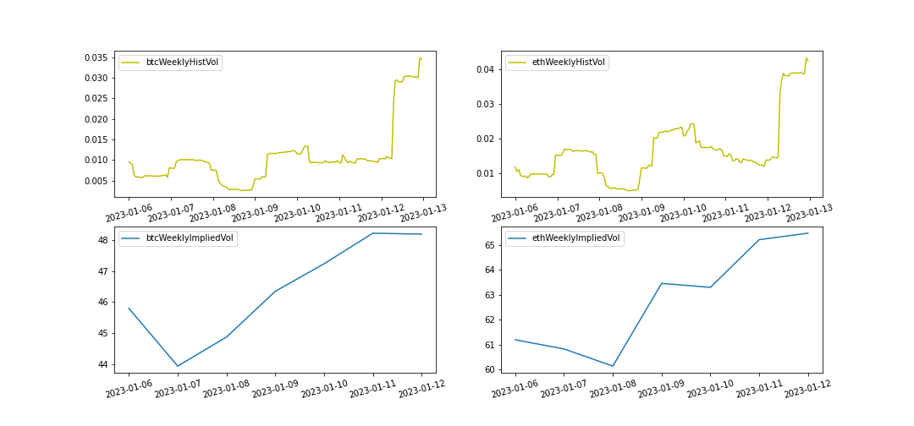

|  |  |  |
| --- | --- | --- |
| Historical Volatility Status | BTC | ETH |
| Current Historical Volatility | 3.44% | 4.23% |
| Current Historical Volatility Quantile | 74.02% | 65.71% |
| Weekly Mean of Historical Volatility | 1.23% | 1.82% |
| Weekly Pct_Change of Historical Volatility | 328.49% | 178.58% |