Weekly Report of DcBot

**1_历史波动率与隐含波动率**

波动率过小会导致盈利空间不足带来的磨损，而波动率过大风险也会随之放大，对策略最佳的波动率处于适中状态。以下是2022日历史波动率的统计：

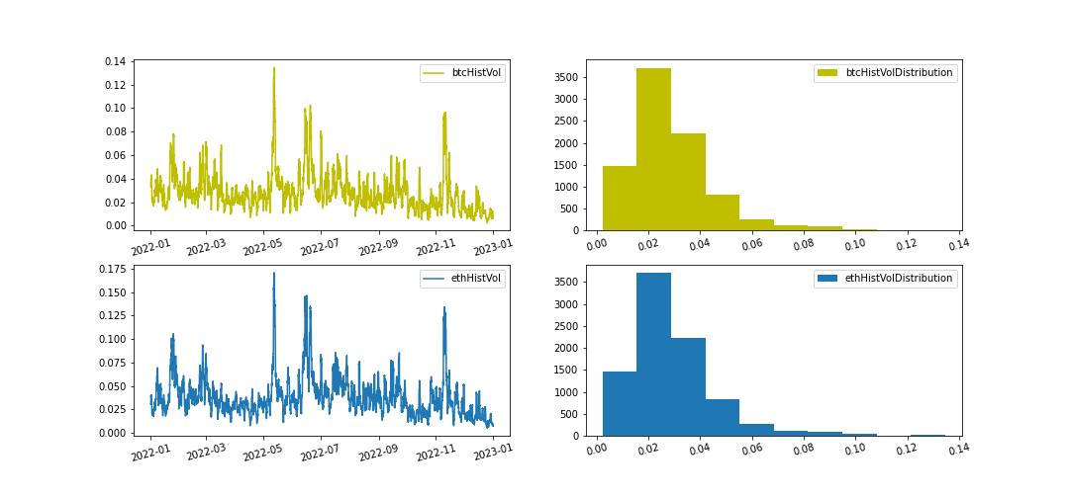

|  |  |  |
| --- | --- | --- |
| Historical Volatility Statistic 2022 | btcHv | ethHv |
| count | 8761.0 | 8761.0 |
| mean | 0.029 | 0.039 |
| std | 0.017 | 0.022 |
| min | 0.002 | 0.005 |
| 25% | 0.018 | 0.026 |
| 50% | 0.026 | 0.035 |
| 75% | 0.035 | 0.047 |
| max | 0.135 | 0.171 |

隐含波动率（Implied Volatility）是通过期权定价模型计算得到的的波动率值,又称未来已实现波动率（Future Volatility）或者未来波动率，是预期未来时间段内的标的资产价格变化的幅度。以下是2022年日级别隐含波动率的统计：

数据来源： https://t3index.com/indexes/bit-vol/

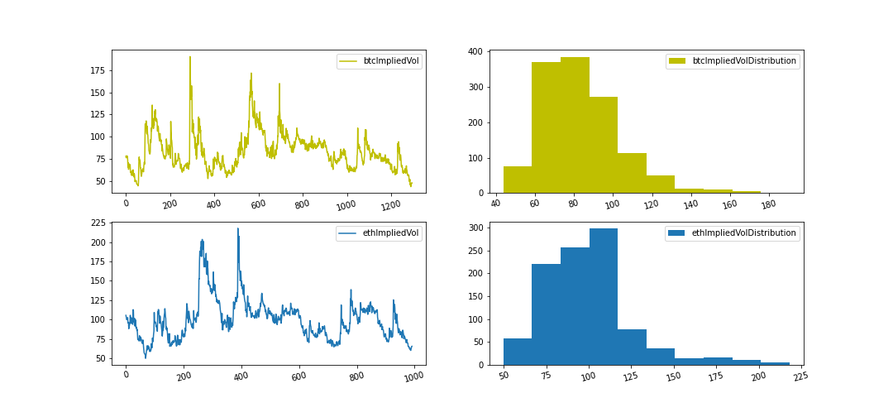

|  |  |  |
| --- | --- | --- |
| Implied Volatility Statistic 2022 | btcHv | ethHv |
| count | 8761.0 | 8761.0 |
| mean | 0.029 | 0.039 |
| std | 0.017 | 0.022 |
| min | 0.002 | 0.005 |
| 25% | 0.018 | 0.026 |
| 50% | 0.026 | 0.035 |
| 75% | 0.035 | 0.047 |
| max | 0.135 | 0.171 |

**本周的历史波动率与隐含波动率的统计**

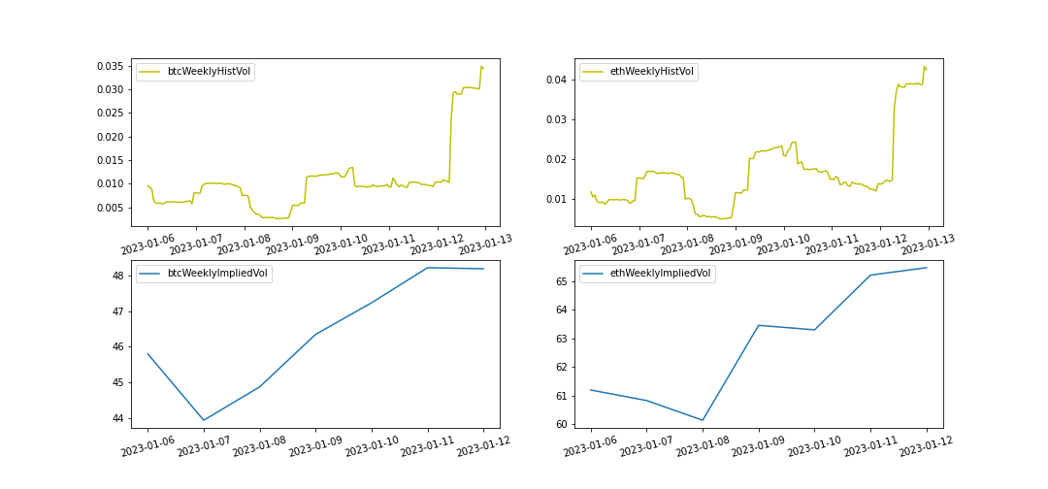

|  |  |  |
| --- | --- | --- |
| 2023-01-06~2023-01-13 | BTC | ETH |
| Current Historical Volatility | 3.44% | 4.23% |
| Current Historical Volatility Quantile | 74.02% | 65.71% |
| Weekly Mean of Historical Volatility | 1.23% | 1.82% |
| Weekly Pct_Change of Historical Volatility | 328.49% | 178.58% |

|  |  |  |
| --- | --- | --- |
| 2023-01-06~2023-01-13 | BTC | ETH |
| Current Implied Volatility | 48 | 65 |
| Current Implied Quantile | 0.0% | 1.09% |
| Weekly Mean of Implied Volatility | 46 | 63 |
| Weekly Pct Change of Implied Volatility | 5.24% | 7.01% |