Weekly Report of DcBot

**本周的历史波动率与隐含波动率的统计**

波动率过小会导致盈利空间不足带来的磨损，而波动率过大风险也会随之放大，对策略最佳的波动率处于适中状态。

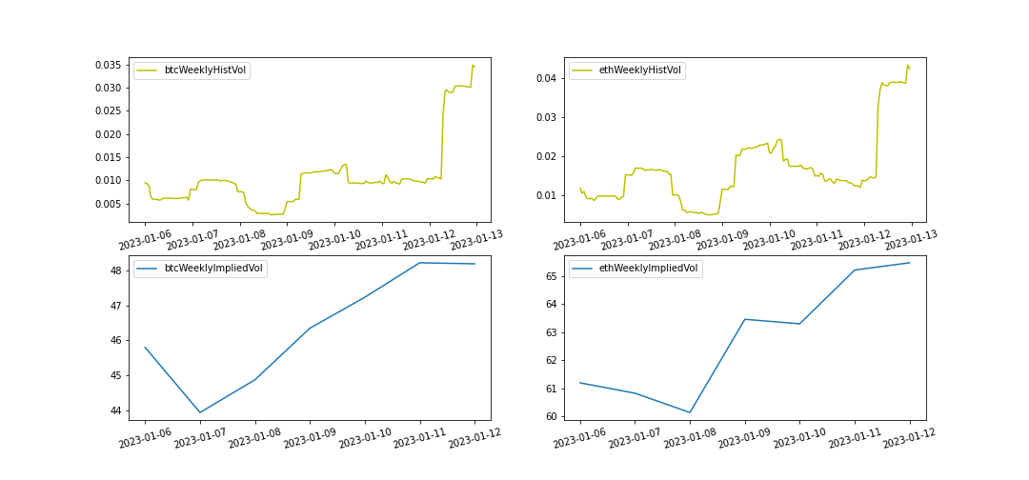

本周波动率与隐含波动率都从低位回升，CTA策略有较好的表现。

|  |  |  |
| --- | --- | --- |
| 2023-01-06~2023-01-13 | BTC | ETH |
| Current Historical Volatility | 3.44% | 4.23% |
| Current Historical Volatility Quantile | 74.02% | 65.71% |
| Weekly Mean of Historical Volatility | 1.23% | 1.82% |
| Weekly Pct_Change of Historical Volatility | 328.49% | 178.58% |

|  |  |  |
| --- | --- | --- |
| 2023-01-06~2023-01-13 | BTC | ETH |
| Current Implied Volatility | 48 | 65 |
| Current Implied Quantile | 0.0% | 1.09% |
| Weekly Mean of Implied Volatility | 46 | 63 |
| Weekly Pct Change of Implied Volatility | 5.24% | 7.01% |