Weekly Report of DcBot

**2023美国数据公布的时间（瞬间波动率）**

事件驱动策略，是一种利用市场的非有效性，通过挖掘市场信息决定采取对相关投资标的物多头或空头态度的一种投资策略。另外FOMC公布时，市场波动极大，风险较高，策略需要提前设置防范措施。

|  |  |  |
| --- | --- | --- |
| Non Farm Payrolls | The Cumsumer Price Index | FOMC |
| 2023-01-06 21:30:00 | 2023-01-12 21:30:00 | 2023-02-03 02:00:00 |
| 2023-02-03 21:30:00 | 2023-02-14 21:30:00 | 2023-03-17 02:00:00 |
| 2023-03-03 21:30:00 | 2023-03-14 20:30:00 | 2023-05-05 02:00:00 |
| 2023-04-07 20:30:00 | 2023-04-12 20:30:00 | 2023-06-16 02:00:00 |
| 2023-05-08 20:30:00 | 2023-05-10 20:30:00 | 2023-07-28 02:00:00 |
| 2023-06-02 20:30:00 | 2023-06-13 20:30:00 | 2023-09-22 02:00:00 |
| 2023-07-07 20:30:00 | 2023-07-12 20:30:00 | 2023-11-03 02:00:00 |
| 2023-08-04 20:30:00 | 2023-08-10 20:30:00 | 2023-12-15 02:00:00 |
| 2023-09-01 20:30:00 | 2023-09-13 20:30:00 | nan |
| 2023-10-06 20:30:00 | 2023-10-12 20:30:00 | nan |
| 2023-11-03 20:30:00 | 2023-11-14 21:30:00 | nan |
| 2023-12-01 21:30:00 | 2023-12-12 21:30:00 | nan |

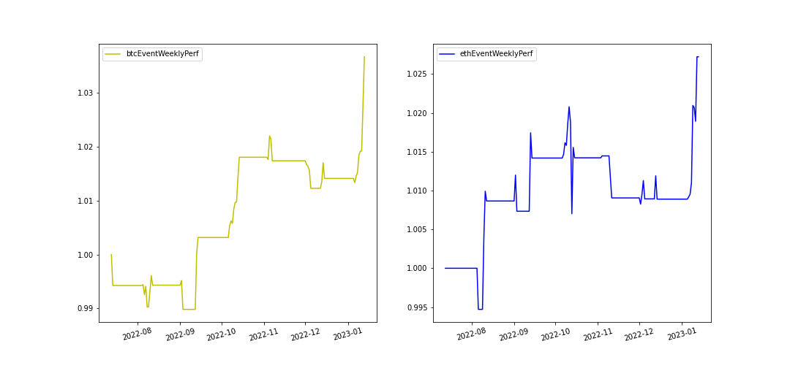

本月的非农数据与CPI公布后都有较大幅的上涨，事件驱动策略有较好的表现。

|  |  |
| --- | --- |
| Last 30 days | eventPerf |
| btcEventMonthlyReturn: | 2.22% |
| ethEventMonthlyReturn: | 1.82% |