Monthly Report of DcBot

**1. 本月的价格走势与每周的变化率。**

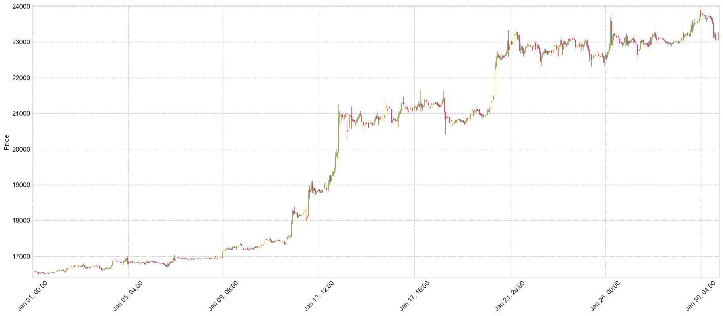

-上图是BTC本月的价格图

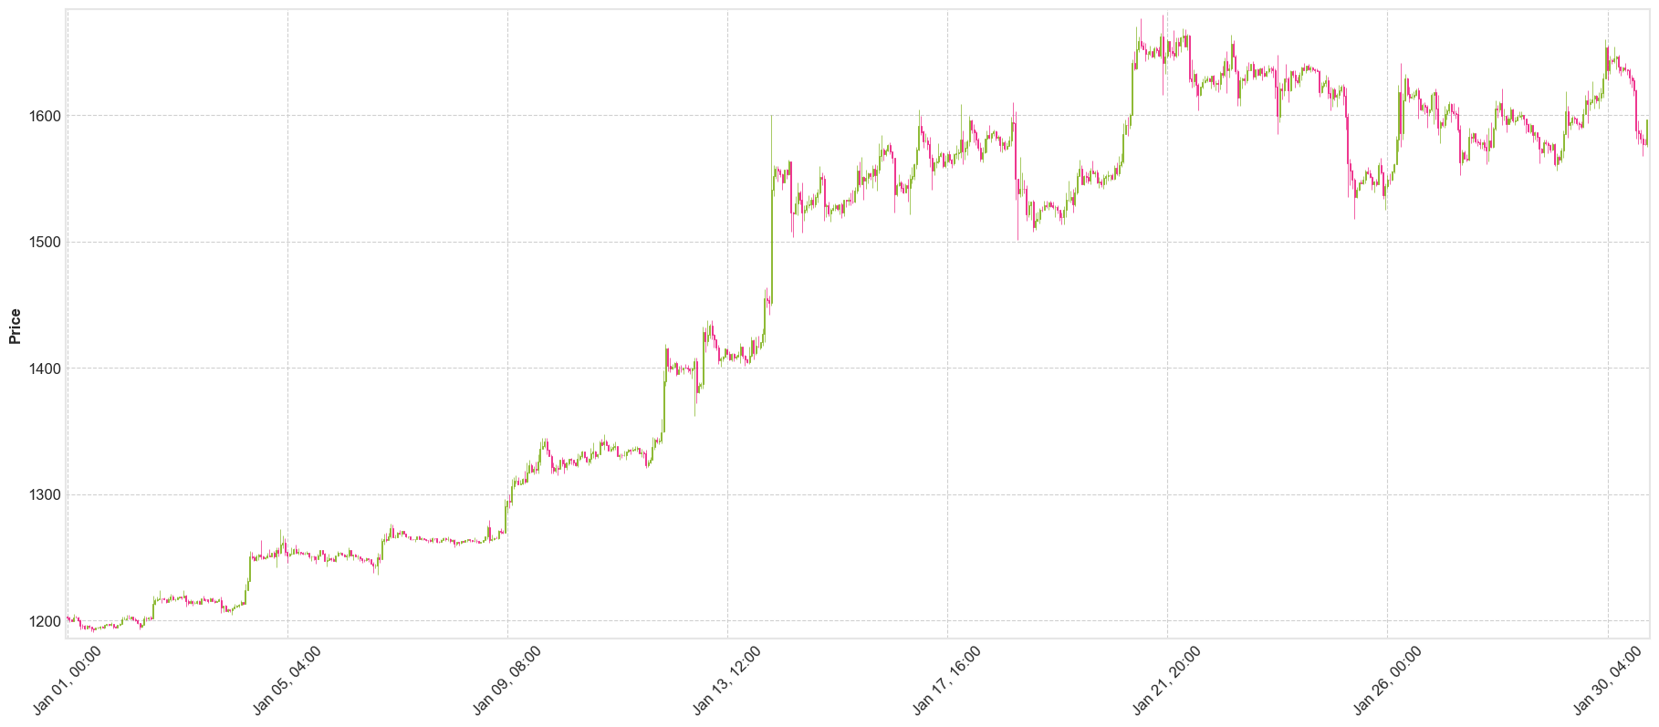

-上图是ETH本月的价格图

表格显示过去一个月中每周的价格变化率

|  |  |  |  |  |  |
| --- | --- | --- | --- | --- | --- |
| pctChange | Week1 | Week2 | Week3 | Week4 | monthly |
| btc_pctChange | 1.42% | 8.85% | 21.58% | 3.19% | 38.51% |
| eth_pctChange | -2.21% | 4.57% | 16.04% | 9.57% | 30.03% |