Monthly Report of DcBot

**本月的历史波动率与隐含波动率的统计**

波动率过小会导致盈利空间不足带来的磨损，而波动率过大风险也会随之放大，对策略最佳的波动率处于适中状态。

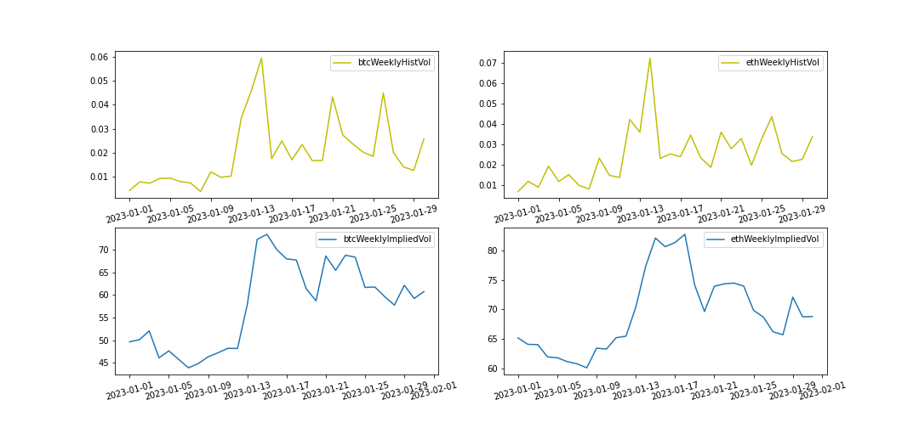

本月波动率与隐含波动率都从低位回升，CTA策略有较好的表现。

|  |  |  |
| --- | --- | --- |
| 2022-12-31~2023-01-31 | BTC | ETH |
| Current Historical Volatility | 2.62% | 2.97% |
| Current Historical Volatility Quantile | 50.94% | 35.63% |
| Monthly Mean of Historical Volatility | 1.97% | 2.43% |
| Monthly Pct_Change of Historical Volatility | 503.71% | 333.02% |

|  |  |  |
| --- | --- | --- |
| 2022-12-31~2023-01-31 | BTC | ETH |
| Current Implied Volatility | 61 | 69 |
| Current Implied Quantile | 9.26% | 5.18% |
| Monthly Mean of Implied Volatility | 58 | 69 |
| Monthly Pct Change of Implied Volatility | 22.31% | 5.55% |